IoTivity-based application manual

* Declare the folder structure of the source code and the meaning of each file

Folder path: ~/iotivity/resource/examples

Assignment files:

1. ~/iotivity/resource/examples/hoo_fridgeserver.cpp  
   This file is the server which hosts 3 resources: */device, /light and /door*
2. ~/iotivity/resource/examples/hoo_devicediscoveryclient.cpp

This file discovers resources in the vicinity, queries (GET operation) each resource and can sends message (PUT) to all resources.

* Declare your development/deployment environment (platform & compiler) and how to build your application step by step

Development/Deployment Environment:

Virtual Box 5.0.8, Ubuntu 14.04 LTS, Atom Editor. Host OS: Windows 7 Ultimate.

How to build your application:

Install the IoTivity framework for Linux. (Followed Wiki Instructions).

* Describe in detail about your implementation of functionalities that are considered very important (based on your perspective)

1. To search all devices and resources:

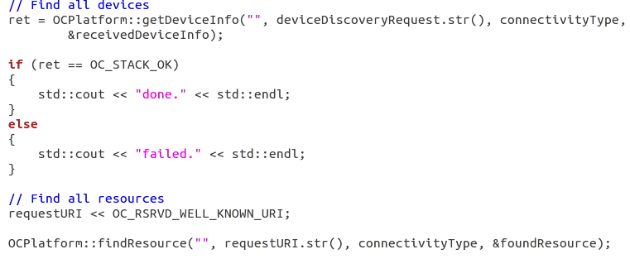

1. Refreshing the discovered devices and resources

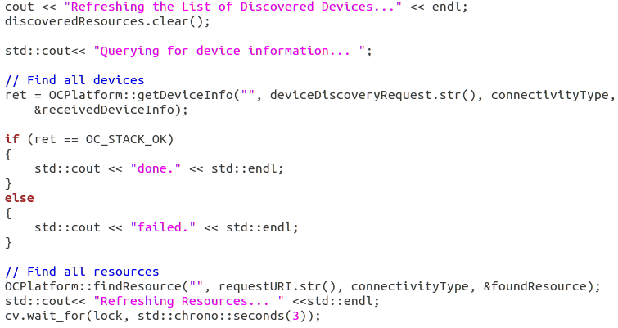

1. Sending the text message to all resources

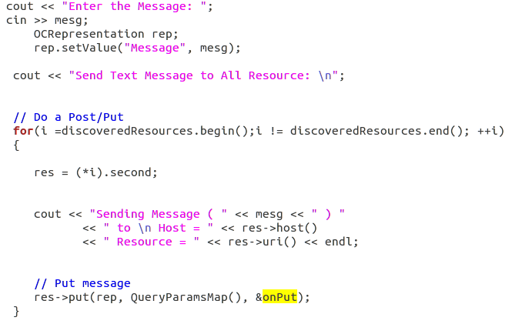

* Screen shots:

1. Starting application and CLI (Command Line Interface)



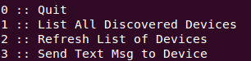

When user presses 1 (List All Devices and resources)

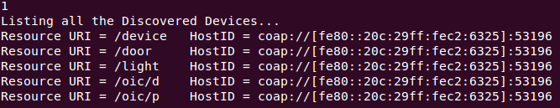

1. List All Discovered Devices   
   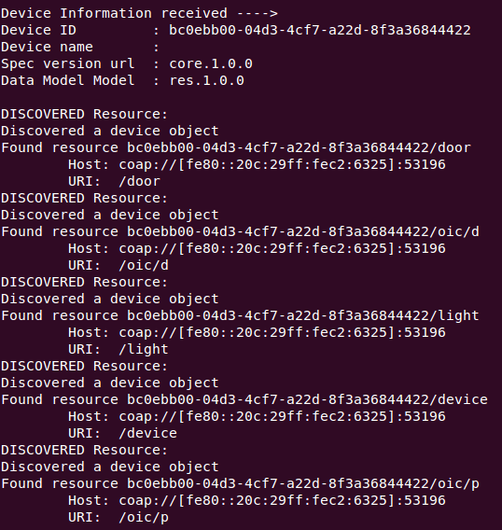
2. Refresh Discovery of devices/resources in the vicinity:  
   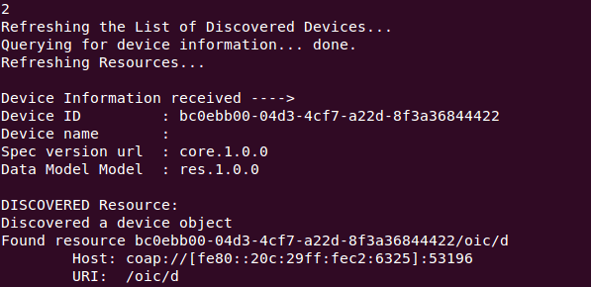
3. Sending Text   
   CLIENT SIDE OUTPUT  
   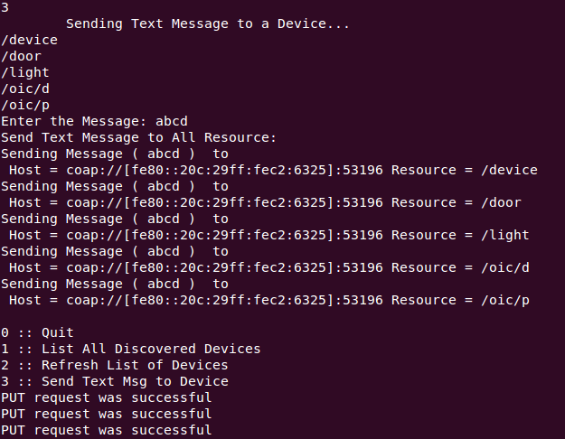

SERVER SIDE OUTPUT

