**Wars and World Trade**

Hyun Jun Choi1[949*−*864*−*7050], Shiv Prathik Velagala2[213*−*245*−*4406], and Seun Deleawe3[817*−*707*−*7992]

1 University of Southern California, CA 90007, USA. [choi797@usc.edu](mailto:choi797@usc.edu)

2 [velagala@usc.edu](mailto:velagala@usc.edu)

3 [deleawe@usc.edu](mailto:deleawe@usc.edu)

h[ttps://www.usc.edu/](http://www.usc.edu/)

**Abstract.** The history of war is as old as the history of humankind. Over the years, millions of people have died as a result of major and minor wars between different countries. After World War 1 and World War 2, many leaders felt that steps should be taken to reduce the number of wars. Through internationalization, these days, many countries trade and communicate. In this study, we address the question of whether there has been an increase in the number of wars over the years and explore the relationship between trade and war. By visualizing the Correlates of War datasets, which include data on militarized interstate disputes, wars, and trade, we try to uncover how economic dependence on trade has affected the number of wars between countries. In addition, using a map, we show which area has the most disputes, how the number of disputes has changed from 1816 to 2014, and for each year, how many countries are at war. We also explore how these figures have changed over time, whether they have increased or decreased, which countries have taken part in the major wars, and each war record.

**Keywords:** The Correlates of War Project *·* Wars dataset *·* Trade dataset *·* Militarized Interstate Disputes dataset

# Introduction

Since the beginning of human existence, war and the loss of human life that it leads to has been a reality. Since World War 1 and World War 2, many countries have traded and communicated. Here, we question whether the number of wars has increased and how the trade relationship between each country affects this issue. By visualizing the Correlates of War (COW) datasets, which includes militarized interstate disputes (MIDs), wars, and trade, we aim to show how the number of countries at war and the number of MIDs have changed. In addition, we show how trade dependency between two countries has had an effect on wars with complete dyadic war records.

# Data

## Data Description of MIDs, Wars, and Trade

The data on MIDs we use in this paper come from the COW project, which is a very large dataset related to militarized disputes over the last century. The file name is Militarized Interstate Disputes v 4.2. This dataset is available for all years from 1816 to 2010. Each row includes fields such as year, dispute number, and location. In the COW project, war is defined as a conflict with at least 1,000 deaths of military personnel. The War dataset includes war number, dispute number, two states, year, and battle deaths. The Trade dataset has two files. One file has national information, where each row has the country code, state name, state abbreviation, year, import, and export. The other trade file has dyadic information. Each row has country code1, country code2, year, importer1, importer2, flow1, and flow2. Flow1 represents the export amount of importer2 to importer1 in US millions of current dollars, and flow2 represents the export amount of importer1 in US millions of current dollars.

# Approach, Development, and Evaluation

## Bubble Chart

To create the JSON file for the bubble chart, we used the War dataset and Trade dataset. We named the JSON file BothWarAndTradeInter10ForBubble.json. In each part, there are records about wars, trade, the names of major wars, and an explanation. In the JSON file, there are three parts named BeforeWWone, BetweenWWoneWWtwo, and PostWWtwo. BeforeWWone includes three periods, and each period contains the total number of countries at war during the period. For example, there were 30 countries at war during 1870–1883. During this period, the major war was the Franco–Prussian war. We uploaded the python file for processing data named 554DataPreprocessing.py. Using this bubble chart, we explain how the number of countries at war has changed over time and which wars were major events in each period of interest.

## Bar Chart and Map

We used the geoMercator function to draw the map. Using the GeoJSON file, we created a projection and drew the path using a data join. After completing the data join, we created the bars. When users hover their mouse over the bars, the MID information appears and they can see where the outbreaks of MIDs occurred. We explain and show the corresponding information in the map. We also combine bar charts with the map using the dots- drawMIDsDotOnMap function. This function is called when the bar charts are clicked. When the users’ mouse hovers over the MID point, they are shown year and location information. Using a similar process, we plot the bars and maps for the Wars and Trade datasets.

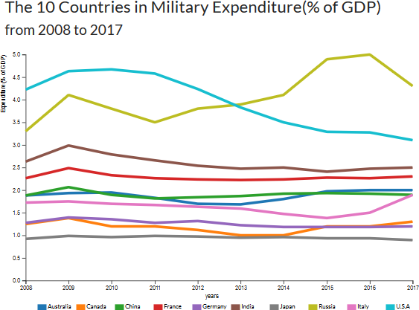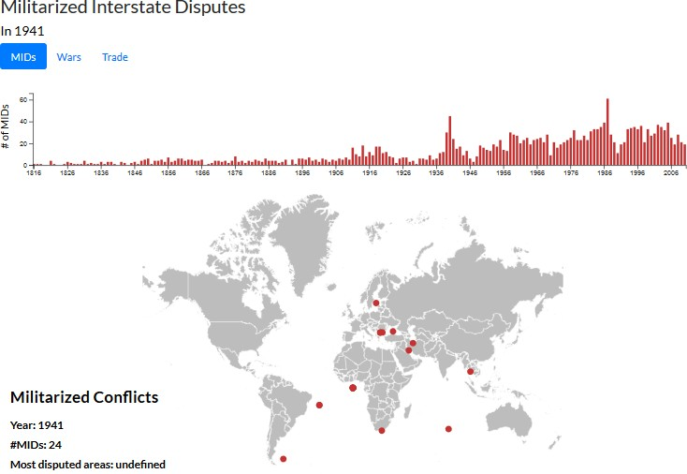

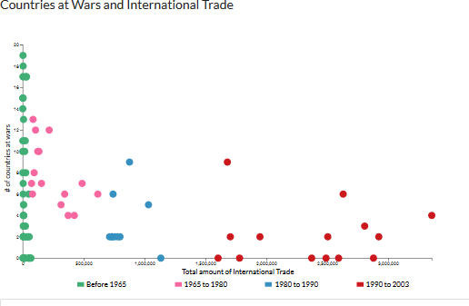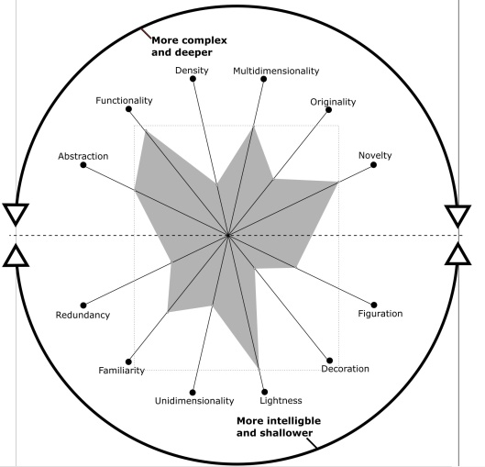

## Scatterplot

For the scatter plot, the HTML code is located in scatter.component.html. To implement this code, we create a csv file. In the code of the typescript file, we select the div with scatterChart1Div. Each circle was made by using a data join and filled based on the year. When the users’ mouse hovers over the circle, its edge is black and thick and the corresponding year, number of wars, and total trade amount are shown using a tooltip.

# Main Visualizations and Visualization Wheel

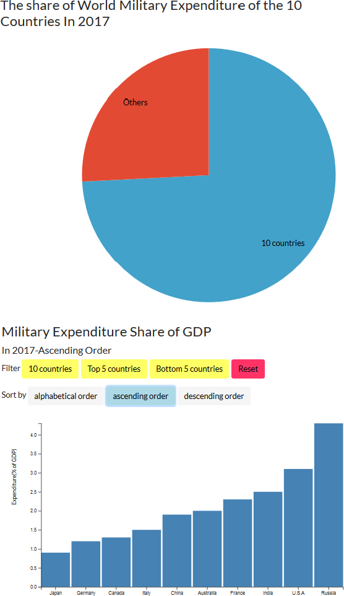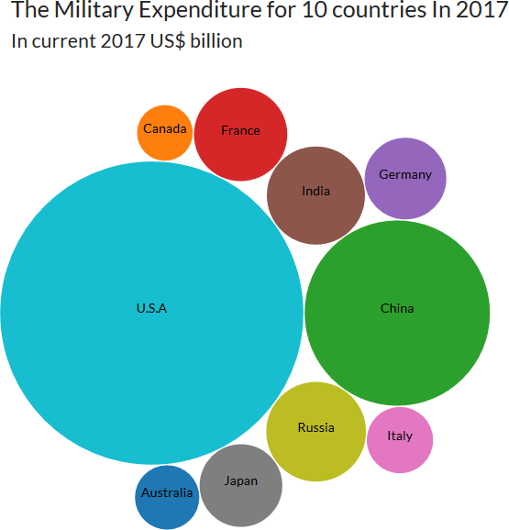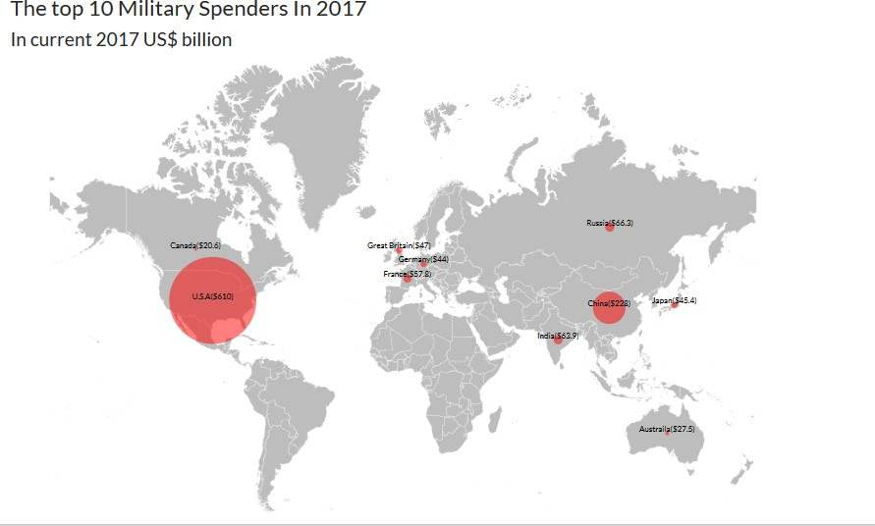

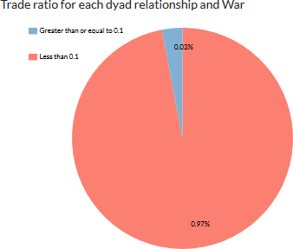

1. **Design and Technical Considerations**

We used a simple and clean layout with well-designed pages having good story flow. We made use of commonly used charts like line charts and pie charts, which are popular with the average user. This was done to make the information more accessible to people who are new to this domain. That is, the aim was to grab users’ attention initially and maintain their interest long enough for them to explore the novel and complex visualizations. For example, we made use of bar charts and maps together to show the multilevel, multidimensional visualization of information. Users can easily explore the MID, War, and Trade datasets with a single click and find patterns and relations between these entities. By showing different views at once, it is more informative and exploratory in nature for the user. These kinds of visualizations are very useful to political scientists or people who want to delve more deeply into this subject.

# Conclusion

The number of wars in recent years is significantly less than the number of wars a century ago. These days, international trade has had a material effect on countries’ economies. Therefore, many countries have developed their economies through international trade, and through this, economic inter-dependency between countries has increased. In many cases, developed countries hesitate to initiate or participate in wars because of the negative effect that it has on them. For instance, they must spend large amounts of money to win wars, which could have otherwise been spent to develop their economies. Therefore, nowadays, participating in war has become an unreasonable decision for many developed countries. We observed that prior to 1965, very few countries had good trade relationships and the number of wars was high. Presently, most countries have good trade relationships and the number of wars has decreased significantly. Thus, we conclude that international trade is a major factor in deterring wars and maintaining peace around the world.

# References

Amr, T., & Stamboliyska, R. Practical D3.js.

Barbieri, K. Economic geography, trade, and war.

Barbieri, K. Globalization and peace: Assessing new directions in the study of trade and conflict.

Barbieri, K., & Keshk, O. M. G. Correlates of War project trade data set codebook, version 4.0.

Barbieri, K., Keshk, O. M. G., & Pollins, B.M. Trading data: Evaluating our assumptions and coding rules.

Bearce, D. H., & Fisher, E. O. N. Economic geography, trade, and war.

Bezerra, P., & Braithwaite, A. Codebook for the Militarized Interstate Dispute Location (MIDLOC-A) dataset, v2.0.

Bostock, M. (2016) D3. js-data-driven documents. Retrieved from: https://d3js. org.

Bostock, M., Ogievetsky, V., & Heer, J. A tour through the visualization zoo.

Bostock, M., Ogievetsky, V., & Heer, J. D3: Data-driven documents.

Copeland, D. C. Economic interdependence and war.

Copeland, D. C. The origins of major war.

Crockford, D. JavaScript: The good parts.

Croicu, M., & Sundberg, R. UCDP georeferenced event dataset codebook version 18.1.

Dewar, M. Getting started with D3.

Gray, J., Bounegru, L., & Chambers, L. The data journalism handbook.

Greig, J. M., & Enterline, A. J. National Material Capabilities (NMC) data documentation version 5.0.

Heydt, M. D3.js by example.

Humphreys, M. Economics and violent conflict.

Mansfield, E. D., & Pollins, B. M. Economic interdependence and international conflict.

Martin, P., Thierry, M., & Thoenig, M. Make trade not war?

Masad, D. P. Agents in conflict: Comparative agent-based modeling of international crises and conflicts.

Murray, S. Interactive data visualization for the web.

n.a. State system membership list codebook version 2016. Retrieved from: [http://correlatesofwar.org](http://correlatesofwar.org/)

n.a. State system membership list frequently asked questions version 2002.1. Retrieved from: [http://correlatesofwar.org](http://correlatesofwar.org/)

Newton, T., & Villarreal, O. Learning D3.js mapping.

Niederst Robbins, J. Learning web design.

Reid Sarkees, M. Inter-state wars codebook.

Thomas, S. A. Data visualization with JavaScript.

Tufte, E. R. D3.js in action.

Tufte, E. R. Envisioning information.

Tufte, E. R. The visual display of quantitative information.

Ware, C. Visual thinking for design.