**Lab10**

**Hyunki Lee**

Problem1

a. AL = 0019FF2D ZF = 0 SF = 1

b. AL = 0019FF48 ZF = 0 SF = 1

c. AL = 0019FF6F ZF = 0 SF = 1

d. AL = 0019FFA3 ZF = 0 SF = 1 PF = 1

Yes changed. After ‘and, or, xor’ are operated, the result will be stored in the destination operand.

Therefore, the value of al which is the destination operand is changed.

Problem2

a. CF = 0 ZF = 0 SF = 0 al = 0019FF0F

b. CF = 0 ZF = 0 SF = 0 bl = 00231006

c. CF = 1 ZF = 0 SF = 1 cl = 00401005

Test: no change

Cmp: no change

The two instructions – test and cmp – are not destructive subtraction of source from destination.

Therefore, the result value of destination operand is not changed.

Problem3

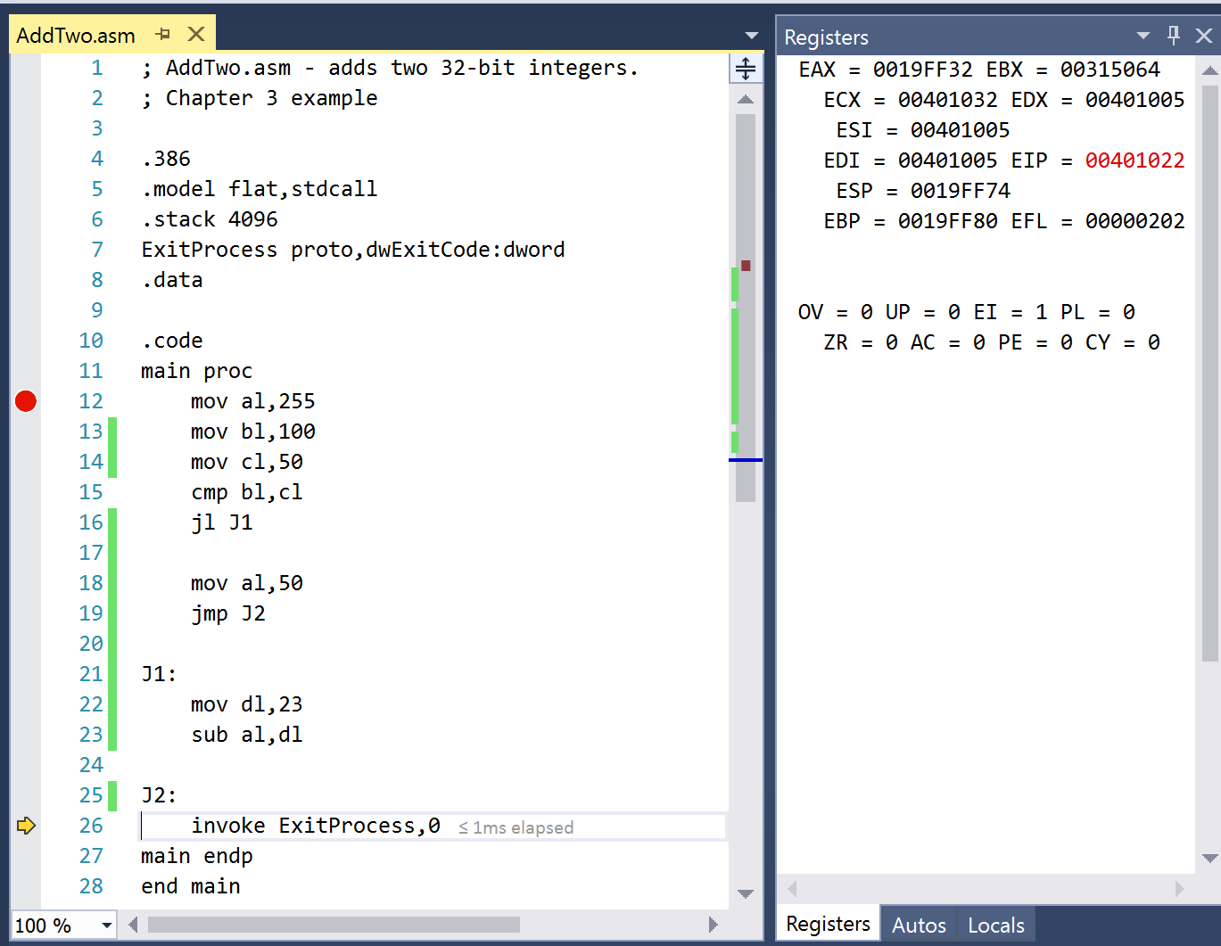

Final value of al : 0019FF32

Problem4

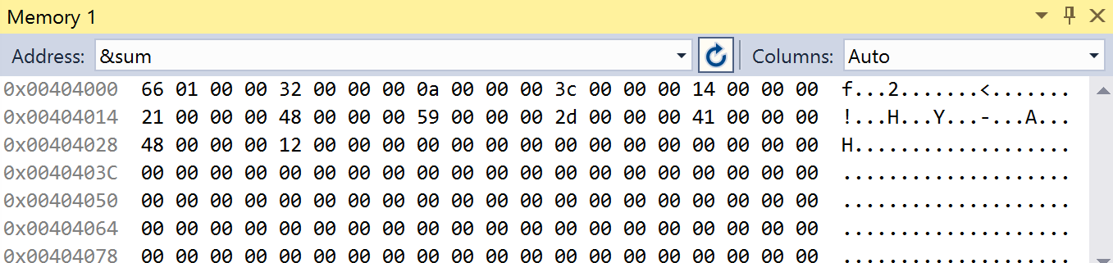

Sum: 00000166