Lab11

Hyunki Lee

Problem1

a. al= 0019FF6A CF= 0 OF= 1

b. al= 0019FFEA CF= 0 OF= 0

c. al= 0019FFFD CF= 0 OF= 0

d. al= 0019FFA9 CF= 1 OF= 0

e. al= 0019FF9A CF= 1 OF= 0

Problem2

Output al= 0019FF90

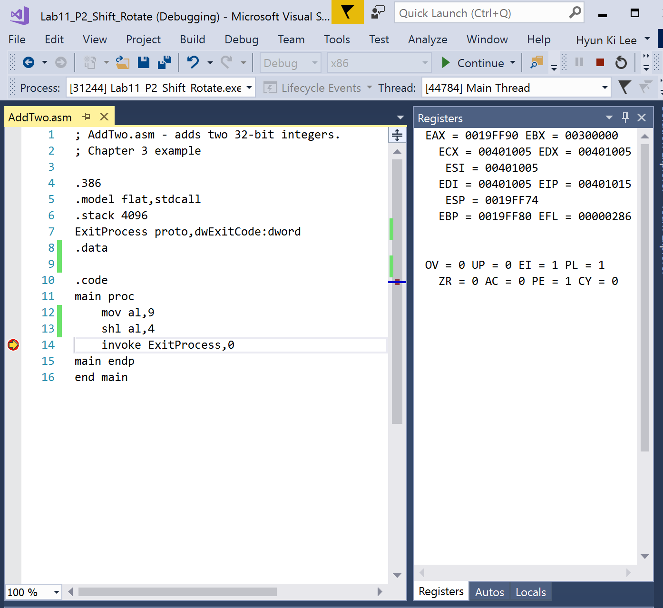

Problem3

Var4: 00190080

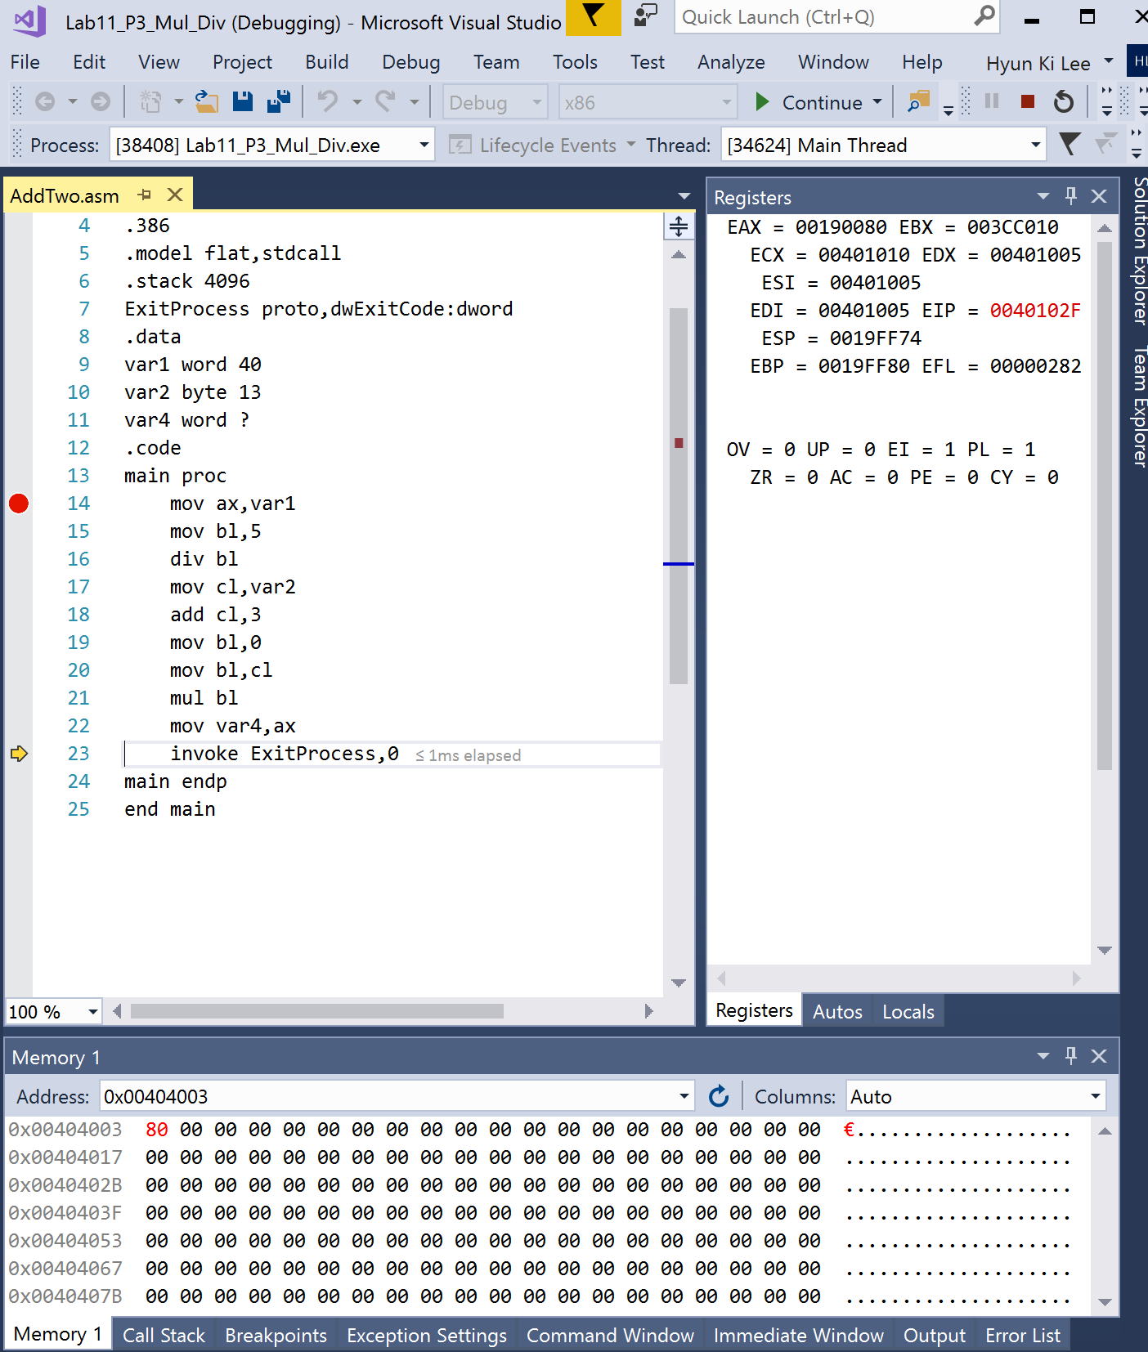

Problem4

Var4= 00190046

I figure out that idiv is also using ax register, thus I used ax as Dividend and Multiplicand.

Finally it works.

