Lab12

Hyunki Lee

Problem1

Code (result is in ECX and var)

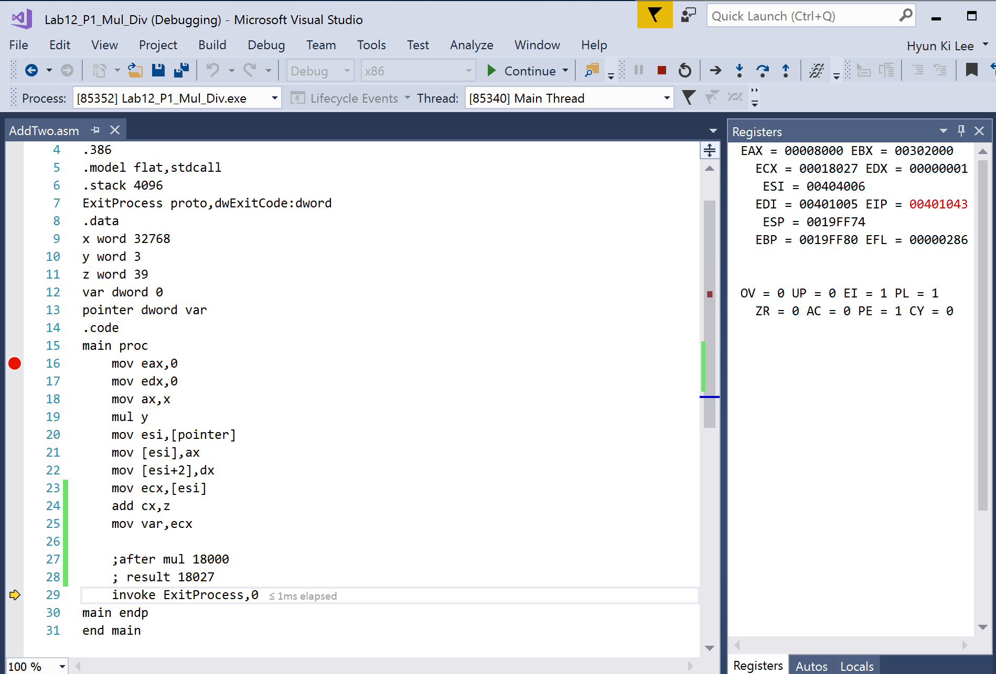

Output

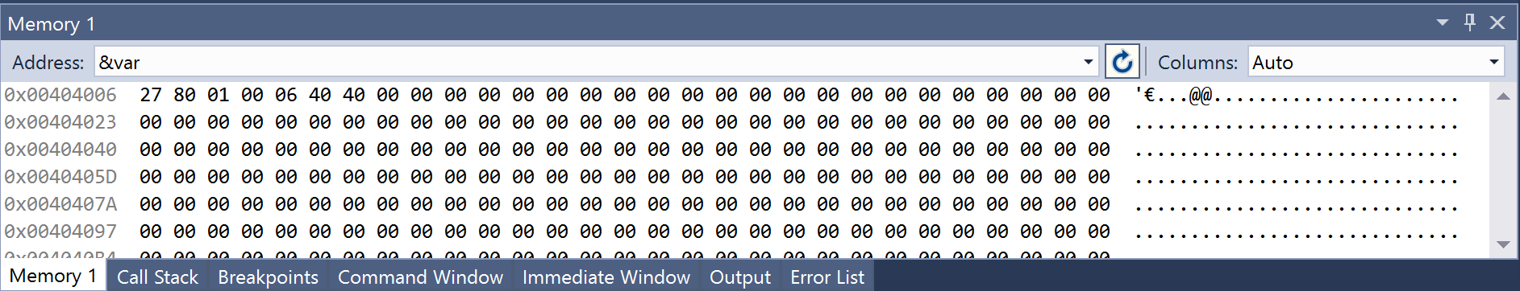

When I did mul operation CF =1 ZF=0,but the end of result CF=0, ZF=0.

Problem2

Code

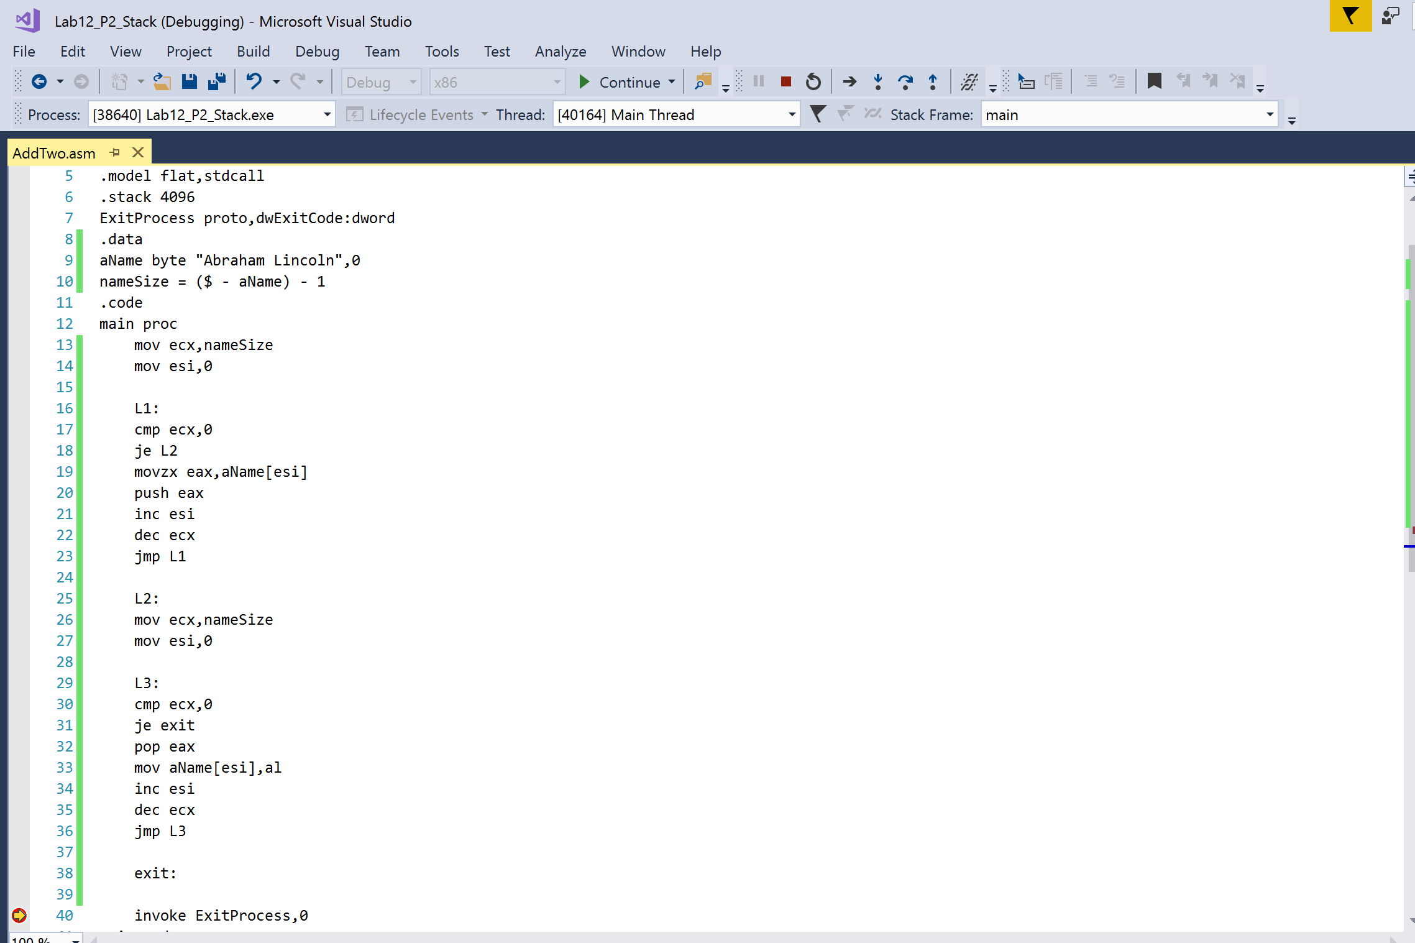

Output

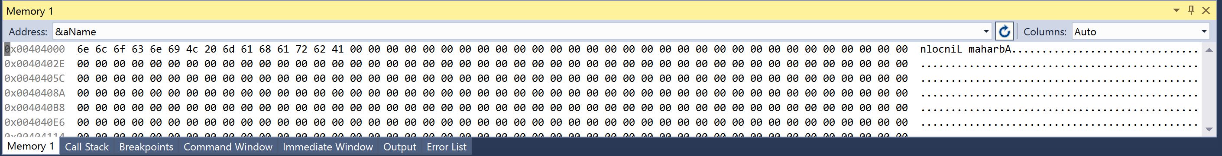

Problem3

Command prompt screen

