Lab6 (InLab)

Hyunki Lee

Part1

1: #/bin/bash: #!/bin/bash

2: /\* Check Error Script \*/: # Check Error Script

15: -ENDHERE: END

20: ls mail $1 < Result: mail $1@student.gsu.edu < Result

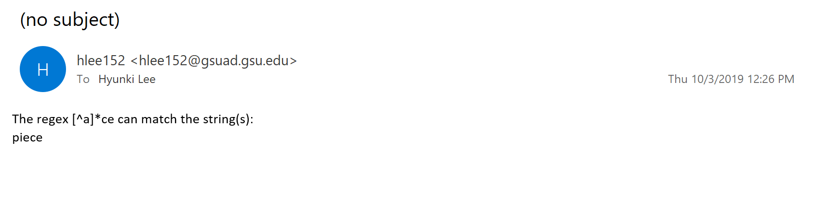

Part2

