Lab8

Hyunki Lee

1. Problem1 OFFSET Operator
2. AX = 00192010
3. AX = 00190000
4. AX = 00190000
5. AX = 00190044
6. Problem2 PTR Operator
7. ax = 00190502
8. bl = 00276078
9. bl = 00276002
10. ax = 00191234
11. eax = 12026543
12. Problem3 OFFSET Operator

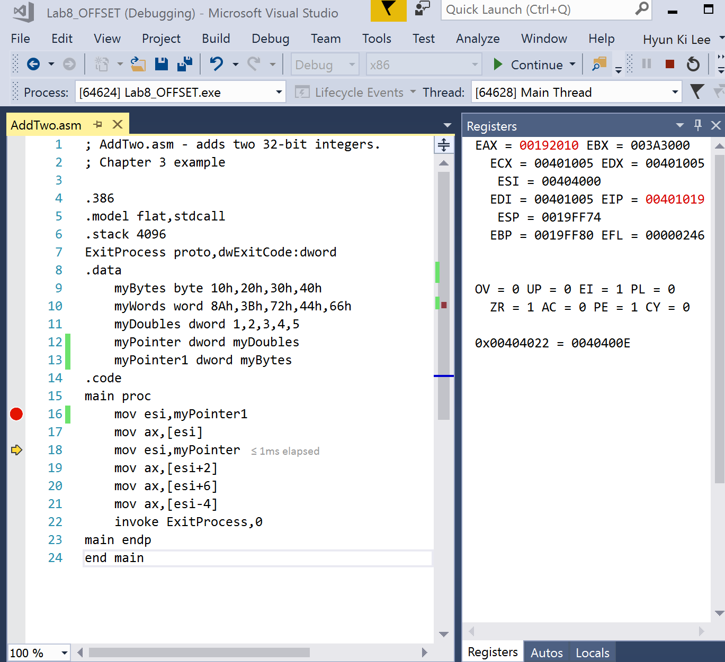

4. Problem4 Type, Length, & Sizeof Operators

a. eax = 00000001

b. eax = 00000004

c. eax = 00000004

d. eax = 00000002

e. eax = 00000004

f. eax = 00000008

g. eax = 00000005