HomeWork3

CSC4320

#002-34-4677

Hyunki Lee

1. Screenshot of output

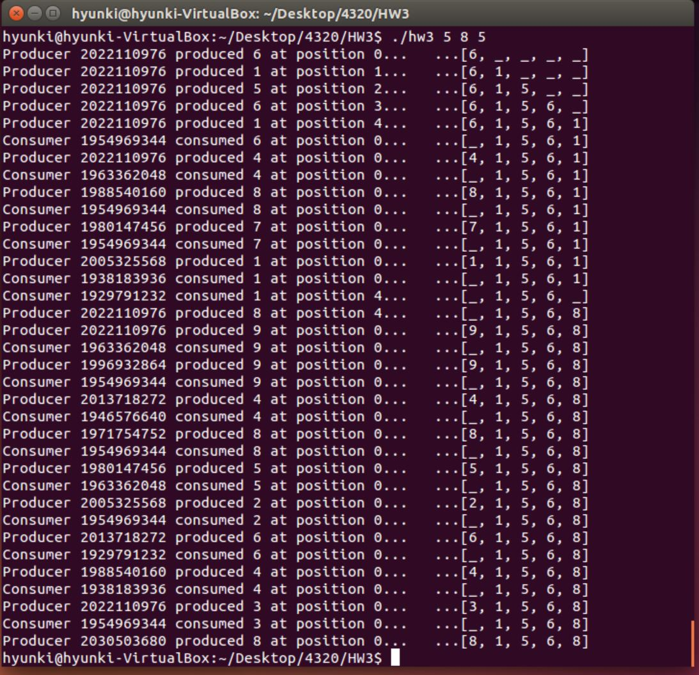

1. C source code

#include "buffer.h"

#include <stdio.h>

#include <stdlib.h>

#include <pthread.h>

#include <semaphore.h>

#include <time.h>

buffer_item buffer[BUFFER_SIZE];

sem_t empty;

sem_t full;

pthread_mutex_t mutex;

int i = 0;

int leftPos = 0;

int rightPos = BUFFER_SIZE-1;

int numOfItemInBuffer;

int pos = 0;

void *producer(void *param);

void *consumer(void *param);

int insert_item(buffer_item item)

{

int check = 0;

/* Acquire Empty Semaphore */

sem_wait(&empty);

/* Acquire mutex lock to protect buffer */

pthread_mutex_lock(&mutex);

/* Insert item into buffer */

if(numOfItemInBuffer == 0){

pos = 0;

leftPos = 0;

rightPos = BUFFER_SIZE-1;

buffer[pos] = item;

numOfItemInBuffer++;

}

else if(numOfItemInBuffer == BUFFER_SIZE){

check = -1;

}

else if(leftPos <= rightPos){

pos = BUFFER_SIZE - rightPos;

rightPos--;

buffer[pos] = item;

numOfItemInBuffer++;

}

else{

pos = leftPos - 1;

leftPos--;

buffer[pos] = item;

numOfItemInBuffer++;

}

printf("Producer %u produced %d at position %d... ...[", (unsigned int)pthread_self(), item, pos);

for( i =0; i < BUFFER_SIZE; i++){

if(buffer[i] == 0){

printf("_");

}else{

printf("%d", buffer[i]);

}

if(i != (BUFFER_SIZE-1)){

printf(", ");

}

}

printf("]\n");

/* Release mutex lock and full semaphore */

pthread_mutex_unlock(&mutex);

sem_post(&full);

return check;

}

int remove_item(buffer_item *item)

{

int check = 0;

/* Acquire Full Semaphore */

sem_wait(&full);

/* Acquire mutex lock to protect buffer */

pthread_mutex_lock(&mutex);

/* remove an object from buffer placing it in item */

if(numOfItemInBuffer == 0){

check = -1;

}

else if(leftPos <= rightPos){

pos = leftPos;

leftPos++;

*item = buffer[pos];

buffer[pos] = 0;

numOfItemInBuffer--;

}

else{

pos = (BUFFER_SIZE-rightPos)-1;

rightPos++;

*item = buffer[pos];

buffer[pos] = 0;

numOfItemInBuffer--;

}

printf("Consumer %u consumed %d at position %d... ...[",(unsigned int)pthread_self(), *item, pos);

for( i = 0; i < BUFFER_SIZE; i++){

if(buffer[i] == 0){

printf("_");

}else{

printf("%d", buffer[i]);

}

if(i != (BUFFER_SIZE-1)){

printf(", ");

}

}

printf("]\n");

/* Release mutex lock and empty semaphore */

pthread_mutex_unlock(&mutex);

sem_post(&empty);

return check;

}

int main(int argc, char *argv[])

{

/* Get command line arguments argv[1],argv[2],argv[3] */

if(argc !=4){

fprintf(stderr, "USAGE:./hw3 <sleeptime> <# of producer threads> <# of consumer threads>\n");

}

int sleepTime = atoi(argv[1]);

int num_Pro_Threads = atoi(argv[2]);

if(num_Pro_Threads < 1){

fprintf(stderr, "USAGE: <# of producer threads> should be larger than 1.\n");

}

int num_Con_Threads = atoi(argv[3]);

if(num_Con_Threads < 1){

fprintf(stderr, "USAGE: <# of consumer threads> should be larger than 1.\n");

}

/* Initialize buffer related synchronization tools */

int j;

pthread_mutex_init(&mutex, NULL);

sem_init(&empty, 0, BUFFER_SIZE);

sem_init(&full, 0, 0);

srand(time(NULL));

/* Create producer threads based on the command line input */

pthread_t pro[num_Pro_Threads];

for(j = 0; j < num_Pro_Threads; j++){

pthread_create(&pro[j], NULL, producer, NULL);

}

/* Create consumer threads based on the command line input */

pthread_t con[num_Con_Threads];

for(j = 0; j < num_Con_Threads; j++){

pthread_create(&con[j], NULL, consumer, NULL);

}

/* Sleep for user specified time based on the command line input */

sleep(sleepTime*3);

return 0;

}

void *producer(void *param)

{

/* producer thread that calls insert_item() */

int ranNum = rand() % 10;

while(1){

sleep(ranNum);

buffer_item item = (rand() % 9)+1;

insert_item(item);

}

}

void *consumer(void *param)

{

int ranNum = rand() % 10;

/* consumer thread that calls remove_item() */

while(1){

sleep(ranNum);

buffer_item item;

remove_item(&item);

}

}