**HW3**

**Hyunki Lee**

1. Shell

Source Code:

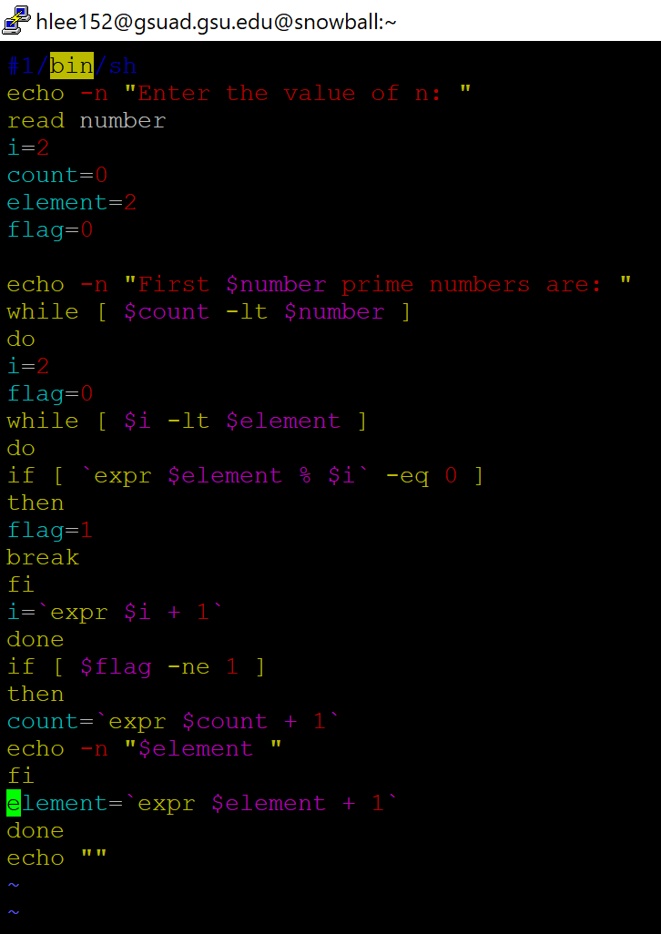

Output:

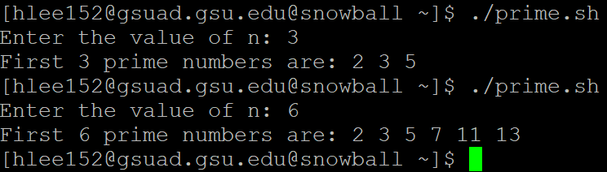

1. C

Source Code:

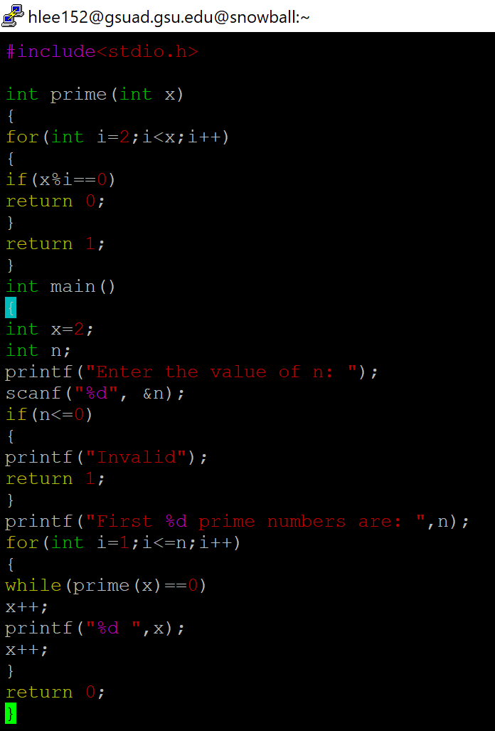

Output:

