Homework 5

Hyunki Lee

Part1

Source Code

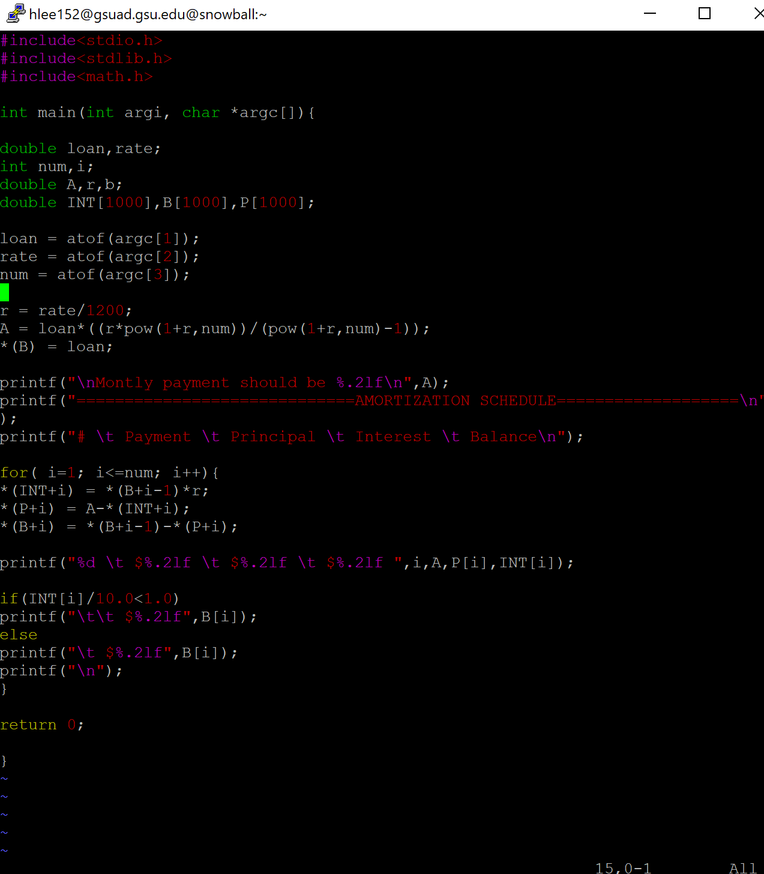

Output

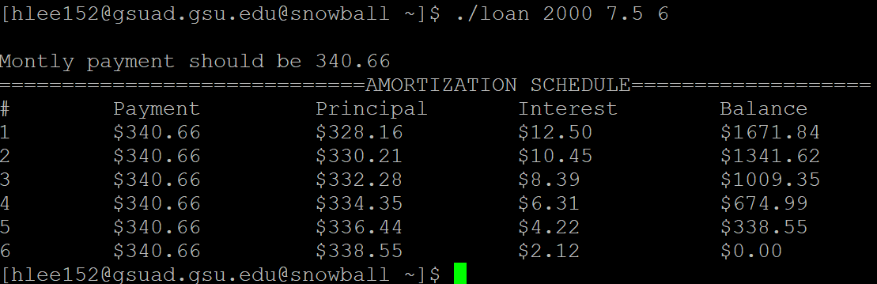

Part2

1)

(a)

struct point Center(struct rect r) {

struct point s;

s.x = (r.upperLeft.x + r.lowerRight.x)/2;

s.y = (r.upperLeft.y + lowerLeft.y)/2;

return s;

}

(b)

struct rect Move(struct rect r, int x, int y) {

r.upperLeft.x += x;

r.upperLeft.y += y;

r.lowerRight.x += x;

r.lowerLeft.y += y;

return r;

}

2)

struct rect \*p;

p = (struct rect \*) malloc(sizeof(struct rect));

p->upperLeft.x = 9;

p->upperLeft.y = 8;

p->lowerRight.x = 2;

p->lowerRight.y = 1;

3)

struct rect \*p;

p = (struct rect \*) malloc(sizeof(struct rect));

p->upperLeft.x = 9;

p->upperLeft.y = 8;

p->lowerRight.x = 2;

p->lowerRight.y = 1;

char aname[] = “MyRect”;

p->name = (char \*)malloc(strlen(aname)+1);

strcpy(p->name, aname);