Lab6 Part2

Hyunki Lee

PartA

1)

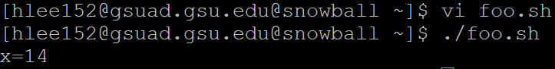

2)

In while condition '$i' represents value of variable i and checking the condition, value of i is less than or equal to 3. the loop continues until the condition becomes false and exits the loop.

when the while loop condition is satisfied loop control comes to next line and performs operations.  
s = i \* i , here multiplication of value at variable i is performed and stored in variable s.

x = x + s, addition of values at variable s and variable x is performed and stored in variable x ( x = 1 + 0, s value is taken from above calculation).

x = x + 1, i value is incremented by 1 and stored into variable i only therefore ( i = 1 + 1)  
here while loop continues till the condition becomes false. when condition becomes control moves to line 15.  
echo x = $x, the value of x is displayed by using echo command.

Part B

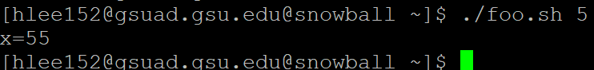

Part C

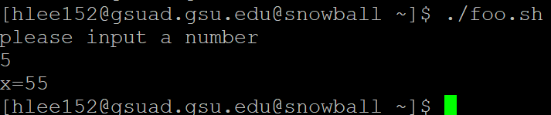

Part D

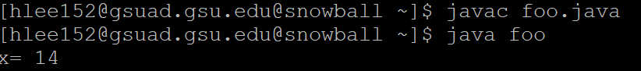

class foo{

public static void main(String[] args){

int x=0;

int i=1;

while(i<=3){

int s=i\*i;

x=s+x;

i = i+1;

}

System.out.print(“x= “+x);

} //main

} //class

Part E

1)



2) “hello” file is made

3)

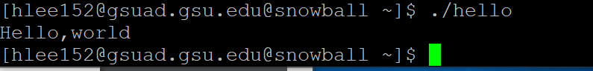

4)

#include <stdio.h>

int main(void)

{

printf(“My name is Hyunki Lee\n”);

return 0;

}

