**Lab10**

**Hyunki Lee**

**Part1**

1) Code

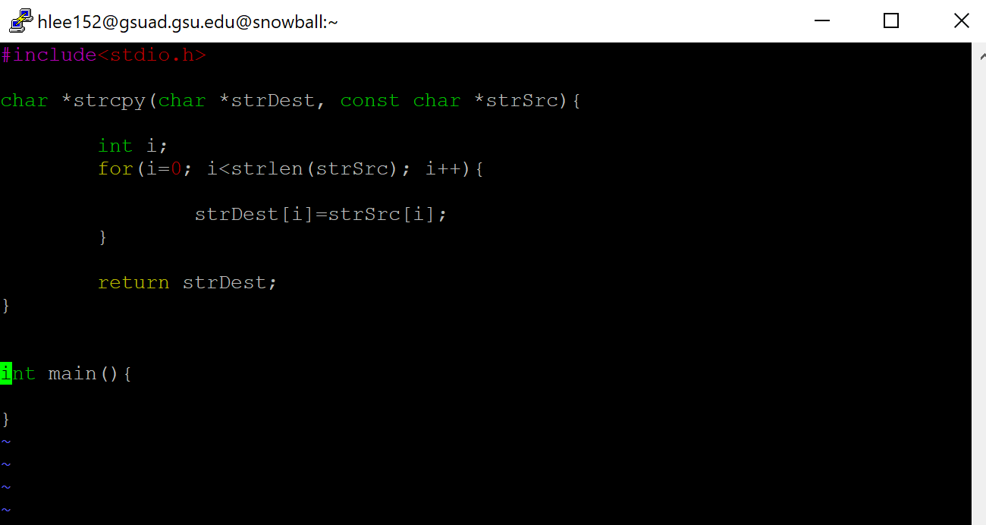

2) If we use char* as return, we can easily access to this function and ease to use it. We can just call this function to use, and we also can call this function within printf(destination string will be returned).

**Part2**

1) Code

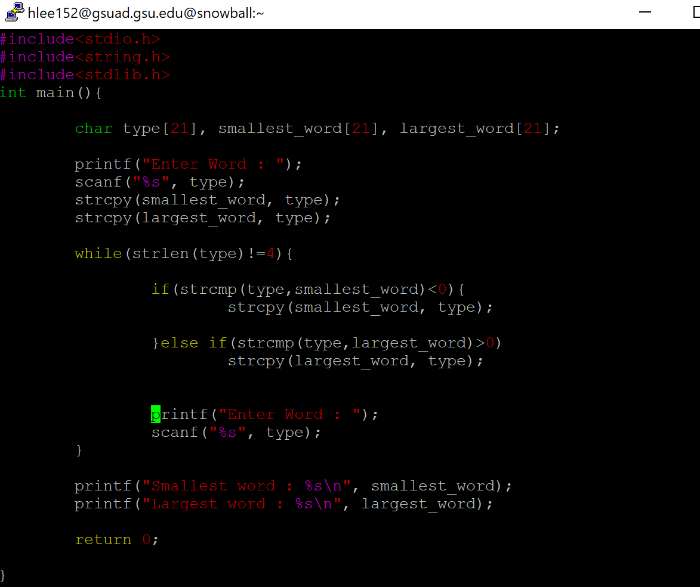

2) Output

