Lab Assignment4 – Part 2

Hyunki Lee

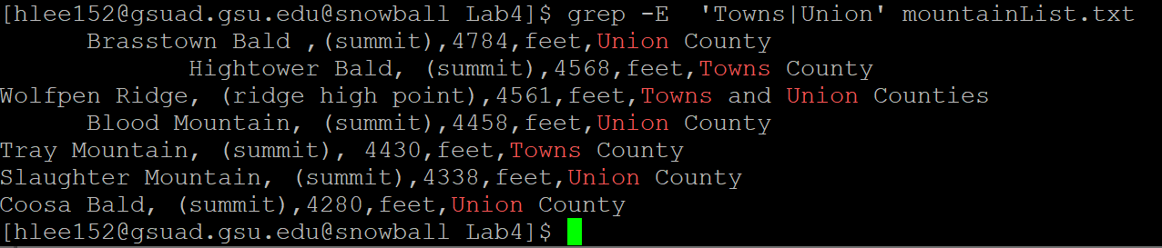





1. A.

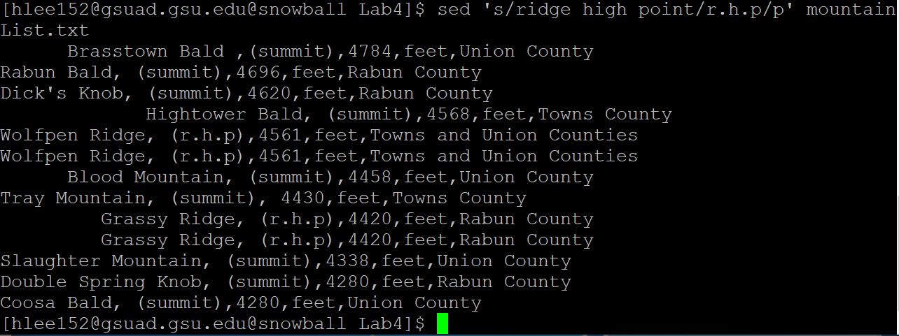

B.

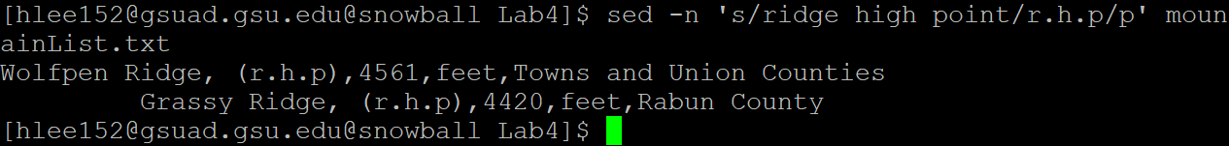

C: Suppress automatic printing of pattern space

D: Substitute ridge high point to r.h.p. To suppress automatic printing of pattern space use ‘-n’. ‘p’ is a command for printing the data from the pattern. Therefore, If I use ‘-n’ but did not use ‘p’, I cannot see the output. Otherwise, If I use ‘p’ but not use ‘-n’. I can see the whole process of substitution.

