**Lab7**

**Hyunki Lee**

Part1

1: Source Code

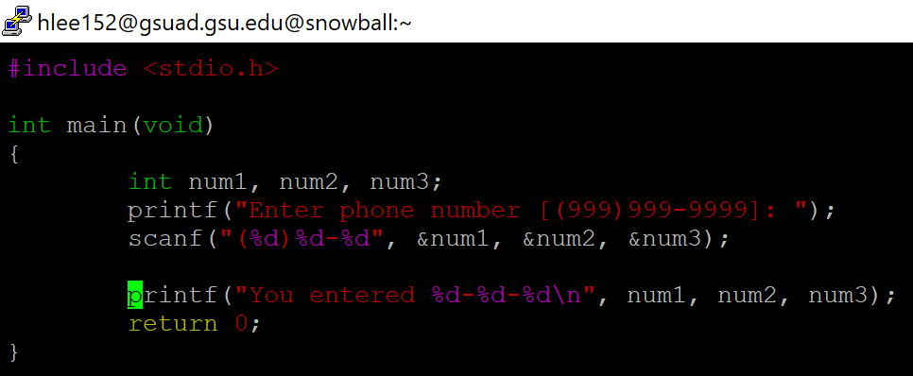

1: Output

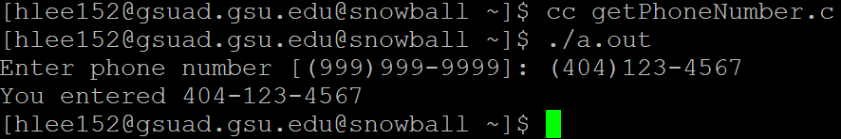

2: Source Code

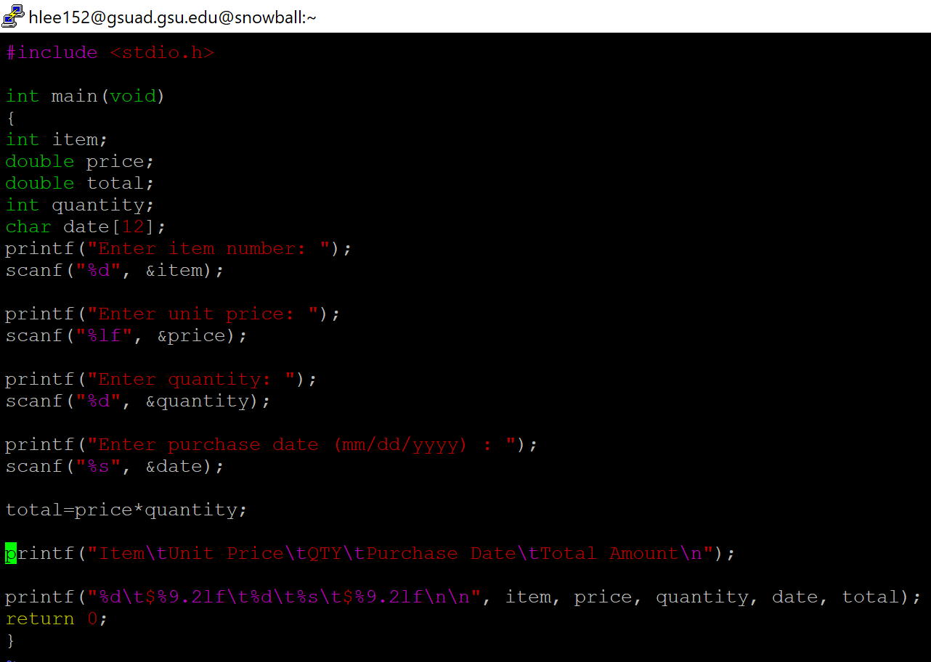

2: Output

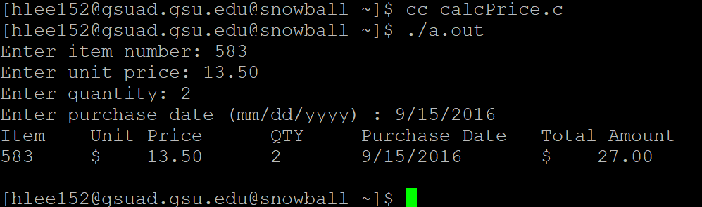

Part2 (Optional)

Source Code:

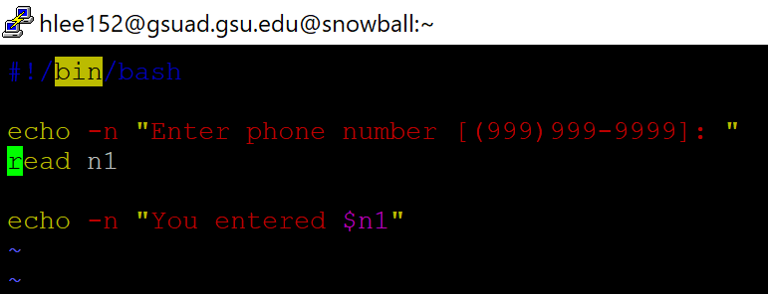

Output:

