**Lab8**

**Hyunki Lee**

**Part1**

4) break 6 (line number was 6)

4) run

6)

|  |  |  |  |  |
| --- | --- | --- | --- | --- |
|  | 1st Iteration | 2nd Iteration | 3rd Iteration | 4th Iteration |
| num | 112 | 11 | 1 | 0 |
| rev_num | 5 | 52 | 521 | 5211 |

8) reverse the given number ex) 1125 -> 5211

**Part2**

1) Errors during compiling

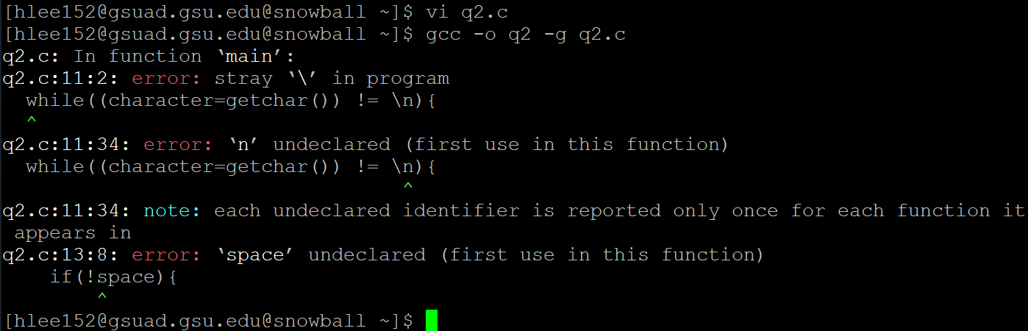

Line 11: ! = \n 🡪 ! = ‘\n’

Line 13: declare ‘space’ 🡪 int space;

2) After running program



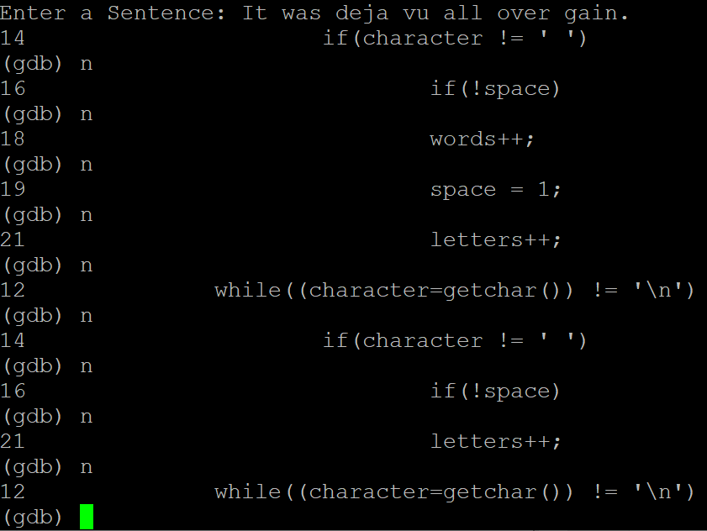

Incorrect output with infinite loop.

To int letters, int space, int words, we need to initialize default value to each variable.

Int letters = 0;

Int space = 0;

Int words = 0;

After that

Also, line 22

printf("Average word length : %.1f", letters/words);

In front of ‘letters’, I need to add ‘(float)’ to cast the type of print statement.

printf("Average word length : %.1f", (float)letters/words);

Output:

