Lab9

Hyunki Lee

**Part1**

Code

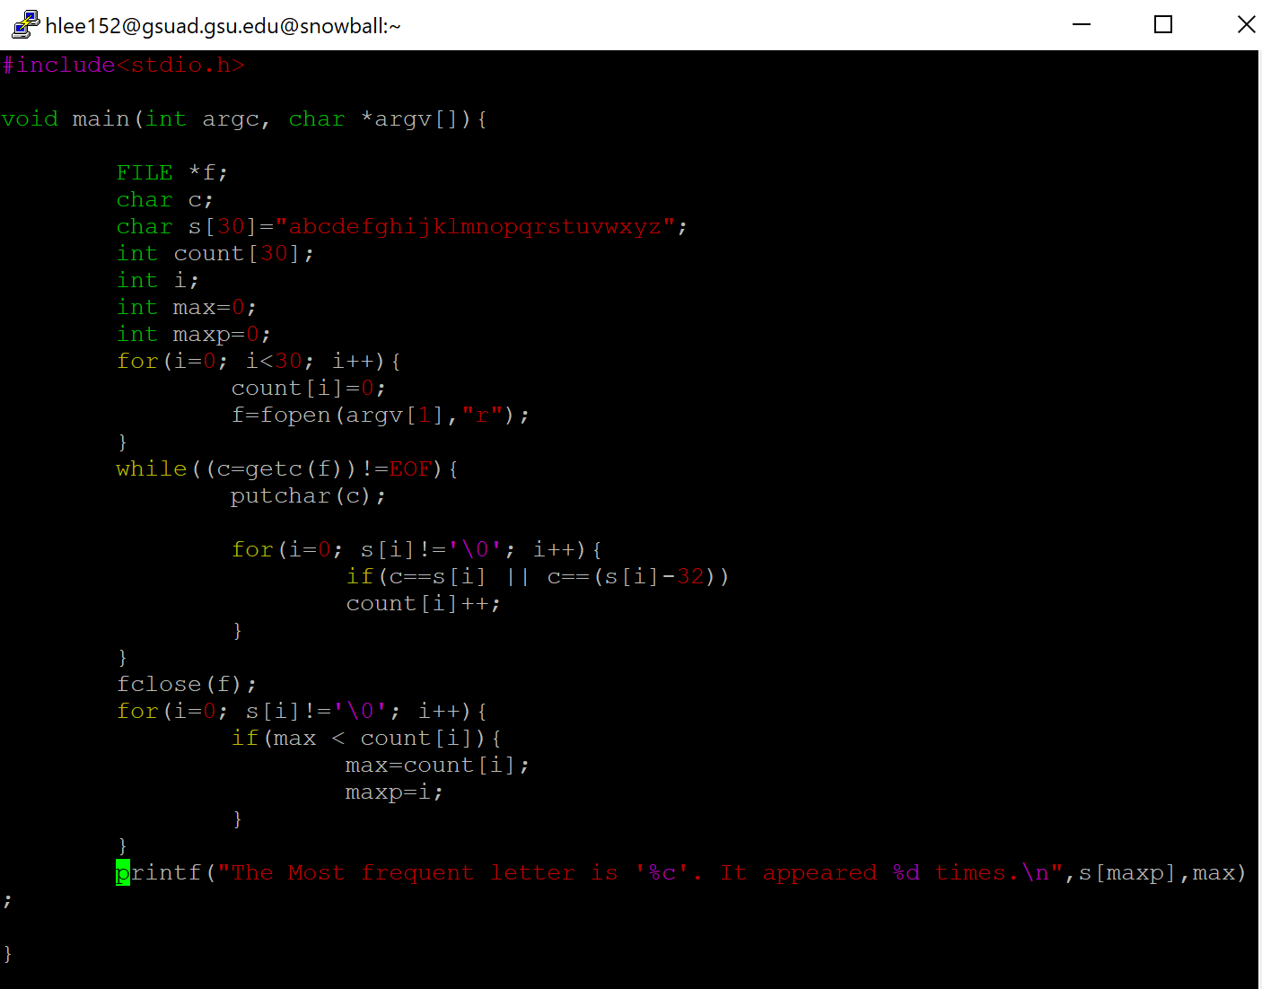

Output

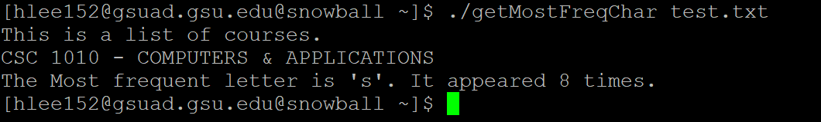

**Part2**

1) Output

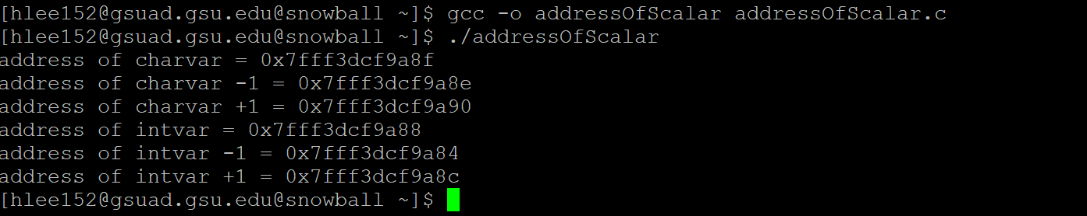

2) Code

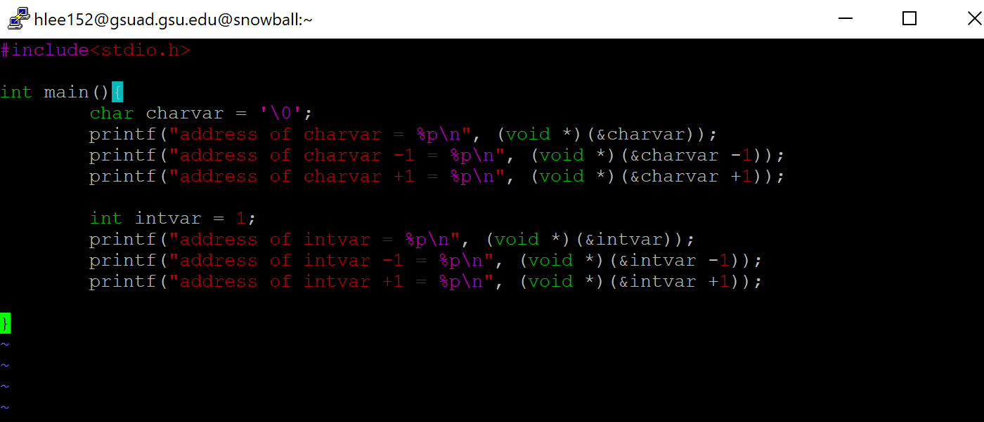

3)

Integer value is treated as 4bytes in C language. When we did any arithmetic for integer, the integer value will take 4 bytes of memory. Therefore, address for integer value also moves 4 bytes.

**Part3**

1) Output (include lengthof)

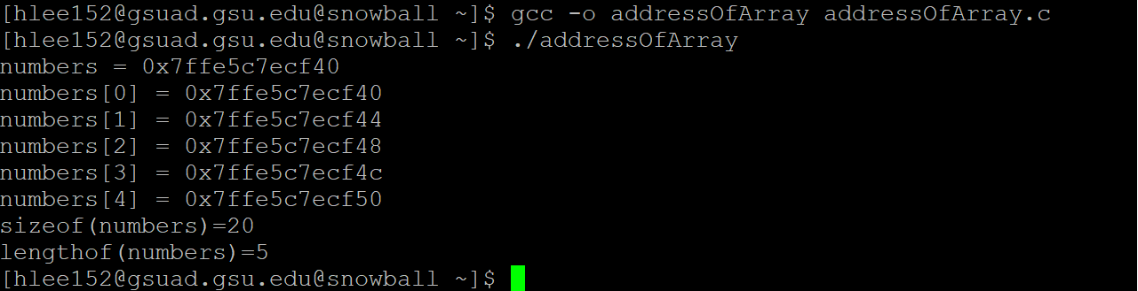

Code (include lengthof)

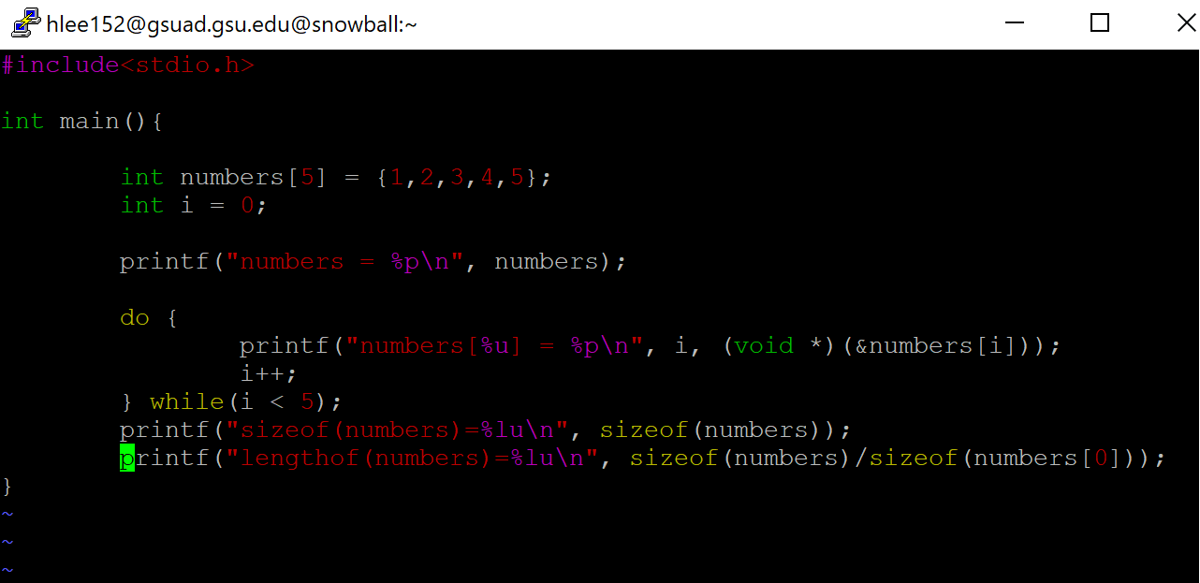

2)

Yes, they are the same address.

3)

printf(“length(numbers)=%lu\n”, sizeof(numbers)/sizeof(numbers[0]));