Camel case naming convention

Primitives string, number, bigint, boolean, undefined, symbol, and null.

No keywords for var names, can start with letter, underscore or $

TYPE COHERSION > CONVERTS TYPES FROM ONE TO ANOTHER AS NEEDED
Undefined vars can be declared on the same line
JS supports variable mutation, in which a declared variable can be overrided with any data type

var isGreater = numbOne < numbTwo; SETS A BOOLEAN

var grade = 100;

grade < 101 ? console.log(true) : console.log(false);

Ternary operator, made up of three parts
var result = grade < 100 ? "failure" : "success";

result of this var will be decided by the ternary operation.

var val = 1000;

switch(val > 100){

case false : console.log("less than val"); break;

case true : console.log("greater than val"); break;

default : console.log ("if no match to case");
}

Case statement, like VBA. Used to judge a expression and decided.

switch(true){

case val < 100 : console.log("less than val"); break;

case val > 100 : console.log("greater than val"); break;

default : console.log ("if no match to case");
}

Another example

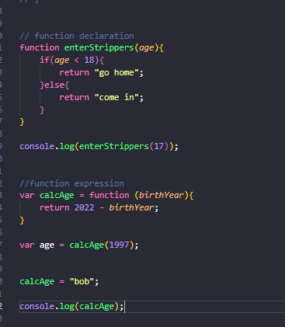

Function declaration and expression. Function declarations are similar to var; they will be automatically hoisted, whereas function expressions will not be hoisted. In simple terms, function declarations will load before any other code, and function expressions will load when the interpreter reaches it.
Expression functions also act as a var, and as can be seen with calcAge, can be overridden with a new value. Think of function as a data type in this scenario.
In short, use function declarations when you want to create a function on the global scope and make it available throughout your code. Use function expressions to limit where the function is available, keep your global scope light, and maintain clean syntax.

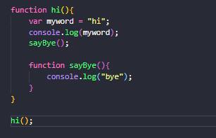

Creating own scope with functions.
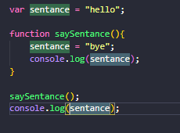

Example of a var being available, due to the global scope in which it was declared.

REMEMBER PARENT AND CHILDREN. A CHILD CAN USE A PARENT VAR, A PARENT CANNOT USE A CHILDS VAR AS IT IS OUT OF SCOPE.

Arrays can be mixed type, also overwritten.

var studnets = ["s","j","k",123]

var arr = new Array();

var friends = studnets.slice(studnets.indexOf("k"));

console.log(friends);

example of using some array functions, also generic ones like push, pip and unshift exist. SLICE DOES NOT EDIT ORIGINAL ARRAY, CREATES A NEW ONE
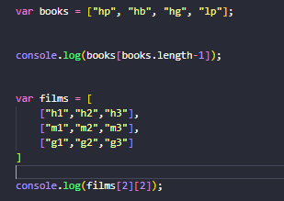

Accessing last arr element, accessing nested array.
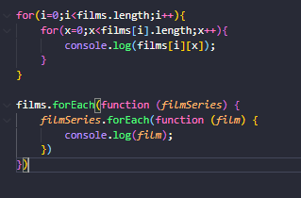

For and for each loops doing the same thing. The forEach() method is not executed for empty elements.

ALWAYS USE LITERAL SYNTAX WHEN DECLARING ARRAY, USING NEW ARRAY() IS AMBIGUOUS.

ITEMS IN AN OBJECT ARE ARRANGE USING KEY VALUE PAIRS

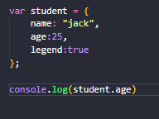

Object example.

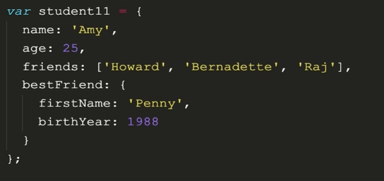

METHODS CAN BE ADDED TO OBJECTS AND CLASSES, USING THIS IN A FUNCTION WILL POINT TO THE GLOBAL OBJECT, WHICH IS ALWAYS THE WINDOW. THIS IS EVEN THE CASE WHEN A FUNCTION IS INSIDE A METHOD
IN A METHOD IT WILL POINT TO AN OBJECT

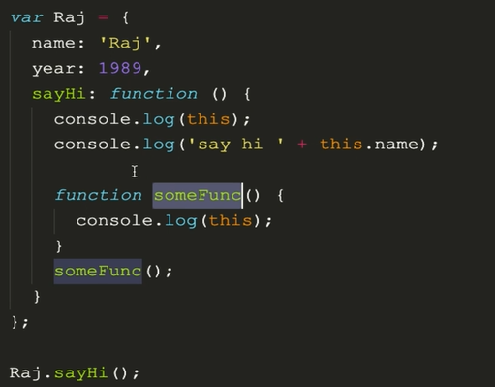

DOM IS THE INTERFACE BETWEEN THE JAVASCRIPT AND THE HTML+CSS
DOM CONVERTS ALL HTML TAGS INTO JAVASCRIPT OBJECTS, IS THE ROOT OBJECT AND IS HOME TO METHODS REQUIRED TO INTERFACE
EVERY CONVERTED OBJECT IS STORED UNDER THE DOCUMENT OBJECT, FUNDAMENTALLY THE SAME AS A GOOD OLD OBJECT
Console.dir(document) to see document object model

Manipulation is using JavaScript to change the style, configuration of classes, changing the content and changing the attributes of a webpage.

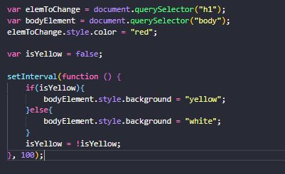

Select and manipulate process, this once changes the screen between yellow and white.

Other selectors include document.getelementbyid(),tagname(),classname() and query selector. Query selector can do all, and will return the first match.
https://www.w3schools.com/jsref/met_document_queryselector.asp

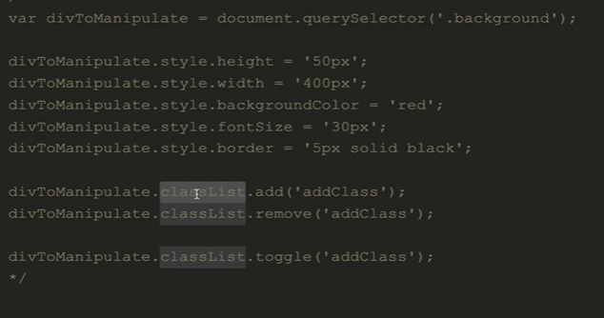

HASH TO SELECT AN ID, . for class.

var para = document.querySelector("#paragrahpToChange");

console.log(para.textContent);

innerHTML method of a paragraph keeps the html tags.

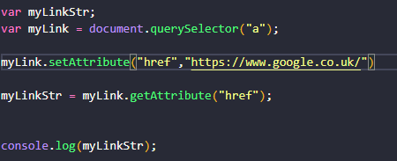

Get and setting an attribute (for example href).
Nodelist is what is returned with any DOM method returning a list, remember that it is just a shit array, does not have access to methods and cannot be in a foreach loop.

DOM EVENTS:
Javascript uses event handlers to trigger code when an event happens. (for example pressing a button, hovers over an element, on scroll etc), drag and drop, enter key. The list is endless!!!
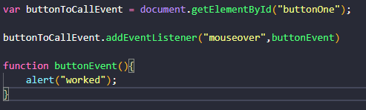
An example, mouse over a button to call a popup window. Alternatively the function could be declared inside the event listener.
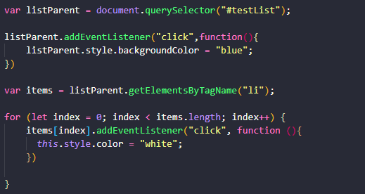

An example of using event listeners, looping through a list to add event listeners to each.
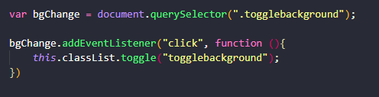
Toggle background event listener, turns a class on and off.

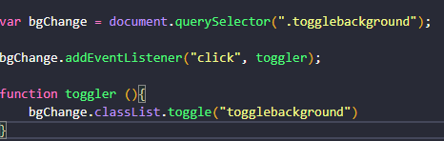
This can be done in a similar way using a callback function.
A callback function is a function passed into another function as an argument, which is then invoked inside the outer function to complete some kind of routine or action.
In this example, the addeventlistener function is calling toggle function.

If brackets were to be present on toggler call, it would run when the code is executed, and does not “callback” to the declared func

Typescript

Typescript is a superset of JavaScript. TS cant be executed via the browser, it is compiled into JavaScript, thus typescript is JavaScript. The Typescript complier compiles TS to JS, and converts functionality into JS work arounds (Potential problems).
It adds types, that gives us the opportunity to identify errors before they occur, tuning up the loose typed nature of JS, runtime errors can also be caught and fixed early.

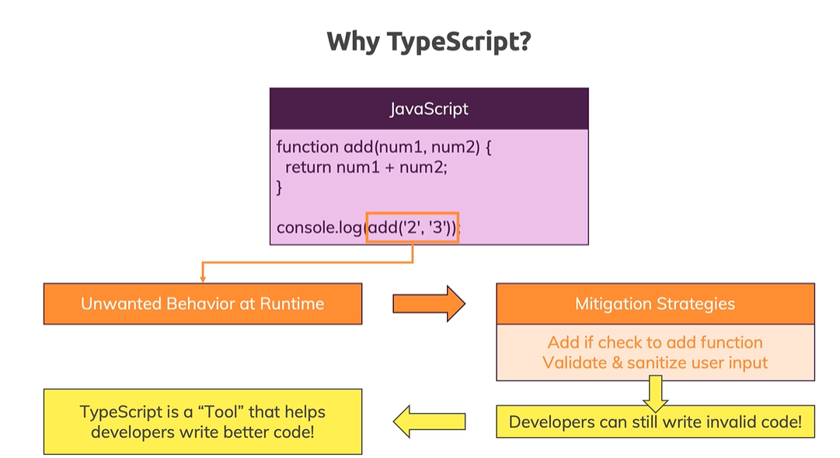

! mean never null, will always find an element
! as HTMLInputElement;

ALWAYS IMPORT TS!!
+ TO CAST TO NUMBER

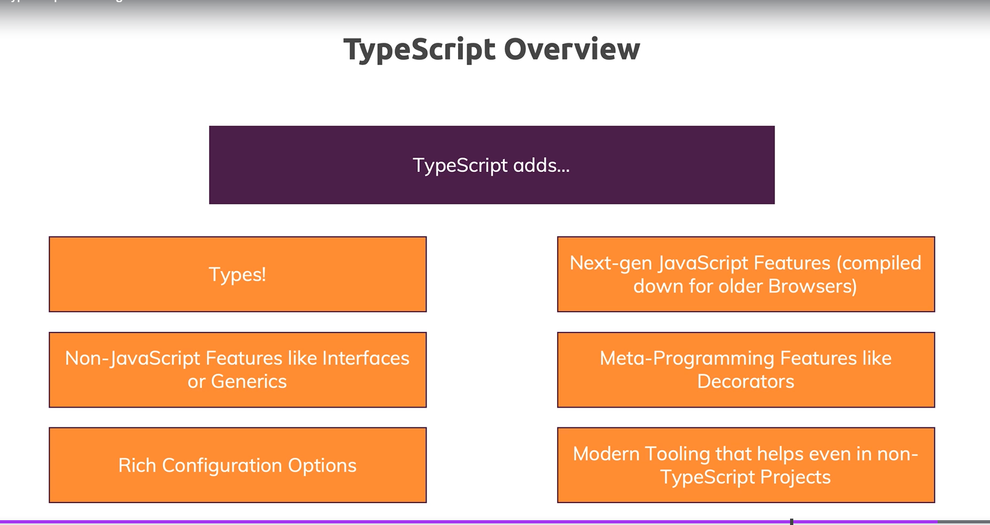

Syntax and Features

Provides many more types than regular JS
Number – All numbers are numbers (No float etc)
String – Normal
Boolean – Normal (Look at Truthy and Falsy – “a value that is considered true or false when encountered in a JS context)
JAVASCRIPT HAS NATIVE CONSTANTS
IMPORTANT!!! -REMEMBER THAT TYPESCRIPT ONLY HELPS US DURING DEVELOPMENT.. AS THE CODE IS COMPLIED TO JS. ADDS AN EXTRA SANITY CHECK.
IT WILL STILL COMPLIE AN ERROR BY DEFAULT!!
TS IS STATICALLY TYPE, COMPARED TO JS LOOSELY TYPED.
JS USES DYNAMIC TYPES (RESOLVED AT RUNTIME) AND TS USES STATIC
PRIMITIVE TYPES IN TYPESCRIPT ARE ALL LOWERCASE
CAREFUL FOR STRING CONVERSIONS
const number1: number = 1.3;
NOT CONSIDERED BEST PRACTICE TO ASSIGN TYPE IN VAR DECLARATION

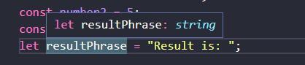
INFERS TYPE STRING AS VAR INITALISED WITH A STRING, ASSIGNING WITH ANTOHER DATA TYPE WOULD BE “ILLEGAL”. TS MAIN JOB, CHECK TYPES AND YELL IF INCORRECT!!
JS has no compilation step but at runtime, you can check for certain types (e.g. in if conditions). TS on the other hand allows you to catch certain errors during development since it checks types during compilation as well.

MISSING OBJECT PROPERTIES ARE HIGHLIGHTED
YOU CAN INFER OBJECT TYPES, HOWEVER BETTER TO LET TS INFER ITSELF
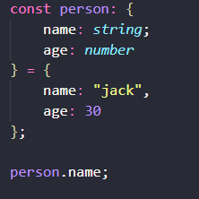

ARRAYS CAN NOMRALLY ONLY BE ONE TYPE IN TS, HOWEVER YOU CAN USE A UNION TYPE TO DEFINE MORE.
const foo: (string|number)[] = [ 1, "message" ];

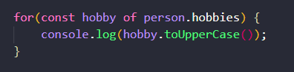
BECAUSE TS KNOWS HOBBY WILL BE A STRING (INFERRED BY TS), IT ALLOWS ACCESS TO STRING METHODS.

TUPLE IS FIXED LENGTH AND TYPE
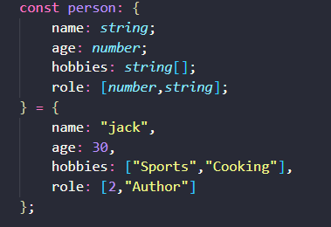

EXAMPLE OF A TUPLE WORKING, DEFINED IN THE OBJECT TYPE DEFINITIONS

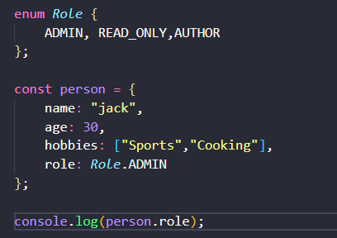

ENUMS GIVE STRING LABELS TO NUMERIC VALUES GLOBALLY, THIS WOULD RETURN 0 FOR EXAMPLE. ADDITIONAL VALUES CAN BE SET IN THE ENUM, ALL MUST BE SAME TYPE.

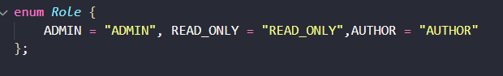
ANY TYPE CAN BE USED TO ALLOW TYPESCRIPT TO USE ANY TYPE. SHOULD ONLY USE ANY AS A FALLBACK….

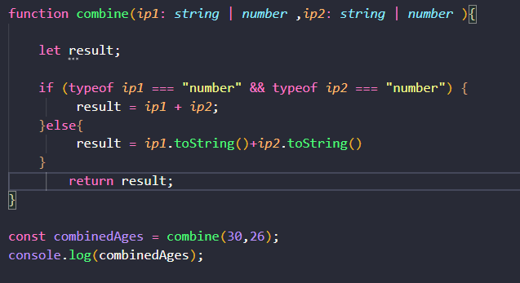

UNION TYPES!! ALLOWING FOR/CHECKING TWO TYPES INSIDE THE FUNCTION.
REMEMBER THE LET DECLARTION. LET IS ONLY VISIBLE TO THE BLOCK OF CODE ( FROM { -→ } ).
VAR IS AVAILABLE TO THE WHOLE SCOPE OF THE FUNCTION, SO THIS COULD BE DEEMED AS SCOPE LEAK. IF LET WAS SET INSIDE EACH IF BLOCK, IT WOULD NOT BE VISIBLE, IF THE VARAIBLE WAS SET WITH VAR, IT WOULD HAVE BEEN “DECLARED” MULTIPLE TIMES.

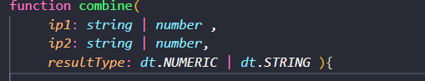
LITERAL TYPE, VAR IS EXPECT TO BE EXACTLY A MATCH. TO A PASSED PARAMETER. OFTEN USED IN CONJUCTION WITH A UNION TYPE TO GIVE SOME FLEXIBILITY (IN THIS CASE RESULT TYPE IS EXPECTING ONE OF TWO STRINGS, LABELLED VIA AN ENUM).

TYPE ALIASES
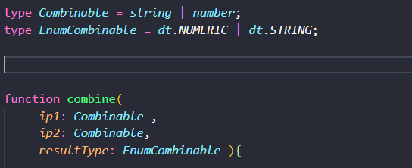

STORING AN OBJECT TEMPLATE AS A TYPE ALIAS.
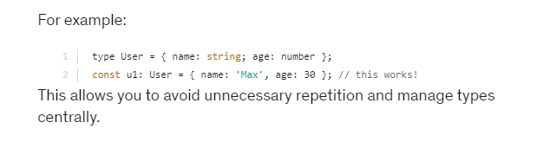

REMEMBER TO USE THE UNION TYPE OF EXPECTING A ENUM TO VALIDATE DATA INPUT!!!

TYPESCRIPT ALSO INFERS THE RETURN TYPE OF A FUNCTION/METHOD, BUT LET TS DO ITS JOB AND INFER

VOID RETURN TYPE, MEANS FUNCTION RETURNS NOTHING LIKE NORMALLY. NORMALLY DUE TO FUNCTION NOT HAVING A RETURN STATEMENT. USE WHEN A FUNCTION RETURNS NOTHING.

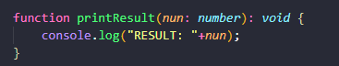
CAN USE TYPES FOR RETURN VALUE. AND PARAMENTERS OF A FUNCTION.
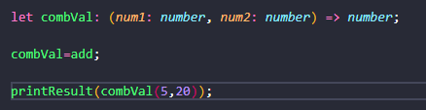
Using a function as a type. Displayed is how this is declared, in the brackets are my arguments, and to the right of the arrow is the return value. TS will only allow functions that match this criteria to be stored inside. Could be used as an argument in a function, loop etc. Known as a function type.

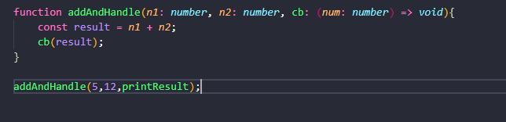
CALLBACK FUNCTION CALLED INSIDE ANOTHER FUNCTION

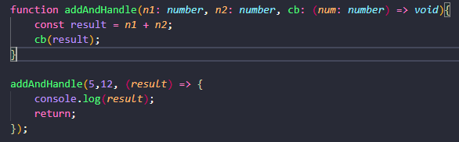

Unknown can be used when the type you need is unknown. Typescript can infer this by adding a check, more secure than using any.
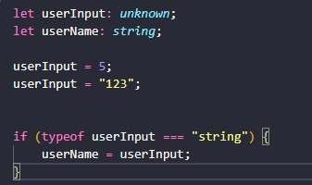

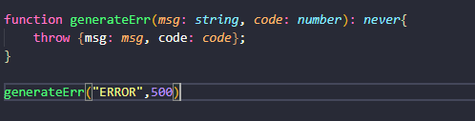
NEVER TYPE IS USED WHEN YOU ARE SURE SOMETHING WILL NEVER RETURN A VALUE, E.G AT THE END OF A SCRIPT THAT WILL CRASH OR BREAK OUT OF A SCRIPT. ANOTHER EXAMPLE WOULD BE A WHILE LOOP.

TYPESCRIPT COMPILER

WATCH MODE “—watch OR -w” WATCHES THE FILE AND MEANS WE DON’T HAVE TO RUN TSC APP.TS OR WHATEVER EACH TIME THERE IS A CHANGE. CTRL C TO EXIT.
Tsc –init can be used to generate a ts config fire (tsconfig.json). THIS FILE HAS AN OPTION TO GENERATE JS FILES FROM ALL TS FILES IN THE PROJECT.
THIS OPERATES BY RUNNING JUST “tsc” IN THE CMD LINE IN THE CORRECT DIRECTORY. FURTHERMORE THIS CAN BE COMBINED WITH WATCH TO COMPILE JS FOR FOR EVERY TS FILE.

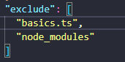

ADDING “exclude” TO TSCONFIG.JSON ALLOWS US TO TELL TSC COMPILER WHAT FILES TO AVOID UPDATING, THIS EXAMPLES SHOWS NODE_MODULES, INCASE ANY DEPENDENCIES CONTAIN TS CODE. VERY COMMON TO EXCLUDE, IS AUTOMATICALLY EXLUDED WITH THIS MISSING. IF YOU ADD EXLCUDE IT WILL NOT BE AUTOMATIC.

INCLUDE IS THE OTHER WAY ROUND, INCLUDE WHAT YOU LIKE, BUT THE SAME RULE APPILES. IF YOU ADD INCLUDE, YOU NEED TO ADD ALL FILES THAT NEED TO BE COMPILED. IF BOTH INCLUDE AND EXCLUDE ARE PRESENT, THIS WORKS BY BEING INCLUDE-EXCLUDE.

FILES IS SIMILAR, AS IT WILL TARGET FILES RATHER THAN LOCATIONS.

Node JS
https://www.learncodebygaming.com/blog/how-to-code-a-runescape-bot-with-robotjs

