Camel case naming convention

Primitives string, number, bigint, boolean, undefined, symbol, and null.

No keywords for var names, can start with letter, underscore or $

TYPE COHERSION > CONVERTS TYPES FROM ONE TO ANOTHER AS NEEDED
Undefined vars can be declared on the same line
JS supports variable mutation, in which a declared variable can be overrided with any data type

var isGreater = numbOne < numbTwo; SETS A BOOLEAN

var grade = 100;

grade < 101 ? console.log(true) : console.log(false);

Ternary operator, made up of three parts
var result = grade < 100 ? "failure" : "success";

result of this var will be decided by the ternary operation.

var val = 1000;

switch(val > 100){

case false : console.log("less than val"); break;

case true : console.log("greater than val"); break;

default : console.log ("if no match to case");
}

Case statement, like VBA. Used to judge a expression and decided.

switch(true){

case val < 100 : console.log("less than val"); break;

case val > 100 : console.log("greater than val"); break;

default : console.log ("if no match to case");
}

Another example

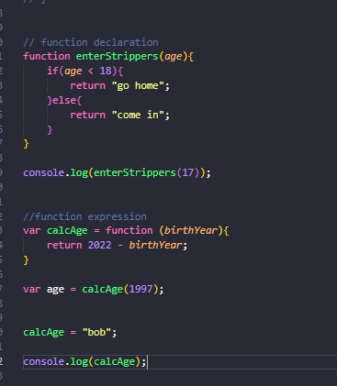

Function declaration and expression. Function declarations are similar to var; they will be automatically hoisted, whereas function expressions will not be hoisted. In simple terms, function declarations will load before any other code, and function expressions will load when the interpreter reaches it.
Expression functions also act as a var, and as can be seen with calcAge, can be overridden with a new value. Think of function as a data type in this scenario.
In short, use function declarations when you want to create a function on the global scope and make it available throughout your code. Use function expressions to limit where the function is available, keep your global scope light, and maintain clean syntax.

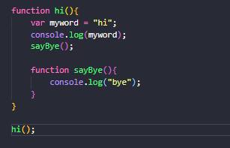

Creating own scope with functions.
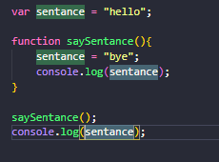

Example of a var being available, due to the global scope in which it was declared.

REMEMBER PARENT AND CHILDREN. A CHILD CAN USE A PARENT VAR, A PARENT CANNOT USE A CHILDS VAR AS IT IS OUT OF SCOPE.

Arrays can be mixed type, also overwritten.

var studnets = ["s","j","k",123]

var arr = new Array();

var friends = studnets.slice(studnets.indexOf("k"));

console.log(friends);

example of using some array functions, also generic ones like push, pip and unshift exist. SLICE DOES NOT EDIT ORIGINAL ARRAY, CREATES A NEW ONE
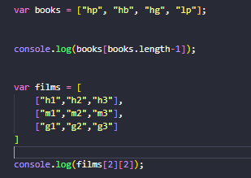

Accessing last arr element, accessing nested array.
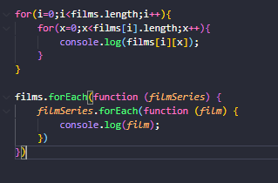

For and for each loops doing the same thing. The forEach() method is not executed for empty elements.

ALWAYS USE LITERAL SYNTAX WHEN DECLARING ARRAY, USING NEW ARRAY() IS AMBIGUOUS.

ITEMS IN AN OBJECT ARE ARRANGE USING KEY VALUE PAIRS

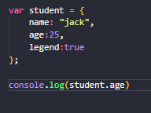

Object example.

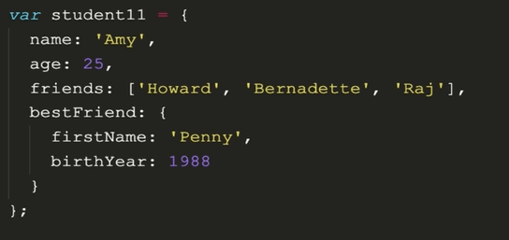

METHODS CAN BE ADDED TO OBJECTS AND CLASSES, USING THIS IN A FUNCTION WILL POINT TO THE GLOBAL OBJECT, WHICH IS ALWAYS THE WINDOW. THIS IS EVEN THE CASE WHEN A FUNCTION IS INSIDE A METHOD
IN A METHOD IT WILL POINT TO AN OBJECT

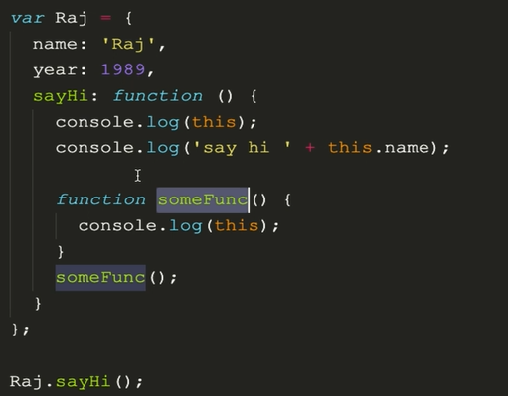

DOM IS THE INTERFACE BETWEEN THE JAVASCRIPT AND THE HTML+CSS
DOM CONVERTS ALL HTML TAGS INTO JAVASCRIPT OBJECTS, IS THE ROOT OBJECT AND IS HOME TO METHODS REQUIRED TO INTERFACE
EVERY CONVERTED OBJECT IS STORED UNDER THE DOCUMENT OBJECT, FUNDAMENTALLY THE SAME AS A GOOD OLD OBJECT
Console.dir(document) to see document object model

Manipulation is using JavaScript to change the style, configuration of classes, changing the content and changing the attributes of a webpage.

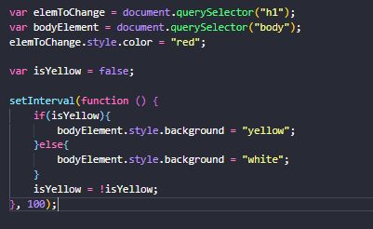

Select and manipulate process, this once changes the screen between yellow and white.

Other selectors include document.getelementbyid(),tagname(),classname() and query selector. Query selector can do all, and will return the first match.
https://www.w3schools.com/jsref/met_document_queryselector.asp

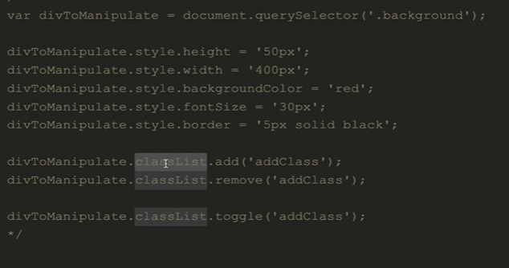

HASH TO SELECT AN ID, . for class.

var para = document.querySelector("#paragrahpToChange");

console.log(para.textContent);

innerHTML method of a paragraph keeps the html tags.

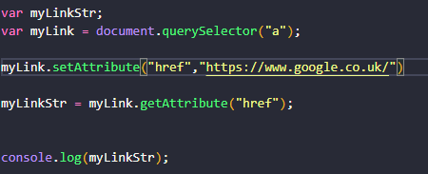

Get and setting an attribute (for example href).
Nodelist is what is returned with any DOM method returning a list, remember that it is just a shit array, does not have access to methods and cannot be in a foreach loop.

DOM EVENTS:
Javascript uses event handlers to trigger code when an event happens. (for example pressing a button, hovers over an element, on scroll etc), drag and drop, enter key. The list is endless!!!
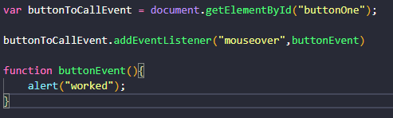
An example, mouse over a button to call a popup window. Alternatively the function could be declared inside the event listener.
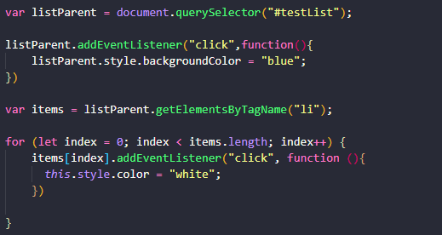

An example of using event listeners, looping through a list to add event listeners to each.
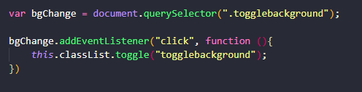
Toggle background event listener, turns a class on and off.

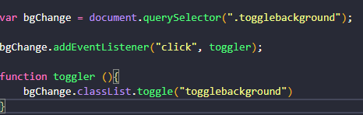
This can be done in a similar way using a callback function.
A callback function is a function passed into another function as an argument, which is then invoked inside the outer function to complete some kind of routine or action.
In this example, the addeventlistener function is calling toggle function.

If brackets were to be present on toggler call, it would run when the code is executed, and does not “callback” to the declared func

Typescript

Typescript is a superset of JavaScript. TS cant be executed via the browser, it is compiled into JavaScript, thus typescript is JavaScript. The Typescript complier compiles TS to JS, and converts functionality into JS work arounds (Potential problems).
It adds types, that gives us the opportunity to identify errors before they occur, tuning up the loose typed nature of JS, runtime errors can also be caught and fixed early.

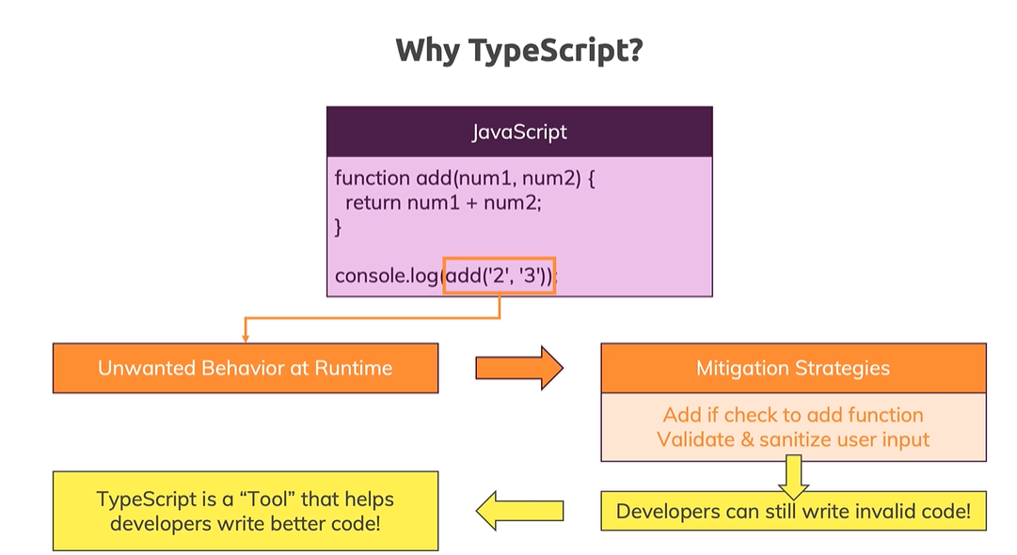

! mean never null, will always find an element
! as HTMLInputElement;

ALWAYS IMPORT TS!!
+ TO CAST TO NUMBER

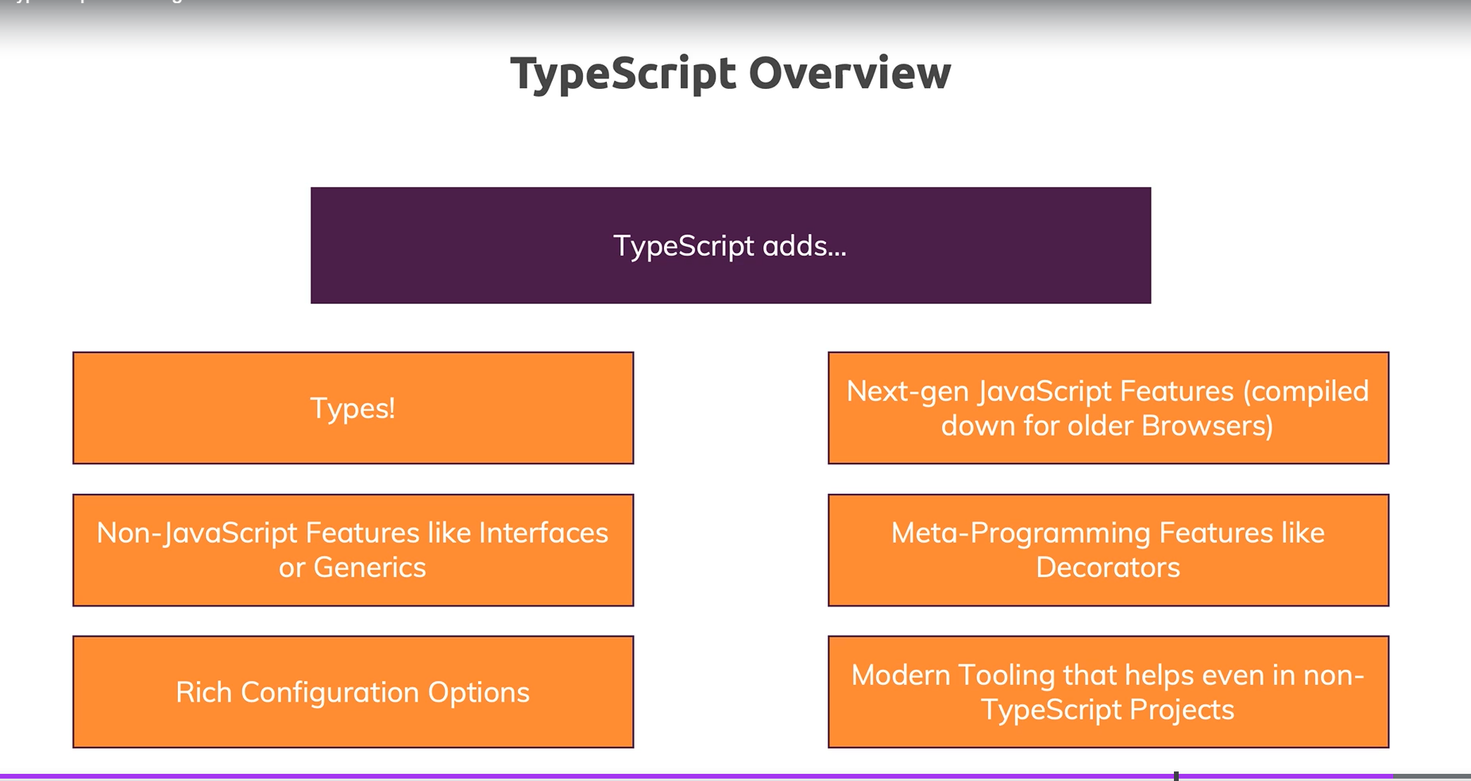

Syntax and Features

Provides many more types than regular JS
Number – All numbers are numbers (No float etc)
String – Normal
Boolean – Normal (Look at Truthy and Falsy – “a value that is considered true or false when encountered in a JS context)
JAVASCRIPT HAS NATIVE CONSTANTS
IMPORTANT!!! -REMEMBER THAT TYPESCRIPT ONLY HELPS US DURING DEVELOPMENT.. AS THE CODE IS COMPLIED TO JS. ADDS AN EXTRA SANITY CHECK.
IT WILL STILL COMPLIE AN ERROR BY DEFAULT!!
TS IS STATICALLY TYPE, COMPARED TO JS LOOSELY TYPED.
JS USES DYNAMIC TYPES (RESOLVED AT RUNTIME) AND TS USES STATIC
PRIMITIVE TYPES IN TYPESCRIPT ARE ALL LOWERCASE
CAREFUL FOR STRING CONVERSIONS
const number1: number = 1.3;
NOT CONSIDERED BEST PRACTICE TO ASSIGN TYPE IN VAR DECLARATION

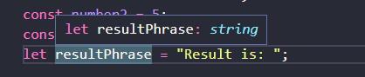
INFERS TYPE STRING AS VAR INITALISED WITH A STRING, ASSIGNING WITH ANTOHER DATA TYPE WOULD BE “ILLEGAL”. TS MAIN JOB, CHECK TYPES AND YELL IF INCORRECT!!
JS has no compilation step but at runtime, you can check for certain types (e.g. in if conditions). TS on the other hand allows you to catch certain errors during development since it checks types during compilation as well.

MISSING OBJECT PROPERTIES ARE HIGHLIGHTED
YOU CAN INFER OBJECT TYPES, HOWEVER BETTER TO LET TS INFER ITSELF
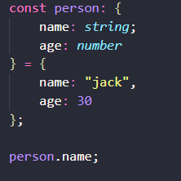

ARRAYS CAN NOMRALLY ONLY BE ONE TYPE IN TS, HOWEVER YOU CAN USE A UNION TYPE TO DEFINE MORE.
const foo: (string|number)[] = [ 1, "message" ];

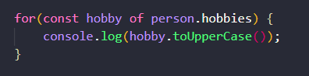
BECAUSE TS KNOWS HOBBY WILL BE A STRING (INFERRED BY TS), IT ALLOWS ACCESS TO STRING METHODS.

TUPLE IS FIXED LENGTH AND TYPE
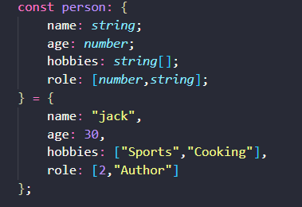

EXAMPLE OF A TUPLE WORKING, DEFINED IN THE OBJECT TYPE DEFINITIONS

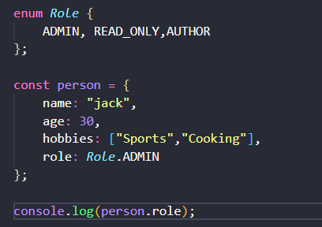

ENUMS GIVE STRING LABELS TO NUMERIC VALUES GLOBALLY, THIS WOULD RETURN 0 FOR EXAMPLE. ADDITIONAL VALUES CAN BE SET IN THE ENUM, ALL MUST BE SAME TYPE.

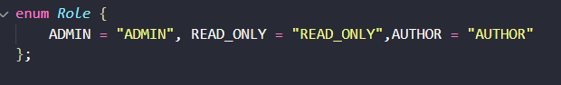
ANY TYPE CAN BE USED TO ALLOW TYPESCRIPT TO USE ANY TYPE. SHOULD ONLY USE ANY AS A FALLBACK….

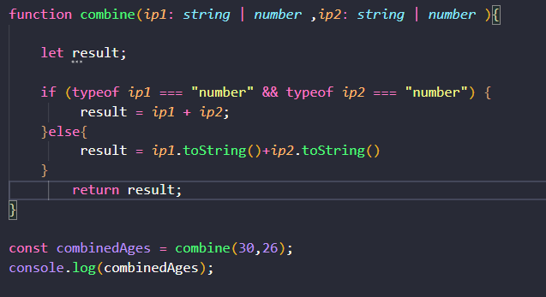

UNION TYPES!! ALLOWING FOR/CHECKING TWO TYPES INSIDE THE FUNCTION.
REMEMBER THE LET DECLARTION. LET IS ONLY VISIBLE TO THE BLOCK OF CODE ( FROM { -→ } ).
VAR IS AVAILABLE TO THE WHOLE SCOPE OF THE FUNCTION, SO THIS COULD BE DEEMED AS SCOPE LEAK. IF LET WAS SET INSIDE EACH IF BLOCK, IT WOULD NOT BE VISIBLE, IF THE VARAIBLE WAS SET WITH VAR, IT WOULD HAVE BEEN “DECLARED” MULTIPLE TIMES.

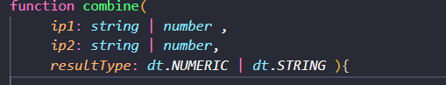
LITERAL TYPE, VAR IS EXPECT TO BE EXACTLY A MATCH. TO A PASSED PARAMETER. OFTEN USED IN CONJUCTION WITH A UNION TYPE TO GIVE SOME FLEXIBILITY (IN THIS CASE RESULT TYPE IS EXPECTING ONE OF TWO STRINGS, LABELLED VIA AN ENUM).

TYPE ALIASES
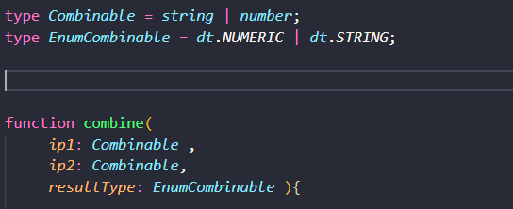

STORING AN OBJECT TEMPLATE AS A TYPE ALIAS.
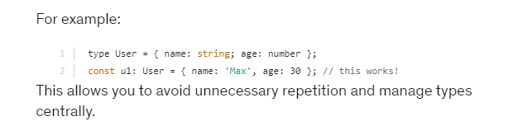

REMEMBER TO USE THE UNION TYPE OF EXPECTING A ENUM TO VALIDATE DATA INPUT!!!

TYPESCRIPT ALSO INFERS THE RETURN TYPE OF A FUNCTION/METHOD, BUT LET TS DO ITS JOB AND INFER

VOID RETURN TYPE, MEANS FUNCTION RETURNS NOTHING LIKE NORMALLY. NORMALLY DUE TO FUNCTION NOT HAVING A RETURN STATEMENT. USE WHEN A FUNCTION RETURNS NOTHING.

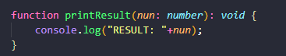
CAN USE TYPES FOR RETURN VALUE. AND PARAMENTERS OF A FUNCTION.
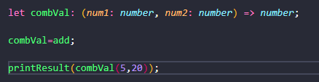
Using a function as a type. Displayed is how this is declared, in the brackets are my arguments, and to the right of the arrow is the return value. TS will only allow functions that match this criteria to be stored inside. Could be used as an argument in a function, loop etc. Known as a function type.

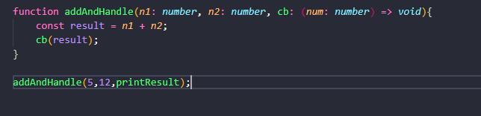
CALLBACK FUNCTION CALLED INSIDE ANOTHER FUNCTION

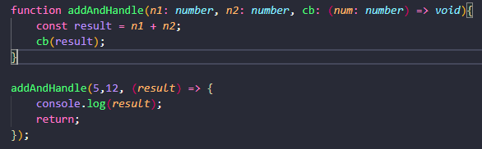

Unknown can be used when the type you need is unknown. Typescript can infer this by adding a check, more secure than using any.
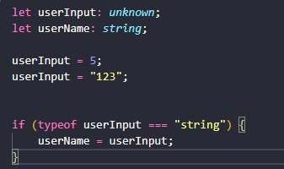

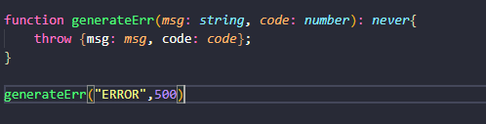
NEVER TYPE IS USED WHEN YOU ARE SURE SOMETHING WILL NEVER RETURN A VALUE, E.G AT THE END OF A SCRIPT THAT WILL CRASH OR BREAK OUT OF A SCRIPT. ANOTHER EXAMPLE WOULD BE A WHILE LOOP.

TYPESCRIPT COMPILER

WATCH MODE “—watch OR -w” WATCHES THE FILE AND MEANS WE DON’T HAVE TO RUN TSC APP.TS OR WHATEVER EACH TIME THERE IS A CHANGE. CTRL C TO EXIT.
Tsc –init can be used to generate a ts config fire (tsconfig.json). THIS FILE HAS AN OPTION TO GENERATE JS FILES FROM ALL TS FILES IN THE PROJECT.
THIS OPERATES BY RUNNING JUST “tsc” IN THE CMD LINE IN THE CORRECT DIRECTORY. FURTHERMORE, THIS CAN BE COMBINED WITH WATCH TO COMPILE JS FOR FOR EVERY TS FILE.

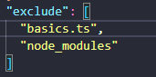

ADDING “exclude” TO TSCONFIG.JSON ALLOWS US TO TELL TSC COMPILER WHAT FILES TO AVOID UPDATING, THIS EXAMPLES SHOWS NODE_MODULES, INCASE ANY DEPENDENCIES CONTAIN TS CODE. VERY COMMON TO EXCLUDE, IS AUTOMATICALLY EXLUDED WITH THIS MISSING. IF YOU ADD EXLCUDE IT WILL NOT BE AUTOMATIC.

INCLUDE IS THE OTHER WAY ROUND, INCLUDE WHAT YOU LIKE, BUT THE SAME RULE APPILES. IF YOU ADD INCLUDE, YOU NEED TO ADD ALL FILES THAT NEED TO BE COMPILED. IF BOTH INCLUDE AND EXCLUDE ARE PRESENT, THIS WORKS BY BEING INCLUDE-EXCLUDE.

FILES IS SIMILAR, AS IT WILL TARGET FILES RATHER THAN LOCATIONS.
TARGET CHANGES HOW VERS OF JS IS COMPILED TO
CTRL SPACE AUTOCOMPLETE
LIB – LIBRARY FILES. IF NOT SET, WILL INCLUDE LIBRARIES AVAILABLE TO TARGET VERSION OF JS/TS. ALSO ASSUMES ALL DOM API’S ARE AVAILABLE.
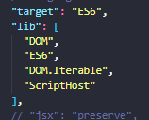
IF LIB NOT SET, THESE WOULD BE THE DEFAULTS IF IT WAS.
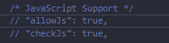
CAN BE ENABLED TO ALLOW JS FILES TO BE PART OF PROJECT, AND ENABLE ERROR IMPORTING FOR PLAIN JS FILES.
Sourcemap: ALLOWS FOR JS FILES TO BE LINKED TO SOURCE FILES, ALLOWS FOR DEBUGGING (LIKE A BRIDGE)

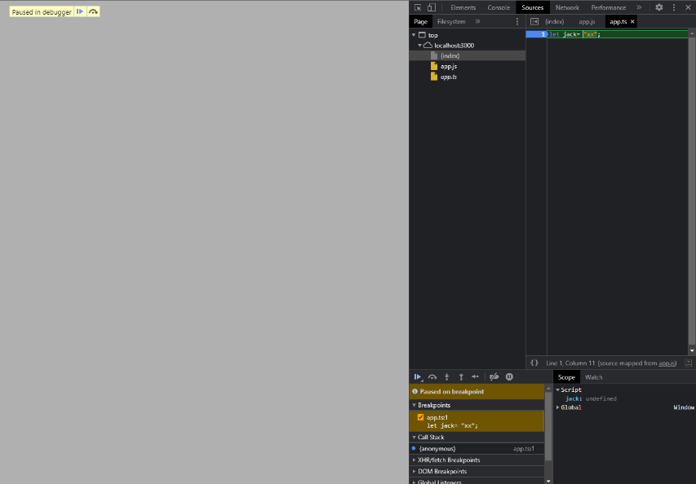

OUTDIR AND ROOTDIR
OUTDIR SPECIFIES THE OUTPUT FOR THE CODE (GENERATED JS). IT SHOULD BE STORED NORMALLY IN A FOLDER NAMED “dist”.
ROOTDIR SPECIFIES THE ROOT FOR ALL SOURCES FILES IN PROJECT. SHOULD BE STORED IN A FOLDER NAMED “src”.
BOTH SHOULD BE ENABLED IN TSCONFIG!!!
REMOVE COMMENTS (GUESS WHAT) REMOVES COMMENTS FROM JS FILES, SAVING FILE SIZE
DOWNLEVEL ITERATION CAN SOLVE PROBLEMS WITH FOR LOOPS IN OLDER VERSIONS OF JS.
“noEmitOnError” ALLOWS US TO NOT COMPILE PROJECTS WHEN THIS IS SET TO TRUE. MISSING BY DEFAULT FROM CONFIG FILE, AND SET TO FALSE AUTOMATICALLY.
STRICT, SETS ALL TYPE CHECKING OPTIONS ON.
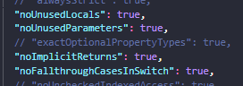

USEFULL!!!!

ENABLE SOURCE MAPS FOR VBA CODE DEBUGGING, SELECT DEBUG WINDOW AND LAUNCH.JSON WILL OPEN. MUST SELECT WHAT WE ARE DEBUGGING WITH (CHROME), WORKS AS NORMAL. IF IN VS CODE, CHANGE LAUNCH.JSON URL, TYPE AND WEB ROOT IF REQUIRED.
REMEMBER LET AND CONST BLOCK SCOPE.

NEXT GEN TS AND JS (ES6+)

https://kangax.github.io/compat-table/es6/ COMPATIBILITY CHECKER
CONST CANNOT BE CHANGED (CONSTANT)
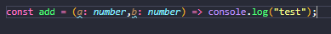
LAMBDA CAN BE WRITTEN LIKE THIS IF ONLY PERFORMING ONE THING.

IF ONE EXPRESSION IN A LAMBDA, CAN OMMIT THE RETURN STATEMENT AND ALWAYS RETURN THE EXPRESSION.
const test = (a: number, b: number) => a+b;
console.log(test(1,2));

THIS WILL RETURN 3, THIS EXAMPLE PRINTS 3 TO CONSOLE. ONLY IF 1 LINE!!
const test1: (a: number) => void = input => console.log(input);

THIS DESCRIBES A FUNCTION, THE TYPE IS BEING DECLARED ON THE LEFT IN THE VARIABLE (A FUNCTION EXPECTING ONE ARGUMENT, THAT RETURNS VOID). THIS EQUALS A FUNCTION THAT USES THIS PASSED VARIABLE (INPUT) AND DOES NOT NEED BRACKETS THIS SIDE AS ITS TYPE IS DECLARED ALREADY (NUMBER). FURTHERMORE THE ACTUAL EXPRESSION DOES NOT NEED BRACKETS AS THERE IS only one. THIS WILL ALSO RETURN VOID FROM THE EXPRESSION ITSELF, AND PRINT THE PASSED VALUE TO THE CONSOLE.
const button = document.querySelector("button");

if (button){
button.addEventListener("click",event=>console.log(event));
}

THIS BECOMES USEFUL WHEN USING A BUTTON, THIS EXAMPLE SETS BUTTON AS A VARIABLE. IF THE IF STATEMENT WAS MISSING TYPESCRIPT WOULD NOT BE ABLE TO GARUNTEE THAT BUTTON WOULD BE ANYTHING. THE FUNCTION PASSED TO THE EVENT LISTEN SIMPLY SAYS WITH THE EVENT OBJECT OF THE BUTTON, LOG THE EVENT.
const add = (a: number, b:number = 1) => a+b;

console.log(add(10));
DEFAULT FUNCTION PARAMETER, AS YOU WOULD EXPECT. HAS TO BE LAST IN THE LIST, AS DEFAULT ARGUMENTS ARE NOT SKIPPED. WORKS ON ALL DATA TYPES

SPREAD:
activeHobs.push(...hobbies);
THE SPREAD OPERATOR (THREE DOTS) TAKES VALUES FROM ONE ARRAY AND APPENDS THEM ALL TO THE ARRAY BEING USED TO RUN THE METHOD. COULD BE USED WHEN A CSV IS NEEDED.

REMEMBER ARRAYS ARE OBJECTS AND OBJECTS ARE REF VALUES, WHEN WE CHANGE THE OBJECT, WE CHANGE THE MEMORY AND NOT THE ADDRESS. SO CONST VALUES CAN BE CHANGED!
const person = {
name:"max",
age: 30
};

const copiedPerson = person;

IF A OBJECT IS COPIED LIKED THIS, IT IS JUST COPYING THE POINTER IN MEMORY, SO IT WILL BE THE SAME.
const person = {
name:"max",
age: 30,
printAge() {
console.log(this.age)
},
setAge(toSet: number){
this.age = toSet;
}
};

const copiedPerson = person;

person.setAge(40);

person.printAge();
copiedPerson.printAge();

THIS EXAMPLE DEMONSTRATES HOW CHANGING THE NAME ON ONE WILL CHANGE THE NAME ON BOTH, AS THE POINTER IS THE SAME.
const actualCopyPerson = {...person};

A PERSON COULD BE ACTUALLY COPIED LIKE THIS….
ADDITIONAL INFORMATION CAN ALSO BE ADDED TO THE OBJECT WITH A SPREAD OPERATOR, LIKE ADDITIONAL PROPERTIES, METHODS ETC. CAN BE USED TO COMBINE TOGETHER!

REST HAS SIMILAR FUNCTIONALITY
const add2 = (...numbers: number[]) => {
return numbers.reduce((curResult, curValue) => {
return curResult + curValue;
}, 0)
}

COULD BE USED TO ACCEPT AN UNLIMITED AMMOUNT OF ARGUMENTS, IN THIS CASE TAKING NUMERIC VALUES, AND USING SPREAD WILL CHANGE THE VALUES TO A LIST AND RETURN A SUM OF THEM.

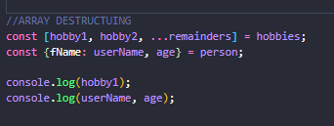

THIS DEMONSTRATES ARRAY AND OBJECT DESTRUCTURING. TO DESTRUCTURE AN ARRAY, PLACE SQUARE BRACKETS ON THE LEFT HAND CALL, AND WRITE THE VARIABLE NAMES IN LINE WITH THE ARRAY, IN THE EXAMPLE A SPREAD HAS ALSO BEEN USED TO STORE THE REMAINDERS. IMAGINE [0,1,REST].

TO PERFORM A SIMILAR ACTION ON AN OBJECT, PLACE CURLY BRACKETS, EXCEPT THIS TIME USE THE SAME ALIAS NAMES TO PULL THEM OUT. THEY CAN ALSO BE RENAMED WITH A COLON.
REMEMBER RULES WITH THIS
CLASSES AND INTERFACES IN TS/JS

REAL LIFE ENTITIES – ABSTRACTION, POLYMORPHISM, INHERITANCE, ENCAPSULATION

REMEMBER USER CASES, UML, CLASS DESCRIPTIONS ETC

GETTERS AND SETTERS ARE WEIRD. THEY ARE CALLED NORMALLY. FOR EXAMPLE A PROPERTY WITH GETTERS AND SETTERS WOULD SIMPLY BE AND EQUALS TO SET, AND A OBJECT.PROPERTY TO GET. WITHOUT THE GETTERS IN SETTERS IN PLACE THEY WILL NOT BE EXPOSED TO THE REST OF THE PROGRAM SCOPE.

CONSTRUCTOR IS LITERALLY A CONSTRUCTOR, NOT CONVENTIONAL OVERLOADING. USING AN OPTIONAL “?”, CHECKS WHAT TO SET OR NOT, SO HAVE ALL OF YOUR CRITERIA IN ONE CONSTRUCTOR AND DECIDE THAT WAY
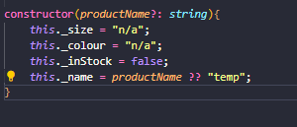

TS HAS A DEFAULT CONSTRUCTOR

REMEMBER THAT THE THIS KEYWORD IS TRICKY
printInfo(this: Clothing){
console.log(this.name+" "+this.size+" "+this.colour+" "+this.inStock)
}

DUMMY PARAMETERS LIKE THIS CAN MAKE SURE THAT A METHOD IS TALKING ABOUT THE RIGHT THIS STATEMENT.
PRIVATE MODIFIERS ARE ALSO AVAILABLE TO METHODS.

constructor (private name: String, public color: String){

}

A SHORTCUT TO DECLARING PROPERTIES IN THE CONSTRUCTOR
printSomethingIDEK(this: Clothing){
console.log(`DEPARTMENT IS ${this.name}`)
}
STRING LITERAL, REQUIRES BACKTICK `

READONLY IS LIKE A CONSTANT FOR A CLASS, LOOK IT UP A LITTLE MORE. REMEMBER GETTERS AND SETTERS HIDE INFORMATION FROM THE USER, WHEREAS READONLY CAN STOP PROPERTIES FROM BEING OVERRIDEEN

NO MULTIPLE INHERITANCE

BASE CLASS CONSTRUCTOR IS USED IN AN INHERITED CLASS, BUT CAN BE DECALRED TO ADD ADDITONAL THINGS.

class Shirt extends Clothing {
constructor(private buttons: number, productName: String){
super(productName);
}
}

REQUIRES A CALL TO THE SUPER CLASSES CONSTRUCTOR!!!

We use super keyword to call the members of the Superclass. IT MUST SUPPLY ALL THE PARAMETERS FOR THE BASE CONSTRUCTOR!!! THE EXAMPLE SHOWS HOW THE SUBCLASS CONSTUCTOR CALLS AND SUPPLIES THE BASE CLASS CPNSTRUCTOR
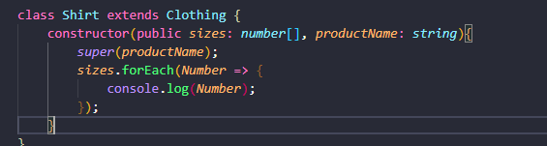

HAS TO BE DONE FIRST, OTHER CALLS AFTER IN CONSTRUCTOR OF A SUB CLASS

As a subclass inherits all the members (fields, methods, nested classes) from its parent and since Constructors are NOT members (They don't belong to objects. They are responsible for creating objects), they are NOT inherited by subclasses.

PROTECTED KEYWORD CAN BE USED TO ACCESS PROPERTIES FROM PARENT CLASSES IN SUB CLASSES. DECLARE AS PROTECTED.

PROPERTIES AND FUNCTIONS BOTH AVAILABLE AS STATIC.

ABSTRACT CLASSES ARE NORMAL

SINGLETON, ONCE INSTANCE OF A SINGLE CLASS.

PRIVATE – ACCESS FROM CLASS ONLY (EVEN SUB)
PROTECTED – ACCESSIBLE FROM PARENT CLASS AND SUBCLASSES
PUBLIC-ACCESSIBLE EVERYWHERE
GETTERS AND SETTERS
READONLY – LIKE CONST BUT FOR PROPERTIES

STATIC METHOD, PROPERTIES, ABSTRACTS AND INHERITANCE ALL NORMAL. INHERITANCE REQUIRES CALL TO SUPER CONSTRUCTOR WITH THE CORRECT PARAMETERS.

SINGLETON AND PRIVATE CONSTRUCTORS FAIRLY NORMAL

INTERFACES ARE ONLY TS

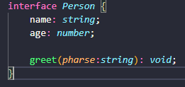

HOW METHODS AND PROPERTIES ARE IMPLEMENTED INTO AN INTERFACE

CAN USE INTERFACES AS A TYPE FOR AN OBJECT???? YES YOU CAN!!! WEIRD THING WHERE FUNCTION DESCRIBED IN AN INTERFACE DOES NOT NEED TO MATCH PARAMETERS DECLARED?

OPTIONAL PROPERTIES ARE A THING.
OBVIOUSLY, AN INTERFACE CAN BE ADDED TO A CLASS, TO DESCRIBE EXTRA FUNCTIONALITY THAT IS REQUIRED (BARE IN MIND, THE DESCRIBED HAS TO BE IDENTICAL IN THE CLASS), HOWEVER, WE CAN DESCIRBE A VARIABLE (A LIST FOR EXAMPLE) OF THAT TYPE OF INTERFACE AS WELL. IF A OBJECT IS INSTANTIATED ON THIS VARIABLE, IT IS LEGAL, HOWEVER THE OBJECT WILL ONLY HAVE ACCESS TO THE PROPERTIES AND METHODS DESCRIBED IN THE INERFACE!!! A USE FOR THIS COULD BE LOOPING THOUGH A LIST OF A INTERFACES TYPE, AND CALLING A COMMON FUNCTION AMONGST DIFFERENT OBJECTS!

Node JS
https://www.learncodebygaming.com/blog/how-to-code-a-runescape-bot-with-robotjs

