FloodCut
Selecting k hypothetical flood-diversion sites with fixed-Hamming-weight QAOA — a synthetic, multi-objective decision-support prototype
Qiskit Fall Fest 2026 Hackathon submission • Domain: Disaster Response
Team lead: Abdul Hannan
Team members: Dayyan Abdullah • Muhammad Dawood Ali Khan
Report generated from saved results created 2026-11-12T17:26:46+00:00 (Python 3.14.0, Qiskit 2.6.2).
Read this first
This is an educational prototype on synthetic data. The river, city, villages, districts and every coefficient are fictional and expressed in normalized units.
It contains no real locations, no breach coordinates, no methods for altering infrastructure and no hydrological model. Scores are a diversion proxy, a synthetic harm index and a fairness penalty — not lives, flood depths or damages.
Nothing here validates real-world safety. Any adaptation would require hydrological modelling, expert, community and regulatory review.
No quantum speedup or advantage is claimed. Every instance is solved exactly by enumeration in under a millisecond.

Abstract
During severe river floods, authorities sometimes have to decide where water may be diverted so that a protected area is relieved, knowing that diversion shifts harm onto other communities. FloodCut turns a stylised, fully synthetic version of this decision into a constrained quadratic optimisation: choose exactly k of n candidate sites to balance a diversion proxy R, a synthetic harm index H with pairwise spill-overlap interactions, and a district-fairness penalty F built from population-normalised burdens. The weighted objective is an exact QUBO (it matches the direct formulas on every plan with a maximum error of 8e-16), mapped to an Ising Hamiltonian and solved with a fixed-k Quantum Alternating Operator Ansatz in Qiskit: one qubit per site, a ring XY mixer built from RXX·RYY exchanges that conserves Hamming weight, and finite-shot sampling of the optimised circuit.
On 4 seeded instances (n = 10 and 12, k = 3; 48 QAOA runs, 40 annealing runs) every sample was feasible and the probability outside the k-subspace stayed below 1e−30 in ideal simulation. Starting from a Dicke state, depth-2 QAOA placed on average 5.8× (n = 10) and 17.3× (n = 12) more probability on the exact optimum than uniform random sampling of feasible plans. However its most-frequent sample was the optimum in only 22% of n = 10 runs. The originally specified computational-basis start collapsed onto single relabelled basis states and did no better than random. Exact enumeration is exact and about four orders of magnitude faster. Greedy and a 200-step annealer were also faster and usually exact, but greedy missed the optimum on the n = 12 instance, where depth-2 QAOA's most frequent sample was optimal in all three runs. Small-budget annealing often failed. The value of the submission is a verified, honest end-to-end pipeline and a clear account of what the mathematics does and does not support.

1. Problem, intended users and motivation
The 2022 monsoon floods in Pakistan affected about 33 million people. The joint Post-Disaster Needs Assessment estimated damages above US$14.9 billion and economic losses of about US$15.2 billion, with reconstruction needs above US$16 billion [1, 2]. In events of this kind, decisions about where flood water may go involve competing objectives and scarce options, and they are made under uncertainty and time pressure. That pattern — select a limited number of actions whose effects interact, while protecting some people and burdening others — is the motivation for FloodCut. Beyond the cited impact figures, this report makes no historical or operational claim about any specific event, structure or location.
Hackathon question. How can quantum computing be used to address a meaningful real-world optimisation problem with competing objectives or limited resources? FloodCut treats the resource limit as an exact cardinality constraint (k sites) and the competing objectives as a weighted, normalised quadratic objective with an exact Pareto analysis alongside.
Intended users. Students, hackathon judges and educators who want to see how a multi-objective siting problem is encoded for QAOA and how its results should be checked. It is not intended for emergency managers making real decisions.

2. Synthetic scenario and modelling assumptions
A deterministic generator (scenario seed 1 by default) places a sinusoidal river in the unit square, a city on the river near the southern edge, and three districts. District A is the upper west bank, B the lower west bank and C the east bank. 15 fictional villages with synthetic populations are placed in a floodplain band, and 10 candidate sites on alternating banks of the upstream reach. Each site has an illustrative spill ellipse beside the river on its own bank. The map and the coefficients come from the same objects, and a SHA-256 fingerprint of all coefficients is stored with every result.
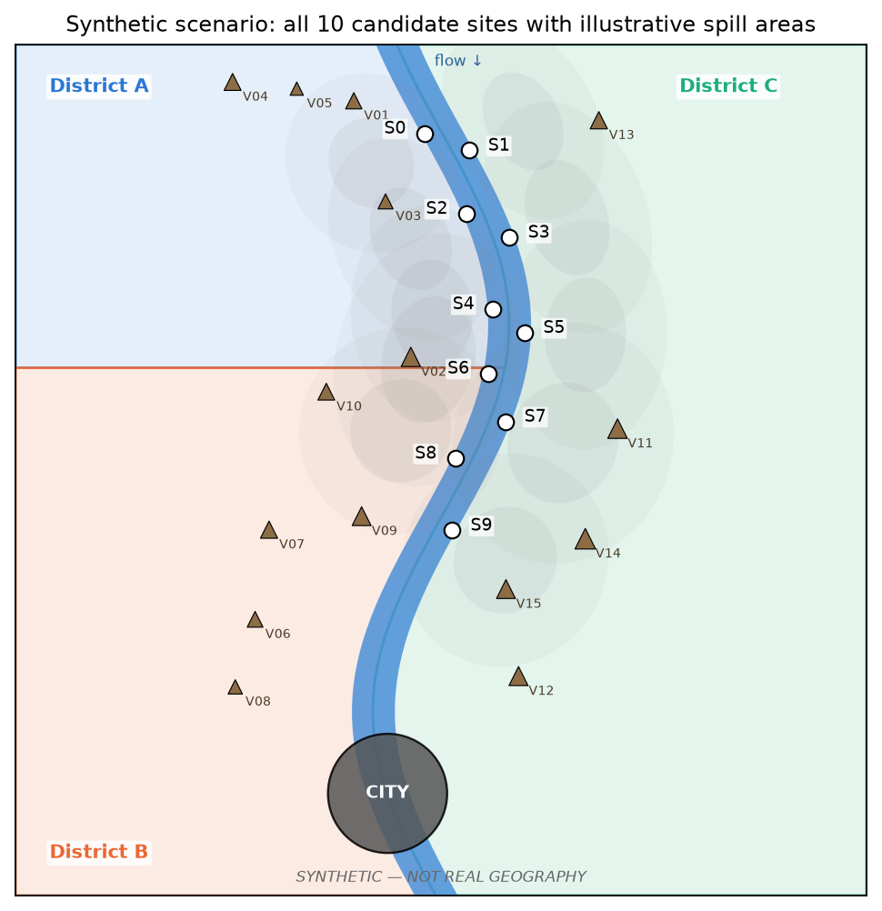
Figure 1. Default synthetic scenario (seed 1). Circles are candidate sites S0–S9 and triangles are fictional villages, sized by synthetic population. Shaded ellipses are the illustrative spill areas (1σ and 2σ contours of the exposure kernel). Not real geography.
Coefficients are derived from the geometry with documented formulas. Here s_i is the river distance from site i up to the city, and p_v the synthetic population of village v.
- Exposure kernel: e_iv = exp(−½ m_iv²), where m_iv is the Mahalanobis distance of village v from spill ellipse i. It is zero across the river, because the illustrative spill stays on its own bank.
- Diversion benefit r_i = c_i·exp(−s_i/L), with synthetic capacity c_i ~ U[0.2, 0.36] and L = 1.5. Units are fractions of a synthetic excess flow.
- Redundancy o_ij = η·min(r_i, r_j)·exp(−|s_i − s_j|/λ), with η = 0.6 and λ = 0.15. Nearby sites divert partly the same water.
- District burden a_di = Σ_{v∈d} p_v e_iv, and individual harm h_i = Σ_d a_di. Harm and fairness therefore use the same exposure data.
- Spill interaction s_ij = κ·Σ_v p_v e_iv e_jv ≥ 0 (κ = 1.0). This is extra harm where two illustrative spill areas reach the same village.
Table 1. Synthetic per-site coefficients of the default instance (normalised units).
site | bank | spill district | s_i | c_i | r_i | h_i
S0 | west | A | 0.837 | 0.322 | 0.184 | 1.145
S1 | east | C | 0.794 | 0.295 | 0.174 | 0.230
S2 | west | A | 0.729 | 0.347 | 0.213 | 0.812
S3 | east | C | 0.684 | 0.310 | 0.197 | 0.192
S4 | west | A | 0.606 | 0.280 | 0.187 | 1.462
S5 | east | C | 0.577 | 0.212 | 0.144 | 0.441
S6 | west | A | 0.524 | 0.278 | 0.196 | 2.283
S7 | east | C | 0.476 | 0.234 | 0.171 | 2.147
S8 | west | B | 0.412 | 0.221 | 0.168 | 1.565
S9 | east | C | 0.335 | 0.281 | 0.225 | 2.753

Validation over every feasible plan (default instance; the same checks pass on all four benchmark instances):
- R > 0, H > 0 and F ≥ 0 on all 120 plans. R ranges over [0.330, 0.561], H over [0.891, 7.868] and F over [0.0060, 1.0042].
- The city is unexposed: its maximum kernel value from any spill is 8.1e-06.
- The objectives compete. The max-relief plan {S2, S6, S9}, the min-harm plan {S1, S3, S5}, the min-fairness plan {S1, S5, S8} and the weighted optimum {S1, S3, S9} are all different.
- Synthetic threshold: 23 of 120 plans reach R ≥ τ = 0.5. On scenario seed 2 the weighted optimum is itself below the threshold (Table 5).
- The analytic bound R ≥ (1 − η(k−1)/2)·Σ r_i holds whenever η < 2/(k−1), and the tests check it numerically for k = 2, 3 and 4.
Seed choice disclosure. Seed 1 is the demo default because its weighted optimum differs from both the max-relief and the min-harm plans, which makes the trade-off visible. Seeds 0 and 2 are benchmarked as well. On seed 0 the optimum equals the min-harm plan, and on seed 2 it misses the threshold.

3. Formulation

3.1 Variables, objectives and constraint
Binary x_i = 1 selects candidate i. The only hard constraint is the cardinality constraint.
Σ_i x_i = k (1)
R(x) = Σ_i r_i x_i − Σ_{i<j} o_ij x_i x_j (diversion proxy, maximise) (2)
H(x) = Σ_i h_i x_i + Σ_{i<j} s_ij x_i x_j (synthetic harm index, minimise) (3)
b_d(x) = Σ_i a_di x_i / P_d , F(x) = Σ_{d<e} (b_d(x) − b_e(x))² (fairness penalty, minimise) (4)
Why the problem is genuinely quadratic. Redundancy and spill interaction are pairwise by construction. Each b_d is linear, so F is a sum of squares of linear forms. With x_i² = x_i this expands into linear terms plus pair terms 2g_i g_j for every pair of sites, where g = a_d/P_d − a_e/P_e. F is therefore dense and couples sites that are far apart. No quadratic expression is squared anywhere, so the model remains a QUBO.
Fairness caveat. F measures the disparity of an additive, population-normalised burden. It ignores the pairwise interactions s_ij, is zero whenever all districts carry the same burden however high, and does not capture who is harmed within a district, vulnerability, consent or other ethical concerns. It is always reported next to H so that a fairer plan with more total harm is visible as a trade-off, not rewarded silently.

3.2 Normalised weighted objective
E(x) = w_H·(H − H_min)/ΔH + w_F·(F − F_min)/ΔF − w_R·(R − R_min)/ΔR (5)
The minima and ranges are taken over all feasible plans for the scenario and k, and are then held fixed. Changing the weights therefore changes priorities on a common scale. This requires enumeration, which is affordable only because there are at most 220 plans. Larger instances would need analytic bounds instead.
Table 2. Fixed normalisation constants (default instance, k = 3) and default weights.
quantity | value | quantity | value
R_min | 0.3299 | ΔR | 0.2314
H_min | 0.8912 | ΔH | 6.9767
F_min | 0.00603 | ΔF | 0.9982
w_H | 1 | w_F | 0.5
w_R | 1 | τ (threshold on R) | 0.5

3.3 The synthetic city-safety threshold is checked after solving
A hard constraint R(x) ≥ τ is a quadratic inequality. Encoding it as a penalty, for example (R(x) − τ − slack)², produces quartic terms because R is already quadratic, so the result is not a QUBO. Keeping a QUBO would need slack qubits plus degree reduction (more qubits and penalty tuning) or a different solver. FloodCut therefore evaluates the threshold after solving and labels every plan from every method “meets τ” or “BELOW τ”. If no feasible plan meets τ, the tools say so explicitly. The weighted objective does not guarantee the threshold, and the threshold itself is a synthetic proxy, not a safety standard.

4. QUBO-to-Ising mapping
Expanding (5) term by term gives E(x) = c₀ + Σ q_i x_i + Σ_{i<j} Q_ij x_i x_j. Substituting x_i = (1 − Z_i)/2, so that |1⟩ means selected, gives:
E = offset + Σ_i h_i Z_i + Σ_{i<j} J_ij Z_i Z_j (6)
J_ij = Q_ij/4, h_i = −q_i/2 − Σ_{j≠i} Q_ij/4, offset = c₀ + Σ_i q_i/2 + Σ_{i<j} Q_ij/4 (7)
Automated checks: direct formulas = QUBO on all feasible plans (max error 8.3e-16) and on random infeasible bitstrings (2.2e-15). The Ising diagonal including the offset matches the QUBO on all 2^n basis states, and the SparsePauliOp expectation matches ⟨E⟩ for random states and basis states. Bit order is checked by preparing known basis states, sampling them, and decoding counts keys with x_i = bit[n−1−i], because Qiskit is little-endian.

5. Fixed-k QAOA design
- Qubits. One per candidate site (10 or 12).
- Cost layer. U_C(γ) = exp(−iγH_C), implemented as RZ(2γh_i) and RZZ(2γJ_ij). The fairness term makes the cost layer all-to-all (45 RZZ gates per layer for n = 10). The offset is a global phase: it is dropped from the circuit but included in every reported energy.
- Mixer layer. A ring of XY exchanges in parity order: first edges (0,1), (2,3), …, then (1,2), …, (n−1,0). Each edge applies RXX(β)·RYY(β), which equals exp(−iβ/2·(XX + YY)) exactly because XX and YY commute on the same pair (checked in the tests). Every factor conserves Hamming weight.
- Not the exact ring exponential. Neighbouring edges share a qubit and do not commute, so the parity-ordered product is not exp(−iβ/2·Σ_edges(XX + YY)). A test confirms that the two operators differ. A mixer_reps option applies Trotter-style repetitions.
- Angles and ordering. The parameters are [γ_1, β_1, …, γ_p, β_p]. Each layer applies U_C(γ_l) and then U_M(β_l). Depths p = 1 and 2 are used.
- Optimisation. The exact ⟨E⟩ is computed from the Qiskit Statevector, and SciPy COBYLA minimises it with rhobeg = 0.5 and a budget of 150 evaluations (p = 1) or 300 (p = 2). Initial angles are seeded draws from U[0, π]. The optimised circuit is then sampled with StatevectorSampler (4096 shots, seeded). Exact expectations and sampled frequencies are reported separately.

5.1 Initial state: a finding that changed the design
The brief asked for a computational-basis initial state with Hamming weight k. Two problems appeared:
- At p = 1 the cost layer has no effect. A basis state is an eigenstate of the diagonal cost unitary, so the first cost layer only adds a global phase. The p = 1 output distribution is then independent of γ_1, which a test verifies. As a fix, the basis mode inserts an extra parameterised mixer layer U_M(β_0) before the first cost layer.
- With that fix, the circuit still collapses. Optimising ⟨E⟩ from a basis start drove the circuit towards angles at which the exchanges act as permutations, leaving a single relabelled basis state. The most likely plan's probability averaged 0.82 (p = 1) and 0.73 (p = 2), and P(opt) was 0.6× and 1.0× the uniform baseline (Table 4). That is a classical search over relabellings, not a useful quantum superposition.
FloodCut therefore makes the Dicke-state start the default. A weight-k basis state |0…0 1…1⟩ is followed by the deterministic Hamming-weight-preserving preparation of Bärtschi and Eidenbenz [5], built from CX, CRY and CCRY gates, which gives the uniform superposition over all C(n,k) plans. The preparation is checked to 1e−12 for every n ≤ 12 and 1 ≤ k < n. The basis-start variant is kept, benchmarked and reported as specified.
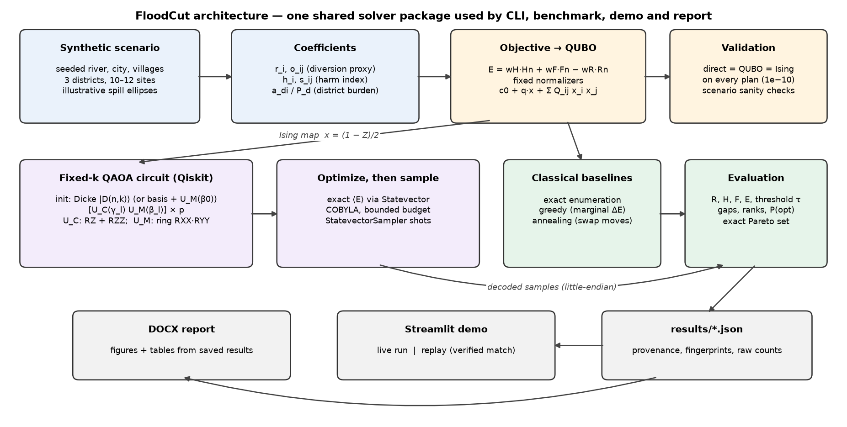
Figure 2. Architecture. One shared Python package (floodcut) provides the scenario, objective, QUBO/Ising mapping, QAOA circuit, classical baselines and evaluation. The CLI, the benchmark, the Streamlit demo and this report all call it.

6. Experimental setup and reproducibility
- Software: Python 3.14.0 on Windows-11-10.0.26200-SP0; Qiskit 2.6.2, NumPy 2.5.4, SciPy 1.18.1. Exact pins are in requirements.txt.
- Simulator: qiskit.quantum_info.Statevector (exact) + qiskit.primitives.StatevectorSampler (shots). Ideal and noiseless, with no hardware coupling map.
- Benchmark preset 'full': scenario seeds [0, 1, 2] at n = 10 and seed 1 at n = 12, k = 3, optimiser seeds [0, 1, 2], p ∈ [1, 2], initial states ['dicke', 'basis'], 4096 shots. Annealing used 10 seeds × 200 steps, plus a budget study.
- Completed: 48 QAOA runs and 40 annealing runs in 98 s of wall time. Every run is stored with its raw counts, angles, timings and provenance in results/benchmark_full.json.
- Commands: pip install -r requirements.txt; pip install -e .; pytest; python -m floodcut quick; python -m floodcut bench --preset full; python -m floodcut figures; python report/build_report.py; streamlit run app/streamlit_app.py.
- Metrics: E, R, H, F; threshold status; the additive gap E − E*; the normalised gap (E − E*)/(E_max − E*) ∈ [0, 1]; and the plan's rank among all feasible plans. Percentage gaps relative to E* are not used, because E* is negative.

7. Results

7.1 Default instance: all methods side by side
Table 3. Default instance (seed 1, n = 10, k = 3, default weights). QAOA: Dicke start, p = 2, optimiser seed 0. *Best observed is the lowest-E plan among the samples, found by classical post-processing.
method | plan | E | R | H | F | τ | gap | rank | budget
Exact enumeration | {S1, S3, S9} | −0.4434 | 0.529 | 3.203 | 0.1737 | meets | 0.0000 | 1/120 | 120 plans
QAOA most frequent | {S2, S5, S9} | −0.3298 | 0.524 | 4.010 | 0.1328 | meets | 0.1136 | 6/120 | 300 evals + 4096 shots
QAOA best observed* | {S1, S3, S9} | −0.4434 | 0.529 | 3.203 | 0.1737 | meets | 0.0000 | 1/120 | post-hoc over samples
Greedy | {S1, S3, S9} | −0.4434 | 0.529 | 3.203 | 0.1737 | meets | 0.0000 | 1/120 | 27 marginals
Annealing (seed 0) | {S1, S3, S9} | −0.4434 | 0.529 | 3.203 | 0.1737 | meets | 0.0000 | 1/120 | 221 evals

The QAOA circuit's most frequent sample was {S2, S5, S9} with 336 of 4096 shots. This is the rank-6 plan, with an additive gap of 0.114. The exact optimum {S1, S3, S9} was sampled 117 times (empirical P = 0.029, exact P = 0.028, uniform 1/120 = 0.0083). Optimisation lowered ⟨E⟩ from +0.065 to −0.165, against a uniform-plan mean of +0.050 and E* = −0.443. The demo displays the most frequent sample. The best-observed plan is shown only with a caveat: with 4096 shots over 120 plans it approaches exhaustive search.
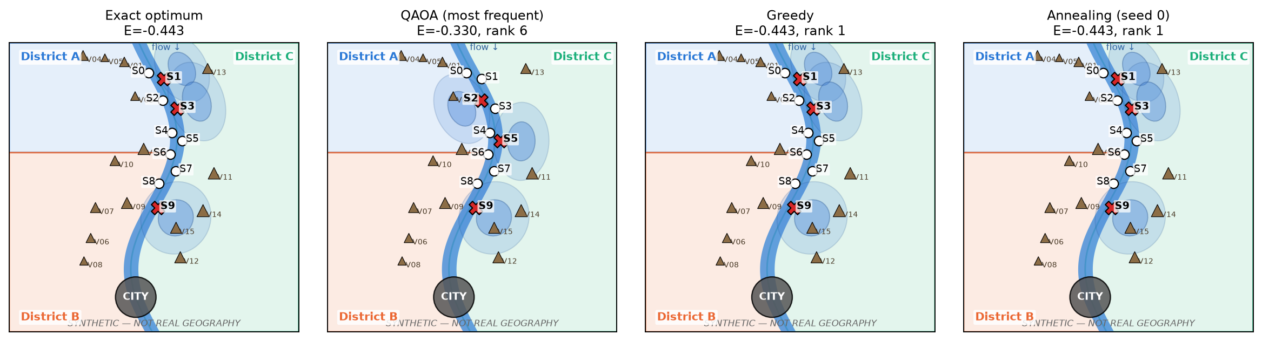
Figure 3. Plans chosen by each method on the default instance. Red crosses mark the selected sites and shaded areas the illustrative spill footprints.
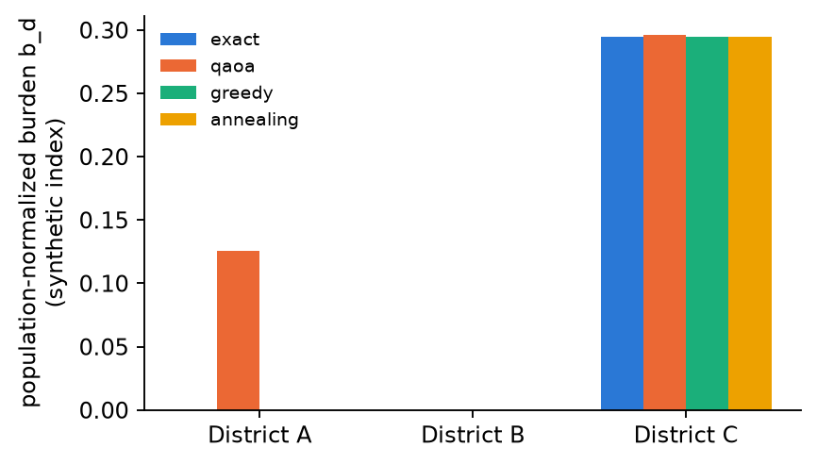
Figure 4. Population-normalised district burdens b_d of each method's plan (additive proxy). Exact, greedy and annealing coincide on this instance.

7.2 QAOA across seeds and depths
Table 4. QAOA summary. P(opt) is the exact probability of the optimal plan in the optimised state. ×unif is P(opt)/(1/C(n,k)) with its min–max range. >unif counts runs above uniform. MF opt is how often the most-frequent sample was optimal, and MF ngap its mean normalised gap. max P is the largest single-plan probability (near 1 means collapse).
n | init | p | runs | P(opt) | ×unif | range | >unif | MF opt | MF ngap | max P | evals
10 | basis | 1 | 9 | 0.005 | 0.6 | 0.0–1.9 | 3/9 | 0% | 0.195 | 0.819 | 114
10 | basis | 2 | 9 | 0.008 | 1.0 | 0.0–4.2 | 3/9 | 0% | 0.156 | 0.735 | 252
10 | dicke | 1 | 9 | 0.026 | 3.1 | 0.3–7.6 | 7/9 | 11% | 0.130 | 0.041 | 140
10 | dicke | 2 | 9 | 0.049 | 5.8 | 0.9–8.9 | 8/9 | 22% | 0.064 | 0.073 | 300
12 | basis | 1 | 3 | 0.000 | 0.1 | 0.0–0.2 | 0/3 | 0% | 0.262 | 0.999 | 115
12 | basis | 2 | 3 | 0.000 | 0.0 | 0.0–0.0 | 0/3 | 0% | 0.283 | 0.687 | 229
12 | dicke | 1 | 3 | 0.020 | 4.4 | 1.5–10.2 | 3/3 | 33% | 0.293 | 0.028 | 150
12 | dicke | 2 | 3 | 0.079 | 17.3 | 16.7–18.1 | 3/3 | 100% | 0.000 | 0.079 | 300

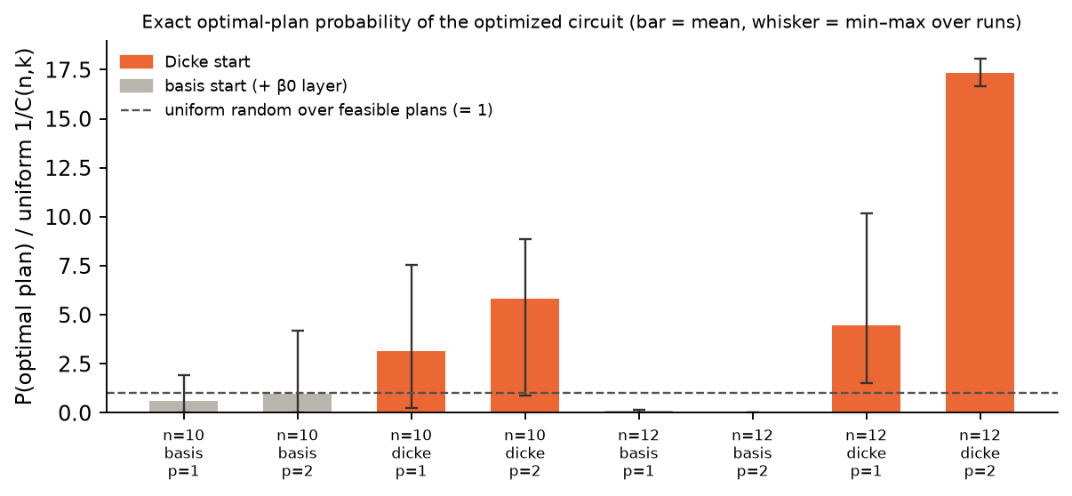
Figure 5. Optimal-plan probability relative to uniform sampling of feasible plans. Orange bars are the Dicke start and grey bars the basis start. Whiskers show the min–max over seeds.
Every QAOA run had a feasible-sample rate of 100% and leakage below 1e−30. With the Dicke start, optimised ⟨E⟩ was below the uniform-plan mean in 18 of 18 n = 10 runs. P(opt) exceeded uniform in 7/9 runs at p = 1 and 8/9 at p = 2. Failures are real. Several p = 1 runs stalled close to or below the uniform baseline, and the most-frequent sample was often a good but suboptimal plan. P(opt) of a few percent means the circuit is a biased sampler, not a solver that outputs the optimum.
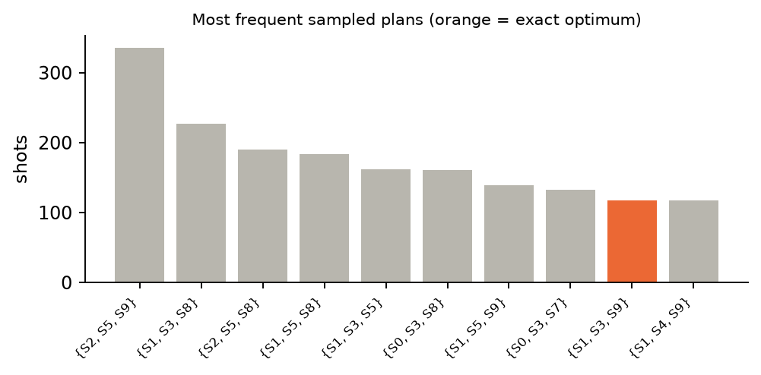
Figure 6. Most frequent sampled plans (default instance, Dicke start, p = 2, seed 0, 4096 shots). The orange bar is the exact optimum.
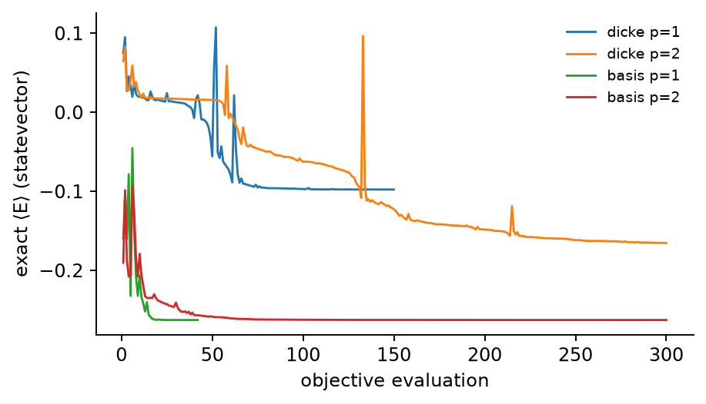
Figure 7. COBYLA traces of the exact ⟨E⟩ (default instance, optimiser seed 0). The basis-start traces reach low ⟨E⟩ by collapsing onto single plans, which is not a better quantum state.

7.3 Classical baselines
Table 5. Exact, greedy and annealing (10 seeds × 200 steps) on every instance. #meet is the number of feasible plans reaching τ.
seed | n | plans | exact optimum | τ | #meet | greedy | rank | gap | SA opt | SA evals
0 | 10 | 120 | {S0, S3, S8} | meets | 41 | {S0, S3, S8} | 1 | 0.0000 | 100% | 221
1 | 10 | 120 | {S1, S3, S9} | meets | 23 | {S1, S3, S9} | 1 | 0.0000 | 100% | 221
2 | 10 | 120 | {S4, S6, S8} | BELOW | 46 | {S4, S6, S8} | 1 | 0.0000 | 100% | 221
1 | 12 | 220 | {S0, S4, S9} | meets | 48 | {S0, S6, S9} | 2 | 0.0224 | 100% | 221

Table 6. Annealing budget study (10 seeds each). At 200 steps annealing spends more evaluations than there are feasible plans, so exhaustive enumeration would be cheaper.
seed | n | steps | evals | plans | success | mean gap | worst rank
0 | 10 | 10 | 31 | 120 | 20% | 0.1352 | 38
0 | 10 | 25 | 46 | 120 | 40% | 0.0321 | 19
0 | 10 | 50 | 71 | 120 | 60% | 0.0058 | 5
0 | 10 | 200 | 221 | 120 | 100% | 0.0000 | 1
1 | 10 | 10 | 31 | 120 | 20% | 0.0749 | 20
1 | 10 | 25 | 46 | 120 | 60% | 0.0410 | 20
1 | 10 | 50 | 71 | 120 | 100% | 0.0000 | 1
1 | 10 | 200 | 221 | 120 | 100% | 0.0000 | 1
2 | 10 | 10 | 31 | 120 | 30% | 0.1260 | 17
2 | 10 | 25 | 46 | 120 | 70% | 0.0372 | 7
2 | 10 | 50 | 71 | 120 | 80% | 0.0227 | 2
2 | 10 | 200 | 221 | 120 | 100% | 0.0000 | 1
1 | 12 | 10 | 31 | 220 | 10% | 0.2516 | 26
1 | 12 | 25 | 46 | 220 | 10% | 0.1378 | 15
1 | 12 | 50 | 71 | 220 | 70% | 0.0267 | 7
1 | 12 | 200 | 221 | 220 | 100% | 0.0000 | 1

Greedy was optimal on 3 of 4 instances and missed on the n = 12 instance (rank 2, gap 0.0224). Annealing with small budgets (10–25 swaps) often failed. On the n = 12 instance it needed about 200 steps to succeed reliably. On scenario seed 2 the weighted optimum misses the synthetic threshold, so the trade-off is visible: a plan that reaches τ exists, but it costs more harm or fairness than the chosen weights accept.

7.4 Runtime and circuit resources
Table 7. Runtime and resources on the default instance (simulation on a laptop CPU).
item | value
exact enumeration of 120 plans | 0.30 ms
QAOA setup / optimisation / sampling (p = 2, seed 0) | 0.012 s / 2.04 s / 0.036 s
logical depth; 2-qubit gates; 3-qubit gates | 110; 187; 15
transpiled depth; CX (basis rz, sx, x, cx; no routing) | 655; 446
of which Dicke preparation: depth; CX | 505; 186
of which 2 QAOA layers: depth; CX | 150; 260
n = 12, p = 2 transpiled CX (prep + layers) | 234 + 360

Simulated QAOA is roughly four orders of magnitude slower than exact enumeration here. Transpilation assumes all-to-all connectivity. On heavy-hex hardware the dense RZZ layer would need SWAP routing and would be much deeper.

8. Pareto analysis
Table 8. Exact nondominated sets over (max R, min H, min F) by full enumeration. Ties are kept, and dominance needs ≤ on all objectives and < on at least one. The last column counts ordered pairs of nondominated plans in which the fairer plan causes more total harm.
seed | n | plans | 3-obj nondominated | 2-obj (R,H) frontier | not reached by weight grid | fairness/harm tension pairs
0 | 10 | 120 | 14 | 6 | 6 | 37
1 | 10 | 120 | 17 | 11 | 9 | 38
2 | 10 | 120 | 21 | 10 | 14 | 113
1 | 12 | 220 | 9 | 2 | 4 | 30

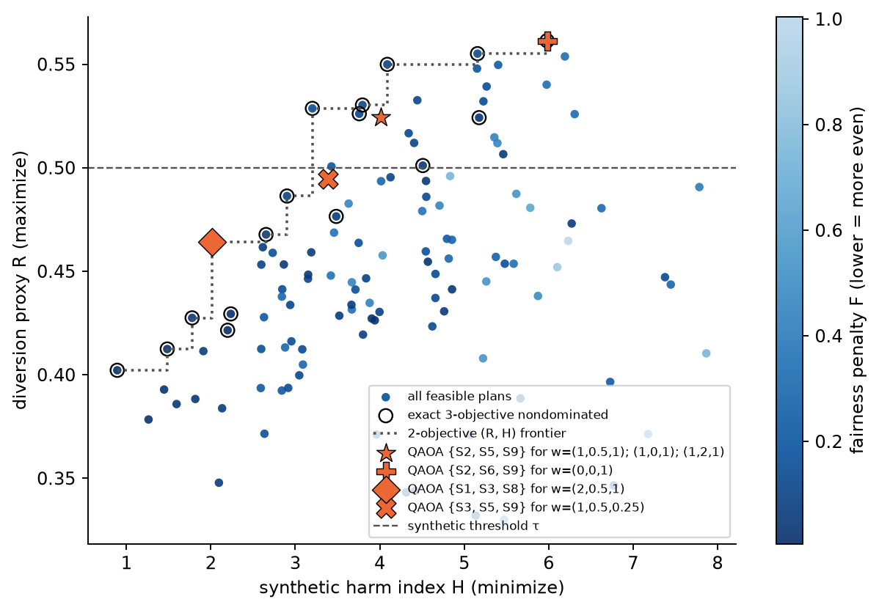
Figure 8. Diversion proxy versus synthetic harm for every feasible plan of the default instance, coloured by fairness penalty. Ringed points are the exact three-objective nondominated set. The dotted step line is the separate two-objective (R, H) frontier. Orange markers are QAOA's most frequent plans under a six-point weight sweep (Dicke start, p = 2, seed 0). Identical plans share a marker.
Table 9. Weight sweep on the default instance.
weights (H, F, R) | QAOA most frequent | rank | 3-obj nondominated | exact weighted optimum | τ | P(opt)
(1, 0.5, 1) | {S2, S5, S9} | 6 | no | {S1, S3, S9} | meets | 0.028
(0, 0, 1) | {S2, S6, S9} | 1 | yes | {S2, S6, S9} | meets | 0.134
(1, 0, 1) | {S2, S5, S9} | 6 | no | {S1, S3, S9} | meets | 0.018
(2, 0.5, 1) | {S1, S3, S8} | 2 | yes | {S1, S3, S5} | BELOW | 0.079
(1, 2, 1) | {S2, S5, S9} | 16 | no | {S1, S3, S8} | BELOW | 0.028
(1, 0.5, 0.25) | {S3, S5, S9} | 32 | no | {S1, S3, S5} | BELOW | 0.000

The sweep is a sparse sample of six weight vectors and is not the Pareto front. A weighted sum can only reach supported nondominated points, those on the convex hull. Table 8 shows that several exact nondominated plans were never the minimiser for any weight on a dense simplex grid. QAOA's most-frequent plan was often not the weighted optimum, and sometimes not nondominated at all. Shallow QAOA here samples the trade-off space; it does not reliably locate it.

9. Limitations
- No hydrodynamic calibration. Relief, harm and spill areas are geometric proxies, not flood simulations. Water levels, timing, flow routing and embankment behaviour are not modelled.
- Uncertainty in input estimates. All coefficients are synthetic point values. A real decision would need uncertain inputs, scenario ensembles and sensitivity analysis. None is modelled.
- Simplified pairwise interactions. Redundancy and spill overlap are pairwise only. Real interactions can be higher-order and dynamic.
- Simplified district fairness. F is an additive, population-normalised disparity proxy. It ignores interaction harm, intra-district distribution, vulnerability and procedural justice, and it can be zero when everyone is badly burdened.
- No guarantee of city safety. The threshold is a synthetic relief proxy checked after solving. The weighted objective can, and on seed 2 does, choose a plan below it.
- Small instances are solved exactly. With 120–220 plans, enumeration is exact and takes under a millisecond. Nothing here suggests a quantum speedup or advantage.
- Ideal-simulator assumptions. Noiseless statevector simulation. On hardware, noise would leak probability out of the k-subspace, the Dicke preparation and all-to-all RZZ would need deep routed circuits, and sampling would replace exact ⟨E⟩ during optimisation.
- QAOA parameter sensitivity and runtime overhead. Results vary strongly with the optimiser seed (Table 4 ranges). The basis-state start collapses. Parameter optimisation dominates runtime.
- Normalisation by enumeration. The fixed normalisers use the exact feasible range, which does not scale. Larger instances would need bounds, which would change the weight semantics.
- Expert review is required before any real-world adaptation, including hydrologists, emergency managers, affected communities, legal and ethics review.

10. Ethical considerations
Deliberately redirecting flood water moves risk from one group of people to another. A tool that hides this trade-off inside a single score, or presents synthetic scores as lives saved, could legitimise harmful choices. FloodCut therefore keeps every objective visible, reports threshold failures rather than hiding them, labels all outputs as synthetic, contains no real locations or operational detail, and does not claim quantum advantage. Weights encode value judgements. They belong to accountable decision makers and affected communities, not to an optimiser.

References and code attribution
[1] Government of Pakistan, ADB, EU, UNDP, World Bank. Pakistan Floods 2022: Post-Disaster Needs Assessment (PDNA), October 2022. https://www.undp.org/pakistan/publications/pakistan-floods-2022-post-disaster-needs-assessment-pdna-main-report
[2] World Bank press release, 28 October 2022: “Pakistan: Flood Damages and Economic Losses Over USD 30 billion and Reconstruction Needs Over USD 16 billion – New Assessment”. https://www.worldbank.org/en/news/press-release/2022/10/28/pakistan-flood-damages-and-economic-losses-over-usd-30-billion-and-reconstruction-needs-over-usd-16-billion-new-assessme
[3] E. Farhi, J. Goldstone, S. Gutmann. A Quantum Approximate Optimization Algorithm. arXiv:1411.4028 (2014).
[4] S. Hadfield et al. From the Quantum Approximate Optimization Algorithm to a Quantum Alternating Operator Ansatz. Algorithms 12(2):34 (2019).
[5] A. Bärtschi, S. Eidenbenz. Deterministic Preparation of Dicke States. FCT 2019, LNCS 11651, 126–139; arXiv:1904.07358.
[6] Z. Wang, N. C. Rubin, J. M. Dominy, E. G. Rieffel. XY mixers: Analytical and numerical results for the quantum alternating operator ansatz. Phys. Rev. A 101, 012320 (2020).
[7] A. Lucas. Ising formulations of many NP problems. Frontiers in Physics 2:5 (2014).
[8] I. Das, J. E. Dennis. A closer look at drawbacks of minimizing weighted sums of objectives for Pareto set generation in multicriteria optimization problems. Structural Optimization 14, 63–69 (1997).
[9] A. Javadi-Abhari et al. Quantum computing with Qiskit. arXiv:2405.08810 (2024). Qiskit is Apache-2.0 licensed.
[10] P. Virtanen et al. SciPy 1.0. Nature Methods 17, 261–272 (2020); M. J. D. Powell, COBYLA (1994).
Code attribution: all FloodCut code was written for this submission. It uses Qiskit (circuits, Statevector, StatevectorSampler, SparsePauliOp, transpile), NumPy, SciPy (COBYLA), Matplotlib, Streamlit and python-docx. The Dicke-state circuit follows the construction in [5]. The figure palette follows a colour-blind-validated categorical order. AI assistance (Claude) was used to write code and draft this report; all reported numbers come from the saved benchmark JSON produced by the code in the repository.

