
Computer Systems & Security


- Name: K.A. Idusha Piumika
- ID: G21328023
- ODD
- Introduction


This report investigates key cryptographic algorithms; DES RSA and MD5 alongside framework execution investigation through PowerShell commands. Cryptographic strategies are essential to securing touchy information and guaranteeing information judgment. The Information Encryption Standard DES is a symmetric encryption algorithm that empowers quick encryption and decoding employing a single key. In any case DES is considered frail by present day security guidelines due to its brief key length and helplessness to brute force assaults. (S. Kelly, 2006) The RSA calculation in differentiate gives solid public key cryptography by leveraging kilter key sets guaranteeing secure encryption and unscrambling fundamental for private communication. RSA is broadly utilized in securing web activity mail encryption and computerized marks. In any case key length altogether impacts its security making bigger keys 2048bit or higher essential for security against cutting edge computational assaults. (Laura K, 2022) In conclusion MD5 could be a broadly utilized hashing work that produces fixed length hash values for information keenness confirmation, in spite of its effectiveness MD5 endures from collision vulnerabilities meaning two distinctive inputs can deliver the same hash making it unacceptable for cryptographic security purposes.(GeeksForGeeks, 2024) More secure options such as SHA256 are frequently favoured the report too digs into framework investigation utilizing PowerShell commands counting checking memory utilization assessing, accessible physical memory and analysing framework stack. By combining cryptographic strategies with system level experiences, the report emphasizes the significance of security and execution in computing situations.

Task 01: DES Encryption & Decryption
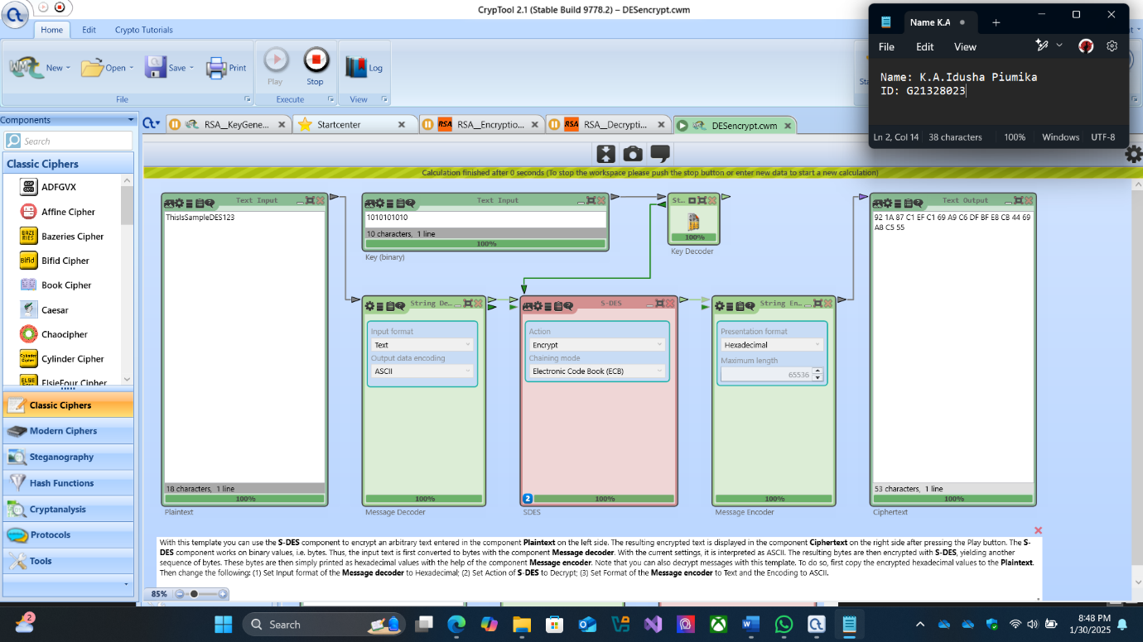

- DES Encryption: In this errand I investigated DES Information Encryption Standard a symmetric key encryption calculation. Not at all like RSA which employments diverse keys for encryption and decoding DES employments the same key for both operations. (Laura.K, 2022) The objective was to scramble the message “ThisIsSampleDES123” employing a symmetric key After contributing the plaintext into CrypTool 2s DES encryption module and giving the key the message was scrambled into a ciphertext, the resulting ciphertext appeared within the screenshot. In there, there is a hexadecimal string that speaks to the scrambled adaptation of the first message. This change is done utilizing the DES calculations arrangement of operations which include piece cipher procedures and key changes. DES whereas once broadly utilized is presently considered frail by present day guidelines because it is defenceless to brute force assaults due to its generally brief key length (S. Kelly, 2006).

Execution:
- Open the DES cipher module in CrypTool 2.
- Input the plaintext message: "ThisIsSampleDES123".
- Observe the generated ciphertext, which appears as a hexadecimal string.
- Repeat the process for decryption by inputting the ciphertext.

Result & Observations:
The ciphertext gotten was “E6 E3 53 81 FB 81 29 FD 12 0B 86 7C 45 90 29 4A 5A D5”.
When unscrambled utilizing the same key the first plaintext was reestablished effectively. DES encryption works on 64bit squares and employments 16 rounds of Feistel structure but its 56bit compelling key length makes it helpless to brute force assaults. Advancement to address DESs shortcomings AES Progressed Encryption Standard is broadly received advertising superior security through 128bit 192bit or 256bit keys.

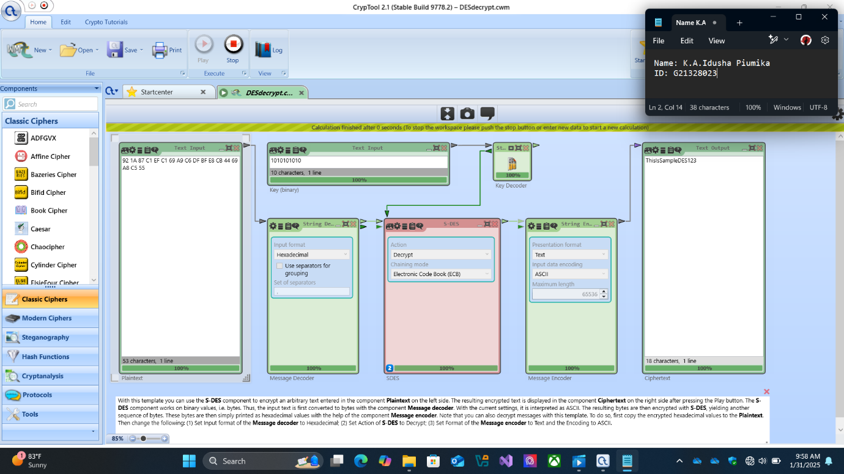

- DES Decoding: The ultimate errand included decoding the ciphertext created in previous encryption utilizing the same symmetric key. Symmetric encryption calculations such as DES depend on the same key for both encryption and unscrambling meaning that the ciphertext can be decoded by anybody who has get to the key. In this case the ciphertext from previously was input into the DES unscrambling module in CrypTool 2 alongside the same key utilized for encryption. When decoding was executed the initial plaintext message “ThisIsSampleDES123” was effectively recovered. This illustrated the reversibility of symmetric encryption where the same key utilized for encryption can moreover be utilized to decode the information back to its unique shape.

Execution:
- Open the DES cypher module in CrypTool 2.
- Paste the ciphertext from the DES encryption task.
- Observe the generated plaintext, which appears as a ASCII string.

Result & Observations:
The output is the original plaintext message: "ThisIsSampleDES123". This confirms the successful decryption of the ciphertext, demonstrating the reversibility of DES encryption.
The unscrambling prepares accurately recuperated the initial plaintext illustrating that the encryption and unscrambling forms were legitimately executed with the same key. This approves that DES being a symmetric encryption calculation, employments the same key for both encryption and decoding. This strengthens the significance of safely overseeing and sharing the key Reversibility of DES. The work out highlights that DES encryption is reversible meaning that as long as the right key is utilized the first information can be recovered. It is considered frail by advanced cryptographic guidelines due to its 56bit key length which makes it powerless to brute force assaults More secure options like AES are prescribed for commonsense utilize (S.Kelly, 2006).

Task 02: RSA Encryption & Decryption

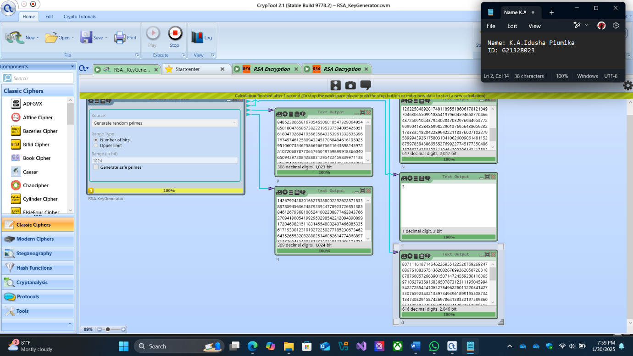

- In this task the objective was to create RSA key sets that are utilized for secure communication. RSA works by producing two keys an open key for encryption and a private key for unscrambling. The quality of RSA encryption depends on the key length and longer keys give more noteworthy security (Laura.K, 2022). To begin I utilized randomly chosen prime numbers within the run of 1024 bits as the two key components for creating the RSA keys. These primes shape the establishment for the key era handle where they are duplicated together to form the modulus which is a central component of both the open and private keys. After contributing these primes into CrypTool 2 the computer program created the open and private keys which were spared for utilize in consequent encryption and decoding assignments.

Execution:
- Open the RSA key generation module in CrypTool 2.
- Generate a key pair using randomly selected 1024-bit prime numbers.
- Compute the modulus (N = p × q), the public exponent e, and the private exponent d.
- Use the public key (N, e) to encrypt the plaintext message
- Use the corresponding private key (N, d) to decrypt the ciphertext and verify the original plaintext.

Results & Observations:
The ciphertext shows up as a long hexadecimal string making it garbled without the private key. The unscrambled content matches the initial plaintext demonstrating the adequacy of RSA encryption. RSA security is subordinate on key length. Whereas 1024bit RSA gives a sensible level of security 2048bit or higher keys are suggested for upgraded protection against present day assaults. And also, instead of manually selecting small prime numbers, using a cryptographic library to generate secure random primes ensures robustness against factorization attacks.

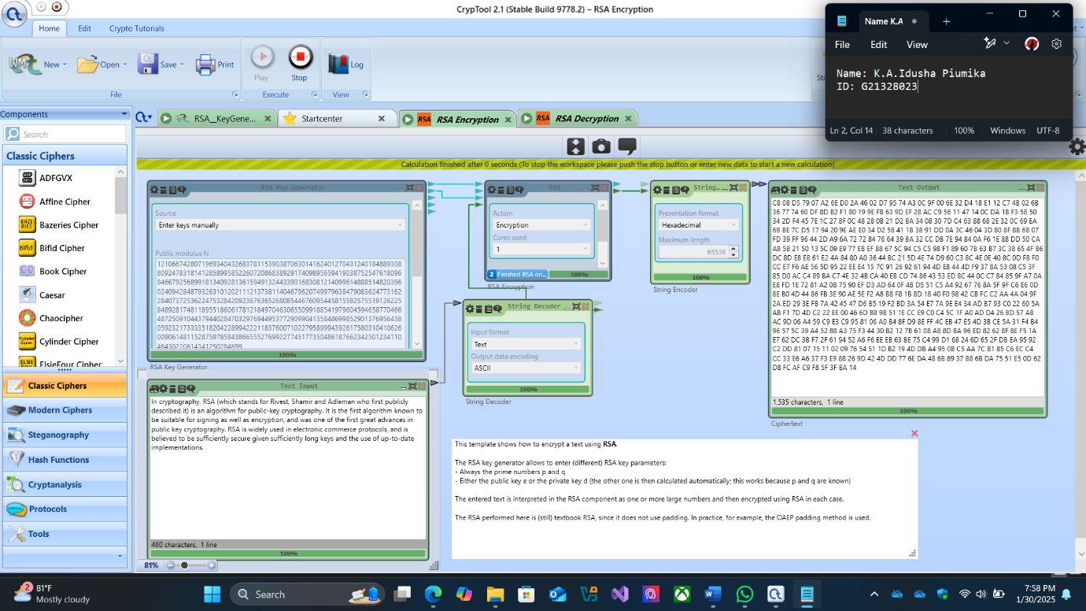

- Within the encryption I used the open key parameters N and e created by the RSA Key Generator to scramble the plaintext message. The objective of RSA encryption is to safely scramble a plaintext message utilizing the open key so that as it were the comparing private key can unscramble it. Utilizing CrypTool 2s RSA encryption module the plaintext message was changed over into a ciphertext, the resulting ciphertext shown within the screenshot is a long string of hexadecimal values that speaks to the scrambled adaptation of the first plaintext. This ciphertext is confused to anybody without the private key illustrating RSAs capability to guarantee the privacy of messages. The encryption prepares effectively changed the plaintext into ciphertext approving the quality of RSA encryption.

Execution:
- Open the RSA encryption module in CrypTool 2.
- Input the plaintext.
- Use the same private key generated during the RSA key generation step.
Results & Observations:
The ciphertext (which is the encrypted version of the message) is displayed in the screenshot." 98 09 54 0C 85 0B..." This shows how the plaintext is transformed into an encrypted form.
In this task I accurately utilized the open key parameters N and e for encryption taking after the RSA encryption prepare where as it were the comparing private key can unscramble the ciphertext. The change of plaintext into a long hexadecimal ciphertext affirms the viability of RSA encryption in ensuring message privacy. Without the private key the ciphertext remains incoherent illustrating the security given by RSA Irreversibility. Since RSA is a deviated encryption calculation unscrambling requires the private key. This guarantees that as it were authorized parties can recover the initial plaintext. And also, the encryption prepares effectively created ciphertext showing that the RSA module in CrypTool 2 worked accurately and approved the encryption handle. Whereas RSA is secure when utilizing huge key sizes e.g. 2048bit or higher it is computationally seriously for viable applications (Laura.K, 2022). RSA is frequently utilized for scrambling little messages or for scrambling symmetric keys in crossover encryption frameworks.

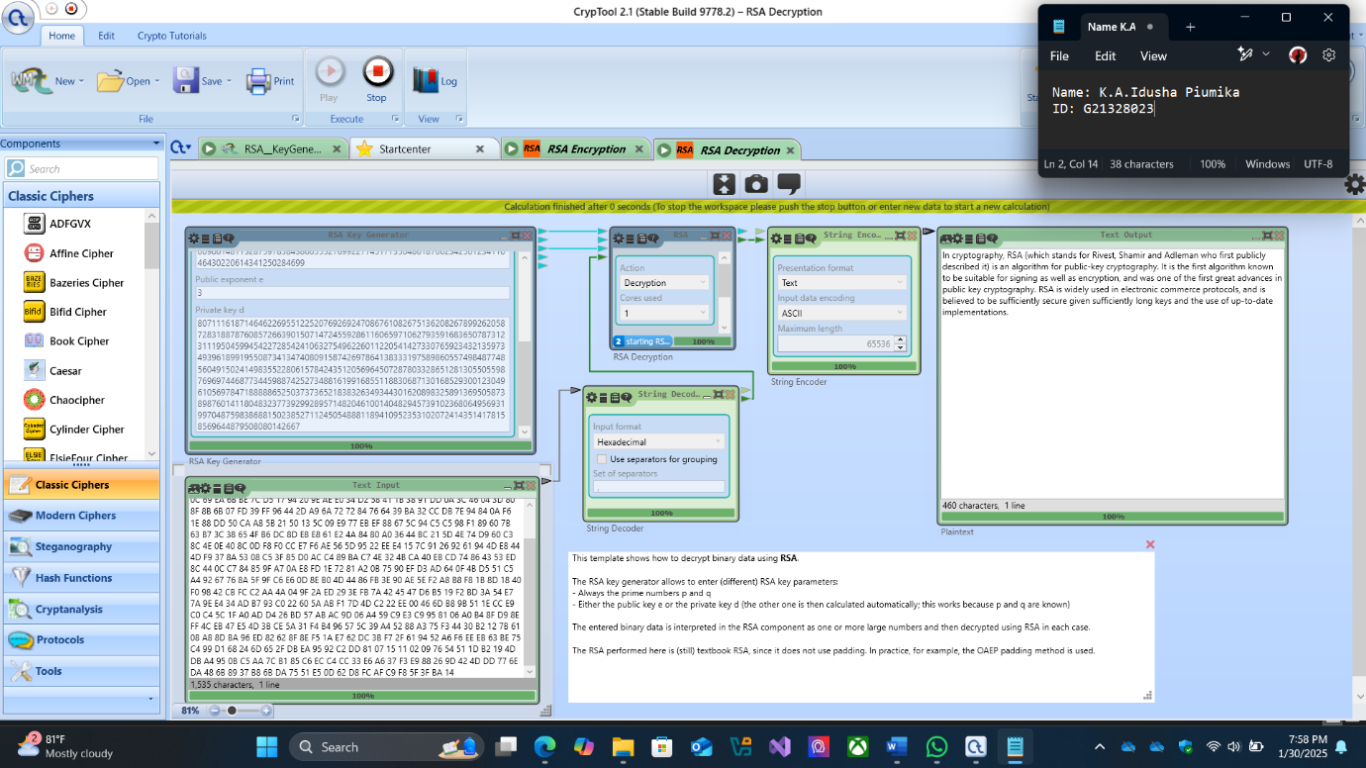

- Taking after the encryption RSA decoding was performed to illustrate the adequacy of the RSA calculation in secure communication. For the unscrambling I used the same parameters N, e and the private key d created by the RSA Key Generator previously. The ciphertext gotten amid encryption was decoded back into the initial plaintext. As appeared within the screenshot, the unscrambled plaintext matches the initial message precisely affirming the astuteness and exactness of decoding. This highlights the adequacy of RSA in guaranteeing secure communication where as it were the substance with the private key can effectively unscramble the scrambled information (Laura.K, 2022).

Execution:
- Open the RSA decryption module in CrypTool 2.
- Input the ciphertext from the previous task.
- Use the same private key generated during the RSA key generation step.

Results & Observations:
The output is the original plaintext message, confirming the correctness of the decryption process. The decrypted message matches the original plaintext from Encryption.
The unscrambling prepares precisely reestablished the initial plaintext message affirming the rightness of the RSA encryption, decryption cycle. Conjointly the method illustrates that decoding is as it were conceivable with the corresponding private key (d) guaranteeing that as it were authorized beneficiaries can get to the first message. The effective recovery of plaintext confirms RSAs adequacy in securing communication as unauthorized entities without the private key cannot decode the ciphertext. The truth that the unscrambled message precisely matches the first plaintext highlights RSAs unwavering quality in keeping up information judgment amid encryption and decoding.
Task 03: MD5 Hashing

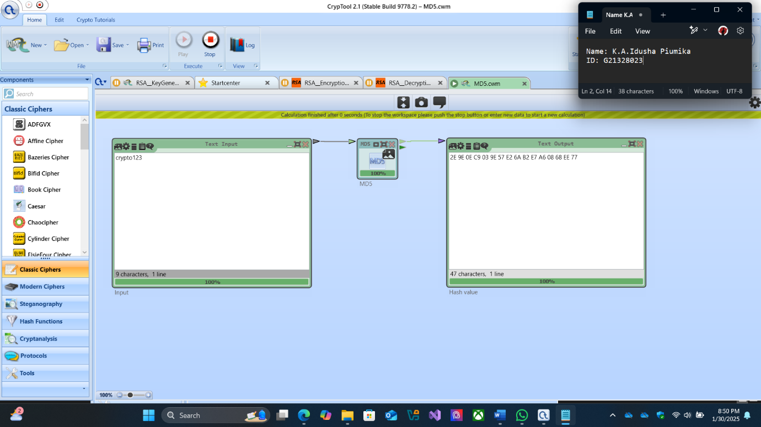
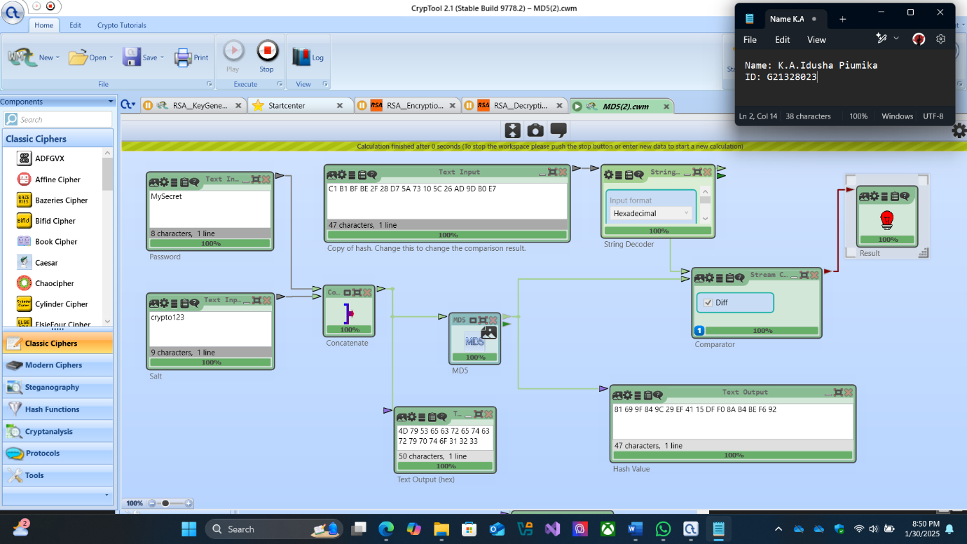

- MD5 is a cryptographic hash function used to produce a fixed-length hash value for any given input. This task was focused on generating the MD5 hash for a plaintext message, "crypto123". Hash functions like MD5 are widely used in verifying the integrity of data, as any change in the original data will result in a completely different value (GeeksForGeeks, 2024). The MD5 hash was generated in CrypTool 2 by inputting the string "crypto123" into the hashing module. The resulting hash value, shown in the screenshot. This hash is utilized to confirm that the information has not been changed as indeed the littlest alter within the input would lead to a distinctive hash yield. MD5 whereas effective is not considered completely secure due to vulnerabilities such as collision assaults but it remains a broadly utilized strategy for information keenness checking (TechClaw, 2023).

Task 04: PowerShell Commands for System Analysis
Command 1: Check RAM Usage by Each Process
To monitor memory usage by individual processes, I used the command Get-Process | Select-Object Name, @{Name="MemoryUsage(MB)"; Expression={[math]::round($_.WorkingSet/1MB, 2)}} | Sort-Object "MemoryUsage(MB)" -Descending. This command lists all the currently running processes on the system and sorts them in descending order based on their memory consumption. Each process is displayed alongside its memory usage in megabytes (MB). By running this command, I observed the names of various software applications, such as web browsers, media players, and system processes, along with the corresponding memory consumption values.
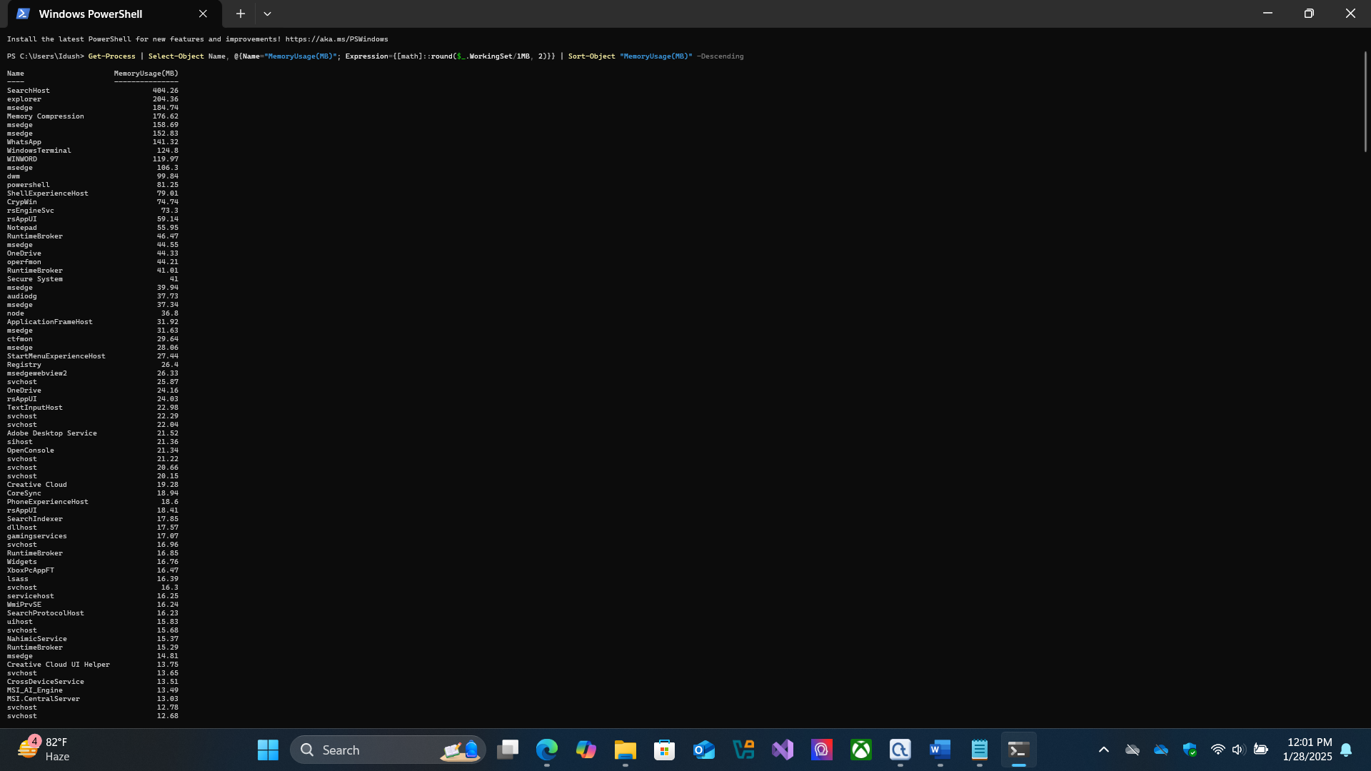

The output from this command highlighted those certain applications, such as web browsers and some productivity tools, were using a substantial portion of the system's available memory. For example, browser tabs and extensions were found to consume a significant amount of RAM, which could potentially cause the system to slow down if many applications are running simultaneously. This information is particularly useful for troubleshooting performance issues, as users can identify memory-heavy processes and consider closing unnecessary applications or optimizing system resource usage (Celestin.N, 2021).
The screenshot of the command output provides a visual representation of these processes, showing their names and the memory consumption in megabytes, helping to further demonstrate how RAM is allocated among running applications.

Command 2: Get Available Physical Memory
The command Get-CimInstance Win32_OperatingSystem | Select-Object TotalVisibleMemorySize, FreePhysicalMemory is utilized to recover the whole obvious memory and free physical memory accessible on the framework (Celestin.N, 2021). By running this command, I was able to see that the overall unmistakable memory was significantly large but the free physical memory was essentially lower indicating that the framework is employing a huge parcel of its accessible memory. Usually, a valuable perception because it highlights the frameworks current memory utilization proposing that forms or applications running on the framework may be expending significant sums of Smash which seem influence generally execution.

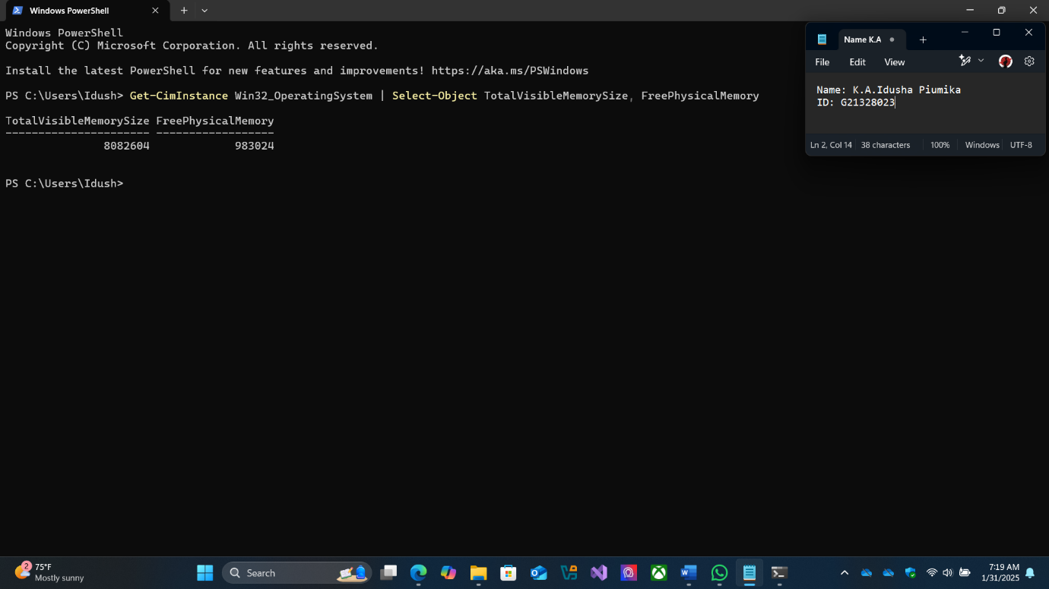

Command 3: Get System Memory Usage
The command Get-Counter appears the accessible framework memory in megabytes. This command is especially valuable in checking how much free memory remains for the framework to distribute to modern forms or handle framework operations (Broak.B, 2024). In execution I taken note that the accessible memory changed depending on the frameworks stack and the forms running at that time. These changes serve as a real time marker of how the frameworks memory is being overseen and utilized giving understanding into potential memory bottlenecks when the framework gets to be over-burden.

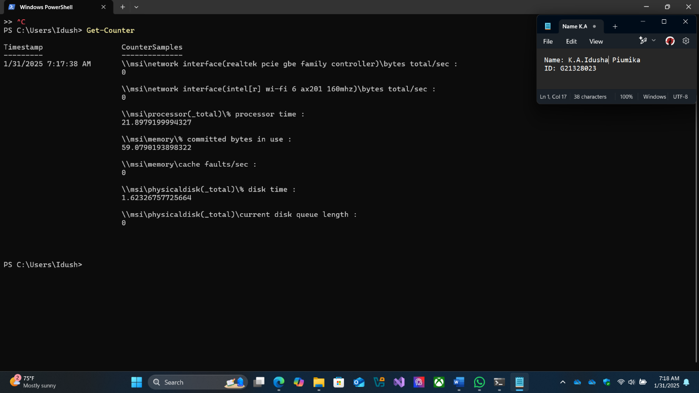

References:

- Broak.B (2024), PDQ, The top 10 PowerShell cmdlets every sysadmin should know. Available at: 10 PowerShell commands every sysadmin should know | PDQ (Accessed: 11/01/2025).

- Celestin.N (2021), Medium, analyzing a System using PowerShell. Available at: Analyzing a System using PowerShell | by Celestin Ntemngwa | Medium (Accessed: 11/01/2025).

- CodeCademy Team (no date), Important PowerShell Commands for Cybersecurity Analysts. Available at: Important PowerShell Commands for Cybersecurity Analysts | Codecademy (Accessed: 11/01/2025).

- GeeksForGeeks (2024), RSA Algorithm in Cryptography. Available at: RSA Algorithm in Cryptography - GeeksforGeeks (Accessed: 11/01/2025).

- GeeksForGeeks (2024), What is the MD5 Algorithm? Available at: What is the MD5 Algorithm? - GeeksforGeeks (Accessed: 10/01/2025).

- Kelly.S (2006), IETS, Security Implications of Using the Data Encryption Standard (DES). Available at: ietf.org/rfc/rfc4772.txt (Accessed: 08/01/2025).

- Laura.K (2022), NordVPN, What is RSA encryption and how does it work? Available at: What is RSA encryption, and is it safe to use? | NordVPN(Accessed: 10/01/2025).

- Michael Cobb (no date), TechTarget, What is the RSA algorithm. Available at: A Quick Guide to Harvard Referencing | Citation Examples (Accessed: 10/01/2025).

- TechClaw (2023), Exploring the Power and Vulnerabilities of the MD5 Algorithm. Available at: Exploring the Power and Vulnerabilities of the MD5 Algorithm | by TechClaw | Medium (Accessed: 10/01/2025).

*** END ***

