2/20/2026
Idusha Piumika
G21328023
Advanced Programming
CO2402
-----Smart Campus System-----

Summary

The Smart Campus system manages various smart devices across several different types of devices. The following classes have been utilized in implementing the Smart Campus system using object-oriented programming principles such as:

- Inheritance - derived class devices are each derived from the base class (Device).
- Polymorphism - the interaction method is overridden by the derived class for interaction using the Device base class pointer.
- Allocating and deallocating through dynamic memory, allowing the devices to be allocated to their respective devices using raw pointers.

Structure of the Class Diagram

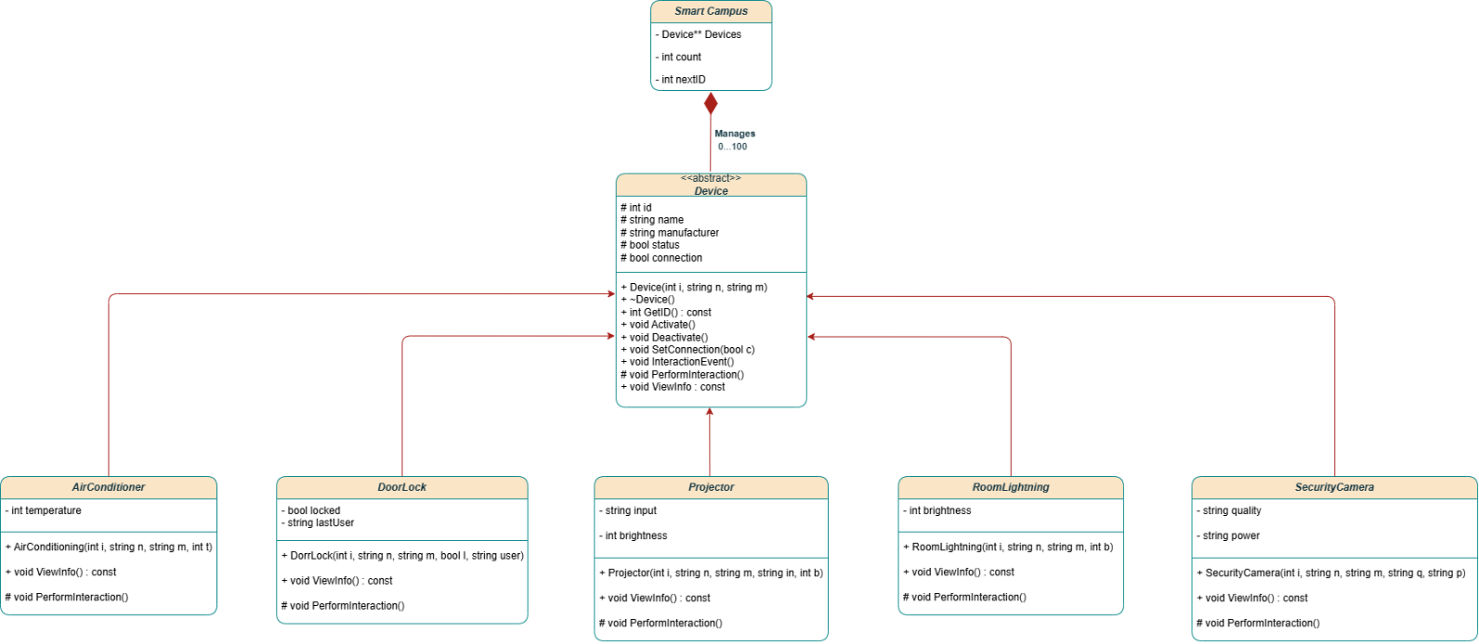
Abstract Base Class - Device
- Definition: This class defines common functionality and properties of all smart devices.
- Access Modifiers:
- Protected Attributes: id, name, manufacturer, status, and connection.
- Public Methods: constructor, destructor, getters and setters, Activate(), Deactivate(), InteractionEvent(), and ViewInfo() (pure virtual functions).
- Protected Method: PerformInteraction() (pure virtual function).

- Key Features:
- This is an abstract class (identified in UML as <>).
- A virtual destructor, or ~Device(), is defined in order to delete all derived class objects.
- The template method pattern has been applied as follows: the InteractionEvent() function is a template function and the PerformInteraction() function is based on the concrete implementation of this template function provided by the various derived classes.

Derived Classes
Class | Attributes | Inheritance / Notes
AirConditioning | temperature : int | Inherits Device
DoorLock | locked : bool, lastUser : string | Inherits Device
Projector | input : string, brightness : int | Inherits Device
RoomLighting | brightness : int | Inherits Device
SecurityCamera | quality : string, power : string | Inherits Device

Notes:

- Each derived class provides its own implementation of PerformInteraction() and ViewInfo().
- Attributes are private (use only in derived classes) and are automatically created and destroyed, so do not need an additional destructor.
- Constructors will initialize attributes of the base class and attributes specific to the derived classes.

Aggregation of Main Program

- The main program will create a dynamic array of devices:

Device** devices = new Device*[MAX];

- Relationship: Smart_Campus (main program) is managing 0 to 100 Device objects.
- All Device objects will be deleted properly upon termination of the program.

for (int i = 0; i < count; i++)
delete devices[i];
delete[] devices;

- This guarantees that we safely release memory when using raw pointers.

UML Design Information

- All device types are direct heirs of Device, thus indicating inheritance.
- Base class Device* pointers use polymorphism when calling overridden methods of respective derived classes.
- All attributes are encapsulated. Attributes are private/protected and can only be accessed via method calls.
- A single instance of the main program can manage up to 100 devices.
- Abstract Class and Method(s):
- Device is an abstract base class.
- PerformInteraction() and ViewInfo() are pure virtual functions.
- The design pattern used here is the Template Method pattern for the interaction flow.

Conclusion

In conclusion, the Smart Campus System is a successful demonstration of practical usage of Object Oriented Programming in C++. The system utilizes an abstract base class called Device that contains common properties and methods for all smart devices, including more specific types of devices (e.g., Air Conditioning, Door Lock, Projector, Room Lighting, Security Camera) that inherit from Device and override Device’s methods to provide the system with their own device type specific implementation of device interaction methods.

The system design provides a clear separation of responsibility and encapsulates the data in a way that utilizes inheritance and polymorphism correctly. The Template Method pattern is implemented using Interaction Event() for creating a consistent flow of interaction, but at the same time allows devices to have their own functionality.

Dynamic memory allocation within the system is handled using raw pointers with appropriate de-allocation to prevent memory leaks. The class diagram used for the system accurately depicts the actual structure of the system and matches the system’s implementation.

References:

- Zobair U. (2016), Implementation of Constructor and Destructor Using C++. Available at: Implementation of Constructor-633.pdf

- Hyong L. and Morris C. (2002), A study of dynamic memory management in C++ programs. Available at: A study of dynamic memory management in C++ programs

- Kumar V. (No Year or Date), Access specifiers (public private protected) C++.
Available at: Access specifiers (Public Private Protected) C++ | PDF

