Block 1: Introduction and data exploration

Hz.Lin

November 2, 2017

# Block 1: Introduction and data exploration

--- Huizhi Lin (881125518130) --- Jan Orsel (950608630010)

## Task 1

First we loaded in the data from file "get_normal_vs_tumor2_RAW_Skin.out" into dataframe "skin.df". This is shown in the following block.

skin.df <- read.table("get_normal_vs_tumor2_RAW_Skin.out",sep=' ', header=TRUE)

Secondly we created another dataframe "re.skin.df" with samples in column and genes in rows. # Transpose just the gene expression

re.skin.df <- data.frame(t(skin.df[,-2562]))  
# Add sample type as column name  
colnames(re.skin.df)<-paste0(skin.df$tissue,1:72)

Thirdly, we chose tumor samples tumor1,tumor2 and tumor3, and normal samples normal70, normal71 and normal72. Then we calculated the range of expressions for thoses sampless.

range(re.skin.df$tumor1)

## [1] 10.40 18651.45

range(re.skin.df$tumor2)

## [1] 10.32 18504.65

range(re.skin.df$tumor3)

## [1] 10.39 20513.70

range(re.skin.df$normal70)

## [1] 10.81 19013.02

range(re.skin.df$normal71)

## [1] 10.47 11436.83

range(re.skin.df$normal72)

## [1] 9.96 14932.83

Fouthly, we calculated the range of expressions for all tumor samples and all normal samples.

# over all tumor smples  
range(re.skin.df[1:43])

## [1] 9.70 21891.76

# over all normal smples  
range(re.skin.df[44:72])

## [1] 9.62 19013.02

Fifthly, we made histograms for selected samples.

# load ggplt2  
library(ggplot2)  
# Create histogram for tumor1  
pl.tumor1 <- ggplot(data=re.skin.df, aes(x=re.skin.df$tumor1))  
pl.tumor1 <- pl.tumor1 + geom_histogram(binwidth=5,color="red",fill="red", alpha=0.8) + xlab("tumor1")  
print(pl.tumor1)

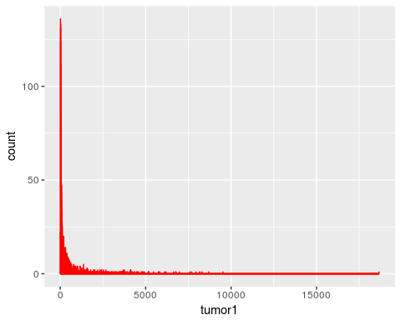

# Create histogram for tumor2  
pl.tumor2 <- ggplot(data=re.skin.df, aes(x=re.skin.df$tumor2))  
pl.tumor2 <- pl.tumor2 + geom_histogram(binwidth=5,color="red",fill="red", alpha=0.8) + xlab("tumor2")  
print(pl.tumor2)

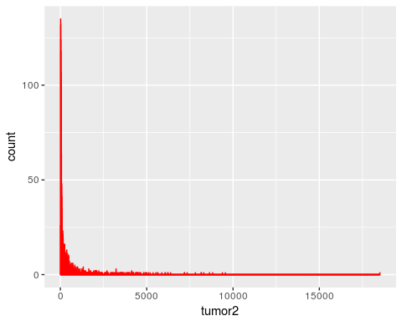

# Create histogram for tumor3  
pl.tumor3 <- ggplot(data=re.skin.df, aes(x=re.skin.df$tumor3))  
pl.tumor3 <- pl.tumor3 + geom_histogram(binwidth=5,color="red",fill="red", alpha=0.8) + xlab("tumor3")  
print(pl.tumor3)

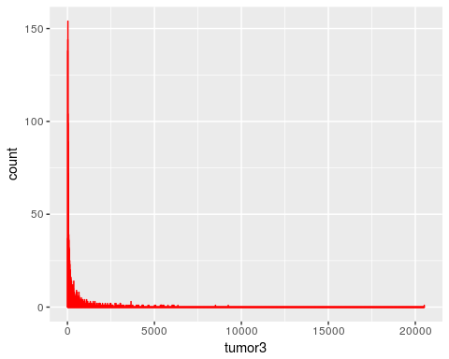

# Create histogram for normall70  
pl.normall70 <- ggplot(data=re.skin.df, aes(x=re.skin.df$normal70))  
pl.normall70 <- pl.normall70 + geom_histogram(binwidth=5,color="blue",fill="blue", alpha=0.8) + xlab("normall70")  
print(pl.normall70)

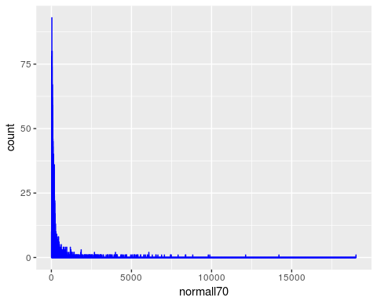

# Create histogram for normall71  
pl.normall71 <- ggplot(data=re.skin.df, aes(x=re.skin.df$normal71))  
pl.normall71 <- pl.normall71 + geom_histogram(binwidth=5,color="blue",fill="blue", alpha=0.8) + xlab("normall71")  
print(pl.normall71)

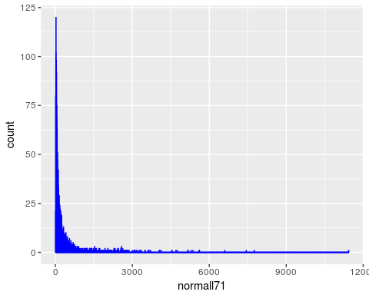

# Create histogram for normall72  
pl.normall72 <- ggplot(data=re.skin.df, aes(x=re.skin.df$normal72))  
pl.normall72 <- pl.normall72 + geom_histogram(binwidth=5,color="blue",fill="blue", alpha=0.8) + xlab("normall72")  
print(pl.normall72)

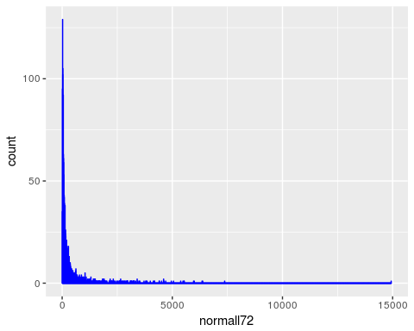

Sixthly, we made histograms for all tumor samples and all normal samples.

# Create histogram for tumor samples  
pl.tumor <- ggplot(data=re.skin.df, aes(x=rowMeans(re.skin.df[1:43])))  
pl.tumor <- pl.tumor + geom_histogram(binwidth=5,color="red",fill="red", alpha=0.8) + xlab("tumor samples")  
print(pl.tumor)

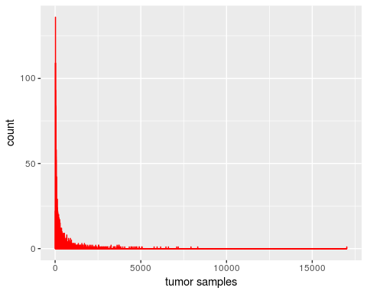

# Create histogram for normal samples  
pl.normal <- ggplot(data=re.skin.df, aes(x=rowMeans(re.skin.df[44:72])))  
pl.normal <- pl.normal + geom_histogram(binwidth=5,color="blue",fill="blue", alpha=0.8) + xlab("normal samples")  
print(pl.normal)

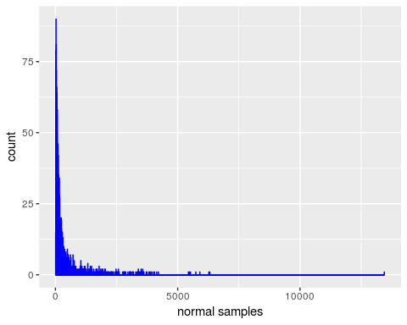

When looking at the gene expression for the three chosen tumor samples it becomes clear that most genes have a low rate of expression with some outliers. The same can be tated on the three samples chosen for the normal samples. In order to compare all the tumor samples to all the normal samples two hisograms were created, this is shown in the block above. When comparing the two hisograms that this code creates no clear differences are shown. It is clear that there are a few genes that are heavily upregulated but a scatterplot is needed to better visualise this.

## Task 2

We made a scatterplot of the average expression level over all tumor samples vs. that over all normal samples.

pl.scatter <- ggplot(data=re.skin.df, aes(x=rowMeans(re.skin.df[1:43]),y=rowMeans(re.skin.df[44:72])))  
pl.scatter <- pl.scatter + geom_point(alpha=0.5,size=4)  
pl.scatter <- pl.scatter + xlab("tumor samples") + ylab("nomal samples")  
print(pl.scatter)

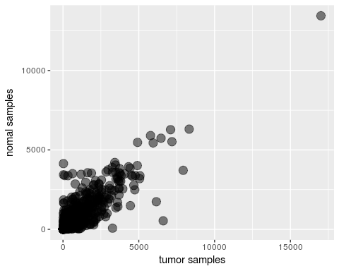 here we see the avarage expression level of tumor samples compared to all normal samples. If there would have been no change in expression all samples would line up in a diagonal line over the middle of the plot. This plot shows a concentraion of dots on this line indicating that for a lot of genes the change in expression is minimal. There are however some dots that clearly show that some genes are over or underexpressed.

## Task 3

Firstly, we made a histogram of the difference between the average expression level over all tumor samples and that over all normal samples.

pl.differ <- ggplot(data=re.skin.df, aes(x=rowMeans(re.skin.df[1:43]) - rowMeans(re.skin.df[44:72])))  
pl.differ <- pl.differ + geom_histogram(binwidth=5,color="blue",fill="blue", alpha=0.8)  
pl.differ <- pl.differ + xlab("difference in average expression")  
print(pl.differ)

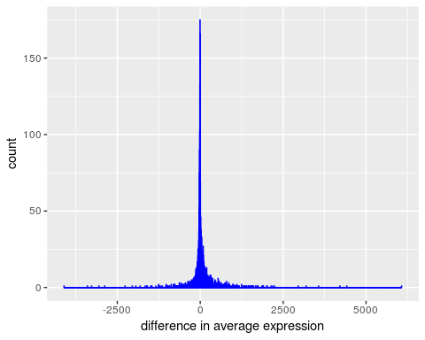

This histogram tell s that the numbers of over- and underexpressed genes are almost the same. We confirmed this by calculating these numbers with a for loop as shown below.

# Calculate the differences  
differ <- rowMeans(re.skin.df[1:43]) - rowMeans(re.skin.df[44:72])  
# Count the numbers of over- and underexpressed genes with a for loop  
overexpressed.gene <- 0  
underexpressed.gene <- 0  
for (dif in differ){  
 if (dif>0){overexpressed.gene <- overexpressed.gene+1}  
 if (dif<0){underexpressed.gene <- underexpressed.gene+1}  
}  
# print out the result  
print(overexpressed.gene)

## [1] 1218

print(underexpressed.gene)

## [1] 1343

The result shows that there are 1218 overexpressed genes and 1343 underexpressed genes. This confirmed out assumption that there is not significant difference in number betwwen overexpressed genes and underexpressed genes.

## Task 4

We Create boxplots of the expression of the genes AMY2B, CLC and NAT1 in tumor and normal samples. Shown as below.

# Creat a boxplot for gene AMY2B  
pl.box1 <- ggplot(data=skin.df, aes(x=factor(skin.df$tissue),y=skin.df$AMY2B))  
pl.box1 <- pl.box1 + geom_boxplot() + xlab("tissue sample types") + ylab("expression")  
pl.box1 <- pl.box1 + ggtitle("Gene AMY2B expression in tumor and normal tissue")  
print(pl.box1)

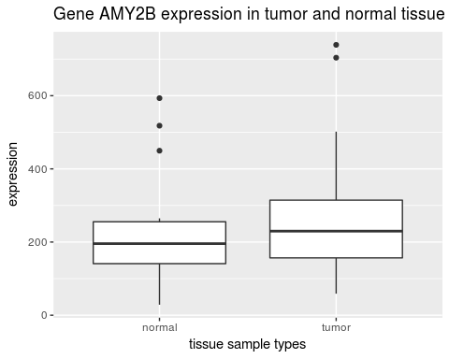

# Creat a boxplot for gene CLC  
pl.box2 <- ggplot(data=skin.df, aes(x=factor(skin.df$tissue),y=skin.df$CLC))  
pl.box2 <- pl.box2 + geom_boxplot() + xlab("tissue sample types") + ylab("expression")  
pl.box2 <- pl.box2 + ggtitle("Gene CLC expression in tumor and normal tissue")  
print(pl.box2)

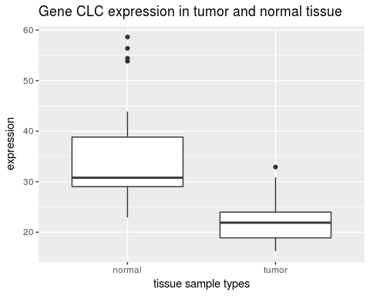

# Creat a boxplot for gene NAT1  
pl.box3 <- ggplot(data=skin.df, aes(x=factor(skin.df$tissue),y=skin.df$NAT1))  
pl.box3 <- pl.box3 + geom_boxplot() + xlab("tissue sample types") + ylab("expression")  
pl.box3 <- pl.box3 + ggtitle("Gene NAT1 expression in tumor and normal tissue")  
print(pl.box3)

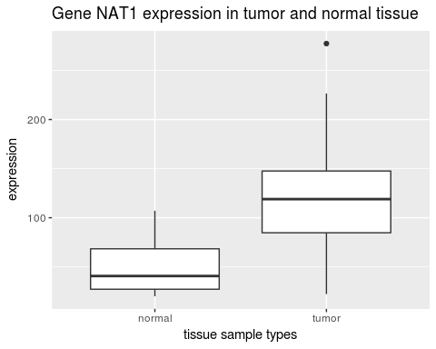

Based on these boxplots, there is no big difference in gene AMY2B expression between normal and tumor samples. However, gene CLC expresses more in normal samples than in tumor samples. On the contrary, gene NAT1 expresses more in tumor samples than in tumor samples.