**Supplementary 3: Report on hypothesis 15**

Given the equation:  Ks  ΔΨmax AS/AL  / h = 1.6 VPD A / (ca - ci) /Patm = E

We hypothesized that the product of Ks (specific xylem hydraulic conductivity) and AS/AL (sapwood to leaf area) vary less than Ks or AS/AL themselves, and there is a trade-off (negative correlation) between Ks and AS/AL.

For Ghana, both hypotheses were rejected, as we see a positive correlation between Ks and AS/AL (slope = 0.95, R-squared : 0.0598, P-value : 0.0224) and the coefficient of variance is found largest for Ks * AS/AL.

For a global dataset (Mencuccini et al., 2019), there is a negative correlation between Ks and AS/AL (slope =-0.919, R-squared :  0.2098, P-value : <2.22e-16) which agreed with the hypothesis but the coefficient of variance of Ks * AS/AL is still larger than that of AS/AL

Why the variance of Ks * AS/AL is not smaller? (1) other variables in equation 1 is also having an impact on the variance of trait (2) The measurements of hydraulic traits have larger uncertainty and may not well represent the overall characteristic of the whole tree

Why is the correlation inversed from global scale to Ghana? (1) probably the Simpson’s paradox (2) these three sites are special, having special deciduous behaviour to cope with aridity

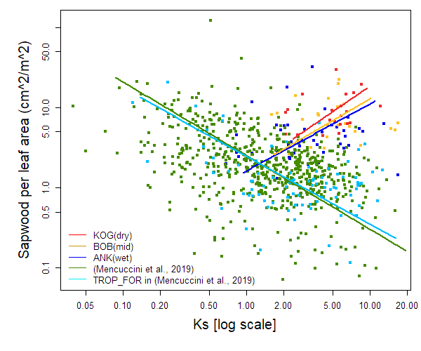

*Figure S1 The correlation between Huber value (AS/AL) and xylem hydraulic conductivity, compared with other studies (REF). Please note that the xylem hydraulic conductivity here mix measurement (e.g., Sperry et al., 1988) and estimation from vessel measurements (e.g., Hagen–Poiseuille equation);Chart, bar chart
*