Methods: Data

The data used for gapfilling was really bad, I compared those two datasets with the observations:

ERA5 daily
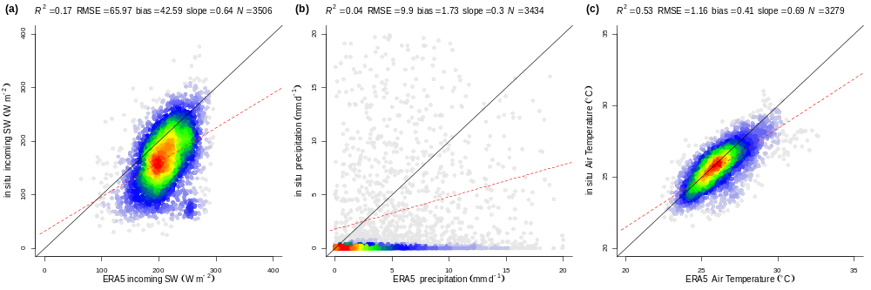

Terraclim monthly
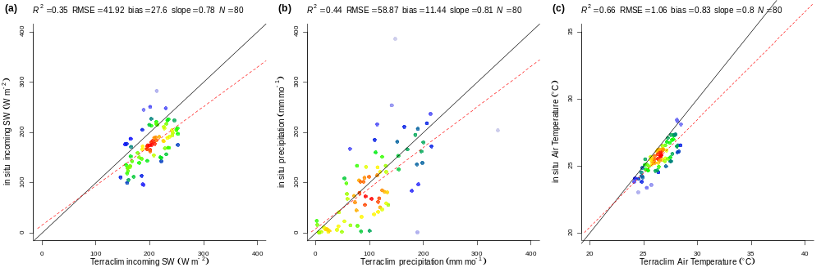
Climate:
At the end I used measured data, gapfilled only within the monitoring period with ERA5, so the time-ranges I used were:
Ankasa: 2011-2014
Bobiri: 2012-2016
Kogyae: 2013-2016

Terrain:
Root zone was assumed 2m, upslope drainage area, slope inclination and orientation were extracted from (Yamazaki et al., 2019)

Methods: Simulation protocol

Simulations were done with SPLASH v2.0 (IDK which one you want to cite here, the manuscript in preparation, my thesis – which should be online soon- or the webpage of the package https://github.com/dsval/rsplash). The climate data was used for each location (Ankara, Bobiri and Kogyae) while the soil and terrain data were used for each plot. The aridity metric used was the ratio of annual potential evapotranspiration (PET) to mean annual precipitation (MAP). The relative soil moisture saturation (Θ) was defined as the volumetric water content (θ) normalized by the volumetric water content at saturation (θ_{SAT}). A vegetation water stress index (α) was estimated as the ratio of annual actual evapotranspiration (AET) to PET.

Results

The values of the aridity index PET/MAP show a clear aridity gradient from Ankara, the less arid, where PET is around 60% of MAP, moving to Bobiri where PET exceeds MAP by ~12%, and reaching Kogyae where PET exceeds MAP by ~25%. The same aridity gradient is observed with the VPD, whose standard deviation also suggests that in the same gradient the seasonality is weaker in Ankara and increases its strength towards Kogyae.

On the other hand, the simulations of Θ and α show that Bobiri is the less stressed site, followed by Ankasa and Kogyae. Here the plot BOB-02 showed the highest values in these two metrics. The plot ANK-03 showed the highest runoff, capturing in some degree the seasonal flooding.

Discussion

The different patterns of Θ and α with respect to PET/MAP seem to be caused by the soil characteristics which in turn define the water holding capacity (WHC) and the hydraulic conductivity. i.e. the plots in Bobiri are atmospherically dryer than in Ankasa but they can hold more water. Here, in BOB-02 the hydraulic conductivity (60 mm/hr), which is less than half of the average, seems to be enhancing this effect by reducing the infiltration rate and forcing the water to stay more time in the root zone while percolating. This phenomenon seems to act as a buffer against the evaporative demand, maintaining water availability during dry months.

*Notes
Here I call the dryness index (PET/MAP) aridity index, just to be consistent with the terminology of the manuscript. I found in the literature aridity index most commonly defined as MAP/PET, please, feel free to change the nomenclature or to use the usual aridity MAP/PET (which to me is counter intuitive, higher values of this index means a site is wetter MAP>PET)

