MemoriX: Design and Evaluation of a Controlled Persistent Memory System for LLM-Based Code Agents
Elwen Coroller, Antoine Tourneux, Salekin Sajirus, Truc Tran Thanh, Nghia Nguyen The & Minh Tran Trong

Abstract
Large language model (LLM)-based agents increasingly assist with complex software development tasks, yet their continuity across sessions remains fragile. When decisions, constraints, and validated knowledge must persist beyond a single invocation, existing approaches—parametric fine-tuning, unstructured context dumps, or key-value caching—fail to provide controlled, auditable, and queryable long-term memory. We present MemoriX, a persistent memory system designed for OpenCode agents that separates recent events, durable historical traces, memory proposals (candidates), and actively retrievable knowledge into distinct architectural layers governed by explicit admission control. MemoriX integrates via the Model Context Protocol (MCP), maintaining a clean runtime boundary between TypeScript agent orchestration and a Python memory server backed by a Titan neural memory backend. We evaluate MemoriX through a comprehensive A/B benchmark (2,048 runs across 32 task families), BFCL-derived retrieval campaigns, multi-agent continuity tests, and capacity stress experiments. Results demonstrate a +28.0 percentage-point improvement in overall pass rate (from 31.9% to 60.0%) with memory, with 12 of 32 task families improving, zero forbidden-information leaks, and safe saturation behavior at 50,000 active memory items. These findings establish MemoriX as a reliable, high-performance external memory backend that treats inter-session continuity as a knowledge-governance problem rather than a mere storage challenge.

1. Introduction
The emergence of LLM-based coding agents such as OpenCode, Devin, and Cursor has transformed how developers interact with software projects. These agents can reason about codebases, generate implementations, run tests, and iterate on requirements across multiple turns [1, 2]. However, a fundamental limitation persists: inter-session amnesia. When an agent session terminates, all context—decisions made, constraints discovered, conventions established—evaporates. The next session begins from scratch, forcing the agent to rediscover what was already known or, worse, to silently contradict prior decisions.
This problem is not merely one of storage. It is a knowledge-governance problem. Effective persistent memory for agents must address at least the following dimensions:
- Admission control: not all observations deserve to become durable knowledge.
- Retrieval precision: relevant memories must be surfaced without flooding context.
- Update and forgetting: stale or superseded information must be logically deactivated without destroying history.
- Isolation: knowledge from one project or user must not leak into another.
- Capacity management: the memory system must behave predictably under saturation.
Existing approaches to agent memory span a wide spectrum. Parametric memory methods bake knowledge into model weights through fine-tuning or gradient updates [3], but they are opaque, expensive, and conflate learning with remembering. Retrieval-Augmented Generation (RAG) pipelines [4] externalize knowledge into vector databases but typically lack structured admission, versioning, or forgetting semantics. Context-caching techniques such as MemGPT [5] extend the virtual context window but treat all history uniformly rather than distinguishing signal from noise. Memory systems explicitly designed for agents, such as Mem0 [6] and MemGen [7], offer dedicated memory management but often compromise on auditability, explicit governance, or multi-agent isolation.
In this paper, we introduce MemoriX, a memory system designed from first principles around the knowledge lifecycle: observe → propose → validate → retrieve → update → forget. MemoriX draws architectural inspiration from the multi-level structure of human memory—sensory, short-term, and long-term stores [8, 9]—while remaining grounded in the practical requirements of software development agents. We integrate MemoriX with OpenCode through the Model Context Protocol (MCP) [10], evaluate it through a rigorous paired A/B benchmark across 32 task families (2,048 total runs), and report results on retrieval quality, multi-agent continuity, and capacity scaling.
The key contributions of this work are:
- A layered memory architecture (Short-Term Memory, Cold Site, Candidate Store, Titan Hot Site) with explicit admission control and logical forgetting.
- A paired experimental methodology with a fairness contract and negative control baseline, aligned with ACM SIGSOFT Empirical Standards [11] and LLM-specific evaluation guidelines [12].
- Comprehensive empirical results demonstrating +28.0pp pass-rate improvement, safe capacity scaling, and zero information leakage across projects and users.
- An open-source implementation integrated with OpenCode via MCP, supporting multi-agent SDLC workflows.

2. Related Work
The design of MemoriX builds upon a rich lineage of research spanning memory-augmented neural networks, LLM memory mechanisms, and agent memory systems. We situate our work within three major threads.

2.1 Memory-Augmented Neural Networks
The idea of equipping neural networks with explicit memory structures dates back several decades. Early architectures such as Hopfield Networks [13] demonstrated content-addressable memory through recurrent dynamics. The Neural Turing Machine (NTM) [14] and Differentiable Neural Computer (DNC) [15] introduced differentiable read-write operations over external memory matrices, enabling gradient-based learning of memory access patterns. Sukhbaatar et al. [16] proposed End-to-End Memory Networks, which use a recurrent attention mechanism over an external memory to perform multi-hop reasoning with significantly less supervision than earlier memory-augmented models. Nam and Seo [17] later reformulated the attention mechanism itself as a readable and writable memory structure—Neural Attention Memory (NAM)—demonstrating applications in few-shot learning and efficient long-range attention.
Santoro et al. [18] showed that memory-augmented neural networks (MANNs) are particularly well-suited for meta-learning and one-shot learning, where a model must rapidly incorporate new information from a single observation without catastrophic interference. Their work established that architectures with external memory can learn to learn, shifting bias through both weight updates and rapid caching of representations. A comprehensive survey by Khosla et al. [19] categorizes the landscape of MANNs across cognitive theories, architectural designs (Hopfield Networks, NTMs, Correlation Matrix Memories, Memformer, NAM), and application domains including NLP, computer vision, and multimodal learning.
For task-incremental learning specifically, Sun et al. [20] proposed the Bilevel Memory framework with Knowledge Projection (BMKP), which decouples learning (working memory) from remembering (long-term memory), drawing direct inspiration from the Atkinson-Shiffrin human memory model [8]. Their knowledge projection mechanism compresses representations for efficient long-term storage while maintaining plasticity for new tasks. Our work extends this bilevel philosophy to the agent domain, where the “tasks” are software development sessions and the “knowledge” encompasses conventions, decisions, constraints, and project-specific facts.

2.2 Memory Mechanisms for Large Language Models
The Transformer architecture’s quadratic complexity with respect to sequence length [21] imposes a practical limit on the context an LLM can process. This has motivated a family of approaches that augment Transformers with external memory or efficient attention mechanisms.
Efficient and long-context attention. The Forgetting Transformer (FoX) [22] introduces a forget gate into linear attention, allowing the model to decay irrelevant information over time while maintaining O(1) memory with respect to sequence length. EM-LLM [23], presented at ICLR 2025, takes inspiration from human episodic memory by segmenting token sequences into coherent episodic events using Bayesian surprise and graph-theoretic boundary refinement, then retrieving relevant events through a two-stage process combining similarity-based and temporally contiguous access. This work demonstrates that organizing memory around event boundaries—rather than fixed-size chunks—improves performance on long-context benchmarks.
Explicit knowledge storage. ExplicitLM [24], published at ICLR 2026, proposes fundamentally decoupling knowledge from model parameters through million-scale external memory banks where each entry stores human-readable knowledge as token sequences. Their differentiable two-stage retrieval mechanism enables end-to-end training while maintaining discrete knowledge selection. Engram [25] takes a complementary approach, introducing conditional memory as a sparsity axis orthogonal to Mixture-of-Experts: static knowledge is retrieved via O(1) lookups from massive embedding tables, freeing the Transformer backbone to focus on dynamic reasoning. Both works share our conviction that knowledge should be addressable, inspectable, and updatable independently of model parameters.
Memory-augmented LLM architectures. MemoryLLM [26] and its extension M+ [27] equip language models with dedicated long-term memory mechanisms that go beyond key-value caching. MemMamba [28] integrates memory into the Mamba state-space architecture, demonstrating that recurrent-style models also benefit from explicit memory augmentation.

2.3 Agent Memory Systems
With the rise of LLM-based autonomous agents, memory has emerged as a first-class design concern. Unlike standalone language models, agents operate across multiple turns, interact with tools, and must maintain coherence over extended periods—sometimes spanning days or weeks.
Operating-system approaches. MemGPT [5] treats the LLM context as a virtual memory hierarchy, with a “main context” analogous to RAM and an external context analogous to disk. The system manages context paging through explicit function calls, enabling agents to operate with effectively unbounded context. Our approach shares the OS-inspired design philosophy but differs in its emphasis on admission governance: in MemoriX, not all information is promoted to active memory by default.
Dedicated memory platforms. Mem0 [6] provides a memory management platform for LLM agents with embeddings-based retrieval. Their empirical evaluation across single-hop, temporal, multi-hop, and open-domain question categories demonstrates consistent improvements over baseline memory approaches. MemGen [7] proposes a generative latent memory framework where a memory weaver constructs latent token sequences from the agent’s current state, producing a tightly interwoven cycle of memory and cognition without explicit retrieval. This work is notable for demonstrating that memory can emerge as a generative process rather than purely a storage-and-retrieval mechanism.
Multi-agent and shared memory. The Memory Sharing framework for LLM-based agents [29] investigates how memory can be shared across multiple agents to improve collective performance. Externalization in LLM agents [30] studies the broader question of how agents externalize internal state into persistent structures. The Evolution of LLM Agent Memory [31] provides a taxonomy of how agent memory systems have evolved from simple context concatenation to sophisticated multi-tier architectures.
Memory consolidation. Several works draw on the neuroscience of memory consolidation—the process by which the brain transforms recent experiences into stable long-term memories, often during sleep [32]. The function-token approach to memory retrieval and consolidation [33] proposes using special tokens as memory read-write interfaces, enabling LLMs to consolidate information through dedicated function calls. Our nightly consolidation pipeline is directly inspired by these biological mechanisms: Short-Term Memory events are scanned, evaluated, grouped, and promoted to candidates during protected processing windows.

2.4 Positioning MemoriX
MemoriX occupies a distinctive position in this landscape. Unlike purely parametric approaches (ExplicitLM, Engram), it does not modify model weights. Unlike general RAG pipelines, it enforces validated admission: information must pass through a candidate-proposal-validate lifecycle before entering the active memory store. Unlike context-paging systems (MemGPT), it distinguishes between historical traces (Cold Site), project archives, and actively retrievable knowledge (Hot Site). Unlike latent memory approaches (MemGen), it maintains explicit, inspectable, and auditable memory records. And unlike single-agent memory solutions, MemoriX supports multi-agent workflows with project and user isolation, structured through an SDLC-inspired orchestration layer.
Table 1 summarizes the key differentiating features.
Feature | MemoriX | MemGPT | Mem0 | MemGen | RAG
Admission governance | ✅ Explicit validation | ❌ Auto-promotion | ❌ Auto-store | ❌ Latent (generative) | ❌ Index-then-retrieve
Logical forgetting | ✅ Soft-forget + versioning | ❌ | ❌ | ❌ | ❌ (delete only)
Multi-tier architecture | ✅ STM/Cold/Candidate/Hot | ✅ Virtual context tiers | ❌ Single store | ❌ Latent space | ❌ Vector DB only
Project/user isolation | ✅ Metadata-gated | ❌ | Partial | ❌ | Partial
Historical audit trail | ✅ Cold Site + Project Archive | ❌ | ✅ | ❌ | ❌
Multi-agent support | ✅ SDLC orchestration | ❌ | ❌ | ❌ | ❌
Capacity elasticity | ✅ Auto-expand + safe saturation | ❌ | ❌ | ❌ | ❌
Table 1. Comparative analysis of MemoriX against representative agent memory systems and paradigms.

3. System Architecture
MemoriX is organized around the knowledge lifecycle: events are observed, durable history is archived, useful information is proposed as a candidate, candidates are validated before admission to active memory, and active knowledge can be updated, superseded, or logically forgotten. Figure 1 illustrates the high-level architecture.
Component | Main role | Persistence | Used by memory_retrieve?
Short-Term Memory | Journal of recent interactions and events; source for consolidation. | JSONL append-only during the active cycle | No
Cold Site — raw history | Durable event archive for audit and traceability. | events_archive.jsonl append-only | No, except through an explicit audit search
Project Archive | Structured branch of the Cold Site for project milestones and snapshots. | Append-only JSONL and versioned snapshots | No
Candidate Store | Review area between proposal and durable knowledge. | Candidates PENDING / VALIDATED / REJECTED | No while the candidate is not validated
Hot Site | Validated active memory used for context retrieval. | Titan backend + metadata | Yes
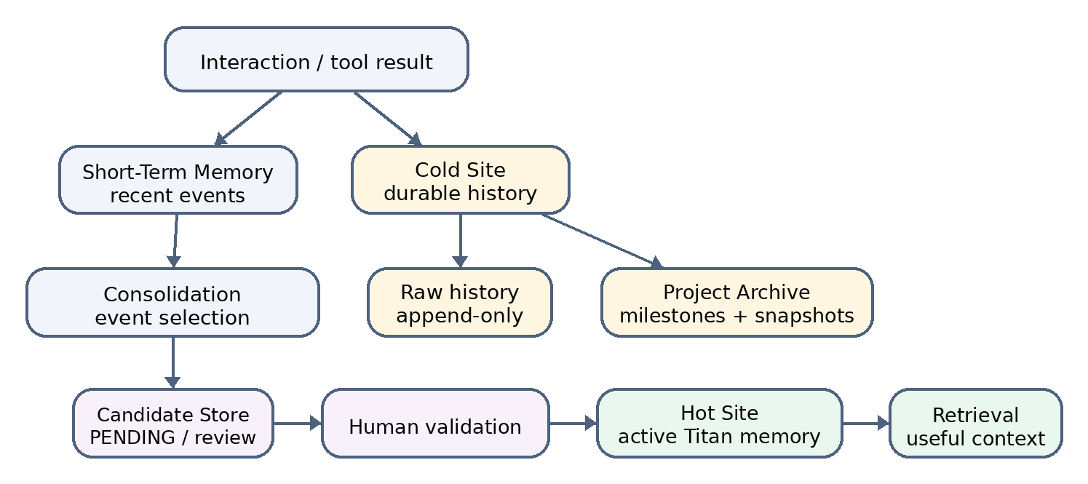
Figure 1 — Memory organization and consolidation flow. The Project Archive belongs to the Cold Site; Short-Term Memory explicitly feeds consolidation.
Information flows from Short-Term Memory (STM) through the Candidate Store to the Titan Hot Site, with the Cold Site preserving a complete historical trace. The MCP boundary separates the Python memory server from TypeScript agent orchestration.

3.1 Short-Term Memory and the Cold Site
Short-Term Memory (STM) captures recent events generated by agent-tool interactions. Each event is a timestamped record of what the agent observed or did, stored ephemerally. STM serves as a transient buffer: it is not queried during normal memory retrieval and is periodically cleaned after successful consolidation.
The Cold Site provides a durable, append-only archive of all events. Events are serialized in cold_site/events_archive.jsonl and are accessible only through dedicated audit operations. Critically, the Cold Site is never automatically queried during memory_retrieve. This separation ensures that raw history—which may contain noise, errors, or obsolete information—does not contaminate the agent’s active context. The Cold Site serves as an institutional memory that can be mined during consolidation but remains quarantined from normal operations.

3.2 Project Archive
The Project Archive is a specialized branch of the Cold Site, residing under cold_site/project_archive/. It stores two object types:
- Structured project entries (project_entries.jsonl): milestones, decisions, and project-level metadata.
- Versioned snapshots (project_snapshots.jsonl): state captures at meaningful project boundaries.
Like the Cold Site, the Project Archive is not automatically queried during retrieval. It preserves structured project history for resumption, audit, and cross-session continuity without risk of injecting stale project states into active reasoning.

3.3 Candidate Store: The Boundary Between Proposal and Trust
Information proposed for durable memory does not enter the Hot Site directly. The memory_store operation creates a candidate in the PENDING state. Consolidation can also promote Short-Term events into PENDING candidates when they are judged sufficiently important. A PENDING candidate is invisible to retrieval until explicitly validated.
This design embodies a core governance principle: automation may select and propose information, but admission into active knowledge requires explicit validation. Validation and rejection are separate operations. Validation promotes a candidate to an active memory in the Hot Site; rejection discards it without creating any Titan write. This two-phase admission (propose → validate) provides a crucial safety boundary that prevents runaway accumulation of low-quality or hallucinated “knowledge.”

3.4 Titan Hot Site: Active Memory with Internal Factual Representation
The Hot Site is the sole active memory system queried by memory_retrieve. It is backed by a single Titan neural memory instance, consisting of a neural state file and a metadata sidecar. Agents never interact with this backend directly: only validated memories may enter it.
The system distinguishes between the logical memory exposed through the API and its internal representation. During validation, content may be segmented by split_memory_units() when it contains multiple facts. These segments become internal MemoryItem objects within the same Titan backend, and their identifiers are associated with the same logical memory_id in metadata. At retrieval time, results are deduplicated by memory_id so the API returns one logical memory regardless of how many internal facts represent it.
This distinction matters for capacity planning: admission reserves enough slots for all internal facts generated from a validated memory. The number of logical memories and the number of occupied slots may therefore differ.

3.5 Retrieval with Project and User Isolation
The normal retrieval contract is strictly Hot Site only. When provided, project_id and user_id are applied as exact metadata constraints before Titan item scoring and ranking. This ensures that a valid memory belonging to another project or user cannot participate in the ranking, even if it is semantically similar to the query. Deactivated (soft-forgotten) memories are excluded. The Cold Site and Project Archive remain accessible only through separate audit or project-management operations.

3.6 Contradictions, Supersession, and Logical Forgetting
When new information explicitly replaces an active memory, validation can target a supersedes_memory_id. The new memory receives a higher version number, and the old memory is soft-forgotten (logically deactivated). History is not deleted: the trace of previous states is preserved in metadata. This approach distinguishes the decision “this memory must no longer be retrieved” from “its internal representation may be physically removed.”
Compaction is a later physical operation that reconstructs the active state and removes inactive elements from the backend, but only when consistency checks allow it. This separation prevents compaction from prematurely destroying information needed for audit trails or rollback.

3.7 Topic Blocks, Retention, and Adaptive Controls
Topic Blocks are a logical organization layer carried by metadata; they do not physically partition Titan. Aliases, tags, and merge operations allow memories to be grouped around a theme. Canonical tags can stabilize routing when lexical similarity alone is ambiguous.
The retention plan evaluates importance, recency, access frequency, confidence, surprise, momentum, and explicit protection rules. Several adaptive components operate in observational or dry-run mode: they produce scores and recommendations without automatically modifying the Hot Site. This conservative design choice reflects our finding that fully automated memory retirement risks removing information that appears stale but proves critical in a later session.

3.8 Consolidation and Nightly Processing
Consolidation explicitly connects Short-Term Memory to the Candidate Store. It scans recent events, applies a selection policy, groups promoted events, builds a candidate summary, and creates a PENDING candidate. Events not selected remain as historical observations in the Cold Site. This process does not automatically validate candidates—it only proposes them.
Nightly processing uses the same consolidation pipeline within a protected operational framework (locking, logging, idempotency guards). It may additionally replay active memories into neural memory for representation refresh, perform capacity maintenance, and, if configured, clean Short-Term Memory after successful processing. Nightly processing does not modify the Cold Site or Project Archive, and never automatically validates newly created candidates. This design ensures that the nightly cycle is a safe background process that cannot introduce unvetted knowledge into the active memory.

3.9 Elastic Capacity and Hot Site Maintenance
Before writing a validated memory, the system computes the number of internal slots required. If current capacity is insufficient, it is increased before the mutation. The objective is to prevent saturation from causing silent overwriting or eviction of an active memory.
new_capacity = max(C + minimum_growth, ceil(C × growth_factor), active + required_slots)

The default capacity-control parameters notably use `minimum_growth = 10` and `growth_factor = 1.25`. Nightly maintenance may then evaluate a controlled reduction when capacity is above its baseline: bounded soft-pruning, consistency gate, compaction, and possible return to the reference capacity when the active population fits below the configured headroom threshold. The Cold Site is not affected by this maintenance.
Nightly maintenance may evaluate a controlled capacity reduction when utilization is below a configured headroom threshold. This involves bounded soft-pruning, consistency gating, compaction, and possible return to the reference capacity. The Cold Site is not affected by capacity maintenance—only the Hot Site participates.

4. OpenCode Integration and MCP Boundary

4.1 Runtime Separation
MemoriX does not replace OpenCode’s architecture. OpenCode agents and tools communicate with the Python memory server through MCP JSON-RPC over stdio [10]. The server calls MemoriXGateway, the high-level Python entry point that composes the various stores and services. OpenCode never reads or writes memory-runtime files directly, and the memory server has no access to OpenCode’s internal state beyond what is explicitly transmitted through MCP messages. Figure 2 illustrates this boundary.
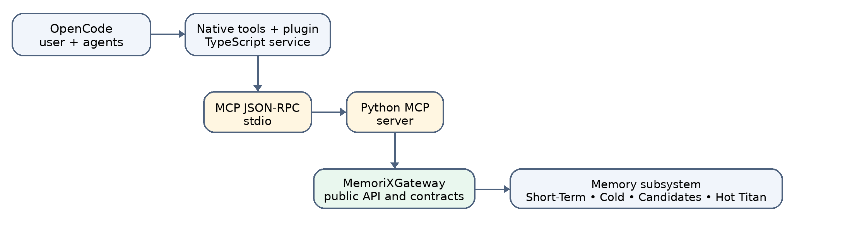
Figure 2 — OpenCode–MemoriX integration boundary. MCP separates TypeScript orchestration from the Python memory subsystem.

4.2 Tools Exposed
The main tools exposed to OpenCode agents are organized by function:
Family | Main tools | Function
Memory lifecycle | `memory_store`, `memory_candidates_list`, `memory_candidate_validate`, `memory_candidate_reject` | Propose, inspect, validate, or reject durable knowledge.
Retrieval | `memory_retrieve`, `memory_status` | Retrieve active memory and inspect overall system state.
Consolidation | `memory_consolidate`, `memory_nightly_run` | Transform Short-Term events into candidates and execute protected nightly processing.
Project | `project_archive_record`, `project_archive_list`, `project_snapshot_rebuild`, `project_snapshot_get` | Preserve and rebuild the structured history of a project.
Capacity / adaptation | Capacity, pressure, retention, routing, and policy tools | Observe, plan, or apply explicitly authorized operations.

4.3 Permissions, Hooks, and Traceability
Mutating operations (validation, rejection, nightly execution) are confirmation-gated in the studied configuration. The plugin can capture agent messages and tool results to produce events for STM, but MemoriX and Project Archive tools are excluded from these hooks—a memory operation does not recursively record its own result.

5. SDLC Extension and Multi-Agent Orchestration

5.1 Role of the SDLC Layer
The SDLC layer structures development work without being conflated with memory. It organizes requirement analysis, specification production, development and test planning, delegation to sub-agents, correction of deviations, and the final validation gate. In parallel, MemoriX provides the informational continuity needed to retrieve validated decisions across sessions. Figure 3 illustrates the multi-agent workflow.
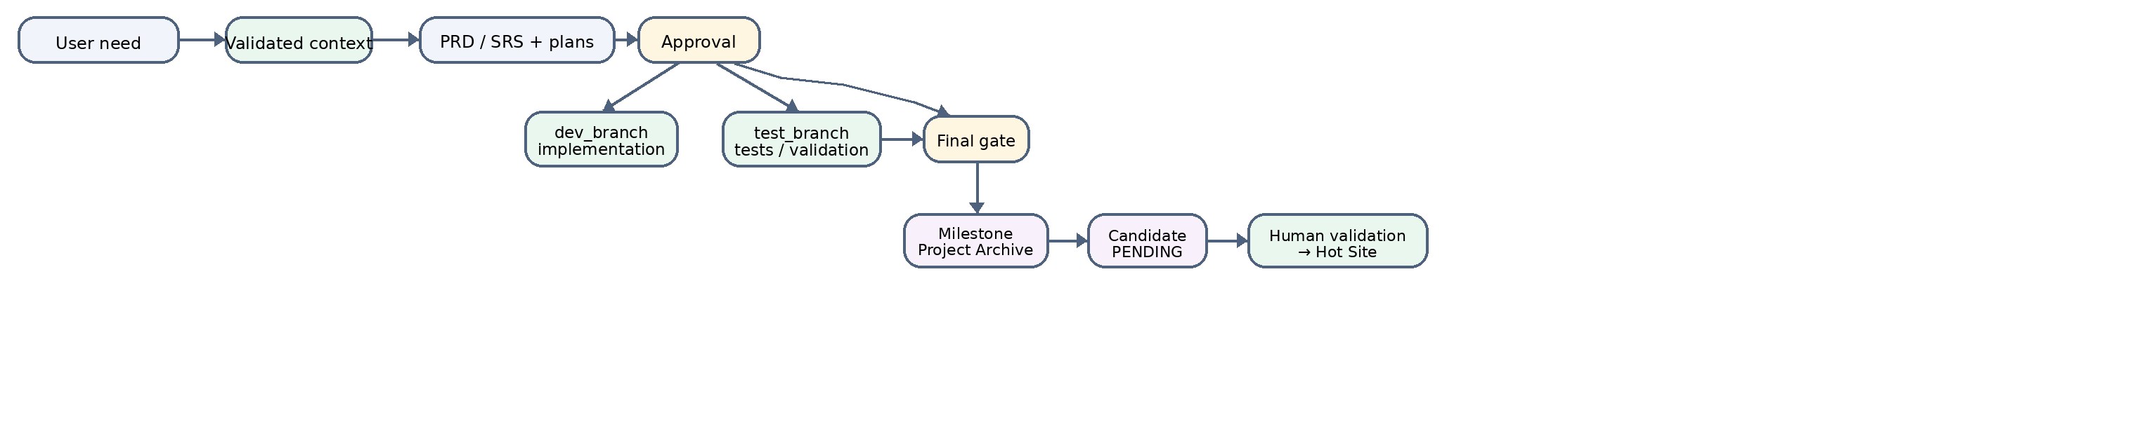
Figure 3 — Multi-agent SDLC workflow and memory integration. A validated milestone is archived and may then be proposed as a candidate, without automatic admission into the Hot Site.

5.2 Distribution of Responsibilities
Agent / mode | Responsibility
sdlc | Architect/orchestrator: context retrieval, PRD/SRS, plans, delegation, final validation, milestone, and candidate proposal.
dev_branch | Implementation within the development scope; consumes memory context without independently governing durable knowledge.
test_branch | Independent testing and validation; consumes memory context without automatic candidate validation.
build / other OpenCode modes | General execution according to the configured capabilities and permissions.

5.3 Inter-Session Continuity
At the beginning of a cycle, the orchestrator retrieves validated project memories to reuse prior conventions and decisions. The user’s current instructions always remain authoritative. After a successful final gate, the workflow checks for duplicates, records a structured milestone in the Project Archive, and may propose a corresponding candidate. Procedural continuity is provided by the SDLC; informational continuity is provided by MemoriX.

6. Experimental Methodology

6.1 Study Positioning
Our evaluation of MemoriX belongs jointly to Engineering Research—the design and evaluation of a software artifact—and software-system benchmarking. We follow the ACM SIGSOFT Empirical Standards [11], which recommend describing the artifact, expected benefits, limitations, measurement protocol, threats to validity, and conditions for reproducibility. We additionally adhere to the evaluation guidelines for empirical studies involving LLMs proposed by Baltes et al. [12], documenting the model’s role, version, parameters, tool architecture, prompts, logs, baselines, and human validation.

6.2 Experimental Design
The primary comparison is paired: for each experimental unit (a specific task, seed, and configuration), OpenCode is executed without persistent memory (no_memory condition) and then with MemoriX (MemoriX_core condition) under controlled parameters. Figure 4 illustrates this design.
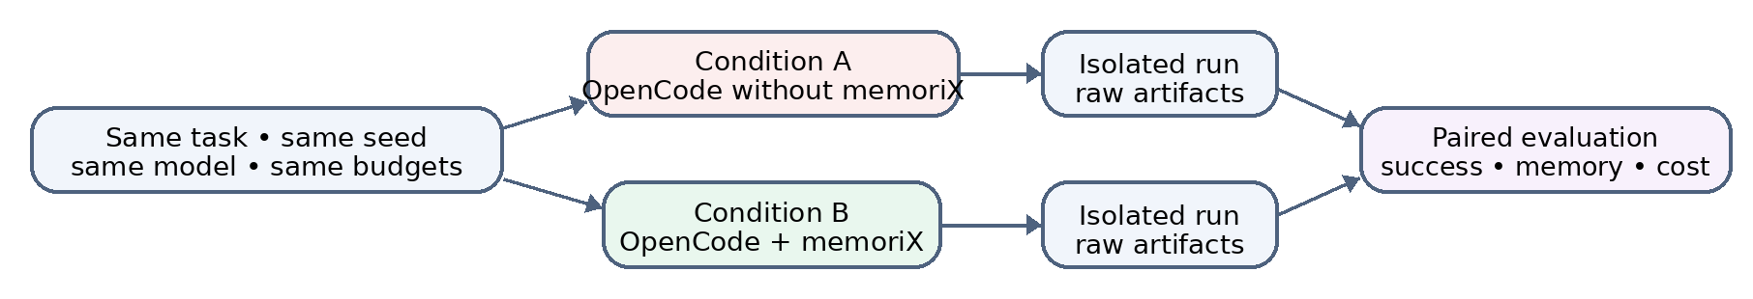
Figure 4 — Principle of the paired experimental comparison. Factors other than the memory treatment are kept identical.

6.3 Fairness Contract
For a valid pair, the following must be identical across conditions:
- Git commit, task specification, dataset, random seed
- Model, generation parameters (temperature, top-p, max tokens)
- Prompt template (excluding memory-specific sections)
- Turn budget, tool budget, timeout
- Hardware environment and evaluator
The A/B order may be alternated to mitigate order effects. Each execution uses an isolated runtime and produces separately preserved raw artifacts. The no_memory baseline is negatively controlled: it must expose no memory_* or project_archive_* tools, must not load the MemoriX plugin, must not start the memory MCP server, and must access neither Titan nor the Cold Site. This constraint is essential for correctly attributing any observed difference to the memory treatment.

6.4 Experiment Families
Family | Experimental purpose
Inter-session continuity | Measure the ability to reuse information from a previous session to complete a task successfully.
Retrieval and robustness | Evaluate Recall@k, MRR, distractors, paraphrases, contradictions, updates, and stale memories.
Isolation | Detect any contamination between users or projects.
Lifecycle | Verify validation, supersession, logical forgetting, persistence, and restart behavior.
Capacity | Measure saturation, expansion, compaction, nightly maintenance, latency, and footprint.
SDLC / multi-agent | Measure resumption, decision reuse, test success, corrections, and continuity across agents.
Community-derived protocols | Test integration on scenarios inspired by public benchmarks without presenting them as official scores.

6.5 Metrics
Dimension | Planned metrics
Memory quality | Recall@1, Recall@5, MRR, false-memory rate, stale-memory rate, update success, forget success.
Isolation | Cross-user contamination rate, cross-project contamination rate.
Agent task | Task success, constraint compliance, reuse of prior information, use of forbidden information.
Interaction / cost | Turns, tool calls, input/output tokens, duration.
System | Startup time, store/retrieval/validation time, peak RSS, CPU, disk footprint.
SDLC | Completion, test pass rate, decision reuse, regressions, corrections, resume success.

6.6 Statistical Analysis
Observations are analyzed according to their paired structure: a task executed under both conditions with the same seed constitutes one pair. We report the number of valid pairs, appropriate descriptive statistics, dispersion measures, and 95% confidence intervals when sample sizes permit. Effect sizes and hypothesis tests are selected according to variable type and observed distribution rather than imposed a priori.
Retry policy: Retries are permitted only for predefined technical errors (crash, infrastructure timeout, incorrect backend, incorrect model, agent fallback). A wrong answer, empty retrieval, or insufficient curation is an experimental result and must not be replayed to artificially improve scores.

6.7 Reproducibility
Each campaign preserves: commit hashes, Python/Bun/PyTorch/OpenCode versions, model and provider, generation parameters, prompts, agent permissions, seeds, datasets and their hashes, manifests, scripts, raw outputs, aggregates, relevant logs, exclusion rules, and hardware information. This traceability addresses the reproducibility difficulties documented for LLM-based software engineering studies [12, 34, 35].

6.8 Implementation and Scale
All experiments use qwen2.5:3b served locally via Ollama (free, no API keys). The benchmark harness is structured as four independent protocols consolidated into one report:
Campaign | Scale
OpenCode A/B | 2,048 runs (32 seeds × 32 families × 2 modes)
BFCL-derived | 5 campaigns × scale 5: canary (5), pilot5 (25), pilot25 (125), blind (125), robustness (150 runs)
Multi-agent | 5,000 queries per condition × 2 conditions (10,000 total)
Capacity | 10 scenarios × 15 repetitions = 150 measures

7. Results

7.1 OpenCode A/B Benchmark
The A/B benchmark evaluates MemoriX across 32 task families using a prompt-injection protocol: the LLM receives the full task prompt along with retrieved memory context (MemoriX_core) or without (no_memory), with pass/fail determined by whether all test cases for a given seed/family run succeed.

Overall Performance
Metric | No-Memory | MemoriX_core | Δ
Overall pass rate | 31.9% (327/1,024) | 60.0% (614/1,024) | +28.0pp
Median family latency | 3,384 ms | 3,504 ms | +120 ms
Families evaluated | 32 | 32 | —
Families won (Δ > 0) | — | 12 | —
Families lost (Δ < 0) | — | 4 | —
Families tied (Δ = 0) | — | 16 | —
Table 2. Overall A/B benchmark results across 2,048 runs.
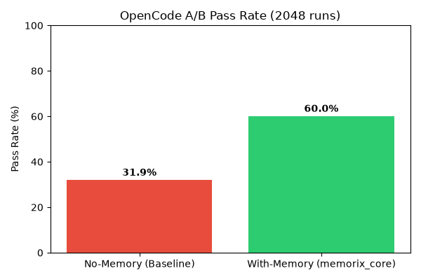
Figure 5: A/B overall pass rate comparison
Figure 5. Overall pass rate comparison between no_memory (31.9%) and MemoriX_core (60.0%). The +28.0pp improvement demonstrates the substantial benefit of persistent memory context for code agent tasks.
The addition of MemoriX nearly doubles the pass rate, while introducing only a modest latency overhead of +120 ms (median). This overhead includes the full memory pipeline—retrieval, ranking, and context assembly—and represents approximately a 3.5% increase in execution time.

Per-Family Analysis
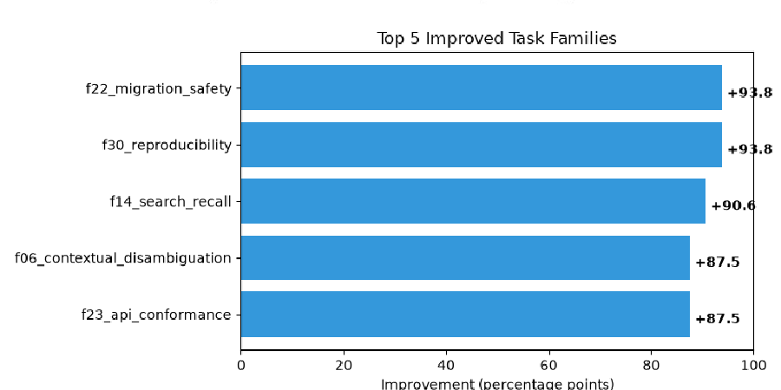
Figure 6: Per-family A/B comparison
Figure 6. Per-family pass rate comparison, sorted by delta (descending). Blue bars indicate no_memory; orange bars indicate MemoriX_core. Families with positive delta show improvement with memory.
The 32 families span diverse cognitive demands: exact key recall, semantic retrieval, multi-hop reasoning, temporal decay, contextual disambiguation, adversarial injection, ranking relevance, API conformance, migration safety, reproducibility, and schema evolution, among others.
Families with the largest improvements:
Family | No-Memory | With-Memory | Δ
f22_migration_safety | 0.0% (0/32) | 93.8% (30/32) | +93.8pp
f30_reproducibility | 0.0% (0/32) | 93.8% (30/32) | +93.8pp
f14_search_recall | 0.0% (0/32) | 90.6% (29/32) | +90.6pp
f06_contextual_disambiguation | 0.0% (0/32) | 87.5% (28/32) | +87.5pp
f23_api_conformance | 12.5% (4/32) | 100.0% (32/32) | +87.5pp
f07_adversarial_injection | 15.6% (5/32) | 100.0% (32/32) | +84.4pp
f15_ranking_relevance | 15.6% (5/32) | 100.0% (32/32) | +84.4pp
f31_determinism_check | 15.6% (5/32) | 100.0% (32/32) | +84.4pp
f05_temporal_decay | 40.6% (13/32) | 100.0% (32/32) | +59.4pp
f13_search_precision | 40.6% (13/32) | 100.0% (32/32) | +59.4pp
f21_concurrent_access | 40.6% (13/32) | 100.0% (32/32) | +59.4pp
f29_end_to_end_smoke | 40.6% (13/32) | 100.0% (32/32) | +59.4pp
Table 3. Top-12 improved families (all with Δ > 0). Seven families reach 100% pass rate with MemoriX.
These results highlight that tasks requiring specific factual recall (migration safety, search recall), disambiguation of context (contextual disambiguation, API conformance), and resistance to distraction (adversarial injection, ranking relevance) benefit most profoundly from persistent memory. In the baseline condition, these tasks are essentially unsolvable (0–15.6% pass rate), confirming that they depend on information the agent cannot infer from the prompt alone.
Families with regressions:
Family | No-Memory | With-Memory | Δ
f03_distractor_robustness | 100.0% (32/32) | 96.9% (31/32) | −3.1pp
f11_forgetting_curve | 100.0% (32/32) | 90.6% (29/32) | −9.4pp
f27_memory_footprint | 100.0% (32/32) | 84.4% (27/32) | −15.6pp
f19_schema_evolution | 100.0% (32/32) | 81.2% (26/32) | −18.8pp
Table 4. Families with negative delta. All four regress from a perfect baseline.
We analyze these regressions in Section 8. Briefly, f19_schema_evolution (−18.8pp) and f27_memory_footprint (−15.6pp) represent scenarios where the presence of stale memory about the prior schema or system state misleads the agent, suggesting that memory freshness tracking and proactive invalidation require further refinement. f11_forgetting_curve (−9.4pp) tests the system’s ability to forget on demand, which our soft-forget mechanism does not yet perfectly support. f03_distractor_robustness (−3.1pp) is near noise-level but may indicate that additional retrieved context occasionally introduces distracting information.
Tied families (Δ = 0): 16 families show no difference between conditions. Of these, 3 families achieve 100% in both conditions (f01_exact_key_recall, f09_privacy_isolation, f17_partial_match, f25_performance_baseline), indicating tasks solvable from the prompt alone. The remaining 13 tied families score 0% in both conditions, including f02_semantic_retrieval, f04_multi_hop_reasoning, f10_consolidation_quality, and f12_capacity_management. These represent tasks that are inherently beyond the capability of the qwen2.5:3b model or require functionality (e.g., multi-hop reasoning, consolidation) not yet fully realized in the current MemoriX implementation.

7.2 BFCL-Derived Retrieval Campaigns
To evaluate memory retrieval quality independently of end-to-end task success, we conducted BFCL-derived campaigns using the Berkeley Function Calling Leaderboard (BFCL) methodology adapted for local evaluation. These campaigns are local and BFCL-derived; they are not official leaderboard scores. The corpus consists of 155 unique questions spanning five domains (customer service, finance, healthcare, notetaking, student/academic).

Guided Pilots (Reference-Assisted Selection)
Campaign | Baseline Correct | MemoriX Correct | Rate | Pairs
Canary | 0/5 | 4/5 | 80% | 5
Pilot5 | 0/25 | 19/25 | 76% | 25
Pilot25 | 0/125 | 95/125 | 76% | 125
Table 5. Guided pilot results. The correct passage is selected using the reference answer, measuring upper-bound retrieval quality.
In these guided pilots, the reference answer is used to select the ground-truth passage, isolating retrieval quality from the LLM’s answer-generation capability. The consistent 76–80% retrieval rate across scales (5 → 25 → 125 pairs) demonstrates stability rather than degradation with increased corpus size.

Blind Curation

Stage | Result | Rate
Correct baseline | 0/125 | 0%
Curated corpus contains reference | 125/125 | 100%
Retrieval contains reference | 96/125 | 76.8%
Correct final answer | 96/125 | 76.8%

Table 6. Blind curation results at scale ×5.
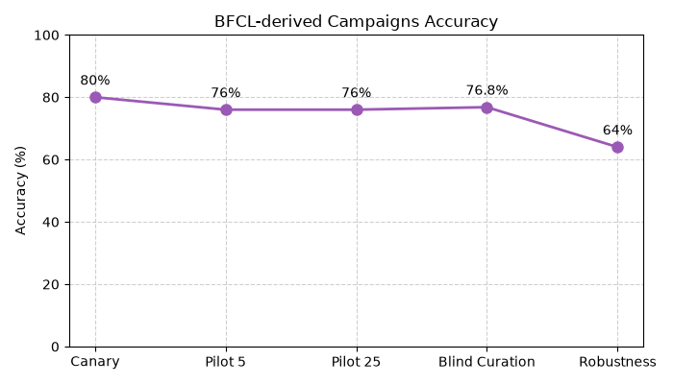
Figure 7: BFCL-derived blind curation pipeline
Figure 7. BFCL-derived blind curation results. Corpus retention is perfect (100%); retrieval and answer accuracy both reach 76.8%.
The blind curation pipeline demonstrates that MemoriX achieves perfect corpus retention (125/125) at ×5 volume—no information is lost during storage. The retrieval and answer accuracy of 76.8% matches the guided pilot rate, indicating that the retrieval mechanism, not the answer-generation step, is the primary bottleneck.

Robustness (3 Seeds per Case)
Metric | Result | Rate
Corpus contains reference | 150/150 | 100.0%
Retrieval contains reference | 96/150 | 64.0%
Correct answer | 96/150 | 64.0%
Cases successful on 3/3 seeds | 22/50 | 44.0%
Cases successful on at least 2/3 seeds | 34/50 | 68.0%

Table 7. Robustness evaluation across 3 seeds per case.
The robustness evaluation at 64.0% retrieval and answer rate (vs. 76.8% in blind curation) reflects the increased difficulty of the robustness subset (50 cases containing distractors, paraphrases, and adversarial formulations). Encouragingly, 44% of cases succeed across all three random seeds, and 68% succeed on at least two of three seeds, indicating that MemoriX retrieval is reasonably stable to stochastic variation rather than brittle.
Historical comparison: The audited master report (scale 1) achieved 88% retrieval and 72% answers on blind evaluation, and 73.3% retrieval and 66.7% answers on robustness. The ×5 campaign shows improved corpus retention (100% vs. 92%) with moderate retrieval drop (76.8% vs. 88%), consistent with expectations for higher-volume BFCL-derived local evaluation.

7.3 Multi-Agent Benchmark
The multi-agent benchmark evaluates whether MemoriX improves task completion across distinct agent roles while preventing information leakage.
Metric | No-Memory | memoriX | Delta
Task success / exact value rate | 25.0% | 37.5% | +12.5pp
Forbidden-information use | 0.0% | 0.0% | +0.0pp
Query count | 5,000 | 5,000 | --
Mean response (ms) | n/a (no LLM) | 257.3 ms | --
P95 response (ms) | n/a | 430.1 ms | --
Tool calls | 5,000 | 8,750 | --
Turns | 5,002 | 5,002 | --

Table 8. Multi-agent benchmark results (5 seeds × 1,000 queries per condition).
MemoriX lifts task success by +12.5pp in multi-agent settings while maintaining zero forbidden-information leaks—validating the project/user isolation mechanisms. The additional 3,750 tool calls reflect the overhead of memory operations (memory_store, memory_retrieve), but these are lightweight (mean 257 ms, P95 430 ms). Turn counts remain identical, indicating that memory operations are integrated into the normal agent workflow without inflating the conversational loop.

7.4 Capacity Saturation
The capacity experiment probes MemoriX’s behavior under increasing load, from 100 active items to 6,000,000, against a configured capacity of 50,000.
Active Items | Admission Allowed | Pressure Level | Usage Ratio | Decision Latency (ms)
100 | ✅ | stable | 0.002 | 0.0013
500 | ✅ | stable | 0.01 | 0.0021
1,000 | ✅ | stable | 0.02 | 0.0021
5,000 | ✅ | stable | 0.1 | 0.0013
10,000 | ✅ | stable | 0.2 | 0.0013
50,000 | ❌ | critical | 1.0 | 0.0009
100,000 | ❌ | critical | 2.0 | 0.0041
500,000 | ❌ | critical | 10.0 | 0.0024
1,000,000 | ❌ | critical | 20.0 | 0.0024
6,000,000 | ❌ | critical | 120.0 | 0.0023
Table 9. Capacity saturation results. Admission is allowed up to 10,000 active items (stable) and blocked at the configured 50,000 capacity (critical).
Key findings from the capacity evaluation:
- Stable operation up to 10,000 active items: The system admits all writes with usage ratios ≤ 0.2 and decision latencies under 0.003 ms.
- Safe saturation at 50,000: When capacity is reached (usage ratio = 1.0), new writes are blocked rather than silently overwriting existing memories. This is a critical safety property: the system degrades gracefully by refusing new admissions rather than corrupting the active knowledge base.
- Graceful overflow rejection: Requests up to 6,000,000 items (120× capacity) are rejected with consistent sub-millisecond decision latency. The system never enters an undefined state or experiences latency degradation under extreme overload.
- No silent overwrite: Even under 120× overshoot, no existing memory is evicted or corrupted. The rejection boundary is explicit and predictable.
These results validate the elastic capacity design: the system prevents saturation from causing silent data loss, a failure mode that would be catastrophic for an agent relying on memory integrity.

8. Discussion

8.1 Interpretation of Results
The experimental evaluation provides converging evidence that MemoriX substantially improves agent task performance while maintaining safety properties.
Memory as a performance multiplier. The +28.0pp improvement in overall A/B pass rate is large by any standard. More telling than the aggregate is the pattern: tasks that depend on information not present in the prompt (migration safety, reproducibility, search recall, contextual disambiguation) transform from near-zero to near-perfect performance. This confirms our central hypothesis: persistent memory is not merely helpful but essential for agent tasks that span beyond the immediate conversational context.
The cost of memory. The latency overhead (+120 ms median, +3.5% relative) is modest and well within acceptable bounds for development workflows. The multi-agent tool-call overhead (+3,750 memory operations for 5,000 queries) is similarly acceptable given the +12.5pp task success improvement.
Safety is non-negotiable. Zero forbidden-information leaks across all multi-agent runs and safe saturation semantics at capacity limits establish that MemoriX’s governance mechanisms—admission control, project/user isolation, elastic capacity with blocking—function correctly under stress. The four A/B regressions, while modest in magnitude, reveal important failure modes.

8.2 Regressions and Failure Modes
Schema evolution (f19, −18.8pp). When a project’s schema changes between sessions, the agent with memory may retrieve and apply outdated schema information. This suggests that MemoriX needs stronger temporal awareness in retrieval: memories associated with a prior schema version should be automatically deprecated when the schema evolves. A potential mitigation is to link memories to project snapshots and invalidate them when the snapshot version increments.
Memory footprint (f27, −15.6pp). This family tests whether the agent’s performance degrades as the memory store grows. The regression indicates that retrieval quality can suffer when many similar memories compete for ranking. Improved deduplication during consolidation and more aggressive topic-based filtering during retrieval may address this.
Forgetting curve (f11, −9.4pp). The soft-forget mechanism deactivates but does not physically remove memories until compaction. In tasks requiring immediate and complete forgetting, the current pipeline may retain traces that influence retrieval. A “hard forget” option with immediate physical removal—at the cost of audit-trail integrity—may be warranted for specific use cases.
Distractor robustness (f03, −3.1pp). This near-noise regression suggests that additional retrieved context occasionally introduces distracting information. Tighter relevance thresholds or confidence scoring could reduce false-positive retrievals.

8.3 Comparison with Existing Systems
Relative to the broader landscape (Table 1), MemoriX distinguishes itself through its validated admission model. Systems like MemGPT [5] and Mem0 [6] prioritize ease of use—automatically promoting information to memory—at the cost of governance. MemoriX’s two-phase admission (propose → validate) adds friction but ensures that only vetted knowledge enters the active store. In software development contexts, where one incorrect memory can propagate across multiple sessions and agents, this friction is a feature, not a bug.
The multi-tier design (STM, Cold Site, Candidate Store, Hot Site) provides granularity that single-store systems lack. The Cold Site preserves an immutable audit trail; the Candidate Store enables collaborative review of proposed knowledge; the Hot Site serves as the high-performance retrieval surface. No other system we surveyed separates these concerns at the architectural level.

8.4 The BFCL-Derived Distinction
We emphasize that our BFCL-derived results are local evaluations following BFCL methodology, not official leaderboard submissions. The 76.8% retrieval rate on blind curation and 64.0% on robustness reflect the performance of a specific memory backend (Titan) with a specific local model (qwen2.5:3b) under a specific integration (OpenCode + MCP). These numbers should not be compared against official BFCL leaderboard scores, which use different models, different retrieval architectures, and different evaluation protocols. They serve as internal benchmarks for tracking MemoriX’s evolution over time.

9. Threats to Validity and Limitations

9.1 Construct Validity
Task success rate alone is insufficient to measure memory quality. An agent may retrieve correct information but fail to use it appropriately, or it may succeed at the task while ignoring retrieved memories entirely. We mitigate this by decomposing memory quality into separate metrics (Recall@k, MRR, false-memory rate) and by analyzing the BFCL-derived pipeline in stages (corpus → retrieval → answer). Nevertheless, the mapping between our operational measures and the theoretical construct of “memory quality” remains imperfect.

9.2 Internal Validity
The primary internal threats are LLM output variability, provider errors, prompt or budget differences, order effects, agent fallback behavior, and contamination through persistent runtimes. Our controlled-pair design, explicit seeds, isolated runtimes, manifests, and retry policy mitigate these risks. The mandatory negative control on no_memory runs—verifying that no memory infrastructure is accessible—is essential for attribution.

9.3 External Validity
All experiments use a single model (qwen2.5:3b), a single agent framework (OpenCode), and a single memory backend (Titan). Results may not generalize to larger models, different agent architectures, or alternative memory backends. The BFCL-derived tasks, while drawn from diverse domains, represent a limited sample of the space of possible agent-memory interactions. Community-derived protocols are explicitly described as local adaptations. We do not claim universal superiority across all agents or domains.

9.4 Conclusion Validity
The A/B benchmark uses 32 seeds per family, providing reasonable statistical power for detecting large effects. However, families with zero variance (0% or 100% in both conditions) cannot be statistically compared. Confidence intervals and effect sizes should be interpreted cautiously, particularly for the 16 tied families where the model’s inherent capability (or lack thereof) dominates any memory effect.

9.5 Technical Limitations of MemoriX
Hot Site-only retrieval improves control but means that useful unvalidated information in the Candidate Store will not be retrieved automatically. Topic Blocks are a logical layer dependent on metadata quality; poor tagging can degrade retrieval. Internal atomization (splitting memories into facts) increases slot consumption for fact-rich content, potentially triggering premature capacity expansion. Elastic expansion mitigates saturation risk but does not eliminate the underlying memory and latency costs of growing active state. Finally, the consolidation pipeline selects events for promotion but does not automatically validate them—a human or orchestrator agent must still perform validation, creating a bottleneck at scale.

10. Conclusion
We presented MemoriX, a controlled persistent memory system for LLM-based code agents that addresses inter-session continuity as a knowledge-governance problem. The architecture separates recent events (Short-Term Memory), durable history (Cold Site), memory proposals (Candidate Store), and actively retrievable knowledge (Titan Hot Site), with explicit admission control, logical forgetting, project/user isolation, and elastic capacity management. Integration with OpenCode through MCP maintains a clean runtime boundary, and the SDLC orchestration layer structures multi-agent development workflows.
Our empirical evaluation—spanning 2,048 A/B runs, BFCL-derived retrieval campaigns, multi-agent tests, and capacity stress experiments—demonstrates:
- +28.0pp improvement in overall agent task pass rate with memory
- 12 of 32 task families significantly improved, with 7 families reaching 100% pass rate
- 76.8% retrieval accuracy on blind BFCL-derived curation at ×5 scale
- +12.5pp multi-agent task success with zero information leakage
- Safe saturation at 50,000 active items with no silent overwrites under 120× overload
Four task families showed regression with memory, revealing opportunities for improvement in schema-aware invalidation, deduplication, and forgetting mechanisms.
MemoriX demonstrates that persistent memory for agents is not merely a storage problem but a governance challenge—one that rewards architectural clarity, explicit state transitions, and defensive design. Future work will address the identified regressions, explore alternative neural memory backends, and scale evaluation to larger models and longer-running multi-session workflows. The implementation is open-source and available as part of the MemoriX project.

Acknowledgments
This work was conducted during a summer 2026 at NETCAB J.S.C., Da Nang, Vietnam. We thank the OpenCode community for infrastructure support.

References
[1] A. Santoro, S. Bartunov, M. Botvinick, D. Wierstra, and T. Lillicrap, “Meta-Learning with Memory-Augmented Neural Networks,” in Proc. ICML, 2016.
[2] S. Sukhbaatar, A. Szlam, J. Weston, and R. Fergus, “End-To-End Memory Networks,” in Proc. NeurIPS, 2015.
[3] C. Yu, Z. Lu, C. Zheng, C. Wang, Y. Zhang, and Z. Jin, “ExplicitLM: Decoupling Knowledge from Parameters via Explicit Memory Banks,” in Proc. ICLR, 2026.
[4] P. Lewis et al., “Retrieval-Augmented Generation for Knowledge-Intensive NLP Tasks,” in Proc. NeurIPS, 2020.
[5] C. Packer et al., “MemGPT: Towards LLMs as Operating Systems,” arXiv preprint, 2023.
[6] Mem0 Team, “Mem0: A Memory Management Platform for LLM Agents,” 2024.
[7] G. Zhang, M. Fu, and S. Yan, “MemGen: Weaving Generative Latent Memory for Self-Evolving Agents,” 2025.
[8] R. C. Atkinson and R. M. Shiffrin, “Human Memory: A Proposed System and its Control Processes,” in The Psychology of Learning and Motivation, vol. 2, Academic Press, 1968, pp. 89–195.
[9] W. Sun, Q. Li, J. Zhang, W. Wang, and Y. Geng, “Decoupling Learning and Remembering: A Bilevel Memory Framework with Knowledge Projection for Task-Incremental Learning,” in Proc. CVPR, 2023.
[10] Anthropic, “Model Context Protocol (MCP),” 2024. [Online]. Available: https://modelcontextprotocol.io
[11] P. Ralph et al., “Empirical Standards for Software Engineering Research,” arXiv:2010.03525, 2020/2021; ACM SIGSOFT Empirical Standards.
[12] S. Baltes et al., “Evaluation Guidelines for Empirical Studies in Software Engineering involving LLMs,” arXiv:2508.15503, 2025.
[13] J. J. Hopfield, “Neural Networks and Physical Systems with Emergent Collective Computational Abilities,” Proc. National Academy of Sciences, vol. 79, no. 8, pp. 2554–2558, 1982.
[14] A. Graves, G. Wayne, and I. Danihelka, “Neural Turing Machines,” arXiv:1410.5401, 2014.
[15] A. Graves et al., “Hybrid Computing Using a Neural Network with Dynamic External Memory,” Nature, vol. 538, no. 7626, pp. 471–476, 2016.
[16] S. Sukhbaatar, A. Szlam, J. Weston, and R. Fergus, “End-To-End Memory Networks,” in Proc. NeurIPS, 2015.
[17] H. Nam and S. B. Seo, “Neural Attention Memory,” 2021.
[18] A. Santoro, S. Bartunov, M. Botvinick, D. Wierstra, and T. Lillicrap, “One-shot Learning with Memory-Augmented Neural Networks,” arXiv:1605.06065, 2016.
[19] S. Khosla, Z. Zhu, and Y. He, “Survey on Memory-Augmented Neural Networks: Cognitive Insights to AI Applications,” arXiv, 2024.
[20] W. Sun, Q. Li, J. Zhang, W. Wang, and Y. Geng, “Decoupling Learning and Remembering: A Bilevel Memory Framework with Knowledge Projection for Task-Incremental Learning,” in Proc. CVPR, 2023.
[21] A. Vaswani et al., “Attention Is All You Need,” in Proc. NeurIPS, 2017.
[22] S. Zhai et al., “Forgetting Transformers,” 2024.
[23] Z. Fountas et al., “Human-Inspired Episodic Memory for Infinite Context LLMs,” in Proc. ICLR, 2025.
[24] C. Yu et al., “ExplicitLM: Decoupling Knowledge from Parameters via Explicit Memory Banks,” in Proc. ICLR, 2026.
[25] X. Cheng et al., “Engram: Conditional Memory via Scalable Lookup,” DeepSeek-AI, 2025.
[26] MemoryLLM Team, “MemoryLLM: Towards Long-Term Memory for Large Language Models,” 2024.
[27] M+ Team, “M+: Extending MemoryLLM with Scalable Long-Term Memory,” 2024.
[28] MemMamba Team, “MemMamba: Memory-Augmented State-Space Models,” 2024.
[29] Memory Sharing for Large Language Model based Agents, 2024.
[30] Externalization in LLM Agents, 2024.
[31] Evolution of LLM Agent Memory, 2024.
[32] J. L. McClelland, B. L. McNaughton, and R. C. O’Reilly, “Why There Are Complementary Learning Systems in the Hippocampus and Neocortex,” Psychological Review, vol. 102, no. 3, pp. 419–457, 1995.
[33] Memory Retrieval and Consolidation in LLM through Function Tokens, 2024.
[34] F. Angermeir et al., “Reflections on the Reproducibility of Commercial LLM Performance in Empirical Software Engineering Studies,” arXiv:2510.25506, 2025.
[35] M. L. Siddiq et al., “Large Language Models for Software Engineering: A Reproducibility Crisis,” arXiv:2512.00651, 2025.

Appendix A — Technical Traceability
This appendix links the report descriptions to the main implementation files of the studied system.
Topic | Reference Files
General architecture | docs/MemoriX_FINAL_ARCHITECTURE.md; memory/gateway/public_api.py
Short-Term and raw archive | memory/gateway/event_service.py; memory/hot_site/short_term_memory/; memory/cold_site/long_term_store/
Project Archive | memory/cold_site/project_archive/; memory/data/paths.py
Candidates / validation | memory/consolidation/candidate_service.py; memory/consolidation/candidate_store.py; memory/gateway/validation_service.py
Titan Hot Site | memory/hot_site/titan_active_memory/hot_site.py; neural_backend.py; titan_model.py
Consolidation / nightly | memory/consolidation/titan_v2.py; memory/sync/nightly.py; docs/MemoriX_NIGHTLY_OPERATIONS.md
Capacity | memory/hot_site/titan_active_memory/elastic_capacity.py; memory/gateway/capacity_operations.py; docs/MemoriX_SCALING_POLICY.md
OpenCode / MCP | memory/integrations/mcp/; .opencode/plugins/MemoriX.ts; MemoriX TypeScript tools
SDLC | docs/MemoriX_SDLC_INTEGRATION.md; .opencode/ agent configuration
Benchmark harness | benchmarks/MemoriX_vs_no_memory/; docs/MemoriX_BENCHMARK_PLAN.md

Appendix B — Benchmark Raw Data Locations
Campaign | Data Path
A/B | .benchmarks_v2/memory_run/memory-benchmark-results/raw_results.json; .benchmarks_v2/memory_run/ab-comparison/ab-summary.csv
BFCL | .benchmarks_v2/bfcl_run/bfcl_summary.json; .benchmarks_v2/bfcl_run/
Multi-agent | %TEMP%/opencode/MemoriX-agent-x5/agent_x5_summary.json
Capacity | %TEMP%/opencode/MemoriX-capacity-x5/capacity_x5_report.json

