**Lab 1**

**Q1:** In the dataset “data.csv”

CODE:

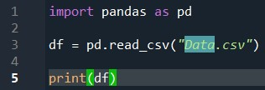

OUTPUT:

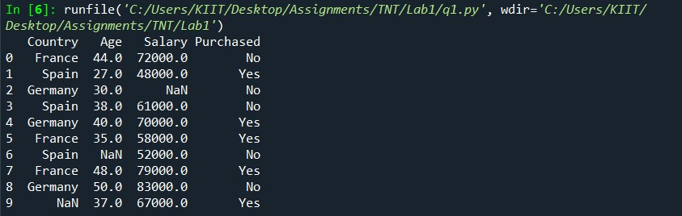

**Q2:** Add a new column : Salary_class

A for loop is implemented and the observations are

separated into three categories:

o Salary

• greater than 70000 - class0

• between 61000-70000 -class1

• between 48000-60000 -class2

• The classes have been stored in a new column ‘Salary Class’

CODE:

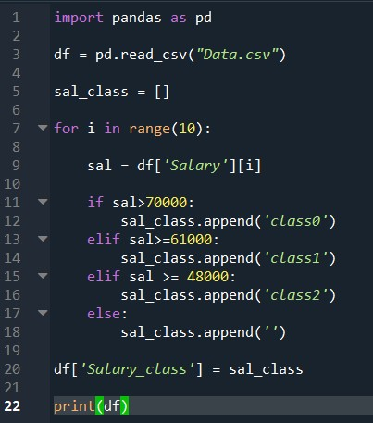

OUTPUT:

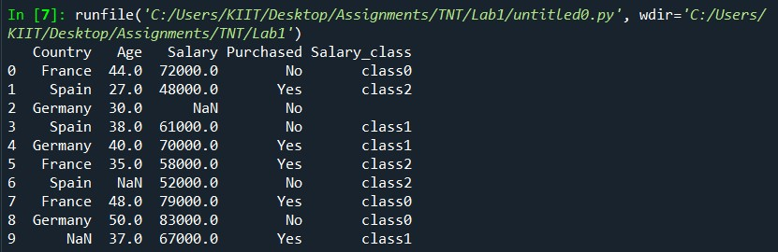

**Q3:** Implement above using both for and while loop

CODE:

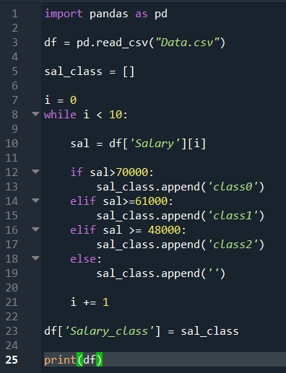

OUTPUT:

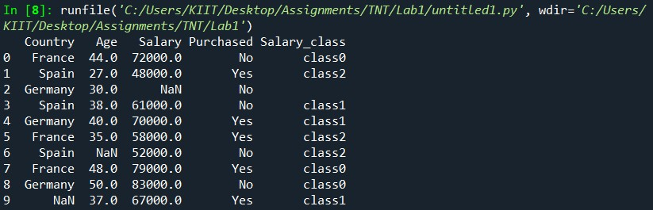

**Q4:** Count the number of each class (class 0, class1,class2) in your

dataset.

CODE:

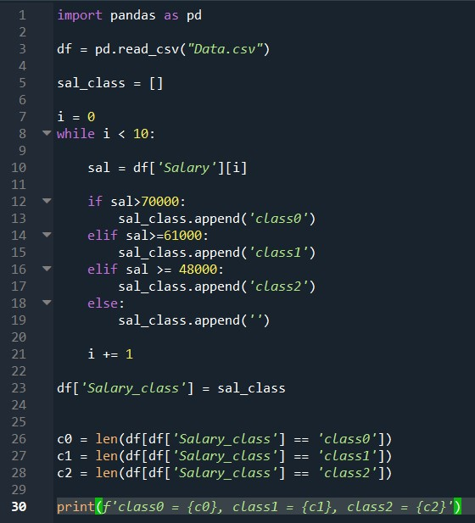

OUPUT:



**Q5:** Insert a new column Age_Converted:

Use function c_convert to add in the new column the converted values

fromcolumn “Age” :

dataset[“Age_Converted”]=dataset[“Age”]*12

CODE:

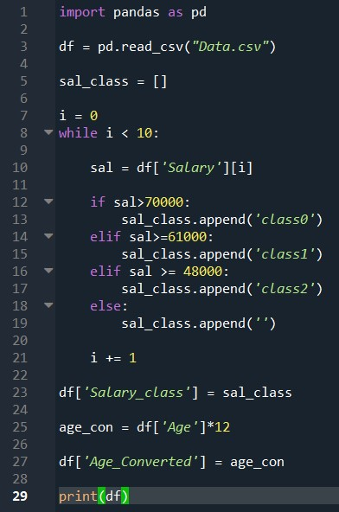

OUTPUT:

