**Lab 2**

**Q1:** Create a copy of the ‘data.csv’ and name the dataframe as dataset1

CODE:

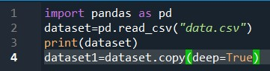

OUTPUT:

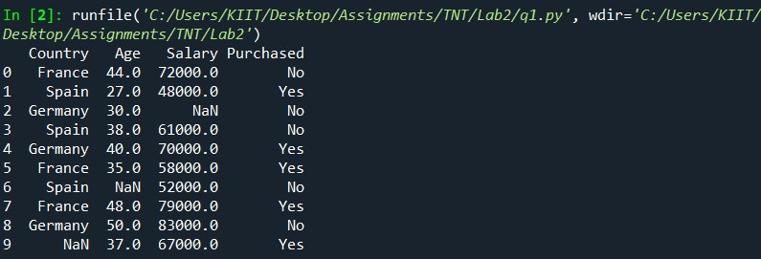

**Q2:** To display the count of each value in the county column

CODE:

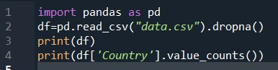

OUTPUT:

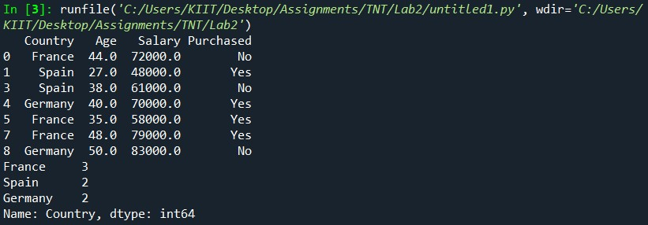

**Q3:** To display how many individuals from each country are buying the

product and how many aren’t.

CODE:

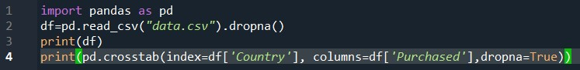

OUTPUT:

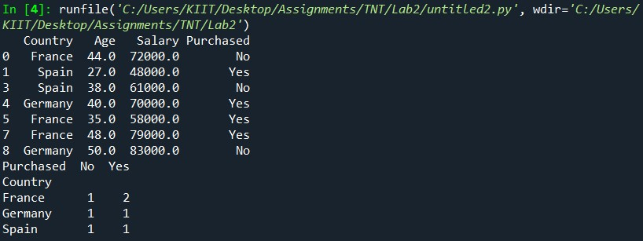

**Q4:** Show all probabilities of occurance:

i) Joint

ii) Marginal

iii) Conditional:

A) Country is known, whether the individual will purchase the

product or not

B) Product has been brought/not brought, find the probability the

individual belongs to which country

CODE:

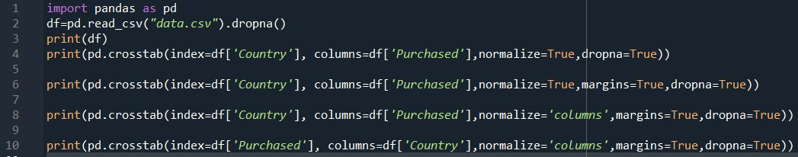

OUTPUT:

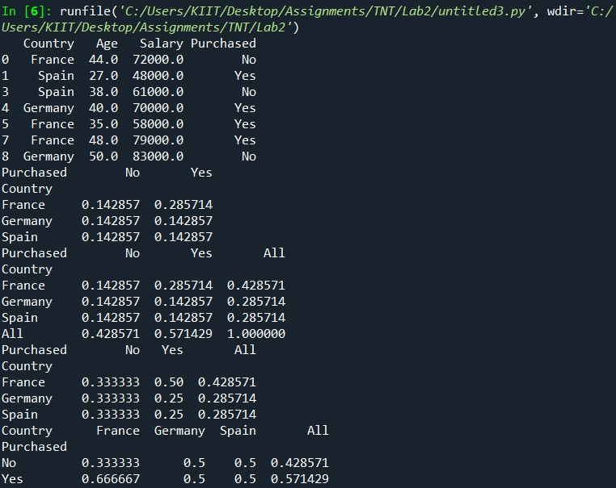

**Q5:** Find out whether there is a correlation between numerical

data(variables) in the dataset.

CODE:

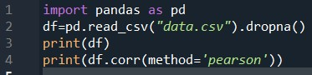

OUTPUT:

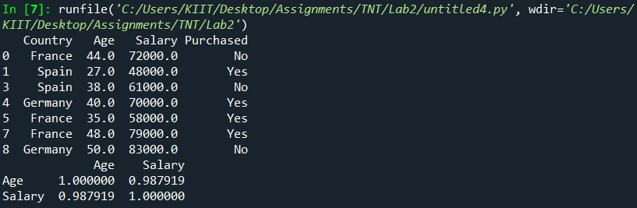

**Q6:** Use scatter plot and plot the data given in

‘social_network_ad.csv’.Keep ‘age’ in x-axis and ‘estimated salary’ in y-

axis.

CODE:

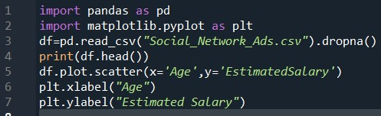

OUTPUT:

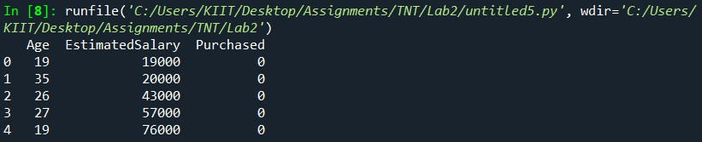

GRAPH:

