**Lab 3**

**Q1:** Plot a histogram with blue color bars of size 4, and edges should be

distinguished from each other, for the dataset social_nework for the

feature estimated salary.

CODE:

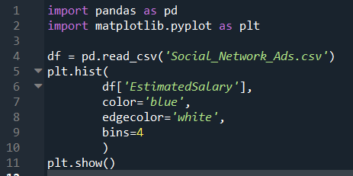

GRAPH:

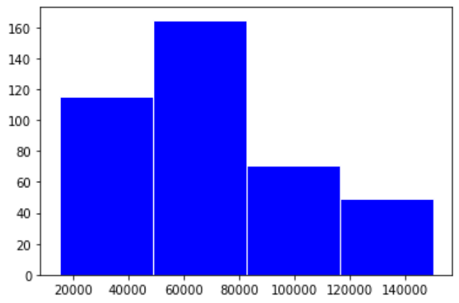

**Q2:** On the dataset ‘data’, draw barplot to show the count of categorical

feature ‘Country’.

CODE:

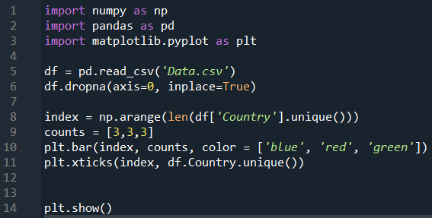

GRAPH:

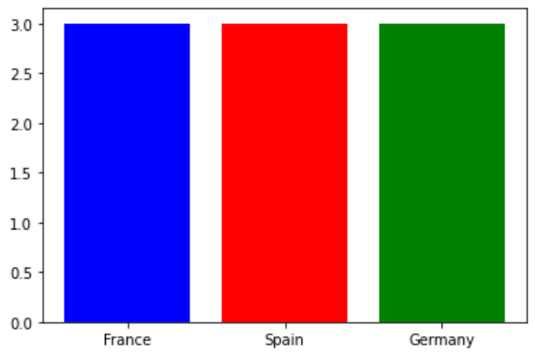

**Q3:** Remove missing values from the dataframe ceated from dataset ‘data’

and display the dimension of dataframe in both cases.

CODE:

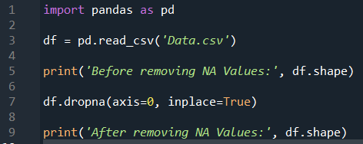

OUTPUT:

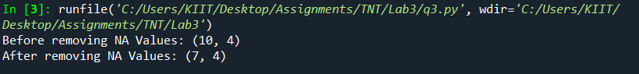

**Q4:** Scatter polt age vs estimated salary on gridview

A) show regression fit line

B) Regression fit line should not be visible

C) Use * symbol to show data points without the regression fit line

CODE:

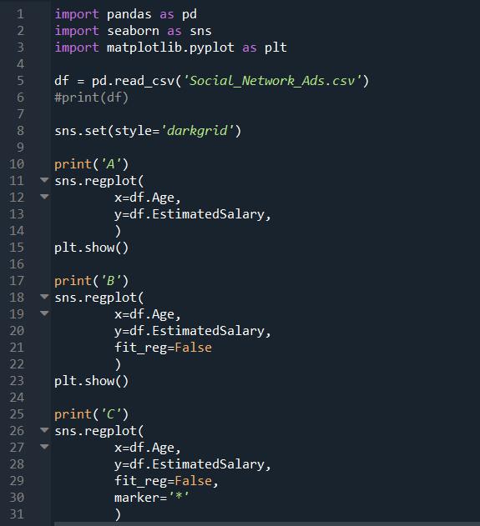

OUTPUT:

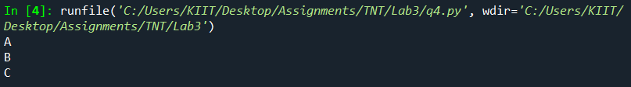

GRAPH:

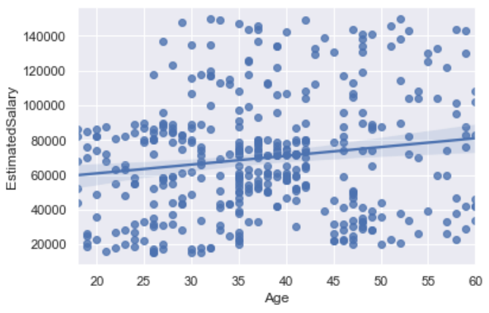

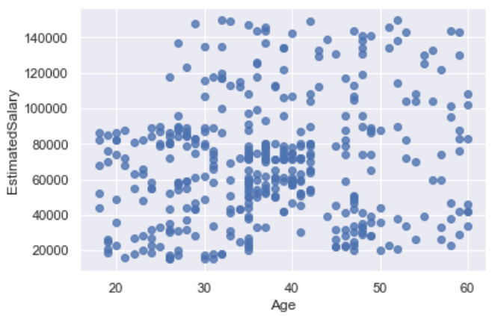

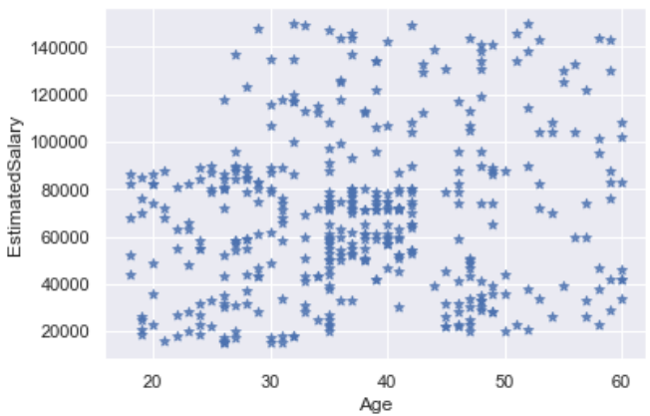

**Q5:** Scatter plot age vs estimated salary vs purchased on dataset ‘social

network.csv’.

CODE:

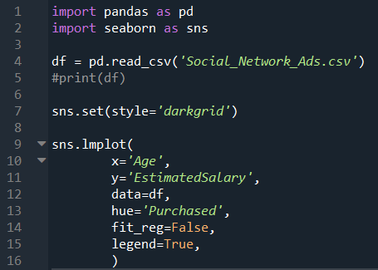

GRAPH:

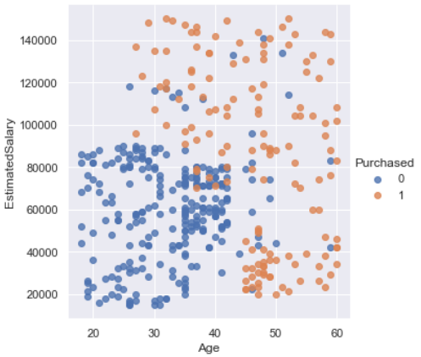

**Q6:** Plot Histogram for estimated salary attribute on dataset ‘social

network.csv’

A) with default kernel density estimate

B) Without kernel density estimate

CODE:

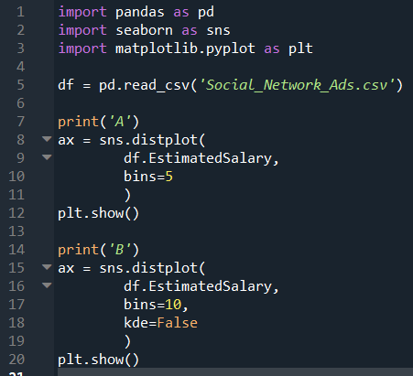

OUTPUT:

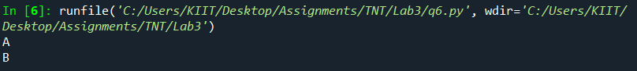

GRAPH:

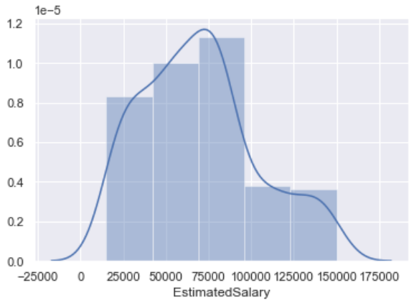

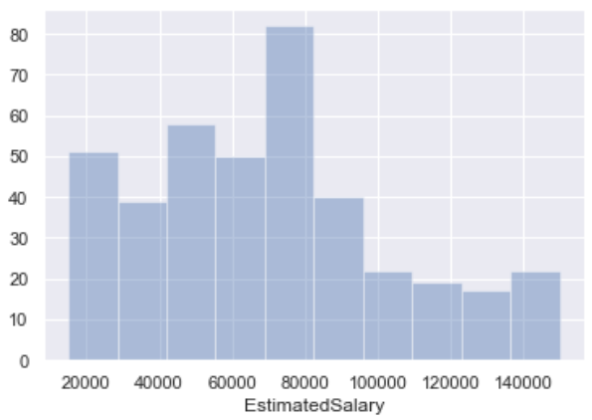

**Q7:** a) Show Bar plot frequency distribution of country attribute on dataset

‘data.csv’

b) Show Grouped bar plot of country and purchased

c) Show Box and whiskers plot for age vs country

CODE:

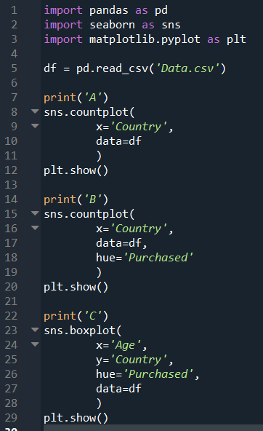

OUTPUT:

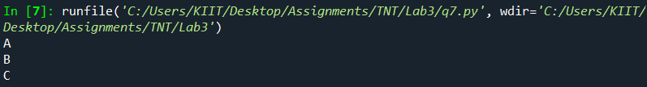

GRAPH:

