**Lab 4**

**Q1:** A sphere has radius equal to 6, calculate its the volume. An

approximate value would do.

CODE:

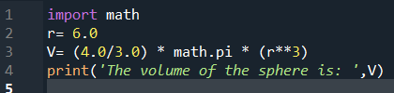

OUTPUT:



**Q2:** The marks obtained by a student in Physics, Chemistry,English and

Maths are 92, 72, 83, and 65 respectively.Add 5 marks to science subjects

and find the average marks obtained by him. Calculate the grade using if

else statement.

CODE:

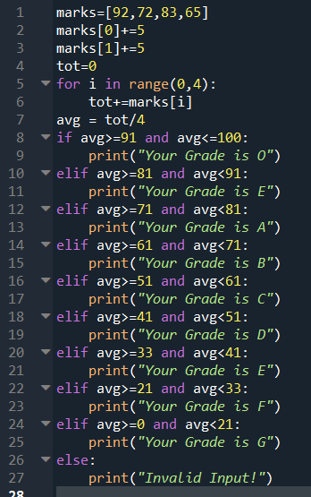

OUTPUT:



**Q3:** A)Write a program which uses a person_age to print number of years

left for retirement (a person retires at 65).

B)You can ask the age from the user as well

• age = input(“How old are you?”).

CODE:

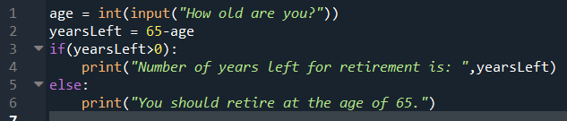

OUTPUT:

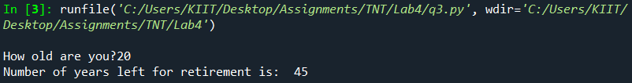

**Q4:** A student campus has got 3 divisions of girls and 5 divisions of boys.

Write a program which asks the user to input number of boys and girls in

each division using for loop.

• It should print

• number of girls,

• number of boys

• total number of students.

Sections:3 for girls A,B,C

Section :5 for boys A,B,C,D,E

CODE:

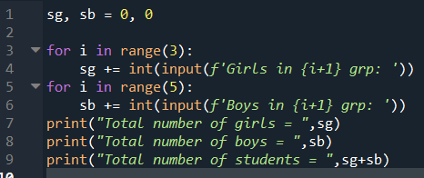

OUTPUT:

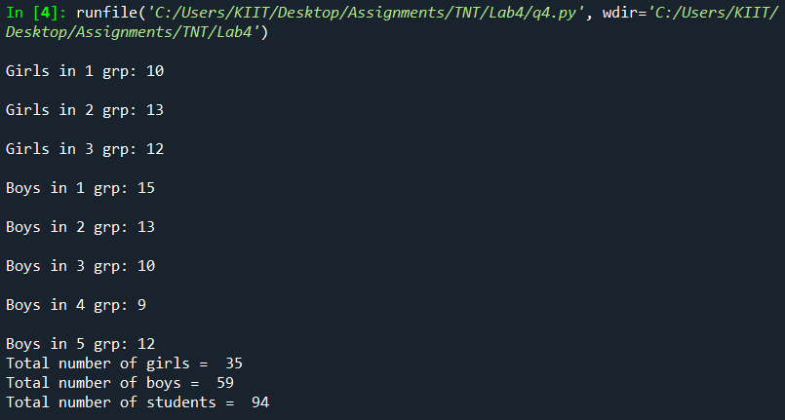

**Q5:** Write a Python program that prompts the user for his/her amount of

money,then reports how many jean pants the person can afford, and how

much more money he/she will need to afford an additional jean pant (cost

of jean pant = need to afford an additional jean pant. (cost of jean pant =

750)

CODE:

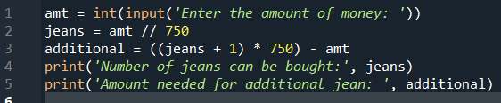

OUTPUT:

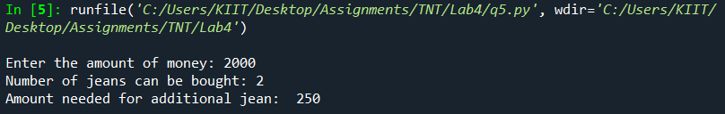

**Q6:** A) Write a program which converts 13 hours and 32 minutes into

seconds.

B) WAP to convert given second into its equivalent hour, minute and

second as per the following format. Ex. 8860 second = 2 Hour, 27 Minute

and 40 Second

CODE:

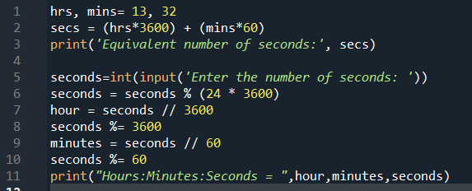

OUTPUT:

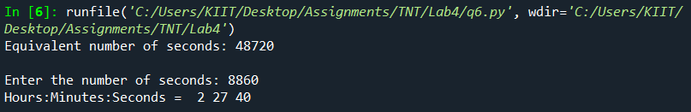

**Q7:** WAP to find the roots of a quadratic equation ax 2 +bx+c=0 using if-

else statement.

CODE:

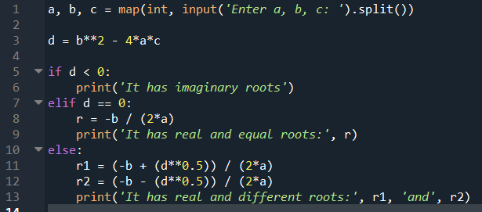

OUTPUT:

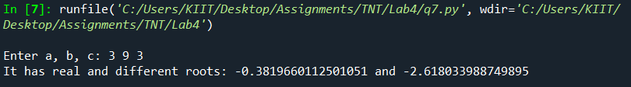

**Q8:** WAP to check whether a number n is prime number or not.

CODE:

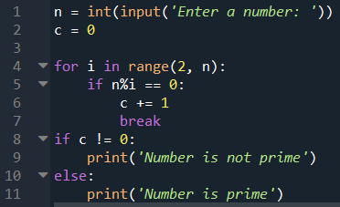

OUTPUT:

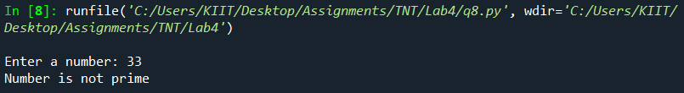

**Q9:** WAP to find the first n numbers of a Fibonacci sequence.

CODE:

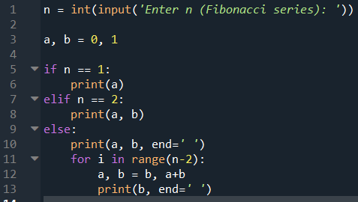

OUTPUT:

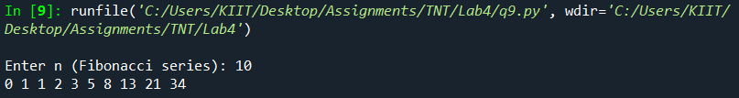

**Q10:** WAP to calculate the factorial of a given number.

CODE:

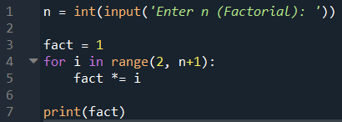

OUTPUT:

