**Lab 7**

**Q1:** Create Lists ,Tuples, Dictionaries and Sets. Print elements stored in each case.

CODE:

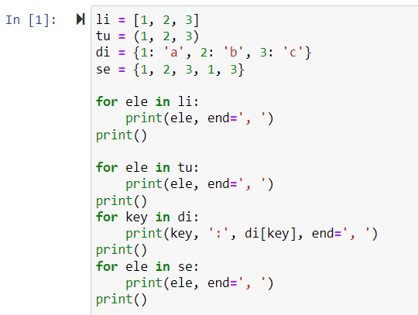

OUTPUT:

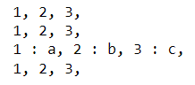

**Q2:** i) Select the Element kept at 2 nd position. From a List and display it.

ii)create numpy array by already existing list and display its datatype and

dimension.

CODE:

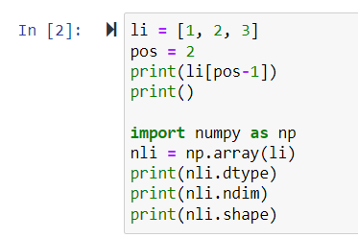

OUTPUT:

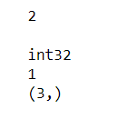

**Q3:** Use range function to generate values with name RangeVar. Keep

lower bound as 1, higher bound 50. and each value should have

difference of 10.

CODE:

3q

OUTPUT:

3a

**Q4:** Create a string ‘Techniquelab’. Find out the character at 5 th position.

Find out the index of ‘l’ in the string.

CODE:

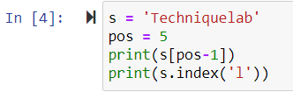

OUTPUT:

4a

**Q5:** In 3rd question, the values populted in RangeVar.Find out if 11 exists

and also find out the value at 3 rd index.

CODE:

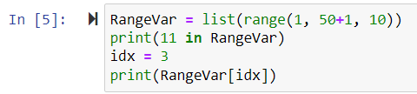

OUTPUT:

5a

**Q6:** Create a list with values 100, ‘Alice’, 12 and ‘Programmer’.Display the

whole list.Then add value ‘Python’ to the list and display the modified

list.

CODE:

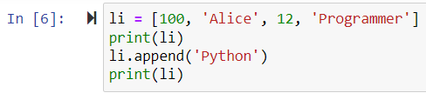

OUTPUT:

6a

**Q7:** Create a tuple with values:100, ‘Alice’, 12 and ‘Programmer’.Display

the tuple.Then add values ‘Python’ and ‘ML’ to it and display the

modified tuple.

CODE:

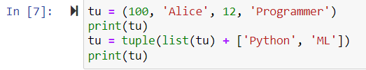

OUTPUT:

7a

**Q8:** In the tuple with values :100, ‘Alice’, 12 and ‘Programmer’,print the

values from index 0 to 2 ,getting displayed on console thrice.

CODE:

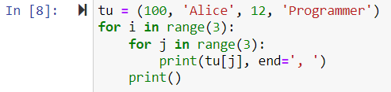

OUTPUT:

