**Lab 8**

**Q1:** Find out if following variables are significant or insignificant and need to be dropped.

i) Seller-insignificant

ii) offerType-insignificant

iii) abtest-insignificant

Iv)vehicleType-significant

V)gearbox,

Vi)Model

Vii)Kilometer

Viii)Fueltype

Ix)Brand

X)notRepairedDamage

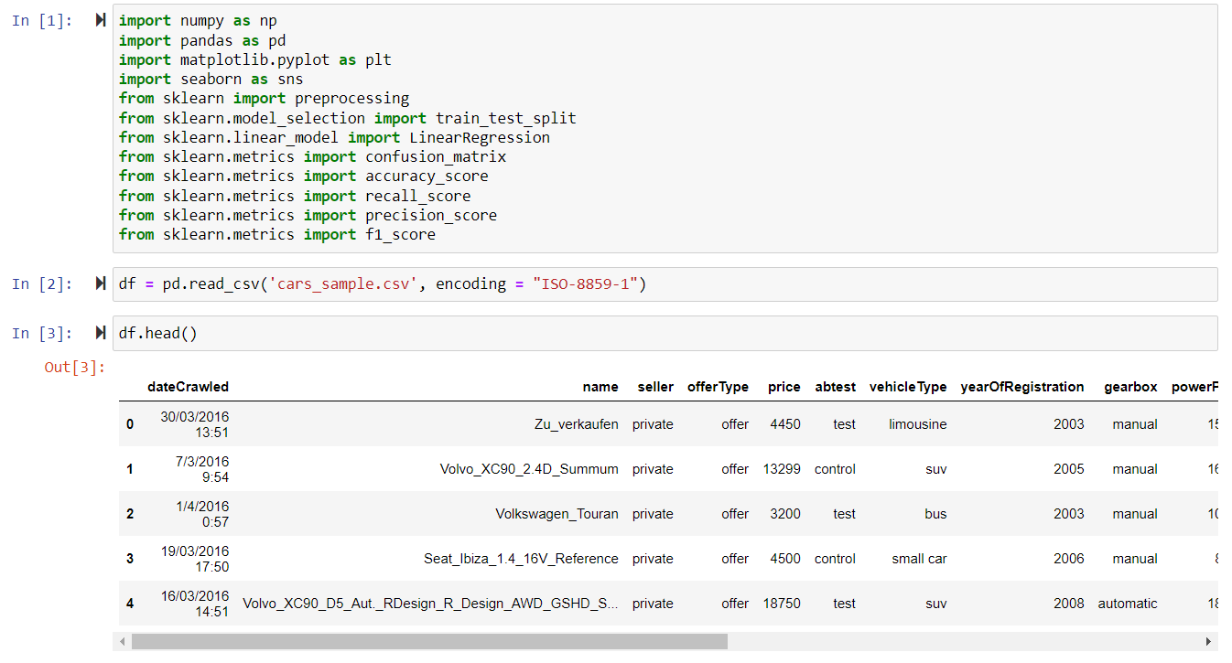

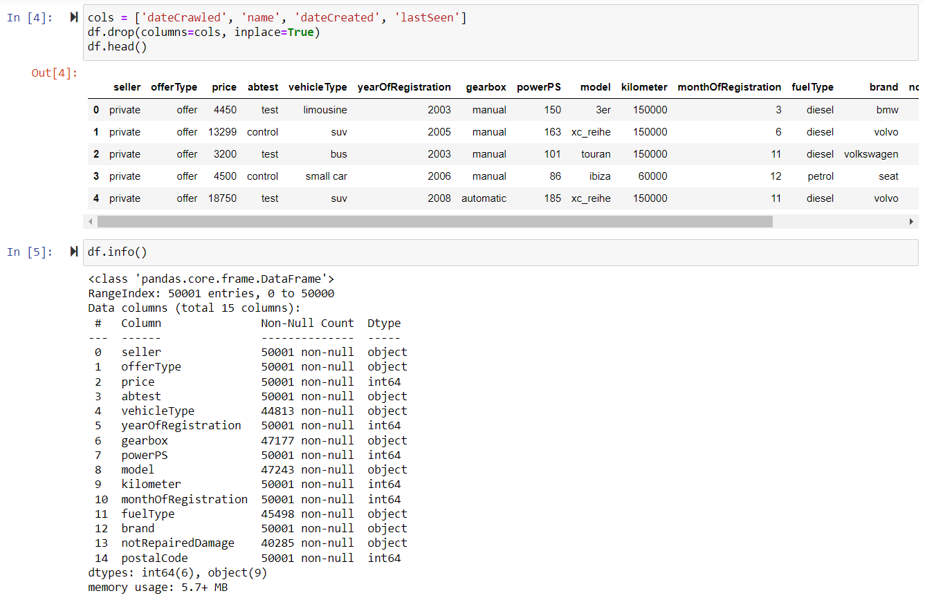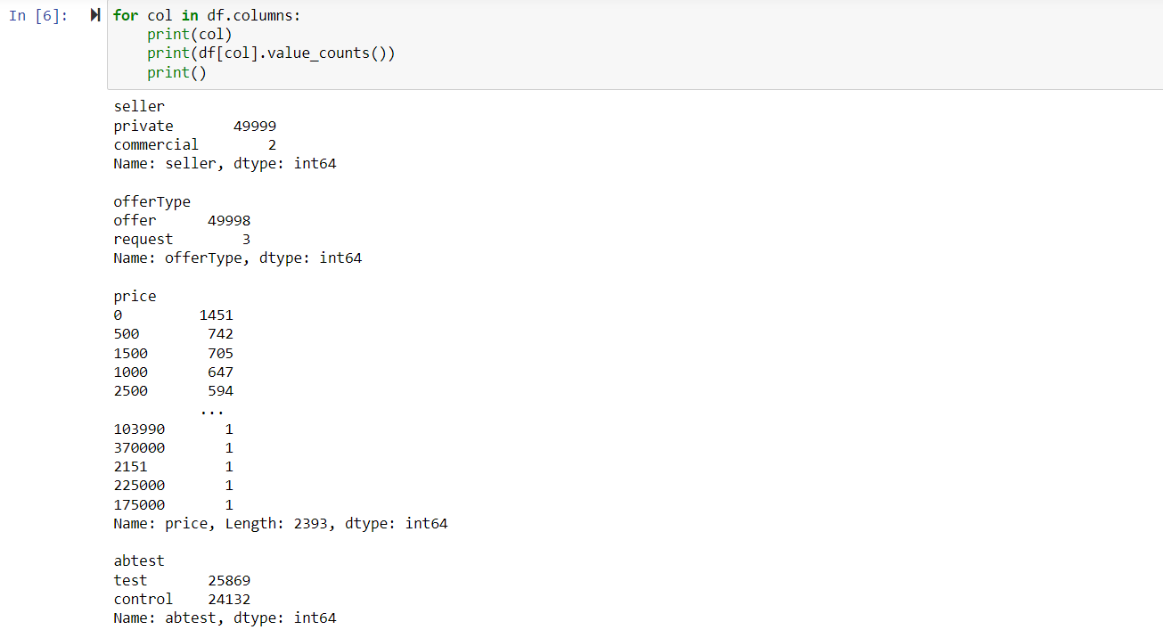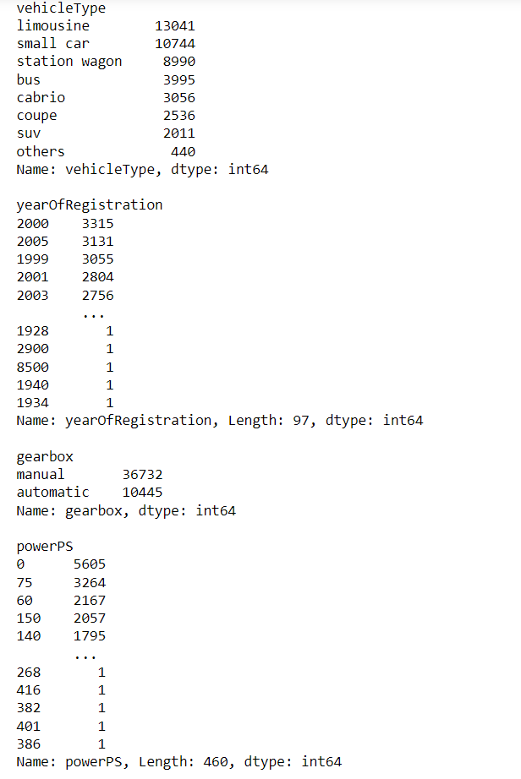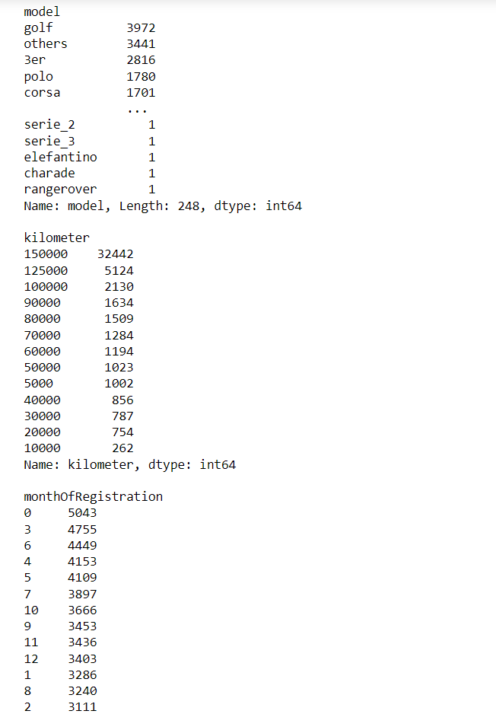

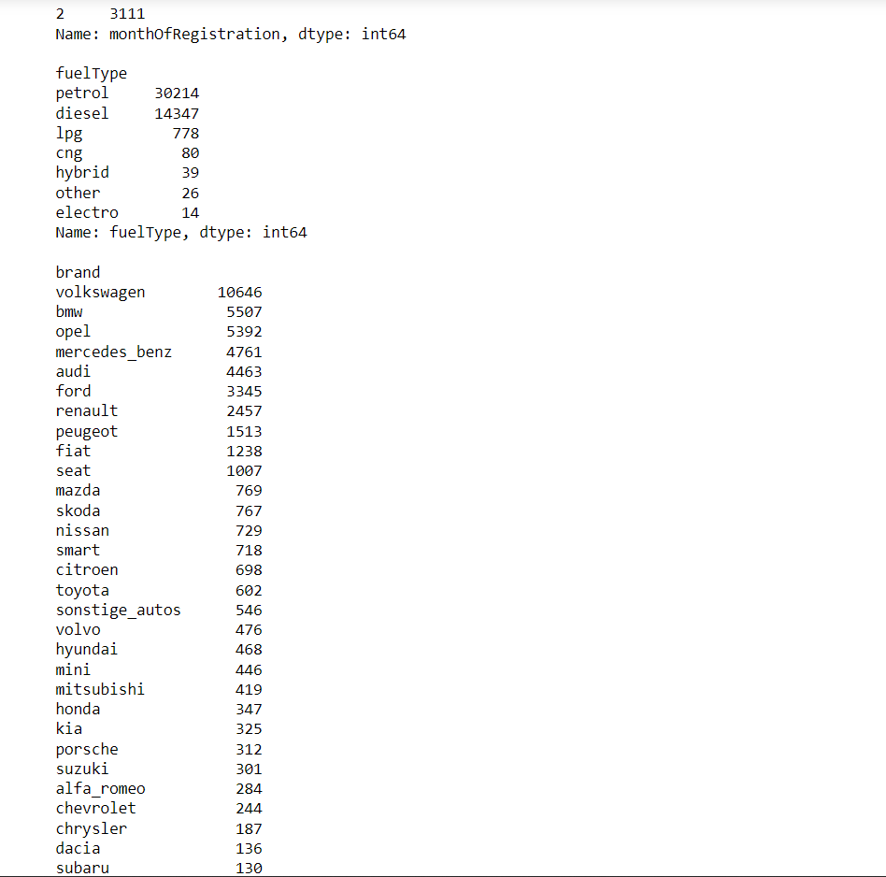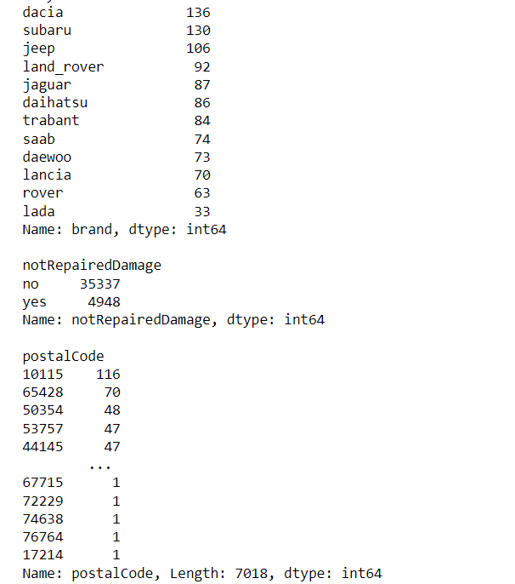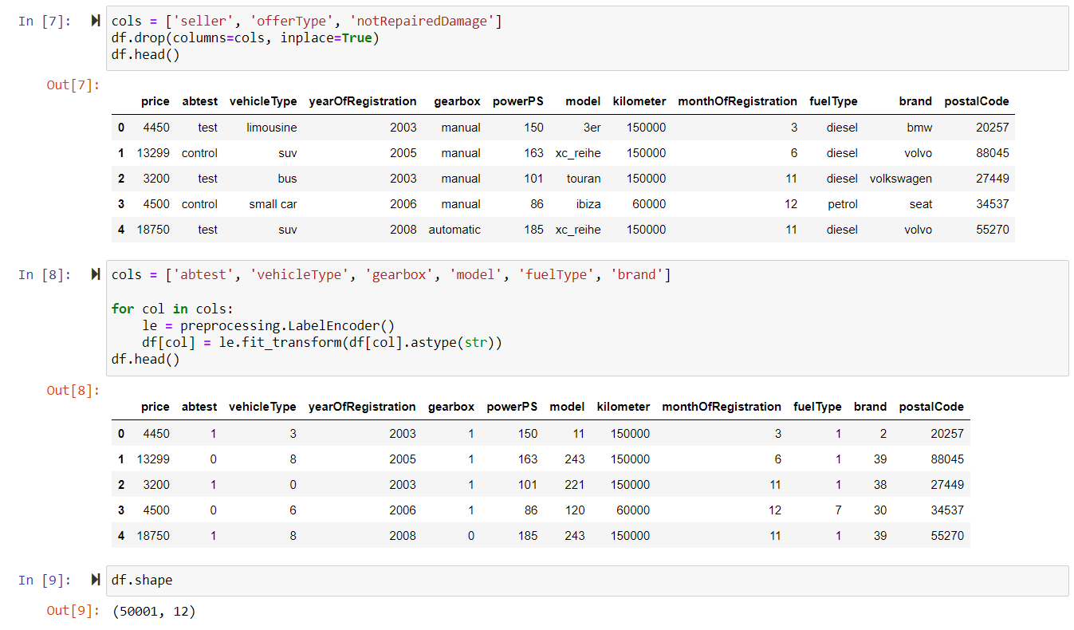

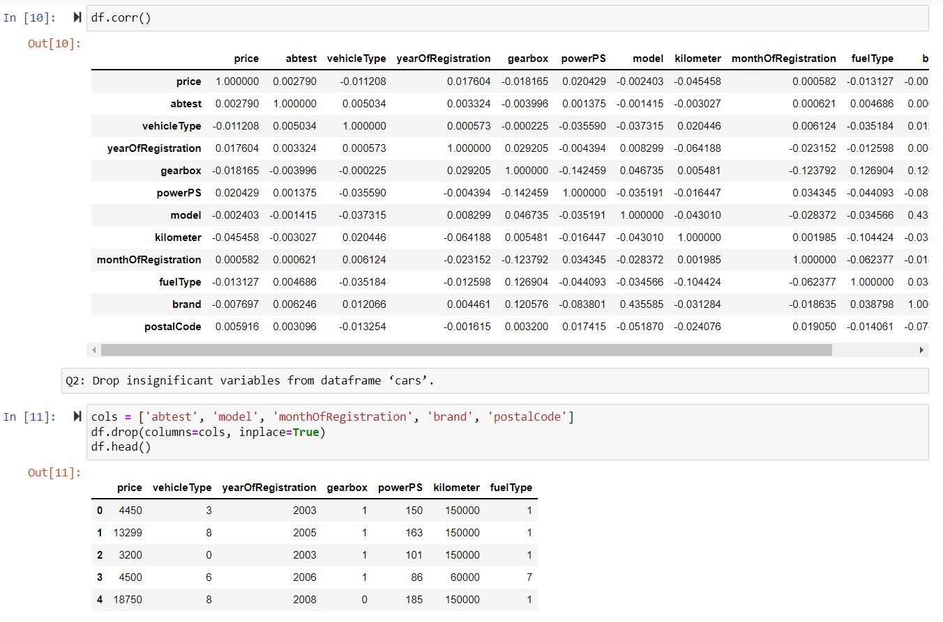

**Q2:** Drop insignificant variables from dataframe ‘cars’.

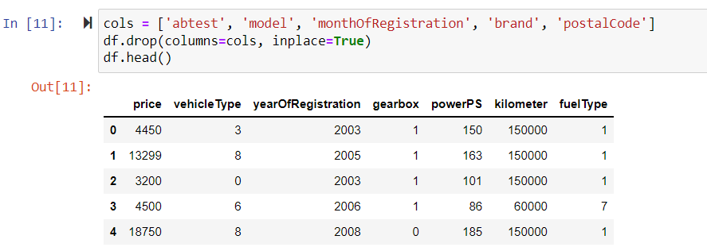

**Q3:** Find correlation between all numerical variables and find which variable has the highest correlation with price.

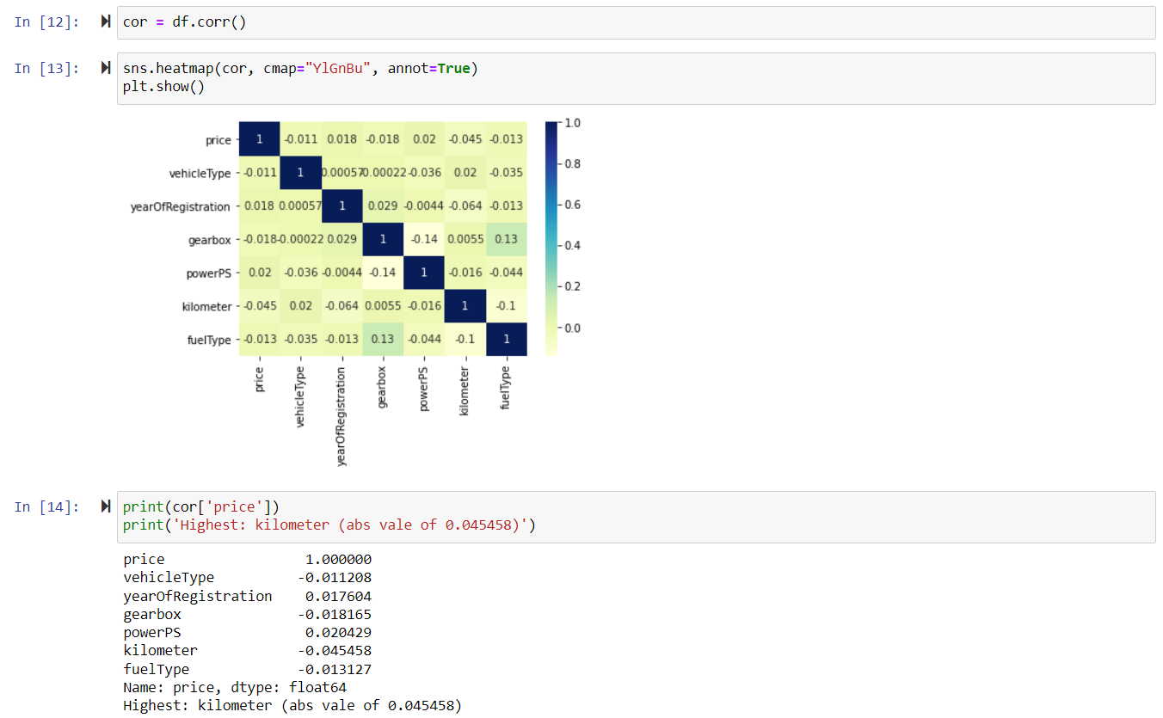

**Q4:** Calculate the training data and testing data score using a linear regression model.

