**TNT Sessional Exam**

**Q1:** Implement the following algoithms on your dataset ‘Iris Form Docker.csv’

With the various performance metrices: (10 marks). Divide dataset into train data and

test data in 80% and 20% ratio.

**TABLE:**

|  |  |  |  |  |  |
| --- | --- | --- | --- | --- | --- |
|  | **Sensitivity/**  **Recall** | **Specificity** | **F-Score** | **Precision** | **Accuracy** |
| **Logistic**  **Regression** | **100.0** | **1.0** | **100.0** | **100.0** | **100.0** |
| **Decision Tree** | **100.0** | **1.0** | **100.0** | **100.0** | **100.0** |
| **Gradient Boost** | **100.0** | **1.0** | **100.0** | **100.0** | **100.0** |
| **Random**  **Forest** | **100.0** | **1.0** | **100.0** | **100.0** | **100.0** |

**CODE:**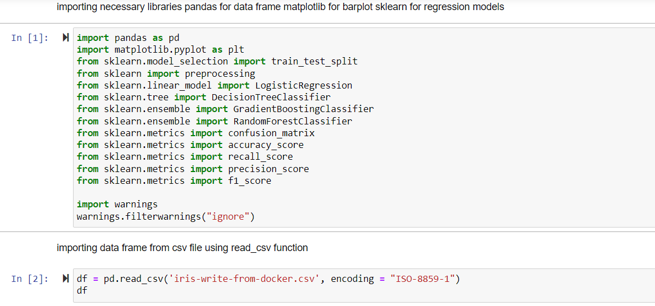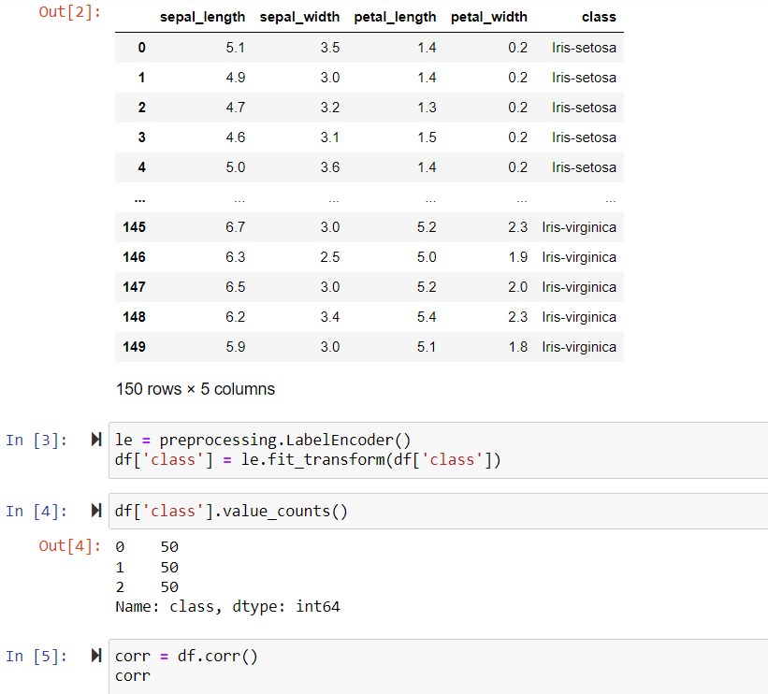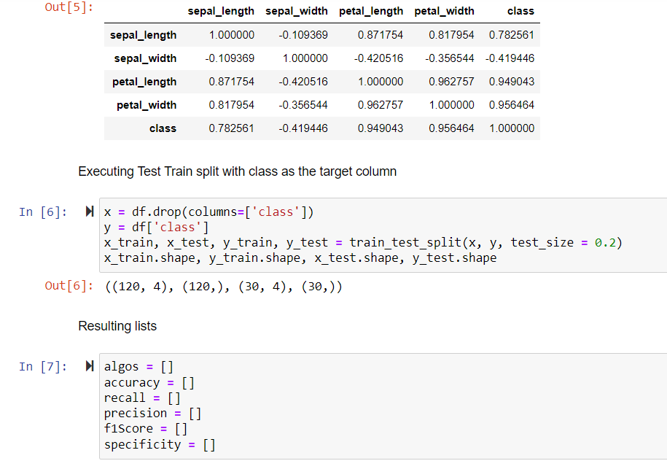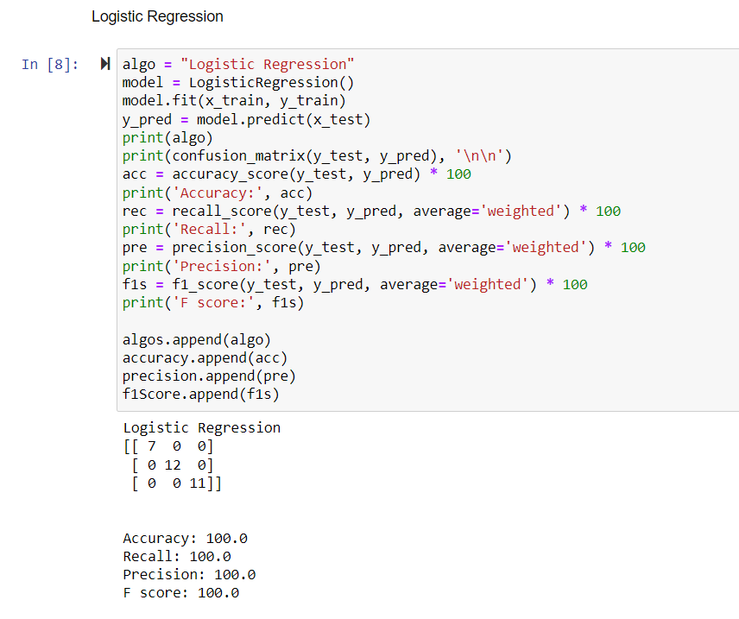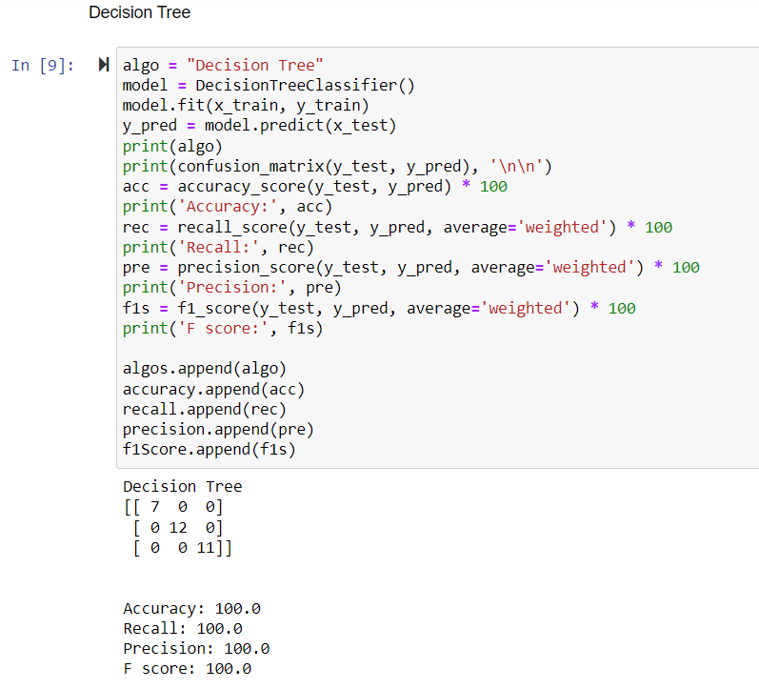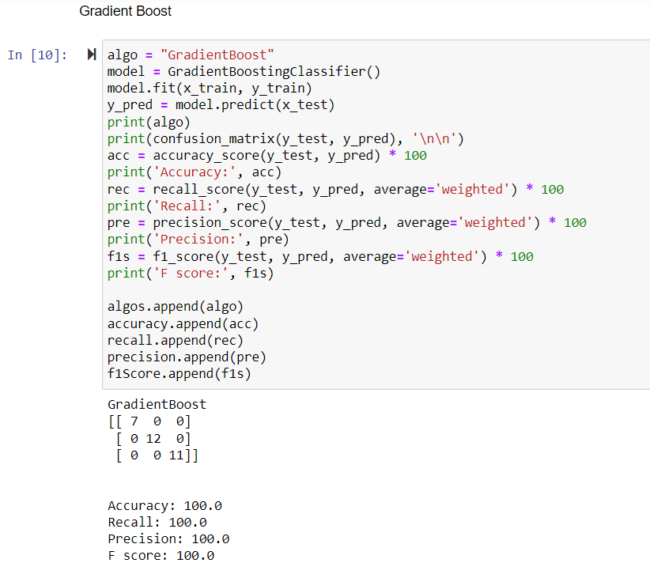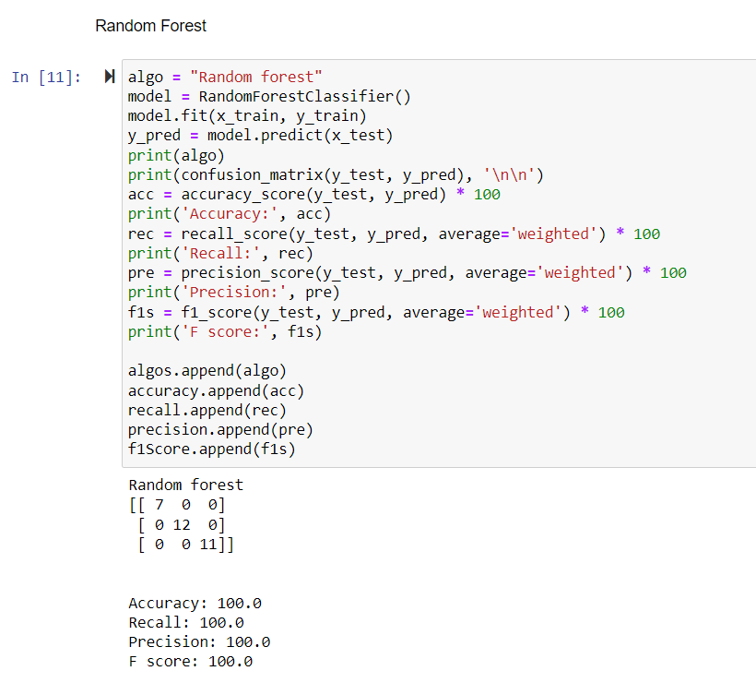

**Q2:** Draw the graph(barplot) for each algorithm,keep on y-axis the accuracy and thus

compare the accuacy in each case.(2 marks)

**CODE:**

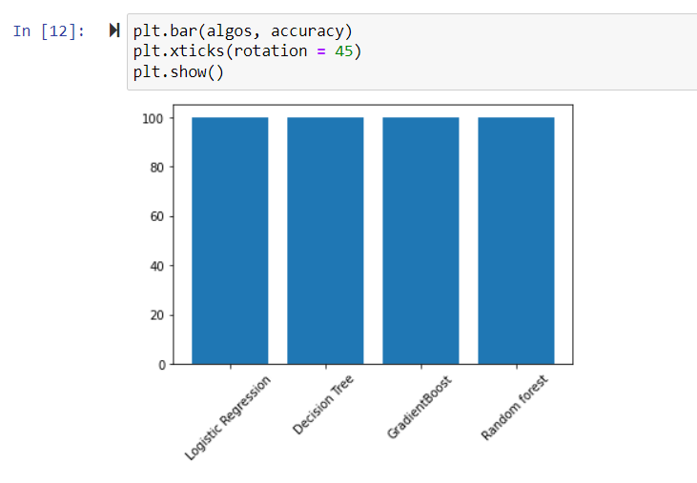

**Q4:** Write the python program using loop to print sum of first 10 natural numbers (2

marks).

**CODE:**

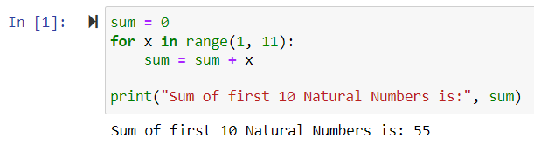

**OUTPUT:**

