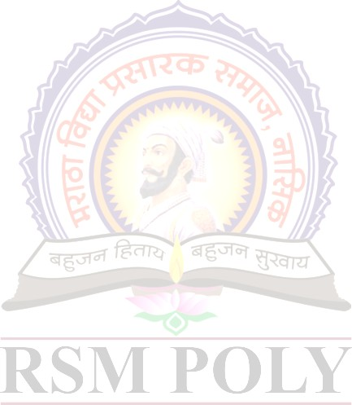 **Sources of energy**

|  |  |  |  |  |
| --- | --- | --- | --- | --- |
| **Details of Student(s)** | **Enrollment No** | | **Exam Seat No** | **Name of Student** |
| 1810020088 | | 240695 | Shewale Aniket Hari |
| 1810020090 | | 240696 | Shinde Saurabh Tanaji |
| 1810020091 | | 240697 | Sinha Abhishek Aakash |
| **Project Guide(s)** | Prof.G.N.Handge | | | |
| **Name of Industry**  (If Sponsored) | NA | | | |
| **Nature of Project** | Study base | | | |
| **Application(s) of Project** | NA | | | |
| **Abstract:** This report contains all the information related to energy and its sources and have a decent explanation of all of them. All the sources of energy production distribution chart is added to the report to explain the reports briefly. The energy is a whole different topic in its own and cannot be complete in few pages, but they are also added in the report. The energies are classified in different types which are also included in the report. | | | | |
| **Introduction** (In brief) :Energy resources may be classified as primary resources, suitable for end use without conversion to another form, or secondary resources, where the usable form of energy required substantial conversion from a primary source. Examples of primary energy resources are wind power, solar power, wood fuel, fossil fuels such as coal, oil and natural gas, and uranium. Secondary resources are those such as electricity, hydrogen, or other synthetic fuels. All organisms need energy to live. Energy is connected to all human activities: whenever we think or move, we use the energy that is stored in our body and all the objects that we use or that surround us need energy to work or needed energy when they were built. | | | | |
|  | |  | |  |
| **Fig 1.Energy** | | **Fig 2.Sources of electricity in India** | | **Fig 3.Total world energy consumption by source** |