BIOACCESS
Beginner Project Handbook
and Supervisor Defense Guide
A detailed explanation of the purpose, architecture, directories, biometric workflows, database, security controls, role-based access control, testing, deployment and remote Git workflow
Item | Current project
Application type | Windows desktop biometric identity and access-control prototype
Main interface | PySide6
Database | MySQL 8 mydatabase schema
Face recognition | OpenCV YuNet detection and SFace embeddings
Fingerprint recognition | Futronic FS80 through official FTRAPI matching
Security | AES-256-GCM, Windows DPAPI, PBKDF2 passwords, TLS and audit logging
Authorization | Role-based access control for administrators, registrars, biometric officers and invigilators
Audience | Beginning developer, project supervisor, examiner and future maintainer
Document date | 29 July 2026
How to use this handbook: Read Chapters 1 to 4 first for the big picture. Use Chapters 5 to 15 when learning the implementation. Use Chapters 16 to 21 for testing, Git, limitations, demonstration planning and supervisor questions.
Confidentiality: The handbook explains where secrets and biometric records live, but it intentionally contains no passwords, encryption keys, reusable database credentials or biometric payloads.

Table of Contents
Table of Contents 2
1. The Project in Plain English 6
1.1 The shortest possible explanation 6
1.2 What problem does it solve? 6
1.3 The people who interact with the system 6
1.4 What the project is—and is not 6
2. Problem Statement, Aim, Objectives and Scope 7
2.1 Problem statement 7
2.2 Aim 7
2.3 Core objectives 7
2.4 Current scope 8
2.5 Success criteria 8
3. Big-Picture Architecture 8
3.1 Why use layers? 9
3.2 The two-language design 9
3.3 Startup sequence 10
4. Understanding the Root Project Directory 10
4.1 The most important beginner distinction 11
4.2 Why the repository should not contain everything 11
5. The biometric_app Source Directory 12
5.1 app.py versus package_bioaccess.py 12
5.2 models.py is not the AI model directory 13
5.3 Why configuration has defaults but no password 13
6. User Interface Pages and Application Control 13
6.1 Why long fingerprint work uses a background thread 13
6.2 Hidden button versus real authorization 14
6.3 The login has two different credentials around it 14
7. Student Enrollment Explained Step by Step 14
7.1 Demographic validation 15
7.2 Why three face samples? 15
7.3 Why three fingerprint scans? 15
7.4 What is stored? 15
7.5 Transactional thinking 15
8. Face Recognition for a Beginner 16
8.1 YuNet: face detection 16
8.2 Alignment 16
8.3 SFace: face representation 16
8.4 Quality controls 16
8.5 Why night conditions matter 16
8.6 Current limitation: presentation attacks 17
9. Fingerprint Recognition for a Beginner 17
9.1 What the FS80 does 17
9.2 What minutiae are 17
9.3 The x86 helper 17
9.4 One-to-many identification 17
9.5 FAR and the configured decision 17
9.6 Why the old version is rejected 18
9.7 Capture guidance 18
10. Verification, Entry and Exit Decisions 18
10.1 Entry mode 19
10.2 Exit mode 19
10.3 Combined VERIFY mode 19
10.4 Fail closed 20
10.5 Identification versus verification 20
11. Database Design and What Each Table Means 20
11.1 Why separate students from users? 21
11.2 Foreign keys and relationships 21
11.3 Soft deactivation 21
11.4 MySQL versus retained SQLite files 21
11.5 Least-privilege database account 21
12. Security Architecture 22
12.1 Biometric encryption at rest 22
12.2 Key protection with Windows DPAPI 22
12.3 Password protection 22
12.4 Transport protection 22
12.5 Auditability 22
12.6 Threat-to-control map 23
13. Role-Based Access Control (RBAC) 23
13.1 Authentication versus authorization 24
13.2 Current role intentions 24
13.3 Why role changes appear after a new login 24
13.4 Administrative safeguards 24
14. SQL, Setup and Administrative Scripts 24
14.1 Why not edit normal roles manually in Workbench? 25
14.2 Idempotent setup 25
15. Packaging and Deployment 25
15.1 BioAccess.spec 26
15.2 Build, dist and output 26
15.3 Why packaged and source launch paths must match 26
15.4 External prerequisites that Git cannot solve 26
16. Tests, Evidence and How to Interpret a Pass 26
16.1 Unit tests 27
16.2 Integration and hardware tests 27
16.3 Controlled biometric evaluation 27
16.4 Current test status 27
17. Troubleshooting by Symptom 28
17.1 Do not solve every failure by changing thresholds 29
18. Git and Remote Repository Guide 29
18.1 Git versus GitHub 29
18.2 Recommended policy for BioAccess 29
18.3 Safety files already prepared 30
18.4 Local initialization workflow 30
18.5 Creating the remote 30
18.6 Daily beginner workflow 30
18.7 Moving to another computer 30
18.8 If a secret is accidentally committed 31
19. Limitations, Ethics, Privacy and Future Work 31
19.1 Technical limitations 31
19.2 Privacy principles 31
19.3 Why biometrics deserve special care 32
19.4 Prioritized roadmap 32
20. Demonstration and Defense Preparation 32
20.1 Thirty-second explanation 32
20.2 Two-minute explanation 33
20.3 Suggested live sequence 33
20.4 Day-before checklist 33
21. Supervisor Questions and Suggested Answers 34
Appendix A. File-by-File Quick Reference 38
Appendix B. Glossary 39
Appendix C. Recommended Acceptance-Test Matrix 40

If Word displays a short placeholder instead of the complete table, select the table, right-click, choose Update Field, and update the entire table.

1. The Project in Plain English
BioAccess is a desktop application that answers a practical question: is the person standing at the computer really a registered student, and is the signed-in staff member allowed to perform the requested operation?

1.1 The shortest possible explanation
The system registers a student, converts face and fingerprint captures into machine-readable templates, encrypts those templates, and later compares fresh biometric evidence with registered database records. It records entry, exit and verification outcomes and restricts staff functions according to job role.

1.2 What problem does it solve?
Names, cards and passwords can be borrowed or shared. In an examination setting, that creates a risk of impersonation. BioAccess adds biometric evidence: a physical characteristic associated with the individual. The aim is not to claim that biometrics are perfect, but to make identity decisions stronger, traceable and more difficult to transfer from one person to another.

1.3 The people who interact with the system
- Student: provides identity details and biometric samples during enrollment, then presents a face or finger during verification.
- Registrar: creates student records and performs initial biometric enrollment.
- Biometric officer: verifies identities and repairs or re-enrolls biometric records when authorized.
- Invigilator: performs entry, exit and general identity checks without managing accounts or student records.
- Administrator or system developer: manages operator accounts, roles, status, configuration and technical maintenance.
- Supervisor or examiner: evaluates whether the design is technically justified, securely implemented and honestly tested.

1.4 What the project is—and is not
It is | It is not
A working final-year prototype with real database and biometric integrations | A certified national identity system
A role-controlled desktop application | A public web service
A template-based face and fingerprint system | A repository of plain raw fingerprint photographs
A security-conscious demonstration platform | A guarantee of zero false acceptances or false rejections
A foundation that can be evaluated and improved | A finished production deployment requiring no further governance
Defense sentence: BioAccess is a security-conscious biometric examination-access prototype that combines identity enrollment, encrypted face and fingerprint templates, role-based staff permissions, access-state rules and auditable decisions.

2. Problem Statement, Aim, Objectives and Scope
A strong defense starts by connecting every technical choice to a project objective. Technology is not the purpose by itself; it is the mechanism used to solve the stated problem.

2.1 Problem statement
Traditional examination identity checks can rely on visual inspection of cards, names or credentials. These methods may be slow, inconsistently applied, vulnerable to impersonation and difficult to audit after the event. The project therefore investigates whether a desktop system can combine biometric evidence, secure storage and role-based control to improve the reliability and accountability of student identity verification.

2.2 Aim
To design and implement a Windows desktop biometric access-control prototype that enrolls students, verifies their identity using face and fingerprint evidence, protects sensitive data, enforces staff permissions and records access decisions for later review.

2.3 Core objectives
- Create a usable staff login and desktop control center.
- Register student demographic data without creating duplicate student identities.
- Enroll repeatable face and fingerprint templates using multiple samples.
- Check live evidence against registered database candidates rather than only the most recent enrollment.
- Reject weak, incompatible, absent or ambiguous biometric evidence.
- Encrypt biometric templates before persistent storage.
- Use role-based access control so each staff member sees and performs only authorized tasks.
- Track entry, exit, verification, account changes and denied actions.
- Package the application with the models and helper runtime needed for a reproducible Windows demonstration.
- Test normal, failure and security-sensitive paths and state limitations honestly.

2.4 Current scope
The implemented user interface covers staff authentication, a dashboard, student registration, biometric enrollment and re-enrollment, fingerprint entry, face exit, combined verification and operator account/role management. The MySQL schema also contains exam, registration and invigilator tables. Those tables make the database future-ready, but the current desktop interface does not yet provide complete exam scheduling or invigilator-assignment screens.

2.5 Success criteria
Criterion | Meaning in the project
Correctness | The genuine person should be recognized and a different person should be denied.
Safety | Uncertain or incompatible evidence must fail closed rather than selecting a convenient identity.
Security | Passwords, biometric templates, transport and administrative actions receive appropriate protection.
Usability | A beginner operator receives clear prompts, progress feedback and understandable error messages.
Accountability | Important events can be connected to an operator, identity, time and result.
Maintainability | Source, services, user interface, database scripts, tests and packaging are separated clearly.

3. Big-Picture Architecture
Architecture is the high-level arrangement of parts. BioAccess uses layers so the interface does not contain all biometric, database and security logic in one large file.
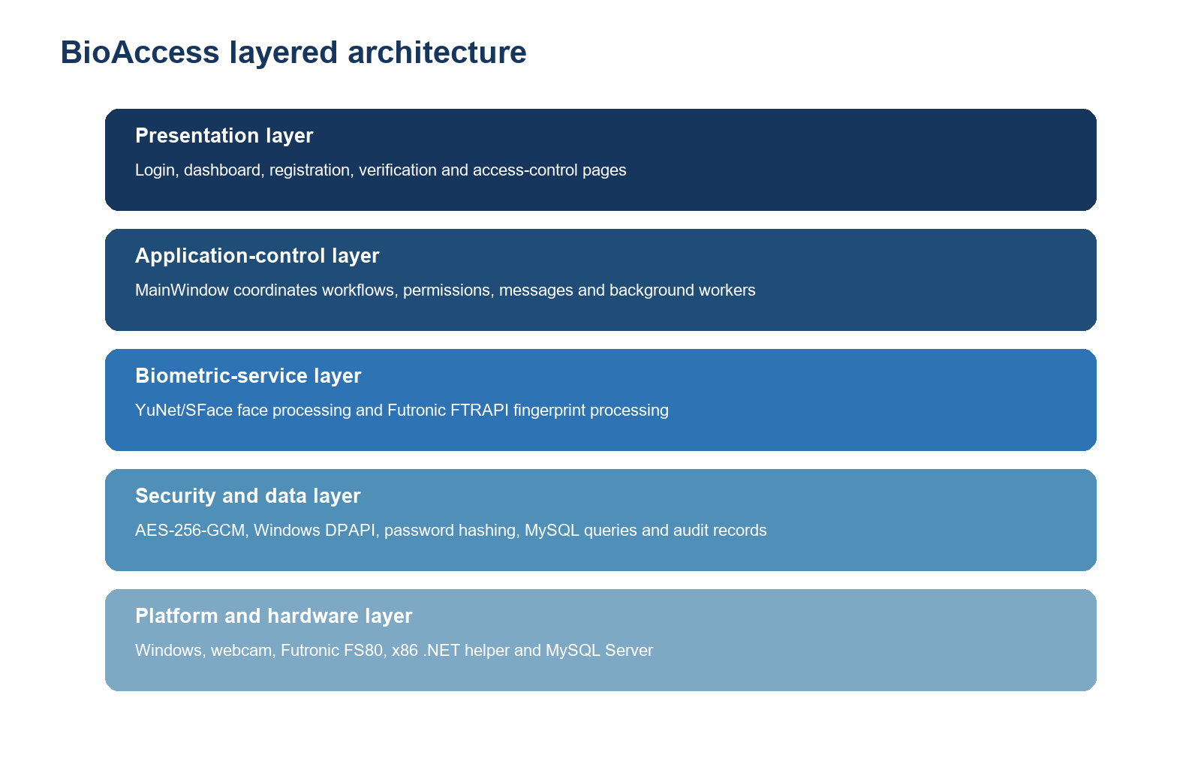
Figure 1. BioAccess is divided into presentation, workflow, biometric, security/data and platform layers.

3.1 Why use layers?
- Separation of concerns: each part has a clear responsibility.
- Testing: biometric and permission logic can be tested without repeatedly clicking the entire interface.
- Change control: the login design can change without rewriting the fingerprint matcher.
- Security: protected operations can be checked again in the database service instead of trusting a hidden button.
- Troubleshooting: scanner, camera, database and interface failures can be isolated more quickly.

3.2 The two-language design
Most of the application is Python because PySide6, OpenCV and database orchestration fit the desktop prototype well. The Futronic recognition DLL is 32-bit, while the main Python application is 64-bit. A small .NET 8 x86 helper process bridges that architecture mismatch. Python sends the requested operation and candidate templates to the helper; the helper calls FTRAPI and returns a structured result.
Why this matters: A 64-bit process cannot directly load a 32-bit DLL. The helper is not unnecessary complexity; it is the safe compatibility boundary that lets the modern desktop interface use the vendor recognition engine.

3.3 Startup sequence
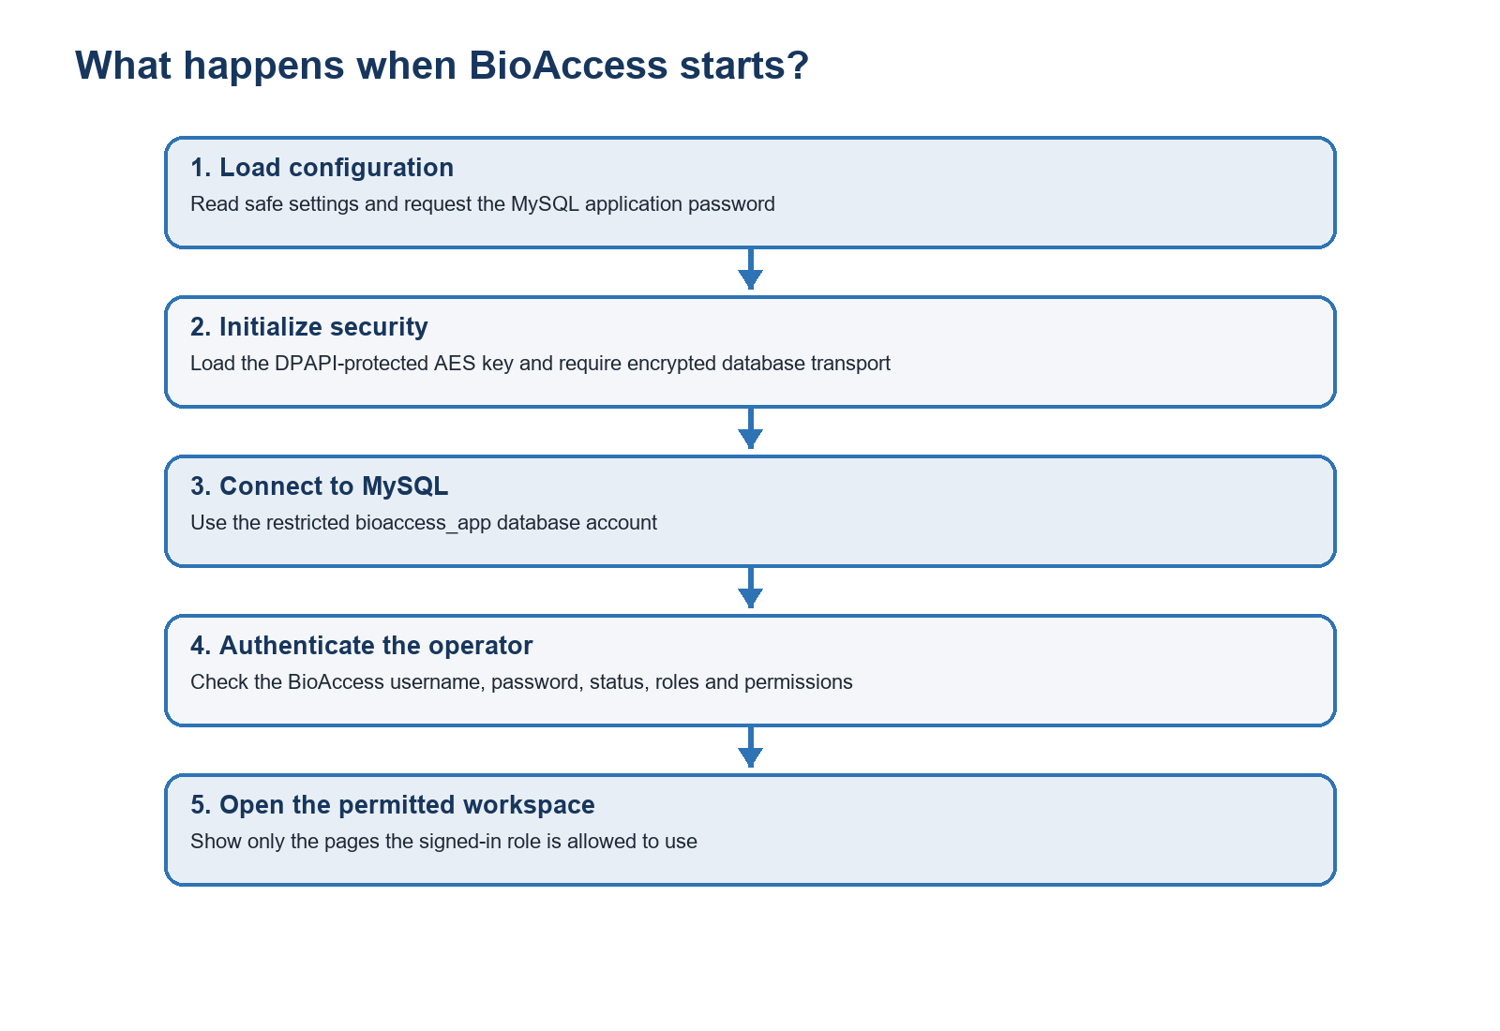
Figure 2. Configuration, encryption, database and operator authentication are completed before protected pages open.

4. Understanding the Root Project Directory
The root directory is the top-level FINAL YEAR PROJECT folder. Some entries are source material that should be maintained; others are generated artifacts that can be recreated and should not be treated as hand-written code.
Directory | Category | Purpose | Maintenance rule
.agents | Tooling metadata | Agent/workspace support metadata; not application runtime logic. | Normally do not edit.
.build-deps | Generated dependency cache | Locally installed packaging tools such as PyInstaller. | Recreate; do not commit.
.deps | Generated dependency cache | Additional local Python packages from earlier setup work. | Recreate; do not commit.
.venv2 | Development environment | Python interpreter and installed packages for local development. | Recreate; do not commit.
biometric_app | Primary source | The actual Python application, models, services, pages and vendor interface files. | Most important directory.
build | Generated build workspace | PyInstaller analysis, logs and intermediate packaging output. | Safe to rebuild.
data | Sensitive runtime data | DPAPI-protected AES key and optional local database. | Back up securely; never publish.
dist | Generated distribution | Packaged BioAccess executable folder for running without the source environment. | Rebuild from source.
output | Delivery staging | Installer/distribution mirror prepared for handover. | Generated; not source.
reports | Project documents | Formal reports and this handbook. | Usually commit approved documents.
sql | Database administration source | SQL migrations, roles, permissions, grants and access-event setup. | Important source.
tests | Quality evidence | Automated checks for biometric routing, RBAC and interface behavior. | Important source.
tmp | Temporary workspace | Previews, logs, extracted paper content and document-rendering artifacts. | Do not commit.
tools | Native integration tools | Futronic helper source plus locally bundled .NET SDK/runtime. | Commit helper source, not generated SDK/runtime.
vendorlibs | Bundled dependencies | Large local copy of Python packages used during packaging. | Recreate; do not commit.
__pycache__ | Generated Python cache | Compiled bytecode produced automatically. | Delete/recreate; do not commit.

4.1 The most important beginner distinction
If the project is moved to a new computer, the irreplaceable parts are source code, SQL scripts, tests, approved documentation and legitimate external prerequisites. Virtual environments, build folders and caches can be recreated. Real database records and the DPAPI key are operational data: they require a protected backup, not a public source-code repository.

4.2 Why the repository should not contain everything
A Git repository records history and is often synchronized to another server. Including database files, passwords or the DPAPI-protected key would expand the number of copies of sensitive material. Including thousands of generated dependency and build files would also make history very large and obscure meaningful source changes. The .gitignore file therefore defines a safety boundary.

5. The biometric_app Source Directory
This directory contains the code that defines BioAccess. A useful way to understand it is to follow the dependency direction: entry points create services; services handle specialist work; pages display results.
Entry | What it is | Why it matters
__init__.py | Marks biometric_app as a Python package. | Allows imports such as biometric_app.services.
main.py | Small development entry point. | Starts the normal source application.
app.py | Creates the Qt application and main services. | Coordinates encryption, database, login and main-window creation.
config.py | Central non-secret defaults and paths. | Prevents database and model settings being repeated in many files.
env_loader.py | Loads configuration from an approved environment file. | Keeps deployment settings outside source code.
models.py | Defines UserRecord, VerificationResult and AccountRecord. | Gives data a predictable structure between layers.
rbac.py | Permission names, role labels and permission helpers. | Creates one shared authorization vocabulary.
models/ | YuNet and SFace ONNX neural-network files. | Makes face processing reproducible without downloading at runtime.
services/ | Database, encryption, face and fingerprint logic. | Contains security-sensitive operations outside the page widgets.
ui/ | Login, dashboard, registration, verification and access-control pages. | Presents information and collects operator actions.
vendor/futronic/ | Futronic native recognition/capture DLL location. | Required by the x86 helper; provenance and license must be controlled.

5.1 app.py versus package_bioaccess.py
app.py is the normal source launcher. package_bioaccess.py performs nearly the same initialization for the packaged executable and additionally handles frozen-resource paths and the database-password prompt expected in the standalone build. Keeping both paths aligned is important: a correction applied only to development code may not appear in the executable.

5.2 models.py is not the AI model directory
The file models.py contains small Python data structures. The folder biometric_app/models contains the ONNX machine-learning model files. The identical word can confuse beginners, so remember: models.py describes application records; models/ contains trained face-network parameters.

5.3 Why configuration has defaults but no password
The host, port, database name and restricted username are safe operational defaults. The MySQL password is requested at startup or supplied through the process environment. This reduces the chance of accidentally publishing a reusable credential in source control. The config.env.example file shows expected names without containing a real secret.

6. User Interface Pages and Application Control
The interface is built with PySide6, the official Python binding for the Qt desktop toolkit. Each page owns its widgets and emits requests; MainWindow coordinates the actual service work.
Page | Responsibility | Importance
login_page.py | Professional two-panel sign-in screen, password visibility and account authentication. | Separates database connection from human operator identity.
main_window.py | Application shell, navigation, signal wiring, workflows and background fingerprint worker. | Central coordinator between pages and services.
dashboard_page.py | Totals, scanner readiness, student list and authorized maintenance buttons. | Gives immediate operational status.
register_page.py | Student demographic form and registration status messages. | Collects enrollment inputs consistently.
verify_page.py | Entry, exit and combined verification mode selection and results. | Makes security decisions understandable to the operator.
access_control_page.py | Create operator accounts, assign roles and change account status. | Makes RBAC manageable without manual SQL for routine changes.

6.1 Why long fingerprint work uses a background thread
Desktop interfaces have a main event loop responsible for repainting windows and responding to clicks. A three-scan Futronic enrollment may wait for a finger to be placed and lifted several times. Running it directly on the interface thread makes the window appear frozen. FingerprintEnrollmentWorker moves this blocking interaction to a QThread and sends progress messages back safely.

6.2 Hidden button versus real authorization
Hiding a page improves usability, but it is not sufficient security. A developer tool or later programming mistake could still call the underlying method. BioAccess therefore checks permissions in the interface and again in DatabaseService before protected reads or writes. This is defense in depth.

6.3 The login has two different credentials around it
- MySQL application credential: bioaccess_app connects the software to the database. Its password is requested when the launcher starts.
- BioAccess operator credential: a named staff account such as an administrator, registrar or invigilator signs in to the application.
- MySQL root credential: used only by setup/administration scripts, never as the normal desktop application's database account.
Common confusion: An operator username cannot replace the MySQL application password, and the MySQL root password should never be used as the normal BioAccess login.

7. Student Enrollment Explained Step by Step
Enrollment creates the reference information used later. A poor enrollment cannot be repaired simply by lowering a threshold; quality and identity controls must be correct at the beginning.
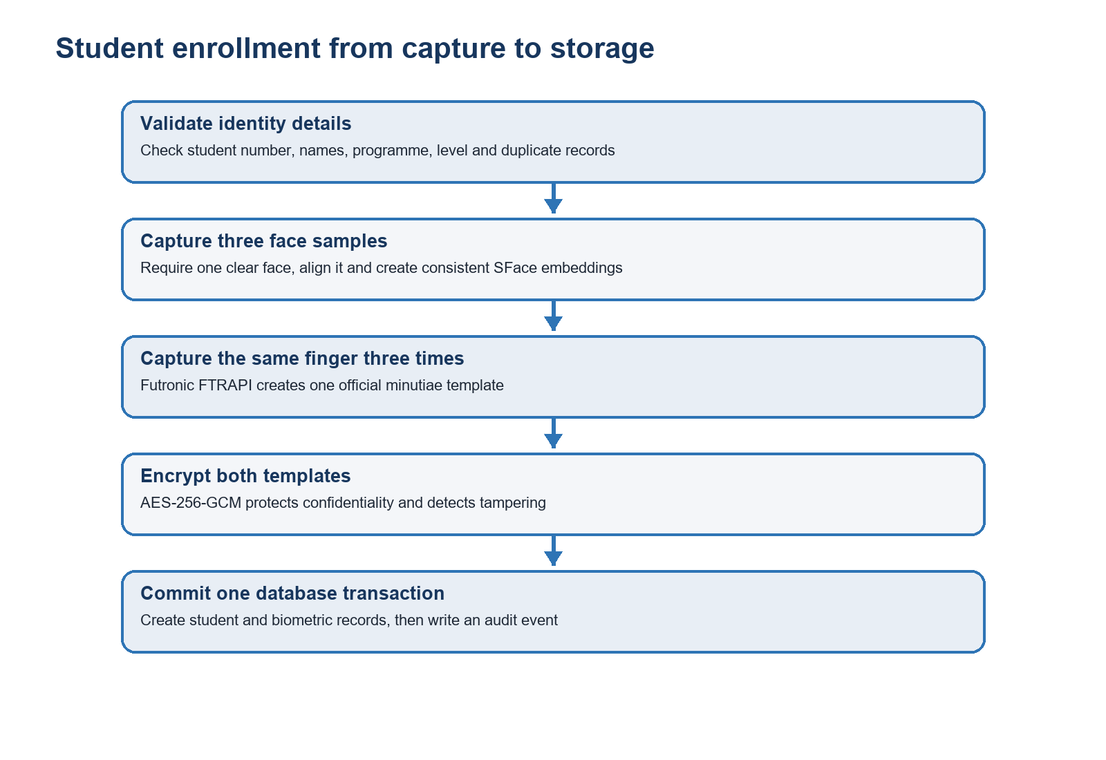
Figure 3. Enrollment validates identity, captures multiple samples, encrypts templates and commits auditable records.

7.1 Demographic validation
Before using the camera or scanner, the application validates the student identifier and required name fields. The student ID is the institutional reference and must remain unique. This prevents two biometric packages from silently attaching to the same institutional identity.

7.2 Why three face samples?
One frame may contain a blink, motion blur, an unusual angle or temporary lighting. The system captures three quality-checked samples, creates an embedding for each and checks their consistency. A representative normalized vector is stored only if the samples appear to describe the same face.

7.3 Why three fingerprint scans?
Finger placement varies in pressure, rotation and contact area. FTRAPI's enrollment operation requests repeated samples from the same finger so the vendor engine can form a more stable minutiae template. The prompts to place and lift the finger are therefore part of the algorithm, not merely interface decoration.

7.4 What is stored?
Data item | Stored form | Reason
Student details | Database text fields | Connects the biometric identity to an institutional record.
Face reference | Versioned normalized SFace embedding encrypted as JSON | Supports repeatable similarity comparison without retaining the enrollment video.
Fingerprint reference | Versioned FTRAPI minutiae-template package encrypted as bytes | Uses the scanner vendor's recognition representation.
Enrollment metadata | Algorithm, version, quality and timestamps | Supports compatibility checks and auditability.
Audit record | Operator, action, target, outcome and time | Explains who performed the enrollment.

7.5 Transactional thinking
The safest enrollment outcome is all-or-nothing: a student should not be left with only half of an intended biometric package because the final scanner step failed. Database transactions and explicit error handling are important because they prevent partial records from being presented as successful enrollment.

8. Face Recognition for a Beginner
Face recognition in this project has two different machine-learning tasks: finding the face and representing the face.

8.1 YuNet: face detection
YuNet receives a camera frame and returns locations and facial landmarks. Detection answers 'where is a face?' It does not decide whose face it is. BioAccess requires exactly one usable face so a background person does not silently become part of the decision.

8.2 Alignment
Eye, nose and mouth landmarks allow the face to be geometrically aligned before recognition. Alignment reduces variation caused by small head rotations and makes the next model compare similar facial regions.

8.3 SFace: face representation
SFace converts the aligned face into an embedding: a vector of numbers that summarizes identity-related patterns. The vector is not a name and does not look like a photograph. Recognition compares a live vector with registered vectors using cosine distance or similarity.

8.4 Quality controls
- Exactly one detectable face.
- Minimum face size so the model receives enough detail.
- Blur check to reject motion or focus failures.
- Darkness and overexposure checks.
- Enrollment consistency across three samples.
- Template-version check so old descriptors are never misread as SFace vectors.
- Ambiguity margin so two close candidates are not resolved by blindly choosing the first.

8.5 Why night conditions matter
Poor lighting can reduce facial detail, increase camera noise and produce shadows that change the embedding. The correct response is consistent lighting and a quality warning, not simply lowering the match requirement. Lowering a threshold may accept more genuine attempts, but it can also accept more impostors.

8.6 Current limitation: presentation attacks
The current face path does not contain independently evaluated presentation attack detection. A photograph, screen replay or mask must therefore be considered a residual risk. Good lighting and exactly-one-face checks improve capture quality, but they are not equivalent to liveness or certified anti-spoofing.

9. Fingerprint Recognition for a Beginner
The corrected fingerprint path deliberately uses the scanner manufacturer's recognition API instead of comparing raw-looking images with a custom similarity formula.

9.1 What the FS80 does
The Futronic FS80 is the capture sensor. It images the ridge pattern when a finger touches the glass. The scanner and ftrScanAPI handle acquisition; FTRAPI handles enrollment and recognition operations.

9.2 What minutiae are
Minutiae are distinctive ridge events such as endings and bifurcations, considered together with their positions and directions. A recognition template encodes features needed by the matcher. It is not a simple JPEG and it is not meaningfully verified by looking at the bytes.

9.3 The x86 helper
FTRAPI.dll in this project is 32-bit. FutronicCaptureHelper is compiled for Windows x86 and loads the DLL in a compatible process. It supports probing the SDK/device, official multi-scan enrollment and live one-to-many identification. The Python service controls timeouts, progress, candidate preparation and result interpretation.

9.4 One-to-many identification
For entry, the user does not first type a student number. The service loads usable active fingerprint templates from the database, decrypts them in memory and sends them as candidates to FTRIdentify. The returned candidate index is mapped back to the correct database student. This proves the system checks the registered database set rather than assuming the newest enrollment is the user.

9.5 FAR and the configured decision
False Acceptance Rate describes how often an impostor attempt may be accepted under defined test conditions. The Futronic matcher is configured with a stringent target approximately corresponding to 1 in 100,000. That configuration is a vendor matching target, not a measured performance claim for this complete application. The project must still run controlled genuine and impostor trials.

9.6 Why the old version is rejected
Earlier fingerprint records used a custom image/texture representation and produced low genuine similarities and cross-person risk. Current templates are version 4 official FTRAPI templates. Treating an old blob as a new template could produce undefined behavior, so BioAccess rejects legacy versions and requires re-enrollment.

9.7 Capture guidance
- Use the same finger used during enrollment.
- Place the finger flat and cover the central sensor area.
- Avoid excessive pressure and movement.
- Clean the scanner glass and use reasonably clean, dry hands.
- Wait for the lift prompt before the next enrollment scan.
- Do not run FinLogon or another scanner utility at the same time.
- Treat device-busy, timeout and disconnection errors as acquisition problems, not identity matches.

10. Verification, Entry and Exit Decisions
A biometric match is only one part of the decision. BioAccess also checks template compatibility, identity agreement, permissions and entry/exit state.
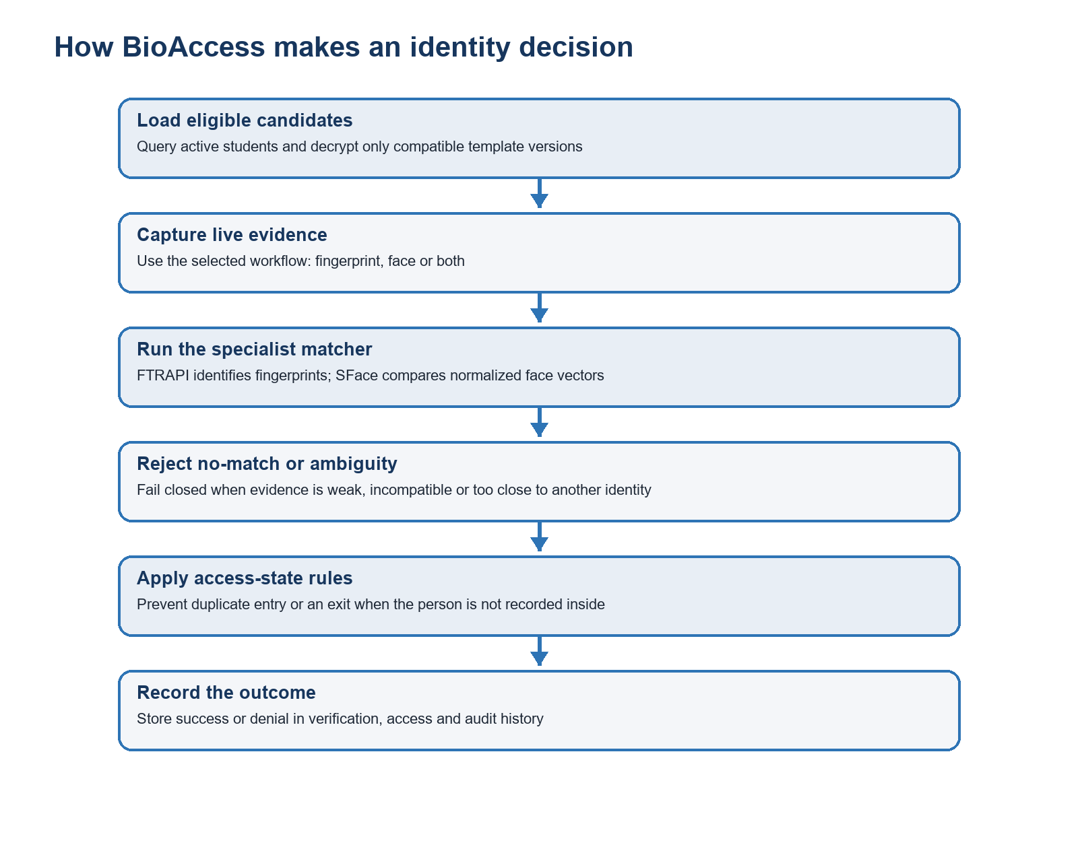
Figure 4. BioAccess loads real candidates, runs a specialist matcher, rejects uncertainty and records the outcome.

10.1 Entry mode
The current entry path uses fingerprint identification. After a successful match, the access-event logic checks whether the student is already marked inside. A duplicate entry is denied or recorded appropriately instead of creating an impossible state.

10.2 Exit mode
The current exit path uses face recognition with a cautious threshold and ambiguity handling. The system checks that the matched student is currently inside before recording an exit.

10.3 Combined VERIFY mode
Combined verification first identifies a face candidate and then checks the fingerprint against the relevant registered evidence. Both modalities must support the same identity. A correct face plus a nonmatching fingerprint is a failed combined decision, not a partial success.

10.4 Fail closed
Fail closed means uncertainty leads to denial or supervised review. Examples include no usable candidate templates, old template versions, camera quality failure, scanner timeout, database error, ambiguous face candidates, FTRAPI no-match and disagreement between face and fingerprint.

10.5 Identification versus verification
Term | Question | BioAccess example
Identification (1:N) | Who is this among many registered people? | Fingerprint entry searches the usable database candidates.
Verification (1:1) | Is this person the claimed identity? | A future student-ID/card-first flow could compare one selected template.
Multi-modal verification | Do two biometric sources agree on one identity? | Combined VERIFY requires face and fingerprint confirmation.

11. Database Design and What Each Table Means
MySQL is the system of record. It stores operator identities, authorization relationships, student information, encrypted biometric packages and event history.
Table | Content | Project importance
users | Staff/operator accounts, password hashes, account status, failed attempts and last login. | Who can sign in to BioAccess.
roles | Named job roles. | Human-readable grouping of permissions.
permissions | Atomic actions such as viewing students or managing accounts. | Defines what can be authorized.
user_roles | Many-to-many link between operator accounts and roles. | Assigns responsibility.
role_permissions | Many-to-many link between roles and permissions. | Turns a role into actual capabilities.
students | Student identity, institutional number, programme/level and active status. | Primary biometric subject record.
biometric_data | Encrypted face/fingerprint templates and algorithm/version metadata. | Keeps sensitive references separate and versioned.
audit_logs | Authentication, authorization, enrollment and administration activity. | Supports accountability and investigation.
verification_logs | Biometric verification outcomes and details. | Measures usage and failure patterns.
access_events | ENTRY/EXIT events and resulting access state. | Answers who entered, who exited and when.
exams | Future exam definitions. | Schema support for later exam workflows.
exam_registration | Future student-to-exam relationship. | Could restrict verification to registered candidates.
exam_invigilators | Future operator-to-exam assignment. | Could enforce invigilator responsibility per session.

11.1 Why separate students from users?
In this schema, users are staff/operator login accounts; students are the people being verified. Mixing them would make authorization and identity data harder to understand. A student should not automatically receive an operator password, and an operator should not automatically become a biometric subject.

11.2 Foreign keys and relationships
A foreign key states that one record refers to another valid record. For example, biometric_data refers to a student, and user_roles refers to both a user and a role. These relationships reduce orphaned records and make joins possible.

11.3 Soft deactivation
When a student is deactivated, the active identity and biometric material are removed or made unavailable while historical audit/access records can remain. This is safer than deleting every trace because a security system must often explain past decisions.

11.4 MySQL versus retained SQLite files
MySQL mydatabase is the intended primary backend. A local SQLite path remains for deliberate fallback/testing only, and ALLOW_SQLITE_FALLBACK defaults to 0. The .db files in the workspace are not evidence that the running packaged application is using SQLite. The active connection settings and startup message determine the real backend.

11.5 Least-privilege database account
The desktop application connects as bioaccess_app, not root. SQL setup scripts grant only the table operations required by application workflows. Root or another database administrator is reserved for schema and grant maintenance. This limits the damage possible if the application credential is exposed.

12. Security Architecture
Security is a chain. Encryption alone is insufficient if accounts have unlimited permissions, keys are lost, events are not logged or uncertain biometrics are accepted.

12.1 Biometric encryption at rest
EncryptionService uses AES-256-GCM. AES protects confidentiality, while GCM authenticates the ciphertext so a modified record fails decryption instead of silently becoming a different template. Every payload receives a fresh 12-byte nonce and authenticated associated data. A small BAE1 marker identifies the encrypted format.

12.2 Key protection with Windows DPAPI
The raw 256-bit AES key is not written directly to the project. Windows Data Protection API protects it in data/biometric_aes256.dpapi using the local machine security context. A managed deployment may instead inject a valid base64 key through BIOMETRIC_AES256_KEY.
Backup rule: The encrypted database and its matching protected AES key must be backed up together. A database without the key cannot be decrypted; a key without the database cannot restore records. Neither belongs in a normal Git remote.

12.3 Password protection
Operator passwords are not stored in plain text. Each receives a random salt and PBKDF2-HMAC-SHA256 derivation with 310,000 iterations. During login, the supplied password is derived again and compared with the stored result. After five failed attempts, the account is locked to resist repeated guessing.

12.4 Transport protection
The application requires encrypted MySQL transport. TLS protects queries and results between the desktop app and database server. In a stronger production configuration, the client should also validate a trusted certificate authority and server hostname, not merely request encryption.

12.5 Auditability
Authentication attempts, permission denials, enrollment, re-enrollment, deactivation, role changes and access decisions are valuable evidence. Logs must be protected from ordinary alteration, time-synchronized and reviewed; simply collecting them is not the same as monitoring them.

12.6 Threat-to-control map
Threat | Current control | Residual concern
Database file copied | AES-256-GCM encrypted biometric payloads | Demographic and event metadata may still be sensitive.
Password database exposed | Salted PBKDF2 hashes | Strong password policy and monitoring remain necessary.
Operator overreach | RBAC, service-layer checks and audit logs | Full-access roles must be assigned sparingly.
Template type confusion | Face v2 and fingerprint v4 compatibility checks | Migration and re-enrollment must be managed.
Wrong biometric candidate | Official FTRAPI, SFace threshold and ambiguity rejection | Performance needs a representative benchmark.
Photo/replay at camera | Quality checks only | Independent PAD/liveness is still required.
Scanner utility conflict | Timeout/error handling and operator guidance | Exclusive device ownership is operational, not cryptographic.
Secret published to Git | .gitignore and runtime password prompt | Previously committed secrets would require history cleanup and rotation.

13. Role-Based Access Control (RBAC)
RBAC assigns permissions to job roles and roles to operator accounts. It answers what a signed-in staff member may do after authentication succeeds.
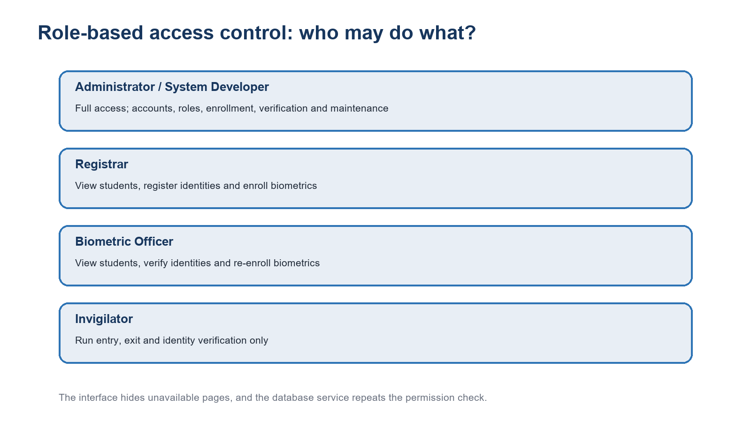
Figure 5. Roles deliberately receive different capabilities, and protected service methods check them again.

13.1 Authentication versus authorization
Concept | Question | Project mechanism
Authentication | Who are you? | BioAccess username/password and account status.
Authorization | What may you do? | Roles, permissions and require_permissions checks.
Accountability | What did you do? | Audit, verification and access-event records.

13.2 Current role intentions
- Administrator / System Developer: full-access wildcard permission for controlled management and maintenance.
- Registrar: view students, register identities and enroll biometrics.
- Biometric Officer: view students, verify identities and re-enroll biometric templates.
- Invigilator: run entry, exit and identity verification, but not manage accounts or enroll students.

13.3 Why role changes appear after a new login
A successful sign-in loads an AccountRecord containing the account ID, status, roles and permissions. The application uses that authenticated session snapshot. Role changes are safest when applied on the next sign-in, preventing an existing screen from quietly changing authority mid-operation. The database service also rechecks active status.

13.4 Administrative safeguards
- An administrator cannot change or disable the currently signed-in account through the routine screen.
- The last active administrator is protected from deactivation or loss of the administrative role.
- New operator passwords require length, upper/lowercase, number and symbol rules.
- Role changes and status changes are written to the audit trail.
- The application service checks permissions even if an interface element was displayed incorrectly.

14. SQL, Setup and Administrative Scripts
The root PowerShell and Python scripts exist so important setup and diagnosis operations are repeatable instead of being remembered as one-off manual steps.
Artifact | Function | Importance
setup_mysql.py | Creates or prepares the MySQL schema and foundational tables. | Initial database provisioning.
setup_database_restrictions.ps1 | Requests an admin password and applies the RBAC/grant SQL. | One-command security setup.
sql/setup_database_restrictions.sql | Creates permissions/roles, relationships, access storage and restricted grants. | Auditable source of database authorization rules.
setup_access_events.ps1 | Applies access-event storage changes. | Migration helper for older installations.
sql/setup_access_events.sql | Defines access-event schema changes. | Keeps entry/exit history explicit.
set_bioaccess_user_role.ps1 | Assigns a managed BioAccess role to an operator. | Recovery/administrative alternative to the UI.
list_bioaccess_users.ps1 | Lists operator accounts and role state. | Troubleshooting and verification.
diagnose_bioaccess_db.ps1 | Checks schema, connection and important database objects. | Evidence-driven database diagnosis.
diagnose_face_duplicates.ps1/.py | Examines face-template candidate duplication/compatibility. | Migration and false-match investigation.
preflight_biometrics.ps1 | Checks models, helper runtime, Futronic SDK/device and automated tests. | Demonstration readiness gate.
run_app.ps1 | Requests the restricted MySQL application password and starts BioAccess. | Normal source-run convenience.

14.1 Why not edit normal roles manually in Workbench?
Manual SQL is valuable for installation and emergency recovery, but routine account management should use the Access Control page. The page validates fields, prevents self-lockout and records an audit event. Direct edits can bypass those business rules and create confusing duplicate accounts or role links.

14.2 Idempotent setup
A good setup script can be run more than once without creating duplicate roles or corrupting the schema. INSERT IGNORE, existence checks and carefully scoped ALTER/GRANT statements help make the process repeatable. Warnings about duplicate seed values may be harmless, but missing-table errors must be handled or corrected.

15. Packaging and Deployment
Development uses source files and an installed Python environment. Deployment uses a packaged directory so the application can run on the demonstration computer with consistent resources.

15.1 BioAccess.spec
The PyInstaller specification defines package_bioaccess.py as the executable entry point and includes application source, face models, needed Python dependencies, the Futronic helper publication, the 32-bit .NET runtime and runtime data paths. Hidden imports tell PyInstaller about modules that dynamic loading might otherwise miss.

15.2 Build, dist and output
- build/: temporary analysis and assembly workspace.
- dist/BioAccess/: direct PyInstaller result containing BioAccess.exe and bundled resources.
- output/installer/BioAccess/: handover/staging mirror of the tested distribution.
- BioAccess_Standalone.zip: archive artifact; useful for transfer, but it should be regenerated rather than treated as source.

15.3 Why packaged and source launch paths must match
A common desktop-project failure is fixing app.py but forgetting package_bioaccess.py. The source run then works while the executable behaves differently. Both launchers must initialize EncryptionService, DatabaseService, authentication and current-account state consistently, and every significant correction should be tested in the final packaged build.

15.4 External prerequisites that Git cannot solve
- A working MySQL Server and correctly provisioned mydatabase schema.
- A permitted Futronic SDK/DLL package whose architecture matches the helper.
- The physical FS80 scanner and its operating-system driver.
- A usable webcam and suitable lighting.
- A local DPAPI/AES key and database restored together when moving operational data.
- Valid local operator accounts and restricted database credentials.

16. Tests, Evidence and How to Interpret a Pass
Tests provide evidence that code behaves as expected under defined conditions. They do not automatically prove biometric accuracy across a real population.
Test module | What it checks | What it supports
test_biometric_services.py | Official model availability, metadata/version handling, positive routing and no-match denial. | Biometric integration decisions.
test_rbac.py | Permission helpers, role labels and authenticated-session permission behavior. | Authorization correctness.
test_rbac_ui.py | Access-control widget data and actions. | Administrative interface behavior.
test_login_ui.py | Login layout and password visibility/state behavior. | Professional sign-in regression protection.

16.1 Unit tests
Unit tests isolate a small behavior and often replace hardware responses with controlled test doubles. This makes them fast and repeatable. A mocked FTRAPI no-match test proves that the application denies the no-match response correctly; it does not measure the physical scanner's real-world false-match rate.

16.2 Integration and hardware tests
A probe confirms that the helper can load the DLL and communicate with the FS80. An end-to-end human trial confirms capture, matching, identity mapping, database logging and interface feedback together. Both are necessary because a unit test can pass while a cable, driver or lighting condition fails.

16.3 Controlled biometric evaluation
Measurement | Plain meaning | How to collect
Genuine acceptance | Correct person is accepted. | Each enrolled participant repeats several attempts.
False non-match | Correct person is denied. | Count genuine attempts that fail after valid capture.
False match | Different person is accepted as someone else. | Run consented cross-person impostor attempts.
Failure to acquire | A usable sample cannot be captured. | Record scanner/camera quality or device failures separately.
Latency | Time from instruction to decision. | Measure capture and total workflow time.
Ambiguity rejection | Two candidates are too close to decide safely. | Record as a distinct safe failure, not as a wrong identity.

16.4 Current test status
The current automated suite contains 14 tests across biometric services, RBAC, access-control UI and login UI. A clean test run supports regression confidence. The final report should still include a dated multi-person hardware matrix, conditions, enrollment finger, number of trials, decisions and latency.

17. Troubleshooting by Symptom
Good troubleshooting starts by separating identity failure from acquisition, database, authorization and deployment failure.
Symptom | Likely category | Correct first response
Access denied for bioaccess_app@localhost | Wrong restricted database password, user/grant mismatch or server authentication setup. | Run DB diagnosis; verify the MySQL application credential and grants. Do not try the operator password.
Correct operator denied at sign-in | Inactive/locked account, wrong password or missing effective permission. | Check account status, login audit and role mapping with an administrator.
FS80 offline | USB/driver/device conflict, helper/runtime/DLL mismatch or another utility owns the scanner. | Close scanner utilities, reconnect directly, run preflight/probe and verify x86 files.
Fingerprint capture timed out | Finger not detected, placement/lift sequence missed or device stopped responding. | Clean glass, place flat, follow lift prompt and retry after device readiness check.
Genuine fingerprint not matched | Wrong enrolled finger, poor enrollment, incompatible legacy record or capture quality. | Confirm template version 4 and re-enroll the same finger with three clean scans.
Wrong person matched | Serious candidate/template/matcher issue. | Stop access decisions, preserve logs, check identity mapping, duplicates and official SDK response; do not lower thresholds.
Face not found at night | Insufficient light, camera noise, blur or shadow. | Add diffuse front lighting and stable position; keep quality controls.
Face matched but combined verification failed | Fingerprint did not confirm the same identity. | Treat as denial; troubleshoot the fingerprint record/capture separately.
UI freezes during enrollment | Long scanner operation executed on UI thread or worker failed to report. | Use the background worker, live progress and safe timeout.
Role page not visible | Signed-in account lacks manage_accounts or session has old roles. | Verify role in database, sign out and sign in again.
Source works but executable fails | Packaged build is stale or missing resources. | Rebuild, inspect packaging logs and test inside dist before copying output.
Cannot decrypt biometrics | Wrong/missing AES key, moved DPAPI key or corrupted ciphertext. | Restore matching database and key; do not generate a replacement key for existing records.

17.1 Do not solve every failure by changing thresholds
A threshold only controls the decision boundary after a usable comparison score exists. It cannot fix a disconnected scanner, wrong finger, old template version, wrong candidate mapping, missing key, dark frame or unauthorized operator. Lowering it without measured data can convert safe rejections into false acceptances.

18. Git and Remote Repository Guide
Git records versions of source files. A remote hosting service such as GitHub, GitLab or Bitbucket stores a synchronized copy so the project can be accessed from another computer and recovered after local damage.

18.1 Git versus GitHub
Term | Meaning
Git | The version-control system running locally. It records commits, branches and file history.
Repository | A project directory whose history is managed by Git.
Commit | A named snapshot of selected changes with author and message.
Branch | A movable line of development, normally main for the stable project.
Remote | A named network location, normally origin, that stores synchronized commits.
GitHub/GitLab/Bitbucket | Online services that host Git remotes and add access control, issues and collaboration.

18.2 Recommended policy for BioAccess
- Use a private remote repository because the project contains security-sensitive implementation details.
- Never commit MySQL passwords, operator passwords, AES keys, DPAPI blobs, real biometric records or database backups.
- Do not commit virtual environments, dependency caches, PyInstaller build output or temporary QA renders.
- Commit source code, SQL scripts, tests, safe configuration examples, documentation and the small Futronic helper source.
- Do not publish vendor DLLs until their license and provenance explicitly permit storage/distribution; obtain them from the official SDK.
- Enable multi-factor authentication on the hosting account and add collaborators individually instead of sharing one password.
- Protect the main branch and create releases/tags for demonstrated versions.

18.3 Safety files already prepared
The project now contains .gitignore and .gitattributes. .gitignore excludes sensitive runtime data and bulky generated folders. .gitattributes normalizes source line endings and marks model/document/image files as binary. The empty data/.gitkeep preserves the directory without publishing its contents.

18.4 Local initialization workflow
git init
git branch -M main
git status
git add .
git commit -m "Initial secure BioAccess project snapshot"
Before git add, inspect git status. The staged set should contain source and documentation, not data/*.db, *.dpapi, config.env, dist, output, virtual environments or vendor DLLs. If Git asks for your identity, configure your real name and email; do not invent values in project history.

18.5 Creating the remote
- Create a new empty private repository in the chosen hosting account.
- Do not ask the website to add a README or .gitignore when the local repository already has them.
- Copy the exact HTTPS or SSH repository address.
- Add it as origin and push the main branch.
git remote add origin <your-private-repository-address>
git push -u origin main

18.6 Daily beginner workflow
git status
git diff
git add <the-files-you-checked>
git commit -m "Describe the reason for the change"
git pull --rebase
git push

18.7 Moving to another computer
Clone the private repository, recreate the Python environment, install requirements, obtain licensed Futronic files, configure MySQL, and run setup/preflight. If real encrypted biometric data must move, transfer the database backup and matching protected key through a separate approved secure channel. Git is not the biometric backup system.

18.8 If a secret is accidentally committed
Deleting the file in a later commit does not remove it from older history. Immediately rotate the credential or key, restrict remote access, remove the secret from history with an appropriate history-rewrite procedure and notify affected stakeholders. Rotation is essential because an exposed secret must be treated as compromised.

19. Limitations, Ethics, Privacy and Future Work
A high-quality final-year defense states limitations clearly and connects them to a realistic improvement roadmap.

19.1 Technical limitations
- No independently evaluated face presentation-attack detection or liveness.
- No formal large-population biometric performance study yet.
- Futronic binary provenance/license should be replaced with an official documented SDK source before production.
- Fingerprint entry uses 1:N identification; larger populations may benefit from student-ID/card selection followed by 1:1 verification.
- MySQL TLS is required, but strict certificate/hostname validation should be documented and enforced for production.
- Exam-related schema exists, but complete exam scheduling and invigilator-assignment UI is not yet implemented.
- The desktop application is a single-site prototype; central multi-device synchronization and offline conflict resolution are not implemented.
- A formal disaster-recovery drill, signed updates and software bill of materials remain future work.

19.2 Privacy principles
- Purpose limitation: use biometric data only for the stated identity/access purpose.
- Data minimization: collect only what the workflow needs.
- Consent and notice: explain the reason, method, risks, retention and fallback.
- Retention: define when inactive students' biometric templates are deleted.
- Access control: restrict staff and database privileges.
- Security: encrypt, protect keys, patch dependencies and monitor logs.
- Alternative procedure: provide a supervised non-biometric path for people who cannot use the sensor.
- Accountability: document incidents, corrections and access to sensitive records.

19.3 Why biometrics deserve special care
A password can be reset after exposure; a fingerprint or face cannot be replaced in the same way. Encryption and template processing reduce risk but do not make biometric characteristics revocable. The project must therefore protect collection, use, transfer, retention and deletion—not only the database column.

19.4 Prioritized roadmap
Priority | Improvement | Reason
Before defense | Re-enroll demo participants; run documented multi-person tests; verify backups and preflight. | Produces credible evidence and reduces avoidable demo failure.
Next security step | Official vendor SDK/license, hashes and signed release. | Improves supply-chain trust.
Next biometric step | Evaluate face PAD and optional live-finger detection. | Addresses presentation attacks.
Next usability step | Device-health panel and supervised exception workflow. | Helps operators handle failure without bypassing security.
Next scale step | Student-ID/QR/card claim followed by 1:1 verification. | Reduces search cost and population false-match exposure.
Next data step | Retention policy, backup restoration test and separate dev/test/prod databases. | Improves governance and recovery.
Next functional step | Exam scheduling, registration eligibility and invigilator assignment screens. | Completes the future-ready schema workflow.

20. Demonstration and Defense Preparation
A good demonstration explains the decision path while proving both success and safe failure.

20.1 Thirty-second explanation
BioAccess is a Windows desktop system for examination identity control. It enrolls a student's face and fingerprint as versioned encrypted templates, later compares live evidence with active database records, applies entry and exit rules, restricts staff actions through role-based permissions and records every important outcome for accountability.

20.2 Two-minute explanation
The interface is PySide6, the database is MySQL and biometrics are handled by separate services. YuNet finds and aligns a face; SFace produces a normalized identity embedding. The Futronic FS80 uses the manufacturer's 32-bit FTRAPI through an x86 .NET helper for three-scan minutiae enrollment and one-to-many identification. Templates are encrypted with AES-256-GCM, while the AES key is protected by Windows DPAPI. Operator passwords are salted PBKDF2 hashes. Staff roles control registration, verification and account management, and the service layer rechecks permissions. The system fails closed on poor quality, no match, ambiguity, incompatible versions or disagreement between modalities.

20.3 Suggested live sequence
- Show the professional login and explain the difference between database and operator credentials.
- Sign in as an invigilator and show that registration/access-control pages are unavailable.
- Sign in as an administrator or registrar and show an authorized enrollment or existing current-version record.
- Demonstrate one genuine fingerprint entry.
- Demonstrate a wrong-finger or different-person denial.
- Demonstrate face exit under controlled front lighting.
- Show combined verification requiring identity agreement.
- Show access state preventing duplicate entry or invalid exit.
- Show encrypted biometric fields and audit/access records without exposing keys or biometric bytes.
- Run or present the automated-test and preflight evidence.
- Finish with limitations and the prioritized roadmap.

20.4 Day-before checklist
- Charge laptop and prepare power adapter.
- Connect FS80 directly; clean glass; close FinLogon and other scanner tools.
- Test webcam and prepare diffuse front lighting.
- Confirm MySQL service, restricted account and operator accounts.
- Run database diagnosis, preflight and all 14 automated tests.
- Confirm demo identities use face version 2 and fingerprint version 4.
- Test genuine, impostor, entry, exit and combined flows.
- Back up database and matching DPAPI key securely; keep a clean packaged build separately.
- Keep supervisor handbook and test matrix available offline.
- Prepare a supervised fallback instead of weakening biometric decisions during the demonstration.

21. Supervisor Questions and Suggested Answers
These answers are speaking guides. Use your own words and connect them to evidence visible in the code, schema, tests and demonstration.
Question: What is the main contribution of the project?
Suggested answer: It integrates real face and fingerprint recognition with encrypted template storage, auditable access decisions and staff RBAC in one working desktop prototype. The major correction was moving fingerprint matching from a custom image-similarity method to the official Futronic minutiae engine.
Question: Why did you choose a desktop application?
Suggested answer: The hardware is physically attached to a Windows workstation, and a desktop application gives direct access to the camera, USB scanner and local operator workflow without depending on a browser's device permissions.
Question: Why PySide6?
Suggested answer: It provides a mature Qt desktop toolkit, signals/slots, tables, forms and background-thread integration while allowing the biometric and database services to remain in Python.
Question: Why MySQL instead of only SQLite?
Suggested answer: MySQL supports a managed multi-table schema, database accounts, restricted grants, relationships and centralized administration. SQLite is retained only as an intentional test fallback, not the normal managed backend.
Question: How do you know verification checks the database?
Suggested answer: DatabaseService loads active, compatible biometric records, decrypts them, assigns each template to its database user ID and passes the candidate set to the matcher. The returned candidate is mapped back to that ID; the code does not assume the most recently enrolled person.
Question: Why were newly enrolled fingerprints previously cross-matching?
Suggested answer: The old implementation compared enhanced image texture features. Pressure, rotation and partial contact made that representation insufficiently discriminative. Official FTRAPI minutiae enrollment and identification replaced that prototype method.
Question: Why not use FinLogon instead of FTRAPI.dll?
Suggested answer: FinLogon is an end-user logon product and may prove the scanner works, but it does not expose the official recognition API that this application must call for enrollment and database identification. It can also compete for exclusive scanner access.
Question: Why is there a .NET helper in a Python project?
Suggested answer: The available Futronic library is 32-bit and the main Python application is 64-bit. A 32-bit helper can load the DLL correctly and communicate structured results back to Python.
Question: Why capture three samples?
Suggested answer: Multiple samples reduce dependence on one accidental pose or placement. SFace enrollment checks face consistency, and Futronic's enrollment engine combines repeated scans of the same finger.
Question: What is a biometric template?
Suggested answer: It is a mathematical or proprietary representation used for comparison, not the person's name or a plain password. Face uses a normalized SFace vector; fingerprint uses a Futronic minutiae template.
Question: Do you store raw fingerprint images?
Suggested answer: The current official path stores the encrypted versioned FTRAPI template package, not an intended long-term raw fingerprint photograph. Capture exists transiently inside the acquisition process.
Question: How is biometric data secured?
Suggested answer: Each face/fingerprint payload is encrypted with AES-256-GCM using a fresh nonce. The AES key is protected by Windows DPAPI or supplied through a managed environment. Database transport requires TLS and access is restricted.
Question: Why AES-GCM?
Suggested answer: It provides confidentiality and authentication. If ciphertext or associated metadata is modified, decryption fails instead of returning silently corrupted biometric data.
Question: How are passwords stored?
Suggested answer: As salted PBKDF2-HMAC-SHA256 derived values with 310,000 iterations. The original password is not stored.
Question: What is RBAC?
Suggested answer: Role-based access control gives permissions to roles and roles to operator accounts. A registrar can enroll, an invigilator can verify and an administrator can manage accounts.
Question: Is hiding a page enough security?
Suggested answer: No. Hiding reduces confusion, but protected DatabaseService methods repeat permission checks and record denials. That prevents a UI mistake from becoming authorization.
Question: What does fail closed mean?
Suggested answer: When evidence is missing, weak, incompatible or ambiguous, access is denied or sent to supervised review. The system does not guess an identity.
Question: What is the face threshold?
Suggested answer: The implementation uses calibrated project decision values around 0.55 for general comparison and a cautious exit path around 0.50, with an ambiguity margin. These are implementation settings that require empirical validation, not universal constants.
Question: What does FAR 1 in 100,000 mean?
Suggested answer: It is the configured vendor matcher target for impostor acceptance under its model. It is not automatically the measured end-to-end application false-match rate; we still need representative trials.
Question: What is the difference between FAR and FRR?
Suggested answer: FAR concerns an impostor being accepted; false rejection or false non-match concerns a genuine person being denied. Tightening security usually lowers false acceptance but may increase genuine rejection.
Question: Why not lower the threshold when genuine users fail?
Suggested answer: Failure may be caused by capture, wrong finger, legacy template, lighting or device state. Lowering the decision boundary without data can increase impostor acceptance and does not fix those root causes.
Question: How do you handle old templates?
Suggested answer: Face v2 and fingerprint v4 are required. Legacy records are rejected and must be re-enrolled so incompatible representations are never compared as if they were current.
Question: Why is face recognition worse at night?
Suggested answer: Low illumination reduces detail, increases sensor noise and creates shadows. We improve lighting and reject poor quality rather than weakening the threshold.
Question: Does the system have liveness detection?
Suggested answer: Not independently evaluated liveness/PAD at present. This is an explicit limitation and one of the highest-priority future improvements.
Question: What if the scanner is unavailable?
Suggested answer: The workflow fails safely with a readiness or timeout message. The operator follows a supervised exception procedure; failure is never converted into automatic access.
Question: How do you prevent duplicate entry?
Suggested answer: The latest successful access state is checked before inserting a new event. Entry while already inside and exit while not inside are rejected or recorded as invalid.
Question: Why retain audit logs after deactivation?
Suggested answer: Historical decisions must remain explainable. Soft deactivation removes active use and biometric material while retaining security history under the retention policy.
Question: What automated evidence do you have?
Suggested answer: Four test modules currently provide 14 tests covering biometric service routing/version decisions, RBAC, access-control UI and login UI. Hardware and multi-person performance tests remain separate evidence.
Question: Are 14 passing tests enough?
Suggested answer: They are useful regression evidence but not biometric certification. Physical genuine/impostor trials, quality conditions, failure-to-acquire and latency must also be documented.
Question: How would you scale the system?
Suggested answer: Use a claimed identity from student ID, QR or card and then perform 1:1 biometric verification; centralize services carefully; add device management, PAD, monitoring, retention and recovery.
Question: Why make the Git repository private?
Suggested answer: The project contains security-sensitive architecture and may depend on licensed vendor components. A private repository with MFA and named collaborators reduces unnecessary exposure.
Question: What must never go to Git?
Suggested answer: Passwords, config.env, database backups, .db files, DPAPI/AES keys, biometric records, logs containing sensitive data, virtual environments and generated build folders.
Question: Is Git a database backup?
Suggested answer: No. Git backs up source history. The encrypted operational database and matching DPAPI key require a separate secure backup and restoration process.
Question: What would you improve first with more time?
Suggested answer: Run a formal multi-person benchmark, obtain an official documented Futronic SDK, add evaluated presentation-attack detection, enforce certificate identity validation, test recovery and implement the exam workflow UI.
Question: What is your honest project maturity level?
Suggested answer: A working, security-conscious supervised final-year prototype. It is suitable for demonstration and controlled evaluation, but not yet an unsupervised production identity system.

Appendix A. File-by-File Quick Reference
Use this index when a supervisor points to a filename and asks what it contributes.
Artifact | Meaning
package_bioaccess.py | Packaged executable launcher; database-password prompt and authenticated session creation.
BioAccess.spec | PyInstaller package definition.
requirements.txt | Direct Python runtime dependencies.
config.env.example | Safe example deployment configuration without a real password.
README.md | Short setup and architecture overview.
.gitignore | Prevents secrets, biometric data and generated artifacts from being committed.
.gitattributes | Normalizes text files and marks large/binary assets correctly.
biometric_app/config.py | Database paths/defaults, TLS settings, fallback flag and AES-key path.
biometric_app/env_loader.py | Configuration-file loading.
biometric_app/models.py | Application record data classes.
biometric_app/rbac.py | Shared permission constants and role labels.
biometric_app/services/encryption_service.py | AES-GCM encryption and DPAPI key lifecycle.
biometric_app/services/db_service.py | Authentication, authorization, schema access, encrypted biometrics, logs and access state.
biometric_app/services/face_service.py | Camera capture, YuNet detection, quality control, SFace templates and matching.
biometric_app/services/fingerprint_service.py | Helper process, progress, official enrollment and database identification.
biometric_app/ui/login_page.py | Professional sign-in window.
biometric_app/ui/main_window.py | Workflow coordinator and background fingerprint enrollment.
biometric_app/ui/dashboard_page.py | Metrics and authorized student maintenance.
biometric_app/ui/register_page.py | Student registration inputs.
biometric_app/ui/verify_page.py | Entry/exit/combined verification controls.
biometric_app/ui/access_control_page.py | Operator account, role and status administration.
tools/FutronicCaptureHelper/Program.cs | 32-bit native FTRAPI bridge implementation.
tools/FutronicCaptureHelper/FutronicCaptureHelper.csproj | x86 .NET build definition.
sql/setup_database_restrictions.sql | RBAC seeds, table support and restricted grants.
sql/setup_access_events.sql | Entry/exit event storage migration.
tests/test_biometric_services.py | Biometric routing/version regression checks.
tests/test_rbac.py | Permission and session regression checks.
tests/test_rbac_ui.py | Access-control UI checks.
tests/test_login_ui.py | Login UI checks.
preflight_biometrics.ps1 | Demonstration readiness check.

Appendix B. Glossary
These terms are useful during a defense because they let you explain the project precisely without unnecessary jargon.
Term | Meaning
Access control | Rules deciding whether an authenticated identity may enter, exit or perform an operation.
AES-256-GCM | Authenticated encryption used to protect biometric templates at rest.
Ambiguity | A situation where more than one candidate is too close for a safe unique decision.
Authentication | Establishing who an operator or subject is.
Authorization | Deciding what an authenticated operator may do.
Biometric | A measurable physical or behavioral characteristic used as identity evidence.
Candidate | A registered database identity considered by a matcher.
Cosine distance | A measure of direction difference between normalized vectors, used for face comparison.
DPAPI | Windows Data Protection API used to protect the AES key.
Embedding | A numerical vector produced by a model to represent a face.
Enrollment | Creating the trusted reference record for later comparison.
FAR/FMR | Measures connected to impostor attempts being accepted or samples falsely matching.
Fail closed | Deny when the system cannot make a sufficiently reliable authorized decision.
FTRAPI | Futronic recognition API used for fingerprint enrollment and matching.
Identification | One-to-many search to determine who a person is among registered candidates.
Least privilege | Giving an account only the permissions required for its job.
Minutiae | Fingerprint ridge endings/bifurcations and related spatial information used by matchers.
Nonce | A unique per-encryption value; it need not be secret but must not be reused with the same key.
ONNX | Portable neural-network model format used by YuNet and SFace files.
PAD | Presentation Attack Detection intended to detect fake biometric presentations.
PBKDF2 | Password-based key derivation function used to store password verifiers more safely.
RBAC | Role-based access control: permissions assigned through job roles.
Salt | Random value stored with a password hash so identical passwords do not have identical stored values.
SFace | OpenCV face-recognition model producing identity embeddings.
Soft delete/deactivation | Disabling active use while retaining necessary historical records.
Template | A machine-readable biometric reference used for comparison.
Threshold | Decision boundary separating acceptable and unacceptable comparison results.
TLS | Transport Layer Security protecting the application-to-database connection.
Transaction | A database unit that either completes fully or rolls back.
Verification | Usually a one-to-one check of a claimed identity; the project also names a combined identity workflow VERIFY.
YuNet | Face-detection model used to locate faces and landmarks.

Appendix C. Recommended Acceptance-Test Matrix
Copy this structure into a spreadsheet and record actual results. Do not invent percentages.
Test | Suggested trials | Expected safe result | Evidence to retain
Genuine fingerprint | At least 5 attempts per participant | Correct identity or documented acquisition failure | Subject code, attempt, outcome, latency, quality/error
Wrong enrolled finger | At least 2 per participant | Denied | Outcome and error category
Cross-person fingerprint | Each participant against another identity | Denied | Any returned identity is a critical failure
Face in standard light | At least 5 per participant | Correct identity | Distance/score, outcome and latency
Face in dim light | At least 2 per participant | Quality rejection or correct identity; never wrong identity | Lighting condition and outcome
Photo/replay attempt | Controlled consented test | Record current behavior; expected future PAD requirement | Attack medium and result
Combined VERIFY | At least 3 genuine and 3 mismatched-modal trials | Accept same identity; deny disagreement | Face candidate, fingerprint outcome and final decision
Entry-state rules | Entry twice; exit twice | Second duplicate action denied | Previous state, requested action and result
Role restrictions | One account per role | Only permitted pages/actions available | Role, action and denial/audit evidence
Device disconnect | Three disconnect/reconnect cycles | Clear failure and recovery without crash | Message and recovery time
Database unavailable | Controlled service stop/test environment | Clear startup failure; no insecure fallback | Error and recovery
Backup restore | One rehearsal in isolated environment | Database and key restore successfully together | Date, operator, restore result
Final reminder: The strength of a biometric project is not the number of features alone. It is the combination of correct identity mapping, safe uncertainty handling, protected data, limited authority, repeatable evidence and honest limitations.

