We need to go to our google forms and inspect element on the answer and copy XPath as we can see in the image.

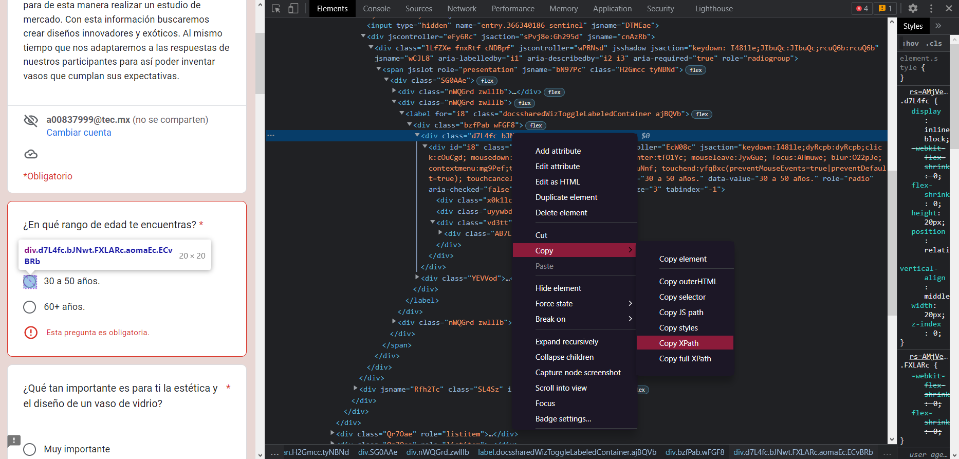

After copying the Xpath now we paste it into “opciones” here is an example:

Now we repeat this process with all the answers.

When you have the list with all the xpath answers go to the send button of the google forms.

The xpath put in this part of the script.

