MIPI PHY
Display
RISC PE
DDR 4
ISP / Open Source omni semi
CMOS Sensors

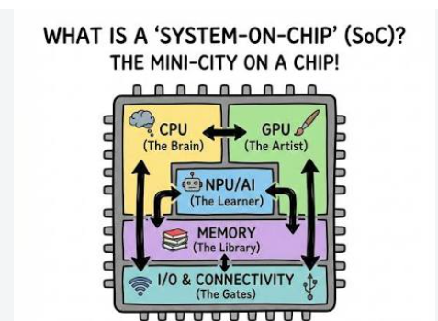

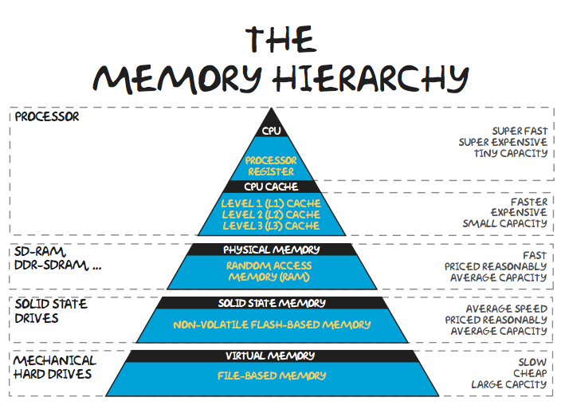

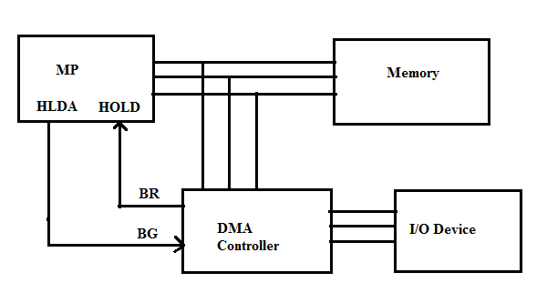

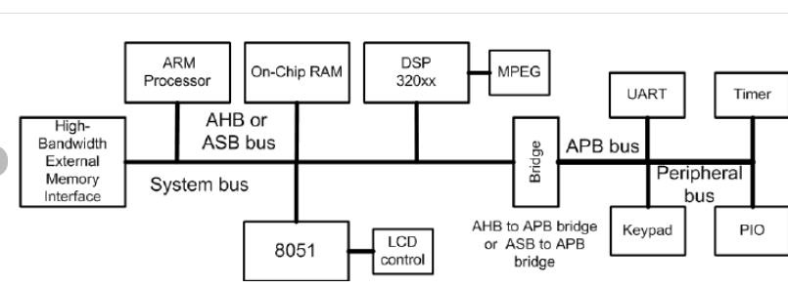

ARM APB, AHB, AXI, and CHI are on-chip communication standards that make up the Arm AMBA Specifications family, used to connect functional blocks inside a System-on-Chip (SoC). [1, 2, 3]

Protocol Comparison
Protocol | Full Name | Primary Use Case | Key Characteristics
APB | Advanced Peripheral Bus | Low-power, low-bandwidth peripherals (UART, timers, GPIOs) | Simple, non-pipelined, single-master, synchronous, 2+ clock cycles per transfer, up to 32-bit.
AHB | Advanced High-Performance Bus | Mid-range CPUs, internal memory, and high-bandwidth interconnects | Pipelined, supports multi-master and burst data transfers; includes AHB-Lite for single masters up to 128-bit.
AXI | Advanced eXtensible Interface | High-performance, high-frequency system designs | Point-to-point, separated read/write channels (5 total), supports bursts, out-of-order transactions, and multiple outstanding addresses.
CHI | Coherent Hub Interface | Scalable, multi-core, heterogeneous computing with full cache coherency | Packet-based, layered architecture that separates protocol from transport layers, superseding older snoop-based ACE protocols.

Summary of How They Fit Together in an SoC
- APB sits at the edge of the chip for slow control registers and slow peripherals, connected to the faster backbone via an AHB-to-APB bridge.
- AHB acts as a reliable mid-range system bus for embedded processors like Cortex-M.
- AXI handles high-speed, parallel data movement (like DMA and main memory traffic) using decoupled independent channels.
- CHI scales this up for complex multi-core processors requiring strict hardware cache consistency over high-speed networks/meshes. [2, 4, 5, 6, 7, 8, 9]
If you'd like, let me know:
- Are you working on a VLSI design/verification project?
- Do you need deep details on signal handshaking (like READY/VALID) or cache line

NOC – CNS for SOC – Tile Cross

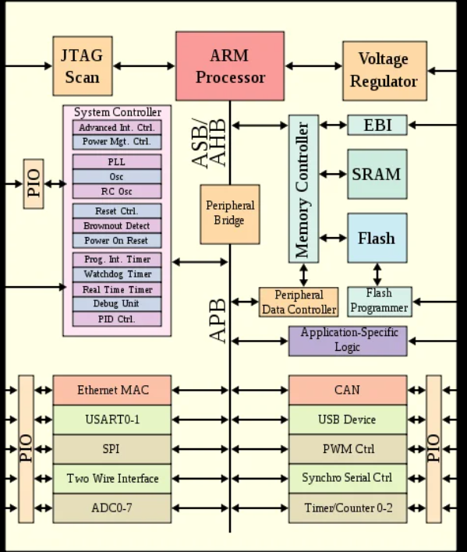

FPGAs – link for AMD
riscv-rocket-chip-tutorial-bootcamp-jan2015.pdf Rocket basic info
What Is a System-on-Chip? SoC Meaning, Architecture & Examples - AnySilicon simple soc definition
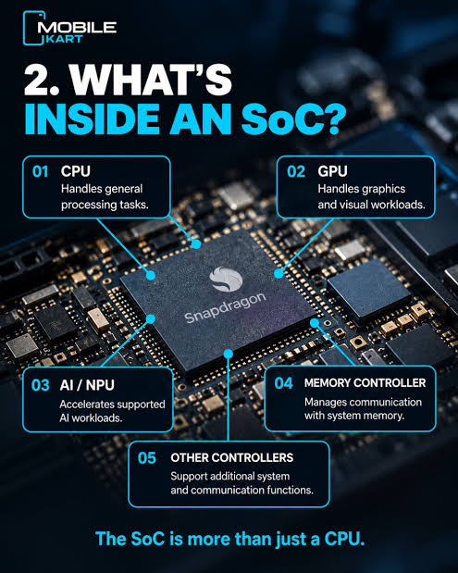
SK-KV260-G AMD, Vision AI Starter Kit, K26, 32 / 64bit | element14 India AMD KV260 data sheet here
Kria KV260 Vision AI Starter Kit
xilinx-kv260-product-brief.pdf
cnrv/rocket-chip-read: Comment on the rocket-chip source code
Digital Design with Chisel HDL for rocket chip
antmicro/fastvdma: Antmicro's fast, vendor-neutral DMA IP in Chisel DMA IP code
Mastering Xilinx DMA IP cores: AXIDMA, CDMA, VDMA on Linux Tutorials on IP cores example DMA
amd/mini-isp: A minimal, open-source Image Signal Processor (ISP) for AMD FPGA, implemented in Verilog.
Open source hardware accelerator subsystem for FPGA/ASICs
10x-Engineers/Infinite-ISP: A camera ISP (image signal processor) pipeline that contains modules with simple to complex algorithms implemented at the application level.
Kria KV260 FPGA ISP - Getting Started - Hackster.io
Hardware Architecture of the Platform — Kria™ KR260 2022.1 documentation
https://www.udemy.com/share/105d1u3@3OWiwQElOGexubxmq3aYY1CdARD6Yn322BIOsk_iuIpUHVQPi_3GiM8PZbzmPZUA/ Matlab to Xilinx system generator
https://www.udemy.com/course/fpga101-digital-system-design-using-verilog-and-python/learn/lecture/45116059#overview for everyone in the team
Untitled Document AMBA (Advanced Microcontroller Bus Architecture ) ARM
https://documentation-service.arm.com/static/64819f1516f0f201aa6b963c --> AXIStream
https://github.com/cnrv/rocket-chip-read/blob/master/tilelink/Xbar.md --> cross bar (Network on chip)
TileLink/README.md at master · merledu/TileLink NoC
Reference design:
10x-Engineers/github_ultraembedded_riscv_soc: Basic RISC-V Test SoC
SpinalHDL/VexRiscv: A FPGA friendly 32 bit RISC-V CPU implementation
riscv/learn: Tracking RISC-V Actions on Education, Training, Courses, Monitorships, etc.
suryakantamangaraj/awesome-riscv: RISC-V: Open-source instruction set architecture based on reduced instruction set computer principles.
eugene-tarassov/vivado-risc-v: Xilinx Vivado block designs for FPGA RISC-V SoC running Debian Linux distro
dineshannayya/riscduino: Arduino compatible Risc-V Based SOC
westerndigitalcorporation/RISC-V-Linux: This repository provides a Linux kernel bootable on RISC-V boards from SiFive
RISC-V Bytes: Cross-Platform Debugging with QEMU and GDB · Daniel Mangum
ash-olakangal/RISC-V-Processor: Verilog implementation of multi-stage 32-bit RISC-V processor
riscv-software-src/riscv-isa-sim: Spike, a RISC-V ISA Simulator
ombhilare999/riscv-core: A customized RISCV core made using verilog very basic
Verilog Code for 16-bit RISC Processor - FPGA4student.com very basic
rocket-chip/docs/src/diplomacy/adder_tutorial.md at master · chipsalliance/rocket-chip
ibex/examples/simple_system at master · lowRISC/ibex
ultraembedded/riscv_soc: Basic RISC-V Test SoC simple example
MuhammadMajiid/RV64IMAC: RV64IMAC modelling using System Verilog HDL
Kiruba-Selvakumar/RISC-V-Processor---Verilog-Implementation: A structural processor design based on the RISC-V ISA, implemented in Verilog. Features both a baseline single-cycle sequential processor and an optimized 5-stage pipelined architecture with robust hazard mitigation. Executes fundamental arithmetic, logical, memory, and branching instructions, verified through comprehensive GTKWave simulations. check this for basic introduction
Ritukrish/RISC-V-Pipeline-Processor: This repo contains the verilog code for simulation of 5 stage pipeline in RISC-V processor Check this for basic introduction

