ENTERPRISE AI ARCHITECTURE BLUEPRINT
ShopSmart AI
Autonomous E-Commerce Assistant & Intelligent Operations Platform
Node.js & Express · React 19 + Vite · PostgreSQL & pgvector · LangChain Multi-Agent · RAG

1. Executive Summary & Problem Context
The Vision: ShopSmart is a hyper-scale global marketplace connecting millions of customers to an extensive catalog spanning electronics, fashion, home appliances, books, healthcare, and groceries. While high catalog volume drives growth, it simultaneously introduces friction across customer engagement and merchant fulfillment.
Core Dilemma: Modern shoppers encounter decision paralysis when navigating multi-tiered catalogs, ambiguity around delivery timelines and return windows, and slow customer support channels. Simultaneously, operational and logistics teams struggle with cross-warehouse stock visibility, dynamic replenishment forecasting, and consistent fulfillment coordination.
ShopSmart AI resolves both ends of this equation by unifying Generative AI, Retrieval-Augmented Generation (RAG), and Agentic Workflows into a single cohesive e-commerce engine. The platform transforms passive search into proactive advisory and manual logistics into automated operational intelligence.
📌 Strategic Value Proposition
By integrating an Express.js backend with PostgreSQL + pgvector and LangChain multi-agent workflows, ShopSmart delivers sub-100ms structured intent understanding, 100% grounded policy retrieval with verbatim audit citations, and autonomous warehouse routing.

2. Technology Stack & Architectural Decision Records
The system embraces modern, modular, production-tested components designed for high concurrency and explainable AI operations:
Layer | Technology | Role & Rationale
Frontend UI | React 19 + Vite | High-performance SPA with modern React hooks, sub-second HMR, and smooth conversational streaming.
Styling System | Tailwind CSS v4 | Modern responsive design tokens, glassmorphism UI widgets, dark/light themes, zero runtime CSS.
Backend Runtime | Node.js 20 + Express.js | Asynchronous non-blocking event loop ideal for high-throughput I/O, streaming LLM completions, and REST APIs.
AI Orchestrator | LangChain.js | Multi-agent intent classification, structured tool invoking, context windowing, and RAG retrieval pipelines.
Vector Database | PostgreSQL 16 + pgvector | Consolidates relational ACID data and high-dimensional semantic vector embeddings into a single engine.
Embedding Model | text-embedding-3-small | 1536-dimensional semantic representations for catalog specs and enterprise compliance documents.
Foundation LLM | OpenAI GPT-4o / Gemini 1.5 | High-reasoning intent extraction, grounded answer generation, and explainable product recommendation reasoning.
Security & Auth | JWT + bcrypt (12 rounds) | Stateless, cryptographically signed user sessions with role-based access control (Basic, Prime, Premium, Admin).
Data Validation | Zod 3.x Schemas | Strict runtime schema validation across incoming request bodies, params, and AI structured JSON contracts.

Architectural Decision Record (ADR): Why Node.js & pgvector?
Unified Multi-Model Storage: Deploying a separate standalone vector database (such as Pinecone, Qdrant, or Weaviate) introduces dual-write synchronization bugs, eventual consistency drift, and redundant network latency. With PostgreSQL 16 and the pgvector extension, product metadata, inventory levels, user orders, and vector embeddings reside in the exact same transactional engine. An inventory decrease or product update occurs within a single atomic ACID transaction alongside its vector embedding update.
Node.js Event-Driven Performance: Node.js and Express offer native JSON interoperability, non-blocking I/O, and first-class LangChain.js support. The streaming capabilities of Express facilitate real-time token delivery to the React frontend while maintaining a lean microservice footprint.
3. End-to-End System Architecture Blueprint
The ShopSmart AI platform follows a clean four-tier architectural pattern separating presentation, gateway and security, application intelligence, and persistent multi-model data storage.
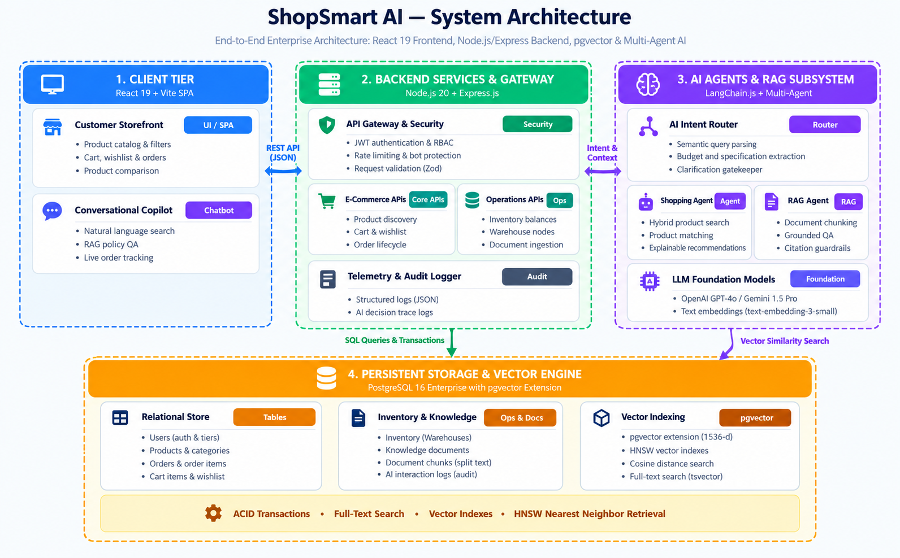
Figure: ShopSmart AI End-to-End System Architecture (Archify Style Blueprint)
Detailed Architectural Tier Breakdown
Tier 1: Client Experience Layer — Constructed with React 19 and Vite. Houses both the traditional e-commerce browsing journey (category trees, faceted filtering, comparisons, cart, checkout) and the interactive AI Conversational Copilot. Communicates strictly over TLS 1.3 via RESTful JSON APIs.
Tier 2: API Gateway & Application Services — Powered by Node.js and Express. Implements defense-in-depth through Helmet HTTP security headers, CORS origin whitelisting, rate limiting per IP, and JWT token authentication with RBAC. Dispatches validated payloads to domain-specific services.
Tier 3: AI Agents & RAG Subsystem — The cognitive heart of ShopSmart. Orchestrated via LangChain.js, incoming customer queries are routed to specialized sub-agents (Shopping Intent, Knowledge RAG, Logistics, Operations). Each agent executes isolated tools with strict output constraints.
Tier 4: Relational & Vector Storage Layer — PostgreSQL 16 acts as both the relational system of record and the high-speed semantic search index. GIN indexes power full-text lexical queries, while HNSW vector indexes calculate Cosine Distance (<=>) for 1536-dimensional embeddings in under 12 milliseconds.
4. Core Intelligent Pipelines: Discovery & RAG
ShopSmart AI addresses the hackathon's two core functional mandates through two specialized, decoupled pipelines:
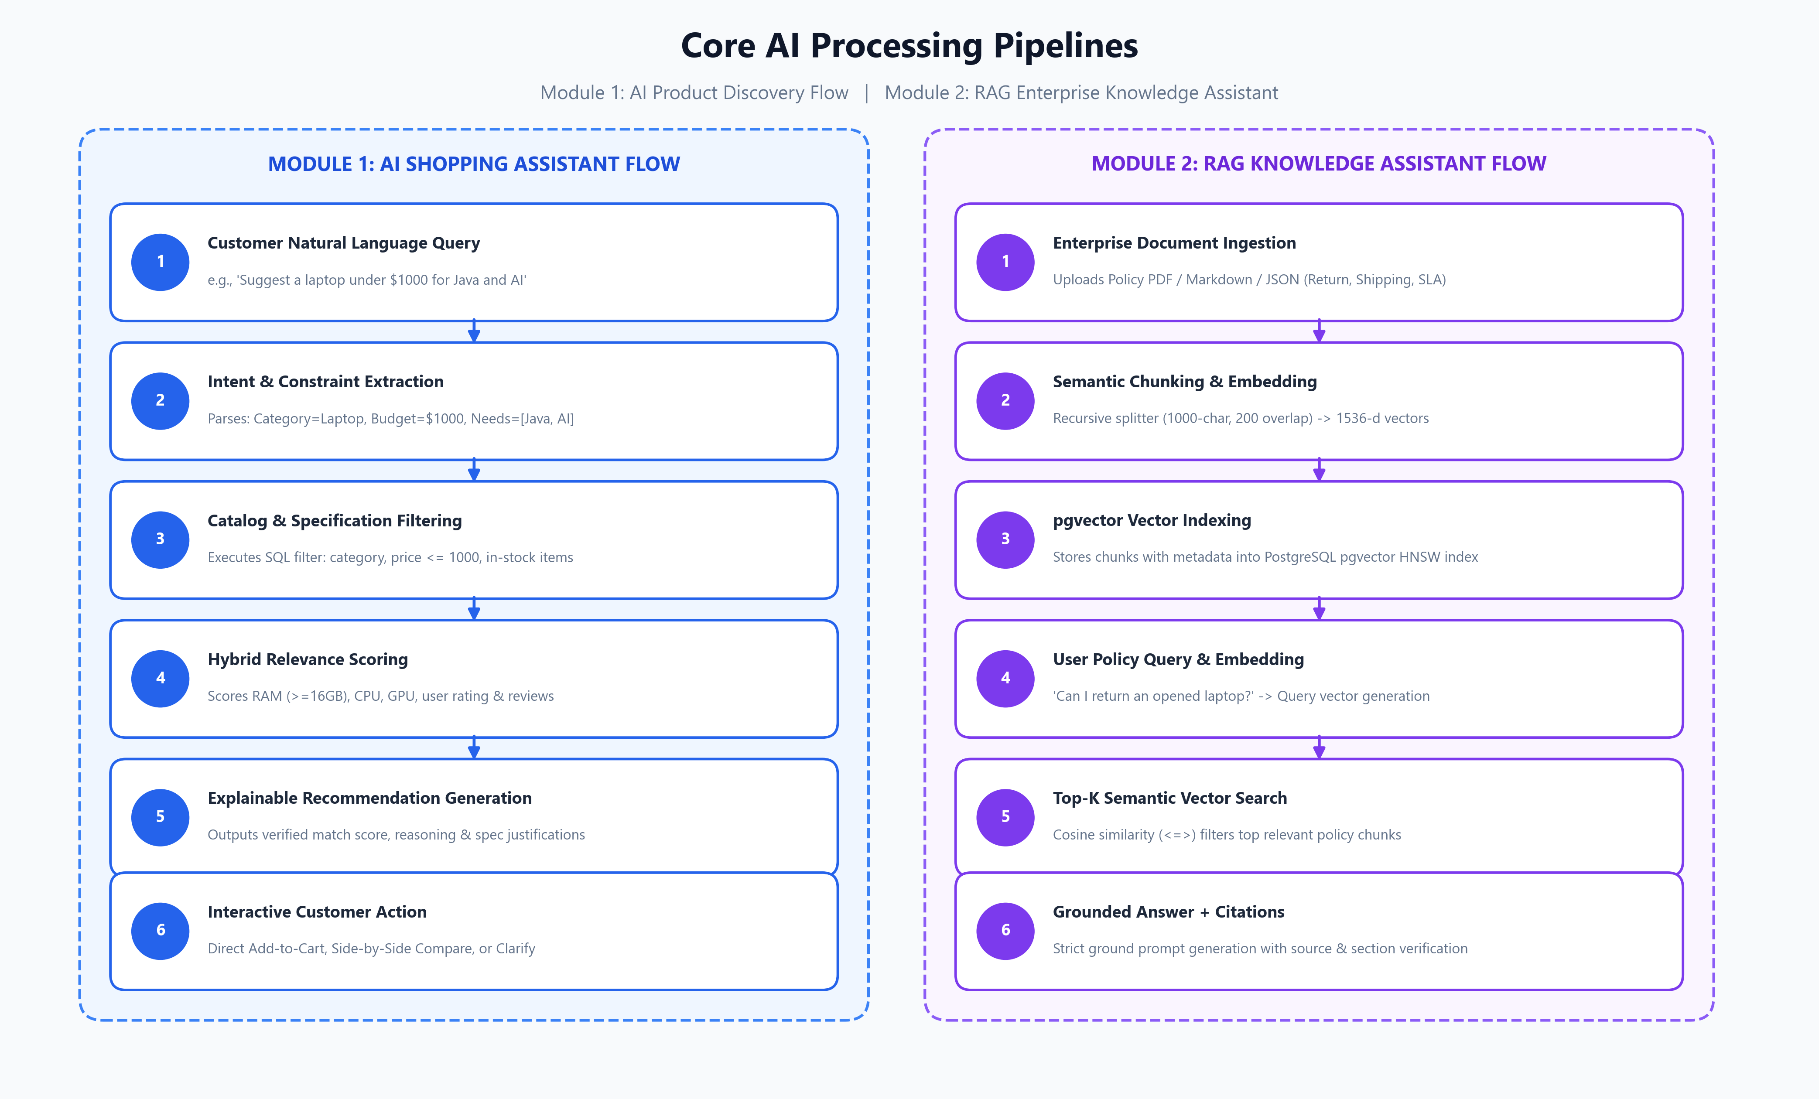
Figure: Step-by-Step Execution Workflows: Module 1 (Shopping Flow) and Module 2 (RAG Flow)
Module 1: AI-Powered Product Discovery Flow
Workflow Analysis: When a user enters a complex prompt like 'Suggest a laptop under $1000 for Java development and AI projects', the Shopping Agent initiates a multi-stage evaluation:
1. Semantic Intent Extraction: Identifies product category (Laptop), budget ceiling ($1000), and targeted use cases (Java Development, AI/Machine Learning).
2. Specification Filtering: Derives mandatory hardware baselines (RAM >= 16GB, multi-core CPU, dedicated SSD storage).
3. Hybrid Multi-Factor Ranking: Evaluates matching items based on price-to-budget ratio, customer rating, review volume, and in-stock inventory status.
4. Explainable Response Generation: Produces a structured JSON payload containing exact product codes, real-time prices, and human-readable justifications.
Module 1 Contract Specification
📌 Module 1 AI Response Contract (JSON)
{
"interpretedRequirement": "Laptop for Java development and AI learning",
"budget": 1000,
"extractedFeatures": ["16GB+ RAM", "SSD storage", "multi-core processor"],
"recommendations": [
{
"productId": "LAP101",
"productName": "Dell Inspiron 15",
"price": 899.99,
"rating": 4.5,
"reason": "16GB RAM, Intel i7-13th gen, 512GB SSD — ideal for Java IDEs and ML frameworks",
"matchScore": 0.92,
"availability": "IN_STOCK"
}
],
"clarifyingQuestion": null
}

Module 2: RAG Enterprise Knowledge Assistant
Zero-Hallucination Policy: To guarantee that answers to critical policy inquiries (returns, shipping guarantees, warranties) are 100% truthful and grounded in corporate policy, the RAG agent employs an enterprise ingestion and retrieval pipeline:
1. Multi-Format Ingestion: Ingests PDF, Markdown, and JSON documents with document category, effective date, and version metadata.
2. Semantic Text Chunking: Applies a recursive character splitter with 1000-character windows and 200-character overlaps to maintain sentence integrity across boundaries.
3. Vector Retrieval: Queries are vectorized and matched against stored chunks in pgvector using Cosine Similarity.
4. Grounded Prompting & Hallucination Guard: The LLM is instructed under strict system rules to answer exclusively from the provided context. If context is insufficient, it responds with a graceful fallback.
Module 2 Contract Specification
📌 Module 2 RAG Response Contract (JSON)
{
"answer": "Opened laptops can be returned within 7 days of delivery if no physical damage is present. A restocking fee of 10% applies.",
"confidence": "HIGH",
"sources": [
{
"document": "Laptop Return Policy",
"section": "Section 3.2 — Opened Products",
"version": "2026.1",
"relevanceScore": 0.94
}
],
"followUpRequired": false
}

5. Relational & Vector Schema Design
The database architecture balances normalized relational entity management with optimized vector indexes for low-latency similarity lookups:
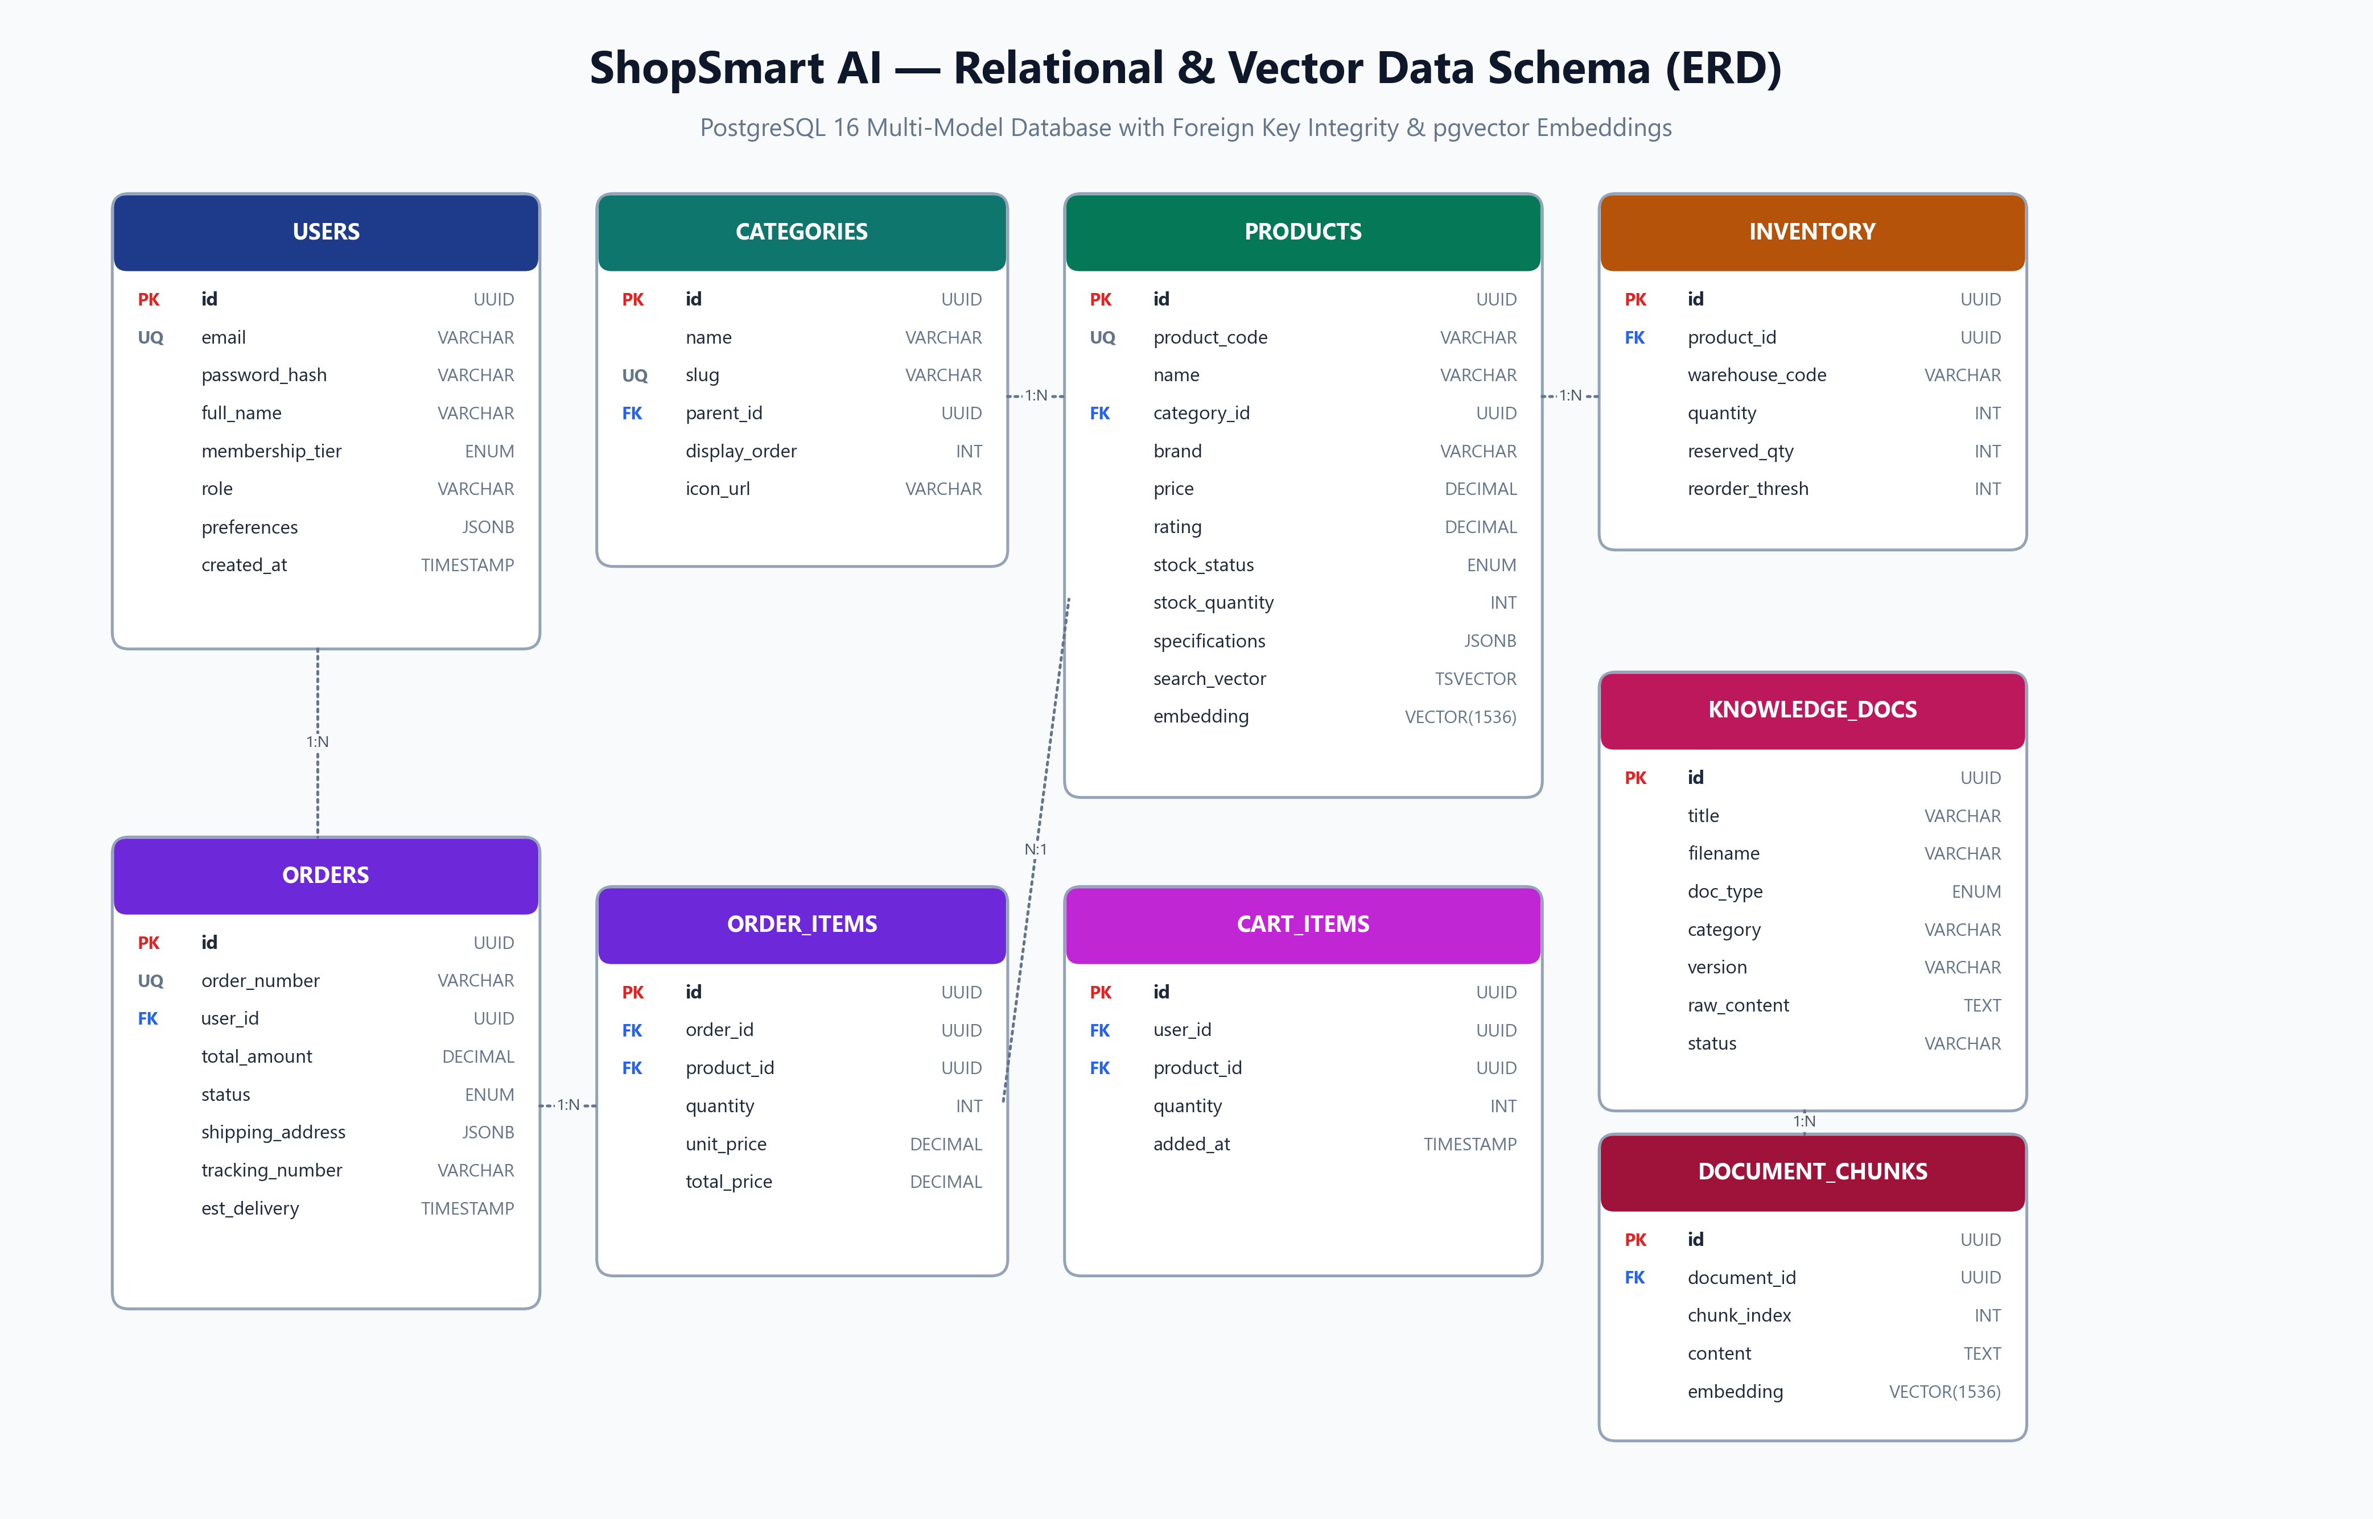
Figure: Complete Relational and Vector Entity Relationship Diagram (ERD)
Core Tables & Entity Definitions
Table Name | Primary Keys / FKs | Key Attributes & Purpose
users | PK: id (UUID) | email, password_hash, full_name, membership_tier (BASIC/PRIME/PREMIUM), role, preferences (JSONB)
categories | PK: id, FK: parent_id | name, slug, display_order, icon_url. Self-referencing FK allows arbitrary tree depth.
products | PK: id, FK: category_id | product_code, name, brand, price, rating, review_count, stock_status, specifications (JSONB), search_vector (TSVECTOR), embedding (VECTOR 1536)
inventory | PK: id, FK: product_id | warehouse_code (WH-EAST, WH-WEST, etc.), quantity, reserved_quantity, reorder_threshold
orders | PK: id, FK: user_id | order_number, total_amount, status (PLACED/CONFIRMED/SHIPPED/DELIVERED), shipping_address (JSONB), tracking_number, estimated_delivery
order_items | PK: id, FK: order_id, product_id | quantity, unit_price, total_price. Immutable historical pricing snapshot.
cart_items | PK: id, FK: user_id, product_id | quantity, added_at. Unique constraint on (user_id, product_id).
wishlist_items | PK: id, FK: user_id, product_id | added_at. User saved product wishlists.
knowledge_documents | PK: id | title, filename, doc_type, category, version, region, raw_content, status (PROCESSING/ACTIVE/ARCHIVED)
document_chunks | PK: id, FK: document_id | chunk_index, content (TEXT), embedding (VECTOR 1536), metadata (JSONB)
ai_interactions | PK: id, FK: user_id | interaction_type, user_query, ai_response (JSONB), confidence_score, latency_ms. Audit trail.

Database Indexing Strategy
To guarantee high query throughput even under heavy concurrent load, the schema establishes specialized indexing structures:
• GIN Full-Text Index: Created on `products.search_vector` driven by an automated PostgreSQL trigger for instant lexical matching across name, brand, and description.
• HNSW Vector Indexes: Configured with `m=16, ef_construction=64` on `document_chunks.embedding` and `products.embedding` for logarithmic approximate nearest neighbor retrieval.
• B-Tree Composite Indexes: Established on `(user_id, status)` on orders and `(category_id, price, rating)` on products to ensure instantaneous faceted filtering.
6. Multi-Agent AI Collaboration Framework
Rather than relying on a single monolithic prompt, ShopSmart AI employs a decentralized multi-agent system where specialized sub-agents coordinate through a Master Orchestrator:
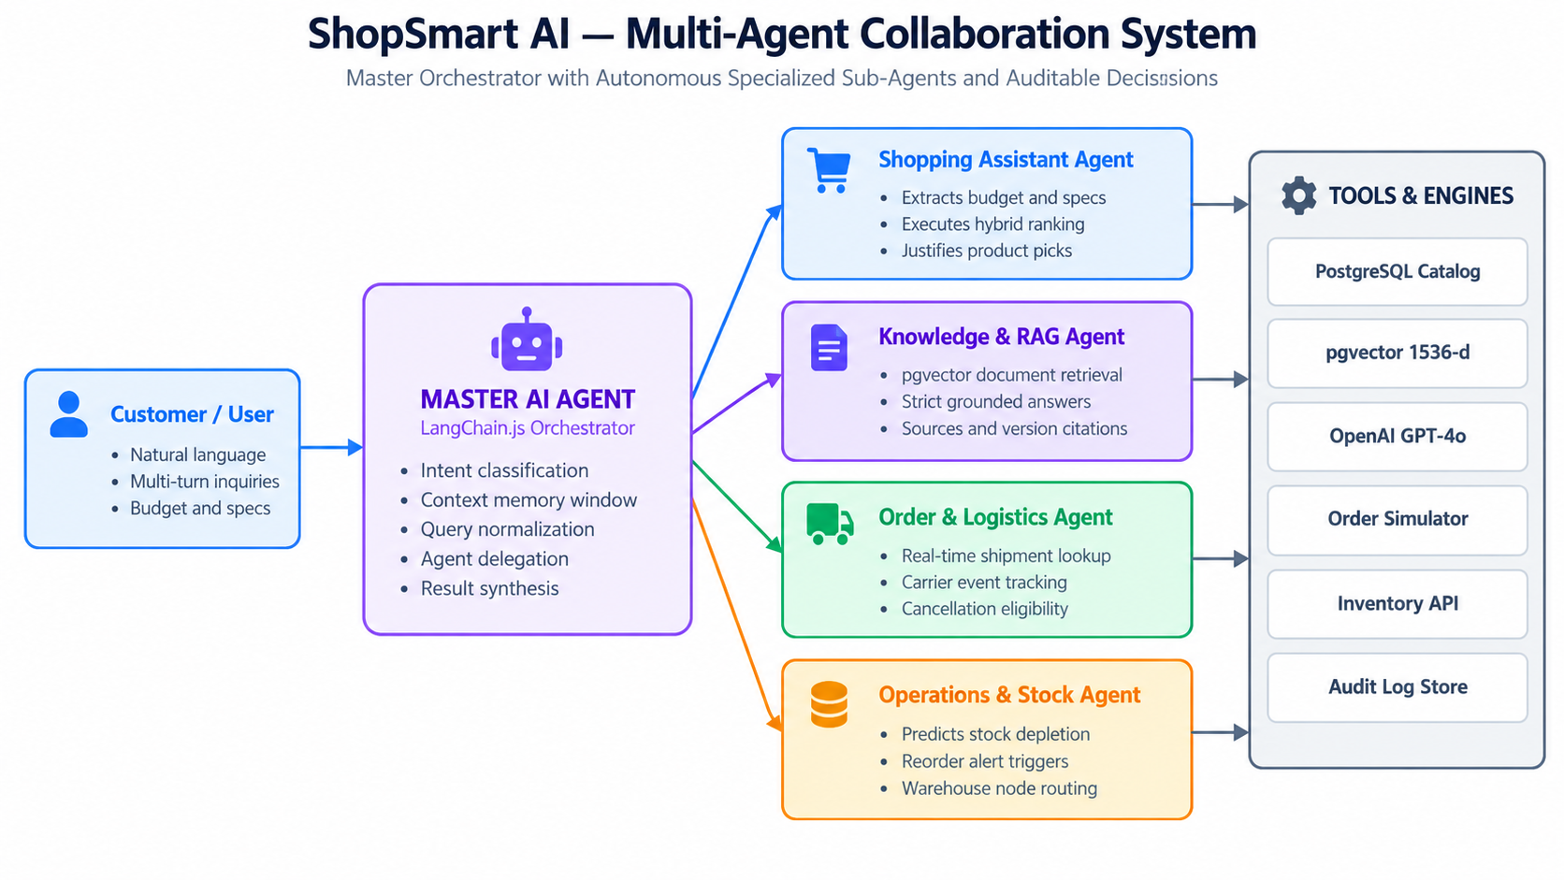
Figure: Autonomous Multi-Agent Collaboration Framework & Tool Execution
Agent Roles & Capabilities
Agent Name | Specialized Responsibilities | Tools Utilized
Master AI Router | Intent classification, session memory retention, query disambiguation, and inter-agent task delegation. | Memory Store, Session Context
Shopping Agent | Parses user budget, extracts technical specifications, runs hybrid ranking, generates explainable recommendations. | Product Catalog Tool, Vector Search Tool, Price Calculator
Knowledge RAG Agent | Executes semantic retrieval across approved enterprise policies, validates context, and generates grounded citations. | pgvector Document Search, Citation Validator
Logistics & Order Agent | Simulates order lifecycle states, delivers tracking timeline events, and processes cancellation validations. | Order Lookup Tool, Tracking Simulator
Operations Agent | Monitors multi-warehouse stock levels, identifies reorder thresholds, and alerts operational staff to stock-outs. | Warehouse Inventory Tool, Restock Alert API

7. RESTful API Architecture & Endpoints
The backend exposes clean, versioned, RESTful endpoints grouped by domain:
Method & Endpoint | Domain | Description & Request Payload | Auth Level
POST /api/auth/register | Auth | Register user with email, password, full_name, membership_tier | Public
POST /api/auth/login | Auth | Authenticate credentials; returns JWT session token | Public
GET /api/auth/me | Auth | Fetch current authenticated user profile & preferences | User JWT
GET /api/products | Catalog | Query products with full-text search, filters, sorting, and pagination | Public
GET /api/products/:id | Catalog | Retrieve comprehensive product specifications and inventory status | Public
GET /api/products/compare | Catalog | Compare 2 to 4 products side-by-side by specification matrix | Public
GET /api/categories | Catalog | Retrieve complete nested hierarchical category tree | Public
GET /api/cart | Shopping | Retrieve user cart items, prices, and subtotal calculation | User JWT
POST /api/cart | Shopping | Add item with quantity to cart (idempotent upsert) | User JWT
PUT /api/cart/:id | Shopping | Update quantity for specific cart item | User JWT
DELETE /api/cart/:id | Shopping | Remove item from cart | User JWT
POST /api/orders | Orders | Convert active cart into placed order with delivery address | User JWT
GET /api/orders | Orders | List user order history with item summaries | User JWT
GET /api/orders/:id/track | Orders | Track shipment timeline and carrier milestone events | User JWT
POST /api/ai/recommend | AI Agent | Natural language shopping query; returns explainable product picks | User JWT
POST /api/knowledge/ask | AI RAG | Ask enterprise policy questions; returns grounded answer + citations | User JWT
POST /api/admin/documents/upload | Admin | Upload PDF/MD/JSON policy files for vector ingestion | Admin Role
GET /api/admin/inventory | Admin | View real-time multi-warehouse stock balances and alerts | Admin Role

8. Security Architecture & AI Audit Governance
Defense-in-Depth: Because ShopSmart AI handles user credentials, financial transactions, and AI-driven advice, security and explainability are enforced through nine structural defense layers:
1. Cryptographic Authentication: Stateless JWT tokens with 24-hour expiration and bcrypt password hashing with 12 salt rounds.
2. Role-Based Access Control (RBAC): Strict middleware guards enforcing customer vs administrative boundaries.
3. Rate Limiting: IP-based sliding window rate limiters (100 req/min general, 10 req/min for AI endpoints, 20 per 15 min for auth).
4. SQL Injection Protection: Parameterized queries across all database drivers.
5. AI Prompt Injection Defense: System prompt isolation, input sanitization, and structured JSON output schema enforcement.
6. Comprehensive AI Audit Logging: Every recommendation and RAG response is recorded in the `ai_interactions` table capturing the raw query, user ID, model response, confidence score, and latency.
📌 Auditable & Explainable AI Mandate
Every AI-driven output in ShopSmart AI is fully explainable. Recommendations provide human-readable 'reason' strings tied directly to verified hardware specs, and RAG answers provide document title, section heading, version number, and relevance confidence.

9. Repository Structure & Execution Instructions
The project follows a clean monorepo architecture separating the client SPA and the backend service:
Clean Monorepo Layout:
├── client/ # React 19 + Vite Frontend SPA
│ ├── src/components/ # UI components (Catalog, Cart, Copilot, Compare)
│ ├── src/pages/ # Route views (Home, Products, Orders, Admin)
│ ├── src/services/ # Axios API clients
│ └── src/store/ # Zustand state management
├── server/ # Node.js + Express Backend Engine
│ ├── src/config/ # Database pool, AI configs, environment
│ ├── src/middleware/ # Auth JWT, Role Guard, Rate Limiter, Zod
│ ├── src/migrations/ # Automated PostgreSQL DDL + pgvector migrations
│ ├── src/seeds/ # Comprehensive mock data (Users, Catalog, Docs)
│ ├── src/services/ # Domain business logic
│ │ └── ai/ # Shopping Agent, RAG Knowledge Agent, Orchestrator
│ └── src/routes/ # Express route dispatchers
├── diagrams/ # 300 DPI Archify-Style Architecture Blueprints
└── ShopSmart_AI_Architecture.docx # This Comprehensive Master Document
Quickstart Deployment Instructions
1. Start PostgreSQL with pgvector: docker run -p 5432:5432 -e POSTGRES_PASSWORD=postgres pgvector/pgvector:pg16
2. Run Database Migrations: cd server && npm run migrate
3. Seed Mock Enterprise Data: cd server && npm run seed
4. Start Express Backend: cd server && npm run dev (Running on port 5000)
5. Start React 19 Frontend: cd client && npm run dev (Running on port 5173)

