1. Add new fields to Add Expense Page

<https://fin.trainingdata.org/fin/add>

* Add Adjusted Month
* Add Adjusted Year

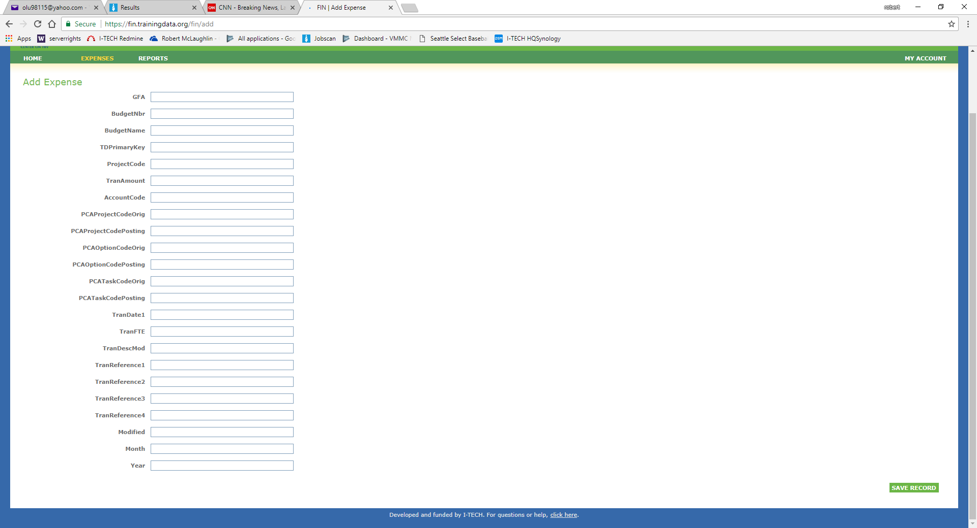

Add Adjusted Month and Adjusted Year to the bottom of the fields already on the page.

1. Change search functionality on preview page

<https://fin.trainingdata.org/fin/search>

* TDPrimary Key search they would like it to be a wildcard search or just have to put in 12 digits And the system returns any likes

1. Change heading columns in bulk Export

<https://fin.trainingdata.org/fin/search?limit=1&gfaInput=&budgetNbrInput=&showBudgetName=on&budgetNameInput=&showTDPrimaryKey=on&tdprimarykeyInput=&showProjectCode=on&projectCodeInput=all&showTranAmount=on&showAccountCode=on&accountCodeInput=&showPCAProjectCodeOrig=on&pcaProjectCodeOrigInput=&showPCAProjectCodePosting=on&pcaProjectCodePostingInput=&showPCAOptionCodeOrig=on&pcaOptionCodeOrigInput=&showPCAOptionCodePosting=on&pcaOptionCodePostingInput=&showPCATaskCodeOrig=on&pcaTaskCodeOrigInput=&showPCATaskCodePosting=on&pcaTaskCodePostingInput=&showTranFTE=on&tranFTEInput=&showTranDate1=on&tranDate1Input=&showTranDescMod=on&tranDescModInput=&showTranReference1=on&tranReference1Input=&showTranReference2=on&tranReference2Input=&showTranReference3=on&tranReference3Input=&showTranReference4=on&tranReference4Input=&showModified=on&modifiedInput=&showFiscalMonth=on&fiscalmonthInput=&showFiscalYear=on&fiscalyearInput=&showItechMonth=on&itechmonthInput=&showItechYear=on&itechyearInput=&start-day=1&start-month=4&start-year=2018&end-day=28&end-month=06&end-year=2018&limit=1&go=Preview>

* Fiscal Year change to Year
* Fiscal Month change to Month

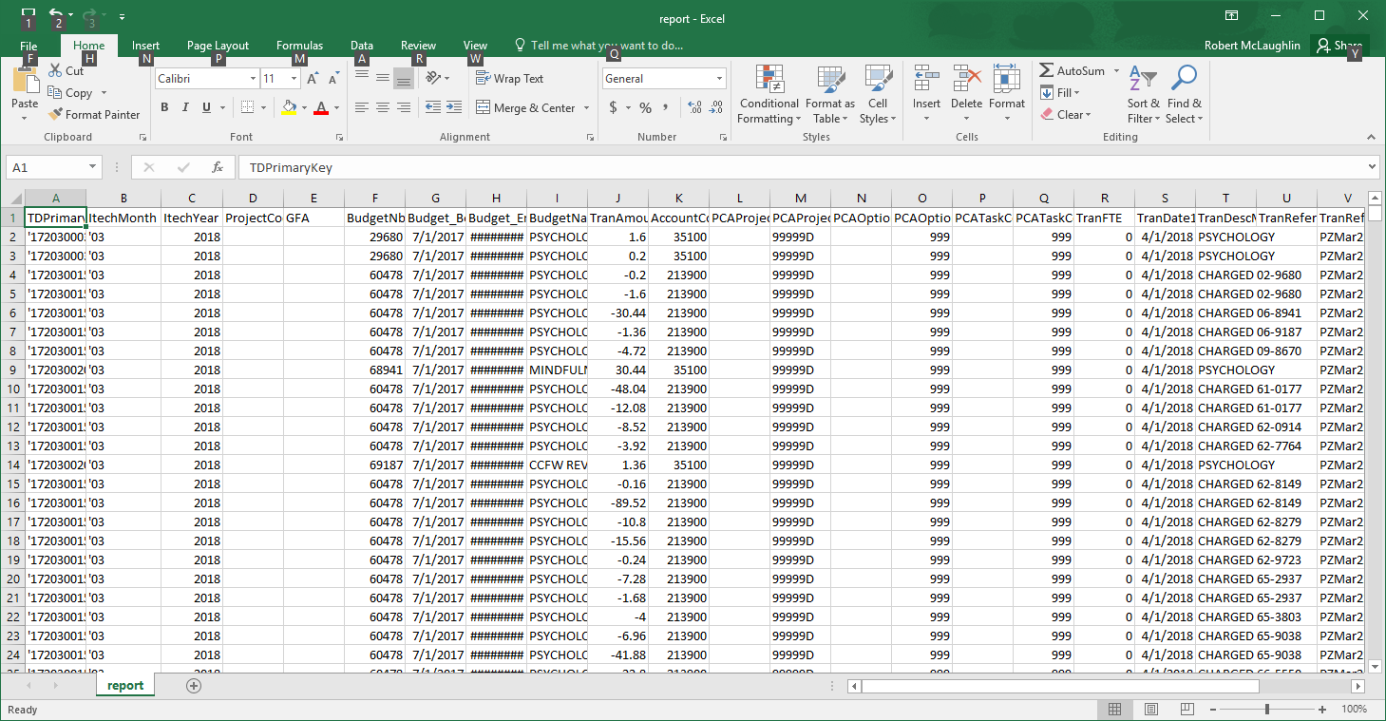

* ITECHYear change to AdjustedYear
* ITECHMonth change to AdjustedMonth

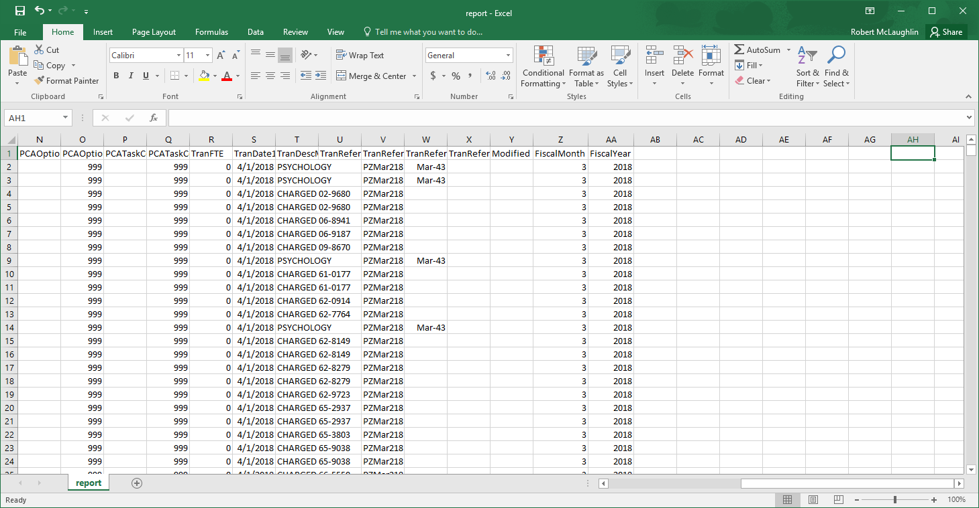

1. Add the ability to query all GFAs

<https://fin.trainingdata.org/fin/search>

* In GFA field add ability to search for all GFAs

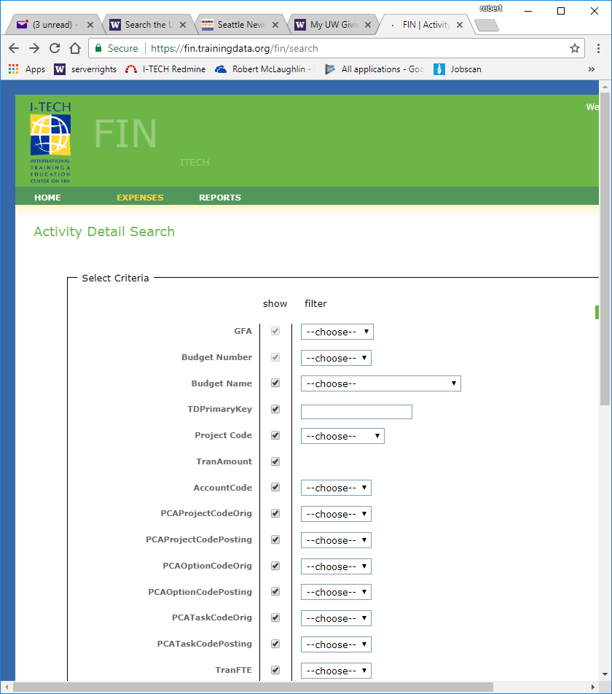

1. Modify the export to pull these 4 columns from the EDW

IDC_Rate, Budget_Status, Budget_Begin, Budget_End

1. Import these 4 columns during the bulk import

IDC_Rate, Budget_Status, Budget_Begin, Budget_End

1. Add 4 additional columns to the Activity Detail Search Page

<https://fin.trainingdata.org/fin/search>

IDC_Rate, Budget_Status, Budget_Begin, Budget_End