OECSM Setup Instructions
The following are the specific functions of the OECSM in regard to CPAD database;
- Mine source database metadata from the CPAD database
- Mine source database metadata from the shadow database (for a case whereby you are running it for the first time, this does not happen.)
- Compare source database metadata mined from the CPAD database and that mined from the shadow database if the data exists
- Generate transactions to be executed against the shadow database to reflect changes to the source database schema
- Apply the transactions generated in 4 above to the shadow database

Step one : Acquire the C-PAD database:

Use the same steps when setting up cpad companion DSN
To setup an ODBC connection to allow the OECSM to read the C-PAD database, follow these steps:
- Open the ODBC Data Source Administrator control panel in Windows (search for ‘odbc’ in the Start menu).
- Go to the ‘System DSN’ tab.
- Click the ‘Add…’ button.
- Select ‘Microsoft Access Driver (*.mdb)’ and click the ‘Finish’ button.
- Enter ‘cpad_companion’ in the ‘Data Source Name:’ field.
- Enter ‘CPAD data connector’ in the ‘Description:’ field.
- Click the ‘Select…’ button underneath the ‘Database:’ text.
- Navigate to the C-PAD installation directory and select the ‘CCC Patient Application Database.mdb’ file in the file window. Then, click the ‘OK’ button.
- Click the ‘OK’ button on the main ‘ODBC Microsoft Access setup’ window.
- You should now see the ‘cpad_companion’ data source in the list of sources.

Configure OECSM properties file:
To configure the OECSM properties file, below are the steps
- Open the E:\OpenEMRConnect\oecsm folder ;
- Locate a file called source_database.properties and configure the source where OECSM will be reading data from. For example for the case of CPAD these are the settings in my machine;
#Tue Jan 17 10:32:22 EAT 2012
password=nairobi
url=jdbc\:odbc\:cpad_companion
driver=sun.jdbc.odbc.JdbcOdbcDriver
database=CCC
username=guest

- Locate a file called shadow_database.properties and configure the shadow where OECSM will dump data mined from the source . For example for the case of CPAD these are the settings in my machine;
#Fri Aug 19 10:55:42 EAT 2011
url=jdbc\:mysql\://localhost\:3306/shadow
driver=com.mysql.jdbc.Driver
database=CPAD
username=root
password=root

- Build your shadow database using the sql script provided in the path where your OpenEMRConnect project folder resides i.e. E:\OpenEMRConnect\oecsm\database

- If you do not want to run OECSM using the IDE , copy the properties file for OECSM into the dist folder in the OpenEMRConnect project folder i.e E:\OpenEMRConnect\oecsm\dist
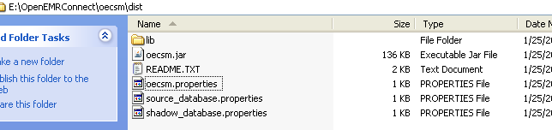

- If you want to check how many transactions and whether inserts, updates or deletes and have been inserted into the shadow database. Log into mysql and run the following query;
SELECT TYPE, COUNT(*), MIN(id), MAX(id), MIN(created_datetime), MAX(created_datetime)
FROM shadow.`transaction`
GROUP BY type

- The OECSM will run on the background as it listens to any change in the source database and will put the log into the shadow.

END.

