*MediAnalyze: A Cloud Based Medical Diagnosis System*

Kunisetty Jaswanth  
*Department. of Computer Science and Engineering*  
*Amrita School of Computing, Bengaluru, Amrita Vishwa Vidyapeetham, India.*  
jaswanthkunisetty3301@gmail.com

S Sruthi   
*Department. of Computer Science and Engineering*  
*Amrita School of Computing, Bengaluru, Amrita Vishwa Vidyapeetham, India.*  
ssruthi1202@gmail.com

Pranav Ramachandrula  
*Department. of Computer Science and Engineering*  
*Amrita School of Computing, Bengaluru, Amrita Vishwa Vidyapeetham, India.*  
pranavramachandrula@gmail.com

Jayana Abhigna Sree  
*Department. of Computer Science and Engineering*  
*Amrita School of Computing, Bengaluru,*

*Amrita Vishwa Vidyapeetham, India*

abhignasree2002@gmail.com

Dr. Beena B.M

*Department. of Computer Science and Engineering*  
*Amrita School of Computing, Bengaluru,*

*Amrita Vishwa Vidyapeetham, India*

bm_beena@blr.amrita.edu

***Abstract* - A Cloud-Based Medical Imaging Diagnosis Platform, leveraging AWS cloud services to automate, secure, and enhance diagnostic tools for medical image analysis. By incorporating AWS Cognito for user authentication and AWS SageMaker for deep learning models, the platform ensures real-time analysis while adhering to healthcare regulations. Designed for affordability, it utilizes the AWS Free Tier, prioritizing data privacy through HIPAA compliance with AWS CloudWatch for monitoring and AWS S3 for secure data management. The user-friendly interface facilitates image uploads, aiming to improve diagnostic precision and expedite patient care. Future enhancements include increased analysis capabilities, collaborative features, and mobile accessibility, marking a significant advancement at the intersection of cloud computing and healthcare.**

***Keywords—*** ***AWS Cognito, AWS SageMaker, AWS ECS, AWS ECR, HIPPA***

# INTRODUCTION

With the help of AWS cloud services, the proposed project seeks to create a cloud-based platform for medical imaging diagnosis that will analyze medical images automatically, securely, and effectively. This platform will make use of deep learning models to allow users to upload and manage imaging data, obtain real-time analysis, and guarantee conformity to healthcare regulations. It has been designed to be an affordable option that improves diagnostic precision and helps medical staff provide prompt patient care.

It involves AWS Cognito for user authentication, deep learning models on AWS SageMaker for real-time diagnostic analysis, and an easy-to-use interface for uploading images. Ensuring data privacy and security, the platform is built to be HIPAA-compliant with AWS CloudWatch for performance monitoring and AWS S3 for secure data management.

The platform's goal is to be as economical as possible, so it makes use of the AWS Free Tier to reduce running costs. It also has plans to add more analysis power, healthcare professional collaboration features, and mobile access in the future to increase its usefulness and accessibility. This scalable solution represents a significant advancement at the nexus of cloud computing and healthcare, as it aims to support timely patient care in addition to improving diagnostic accuracy.

# LITERATURE SURVEY

The authors of [1] presented an Enhanced Deep Learning Assisted Convolutional Neural Network (EDCNN) for heart disease prediction. The EDCNN, designed for the Internet of Medical Things (IoMT), aims to assist in diagnosing heart disease using detailed, precise clinical data analysis. It features a deep architecture with multi-layer perceptron models and regularization learning approaches. The system is tested on various features, showing a high accuracy (up to 99.1%) in heart disease risk level determination, outperforming conventional methods like ANN, DNN, and RNN. The research demonstrates the potential of EDCNN in global healthcare, especially in resource-constrained settings.

The authors of [2] discuss a cloud-based diagnostic platform for obstetric imaging. This platform integrates cloud computing, caching technology, and distributed file systems. It utilizes contrast-enhanced ultrasound technology to provide more precise ultrasound images for assessing placental structure and abnormalities. The platform is designed for efficient storage and diagnosis of obstetric images, with experiments showing its effectiveness in reducing medical equipment costs and improving diagnostic efficiency and accuracy.

The authors of [3] introduced TOMAAT, a framework for cloud-based medical image analysis. It enables the deployment of high-dimensional deep learning models for tasks like segmentation, registration, and landmark localization. TOMAAT consists of server nodes (prediction endpoints), client nodes, and an announcement service acting as a public registry of models. It demonstrates high efficiency and interactivity in medical image analysis tasks, significantly reducing the need for high-performance hardware and complex setup for end users.

The authors of [4] presented an IoMT (Internet of Medical Things) cloud-based model for predicting breast cancer stages. It employs deep learning techniques to accurately detect breast cancer stages, showing high accuracy in both training and validation phases. This model significantly enhances the efficiency of breast cancer diagnosis and stage prediction, demonstrating its potential to reduce breast cancer mortality rates.

The authors of [5] introduced a cloud-based clinical diagnosis system using AWS, designed to enhance the accessibility and accuracy of medical diagnoses. The system leverages decision tree algorithms and multi-classification neural net models to diagnose diseases, focusing initially on Pyrexia of Unknown Origin (FUO) as a case study. The software aims to provide efficient diagnosis, especially in resource-limited settings, and is adaptable for other symptoms. It improves diagnostic processes by integrating advanced machine learning techniques with clinical data.

The authors of [6] present a HIPAA-compliant auditing system designed for medical imaging systems like PACS and RIS. It focuses on establishing audit controls as mandated by HIPAA, using the DICOM standard's Supplement 95: Audit Trail Messages. The system ensures secure and monitored data flow, maintaining the integrity and confidentiality of Protected Health Information (PHI). This approach enhances healthcare privacy and security by providing a robust framework for auditing activities and detecting non-compliant behavior.

The authors of [7] focuses on creating a web application for managing Patient Health Records (PHRs) using Amazon Cloud. It utilizes an item-based collaborative filtering algorithm for generating hospital recommendations based on user data and ratings. The system enhances healthcare by providing easy access to PHRs and personalized hospital suggestions, thereby improving patient engagement in healthcare and decision-making. This approach also aims to reduce administrative costs and improve data portability.

# METHODOLOGY

## AWS services used:

*IAM (Identity and Access Management)* – Used for Managing access to AWS resources securely with the help of Amazon Web Services (AWS). You can manage who has access to what in your AWS account with IAM. To grant or refuse access to AWS services and resources, it assists you in setting up and managing users, groups, and permissions.

*ECS (Elastic Container Service)* – It is a completely managed container orchestration service. In a cluster, it enables you to start, stop, and control Docker containers. Installing, running, and scaling your container orchestration infrastructure is no longer necessary with ECS.

*ECR (Elastic Container Registry)* – It is a completely managed Docker container registry. You can use it to deploy, manage, and store Docker container images. ECR offers safe, scalable storage for your Docker images and works in unison with ECS.

*Fargate –* It is a container-focused serverless compute engine. It enables you to operate containers without having to take care of the supporting infrastructure. It relieves you of the burden of scaling virtual machines so you can concentrate on developing and implementing your containerized applications.

*Sagemaker* – It is a fully managed machine learning solution. Developers and data scientists can create, train, and implement machine learning models at scale with SageMaker,

*S3* - Scalable object storage is provided by S3, which lets you store and retrieve any volume of data. It is made to be scalable, readily available, and extremely durable.

*Cognito* - For web and mobile applications, Cognito offers user management, authorization, and authentication. Access control, sign-in, and sign-up for users are supported.

*Cloudwatch* – It is an observability and monitoring tool that gives you information about the services, apps, and resources you use on AWS.

*KMS (Key Management Service) -* With the help of this managed service, you can easily generate and manage the encryption keys that are used to protect your data.

*EC2 (Elastic Compute Cloud) -* Resizable computing capacity in the cloud is offered by the web service EC2. Instances, or virtual servers, can be operated by users in the AWS cloud.

*VPC (Virtual Private Cloud)* - You can launch AWS resources in a virtual network of your choosing within a logically isolated area of the Amazon Web Services (AWS) Cloud. It gives you complete control over your virtual networking environment,

*Billing and Cost Management console* - AWS account holders can view and manage their billing and cost information via the web-based Billing and Cost Management console. It offers features and tools for tracking, evaluating, and managing the expenses related to using AWS services.

## Dataset

*Pneumonia Detection:* This dataset is around 4 GB taken from Kaggle with dataset named as “Chest X-Ray Images (Pneumonia)”. The images are X-ray and of RGB scale consisting 5856 in total with 3875 Pneumonia and 1341 Normal chest X-ray images. The fig 1.1 below shows a sample image from the dataset.

Fig 1.1: Lung X-Ray sample image

*RSNA Bone Age:* This dataset is around 12 GB of size and it consists of 12,600 images in total. The dataset is taken from Kaggle. The dataset has X-ray images of palms for both genders to different age group people. The dataset also has an excel spreadsheet consisting of the gender and age information for each image. The fig 1.2 shows a sample image from the dataset.

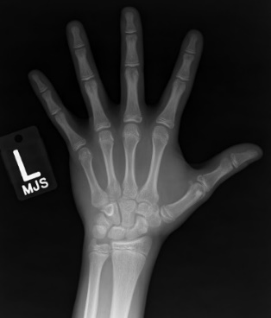

Fig 1.2 : Bone age dataset sample image

Fig 1.3 shows a sample of excel data given in the Kaggle dataset.

Fig 1.3: Data chart of bone age dataset

*Brain Tumor MRI Dataset:* This dataset is a filtered dataset from three popular ones, which are figshare, SARTAJ and Br35H. This dataset is also taken from Kaggle, and it has around 7000 images which are of four classes, namely Pituitary, Glioma, Meningioma and No tumor. The total size of the dataset is around 700 MB and fig 1.4 shows a sample image from this specific dataset.

Fig 1.4 : Sample image of brain tumor dataset

## Image diagnosis

In this project, there are three independent Deep Learning models that are trained on these three specific datasets. Using these models, a web-application has been developed using Flask and related services such that user can select the type of diagnosis they require and can get result based on the uploaded image. The project is client-server based so clients can only get their diagnosis but can’t access any information from server related to trained models etc.

# IMPLEMENTATION

## Deep Learning Implementation:

In this project deep learning is used as base for classification of different kinds of images. The custom model architecture used for training Pneumonia Detection is as shown in fig _.

The models have been completely trained in AWS Sagemaker and the weights have been saved to be utilized later for serverless deployment instead of creation of a Sagemaker endpoint.

Fig 2. Custom architecture of Pneumonia detection model

The above model has been trained for around 2000 epochs and it has shown accuracy of 89% testing accuracy. The training vs validation plots are as shown in fig 2.

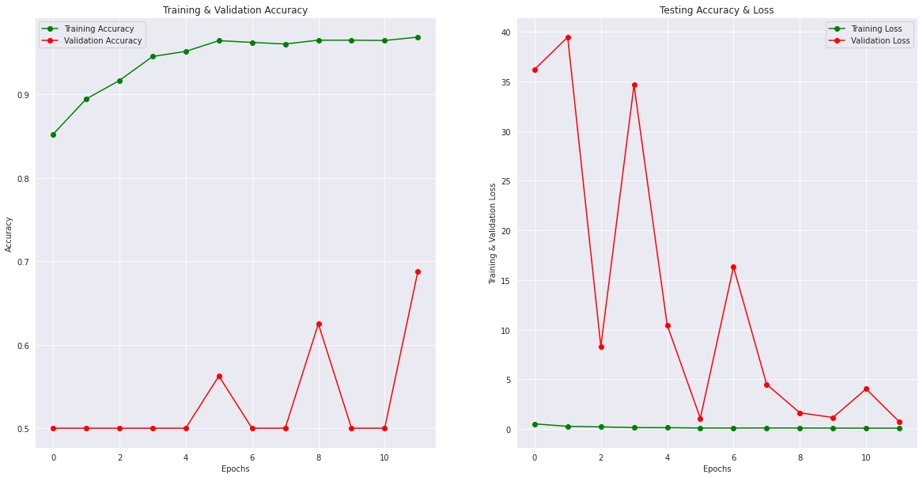

Fig 3. Metrics for Pneumonia detection model

For bone age prediction, the in-built Xception model has been used for training. The top layers have been excluded and the model has been transfer learned on this dataset. It has an error of 10.5, after training for 6300 epochs, in validation and for this MAE has been used as parameter which is Mean Average Error and calculated in months for this specific application. The predictions for this model are as shown in fig 4.

Fig 4. Predictions of bone age model

Now, for brain tumor detection, EfficientNetB3 has been used in the same way as Xception model has been used and it has shown an accuracy of 98% in testing after running for around 4000 epochs. The training vs validation plots for this model are as shown in fig 5.

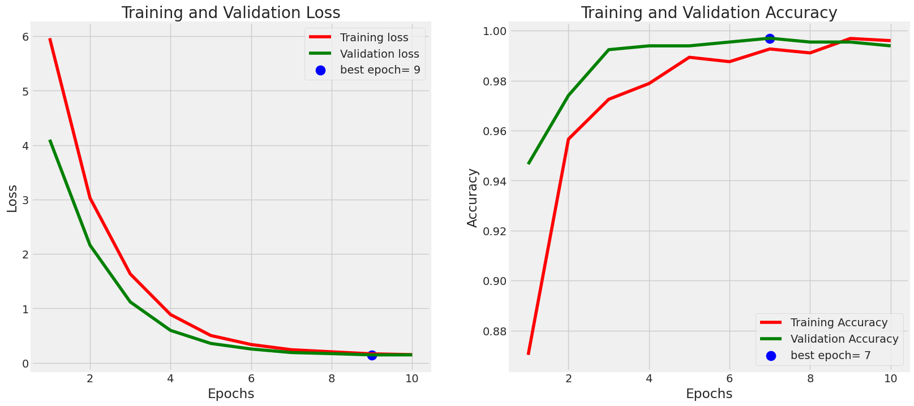

Fig 5. Metrics of Brain tumor detection model

## Cloud-Based Implementation:

In our project, to demonstrate this application numerous amount of cloud services have been utilized. The flowchart shown in fig 6 will give a brief view of the flow of how the services have been configured in way that smooth functionality of the application is ensured.

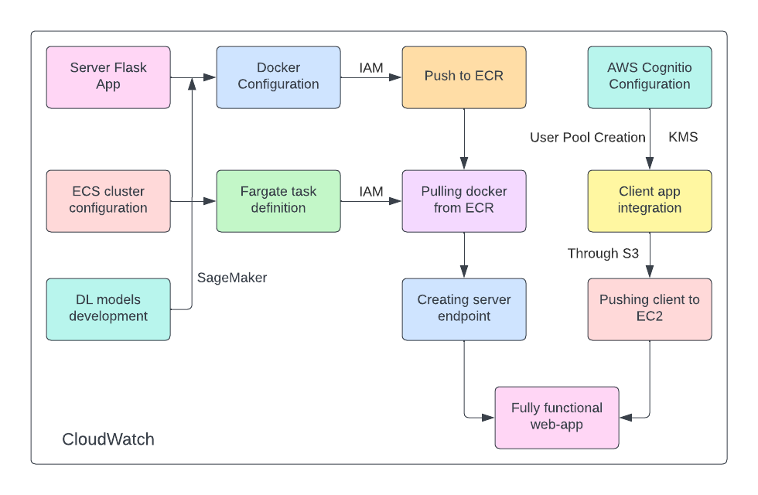

Fig.6. Methodology Flowchart

Initially, the server has been configured, which is an endpoint created using Flask framework. It has three routes specified for three of the models which receive requests, pre-process the images, etc and gives the desired output. Detailed flow has been given in flowchart of fig 7.

Fig 7. Server API flow

The server is entirely configured into a docker file that has all the dependencies installed and then it has been pushed into AWS ECR which stores the docker files for other services to pull and use them. It is also useful for configuration and deployment of dockers. Then using this docker container, a serverless endpoint has been deployed using AWS Fargate with the help of AWS ECS which is a Elastic Container Service, that allowed to create and configure a cluster for running a Fargate task definition in the cluster with this docker container in it. The configuration followed for the creation and deployment of the endpoint as are shown in the fig 8 - 10.

Fig 8. ECS cluster definition

Both the cluster and the task definition running inside the cluster have their own configuration specifications such as CPU requirements, RAM, etc for smooth functionality. The task definition created and configured is as shown in fig 8.

Fig 9.1. Fargate task definition

The networking tab is used to get information such as IPv4, task role, task execution role, etc which are configured during the creation of task definition. It is shown in detail in fig 9.1 and 9.2.

Fig 9.2 Fargate task definition networking

The usage of all these tasks can cost depending upon the configuration set for each service and they can be analyzed and viewed through Billing and Management console. It has many details such as charts, cost-to-service mapping, etc as shown in the fig 10.

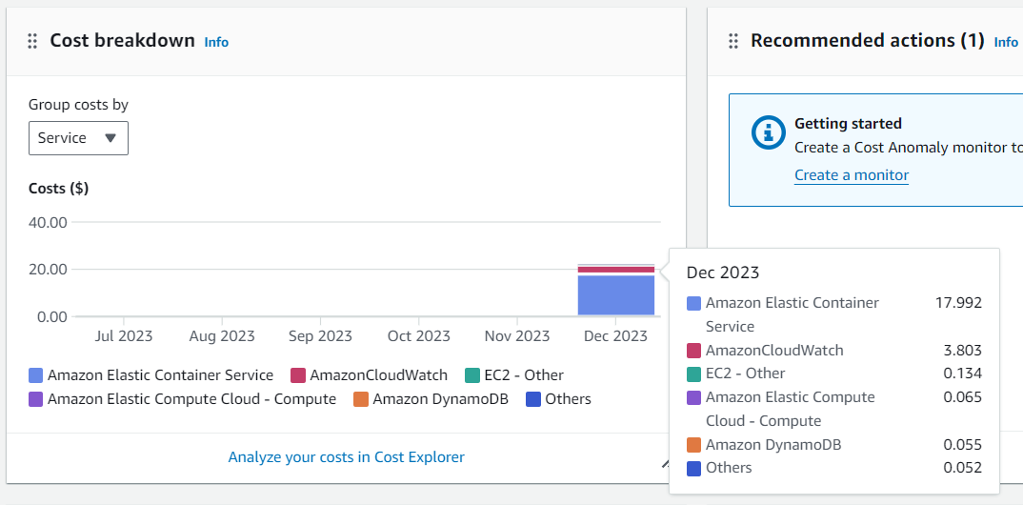

Fig 10. Billing and Management console

After the server is configured and it is up and running, we need to create a client application that uses server capabilities to get and display the responses in an interactive manner.

To create a client application another Flask application can be configured but this flask application does not need to be as heavy as the server, but it works upon the use case of the application. In this project, our client application has static, templates and a flask app which are the basic needs for a good working flask application.

Fig 11.1. Cognito User pool

Fig 11.2 Cognito Hosted UI for login

Now, this client-side application uses a service named AWS Cognito, which is an authentication-based service that helps to create and store user pools. It is basically a added feature so that users can only use the services when they are logged into the application. Using this feature, it is easier to configure any storage-based services to store information such as user uploaded images, their diagnosis etc in a NoSQL database with their credentials.

Fig 12. Flow of client-side application

The flowchart in fig _ shows how the client-side application works and is configured to login and logout URI’s. After the complete configuration of client-side application, it is pushed into AWS S3 to store the files there so that it is easier to push the files into an AWS EC2 instance and deploy the client-side application there so that it can be used across the networks. Fig 13 shows the bucket containing the application.

Fig 13. S3 bucket definition

Fig 14.1 shows an EC2 instance that has been configured to deploy the flask application. The security groups are configured as shown in the fig 14.2 to receive traffic from anywhere around the world using https and IAM roles have been modified for each and every service separately to give access to specific parts such as ECR repository creation, Fargate deployment, EC2 to S3 access, etc

Fig.14.1. EC2 instance overview

Fig 14.2 EC2 instance security groups

Running this application in EC2 instance, by connecting to it through terminal interface it is indirectly hosting the webapp into the world. The fig 14.3 shows the terminal interface after running the flask app in the EC2 instance.

Fig 14.3. EC2 instance deployment

KMS service is configured to be used by Cognito for the encryption of passwords and other sensitive information such as email, mobile number, etc. VPC service is used to connect and communication of the services internally such as ECR to ECS, S3 to EC2, etc to transfer data, posting requests and many more.

# RESULTS

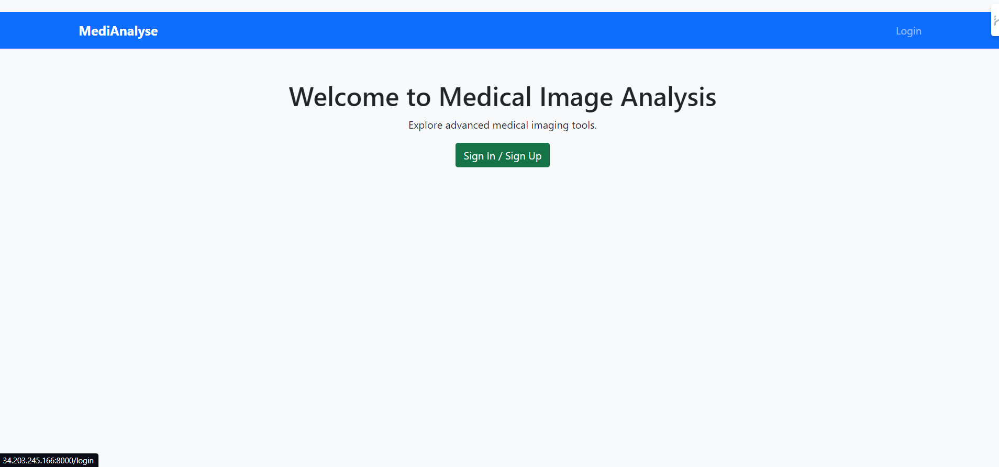

Fig 15. Home page of application

Fig 16.1. Cognito login service

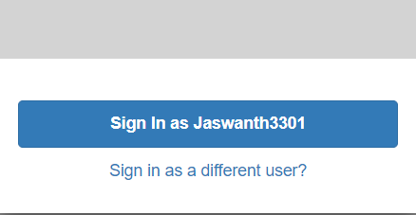

Fig 16.2. Cognito user cache demonstration

Fig 16.3 Cognito Sign Up service

Fig 17. Login redirect

Fig 18. Available models for diagnosis

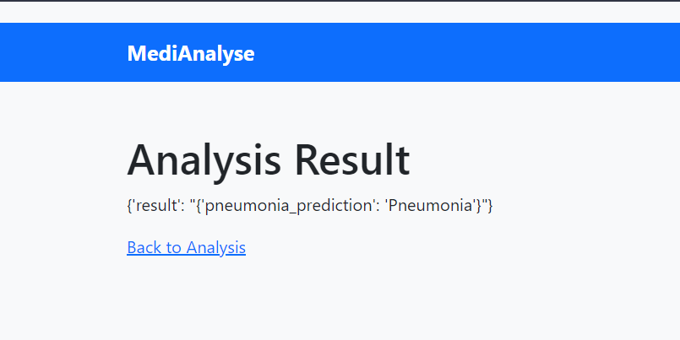

Fig 19. Diagnosis demonstration

# CONCLUSION

The project MediAnalyse utilizes and integrates the capabilities of deep learning and cloud-based architectures to successfully deploy a fully integrated, functional, and scalable application for medical image diagnosis. It can be shown as a base for any server-client based applications that are desired to be deployed in a serverless environment. Such real-time usage of microservices will really help in developing applications in an CI/CD manner which is a boon for the DevOps engineers as it is easier to debug and undo the changes in very less time when compared to development in an Agile manner.

# SOCIETAL IMPACT

The Cloud-Based Medical Imaging Diagnosis Platform has the potential to transform healthcare accessibility and diagnostic accuracy. The platform's user-friendly interface and real-time analysis capabilities enable prompt patient care, which is especially important in areas where access to specialized medical expertise is limited.

The platform guarantees that advanced medical image analysis becomes more accessible to a wider range of healthcare institutions by emphasizing affordability and utilizing the AWS Free Tier. Furthermore, it reduces worries about the security and confidentiality of medical data, promoting trust between patients and healthcare providers through HIPAA compliance and its dedication to data privacy.

# FUTURE SCOPE

This platform encourages professional knowledge sharing by the addition of collaborative features like multi-user access and real-time collaboration, which represent a step toward a more integrated healthcare ecosystem. Furthermore, the platform's endeavor to achieve mobile accessibility will broaden its scope, endowing medical professionals with mobile diagnostic capabilities. In the future, there are plans to seamlessly integrate with Electronic Health Records (EHR), which will streamline the workflow in the healthcare industry and help provide patients with a more comprehensive experience.

The platform promises to close gaps in healthcare and increase diagnostic service accessibility as it develops, demonstrating both its global reach and telemedicine potential. This forward-thinking strategy places the platform at the forefront of the continuing convergence of cloud computing and healthcare, with the potential to influence global health services in the years to come.

The project can also be extended by recognizing uploaded images then directly classifying as per requirement and giving necessary diagnosis so that any type of user can be benefited from the platform without any guidance. A medical chatbot to recommend to the user for getting better or giving any tips regarding their health status will make it interesting and interactive for them to use.

# ACKNOWLEDGEMENT

We would like to express our gratitude to Dr. Beena B. M. for her invaluable advice and constant assistance during the entire drafting process of this project. The direction and caliber of our work have been greatly improved by Dr. Beena's knowledge and mentoring. Additionally, we would like to sincerely thank Amrita Vishwa Vidyapeetham University for providing a learning atmosphere that has allowed this project to be completed successfully.

# REFERENCES

1. Y. Pan, M. Fu, B. Cheng, X. Tao and J. Guo, "Enhanced Deep Learning Assisted Convolutional Neural Network for Heart Disease Prediction on the Internet of Medical Things Platform," in IEEE Access, vol. 8, pp. 189503-189512, 2020, doi: 10.1109/ACCESS.2020.3026214.
2. W. Lie, B. Jiang and W. Zhao, "Obstetric Imaging Diagnostic Platform Based on Cloud Computing Technology Under the Background of Smart Medical Big Data and Deep Learning," in IEEE Access, vol. 8, pp. 78265-78278, 2020, doi: 10.1109/ACCESS.2020.2988563.
3. F. Milletari, J. Frei, M. Aboulatta, G. Vivar and S. -A. Ahmadi, "Cloud Deployment of High-Resolution Medical Image Analysis With TOMAAT," in IEEE Journal of Biomedical and Health Informatics, vol. 23, no. 3, pp. 969-977, May 2019, doi: 10.1109/JBHI.2018.2885214.
4. S. Y. Siddiqui et al., "IoMT Cloud-Based Intelligent Prediction of Breast Cancer Stages Empowered With Deep Learning," in IEEE Access, vol. 9, pp. 146478-146491, 2021, doi: 10.1109/ACCESS.2021.3123472.
5. P. Anand, S. Chatterjee, I. Agarwal, Shantanu, A. Anupam and K. A. Jain, "Intelligent Clinical Diagnosis System," 2019 4th International Conference on Computational Systems and Information Technology for Sustainable Solution (CSITSS), Bengaluru, India, 2019, pp. 1-5, doi: 10.1109/CSITSS47250.2019.9031022.
6. Xiaomeng Chen, Jianguo Zhang, Dongjing Wu and RuoLing Han, "HIPPA's compliant Auditing System for Medical Imaging System," 2005 IEEE Engineering in Medicine and Biology 27th Annual Conference, Shanghai, China, 2005, pp. 562-563, doi: 10.1109/IEMBS.2005.1616473.
7. B. H. Venkatesh, A. P. Sai, M. R. Reddy and S. Fathimabi, "Cloud based Personal Health Record Management System and Medical Recommender System," 2022 7th International Conference on Communication and Electronics Systems (ICCES), Coimbatore, India, 2022, pp. 1744-1749, doi: 10.1109/ICCES54183.2022.9835988.
8. Desislava Ivanova, Plamenka Borovska, Stefan Zahov; Development of PaaS using AWS and Terraform for medical imaging analytics. AIP Conf. Proc. 10 December 2018; 2048 (1): 060018.
9. R. M. P. H. K. Rathnayake, M. S. Karunarathne, N. S. Nafi and M. A. Gregory, "Cloud Enabled Solution for Privacy Concerns in Internet of Medical Things," 2018 28th International Telecommunication Networks and Applications Conference (ITNAC), Sydney, NSW, Australia, 2018, pp. 1-4, doi: 10.1109/ATNAC.2018.8615361.
10. H. Boudlal, M. Serrhini and A. Tahiri, "Cloud Computing Application in Medical Imaging: Challenges and Opportunities," 2022 5th International Conference on Networking, Information Systems and Security: Envisage Intelligent Systems in 5g//6G-based Interconnected Digital Worlds (NISS), Bandung, Indonesia, 2022, pp. 1-5, doi: 10.1109/NISS55057.2022.10084922.
11. T. Xiao-Yan, "Study on Medical Information Resource Sharing System Based on Cloud Computing," 2020 8th International Conference on Orange Technology (ICOT), Daegu, Korea (South), 2020, pp. 1-3, doi: 10.1109/ICOT51877.2020.9468796.
12. J. Tong, Z. Li and Z. Qiao, "Online Legal Cloud Computing Sharing Application for Smart Medical System Management," 2022 International Conference on Sustainable Computing and Data Communication Systems (ICSCDS), Erode, India, 2022, pp. 1290-1293, doi: 10.1109/ICSCDS53736.2022.9760713.
13. B. H. Venkatesh, A. P. Sai, M. R. Reddy and S. Fathimabi, "Cloud based Personal Health Record Management System and Medical Recommender System," 2022 7th International Conference on Communication and Electronics Systems (ICCES), Coimbatore, India, 2022, pp. 1744-1749, doi: 10.1109/ICCES54183.2022.9835988.
14. X. Cui, H. Liu, M. Tang and Y. Ma, "A Medical Pre-diagnosis Scheme Based on Neural Network and Inner Product Function Encryption," 2023 4th International Conference on Electronic Communication and Artificial Intelligence (ICECAI), Guangzhou, China, 2023, pp. 93-97, doi: 10.1109/ICECAI58670.2023.10176838.
15. S. Souiki, M. Hadjila, D. Moussaoui, S. Ferdi and S. Rais, "M-Health Application for Managing a Patient's Medical Record based on the Cloud: Design and Implementation," 2020 2nd International Workshop on Human-Centric Smart Environments for Health and Well-being (IHSH), Boumerdes, Algeria, 2021, pp. 44-47, doi: 10.1109/IHSH51661.2021.9378744.