Web-Based Explainable Artificial Intelligence for Multi-Region Bone Age Assessment and Structured Expert Review
Witsanu Intasuwan, Kanokwatt Shiangjen
University of Phayao, Phayao, Thailand

Abstract
Bone age assessment characterizes skeletal maturation from pediatric hand and wrist radiographs. Although deep learning can estimate bone age in months, agreement with a reference standard alone does not establish whether anatomically relevant evidence supports a prediction. We developed a web-based review workflow that integrates nine anatomical regions of interest (ROIs), bone-age regression, multiple post-hoc explanation views, and structured expert review. A selected FocalNet-Tiny configuration achieved a mean absolute error of 6.619 months (95% bootstrap confidence interval, 5.893–7.331; root mean squared error, 8.795) in 260 retrospectively evaluated cases aged approximately 1–18 years. Project-generated Grad-CAM, Grad-CAM++, ScoreCAM, EigenCAM, and LayerCAM-HR images illustrate differences in spatial response. These examples were generated with an earlier FocalNet configuration and do not establish explanation faithfulness for the selected model. The web workspace brings the source radiograph, anatomical ROIs, prediction, XAI overlays, and review controls into a single interface. The findings support the technical implementation of a prediction-to-review workflow. Attribution faithfulness, ROI localization, expert use, and independent model generalization require further evaluation.
Keywords: bone age assessment; explainable artificial intelligence; multi-region learning; model attribution; web application; structured expert review.

1. Introduction
Bone age reflects the maturation of the skeleton rather than chronological time since birth. Hand and wrist radiographs reveal age-dependent patterns of ossification, epiphyseal morphology, carpal development and progressive physeal fusion. Clinicians use these patterns to support assessment of pediatric growth and maturation. Unlike chronological age, an assessed bone age is a reference-based estimate that may differ from a child’s calendar age [1–3].
Conventional assessment commonly employs the Greulich –Pyle (GP) atlas or Tanner –Whitehouse (TW) scoring methods. GP compares an examination with sex-specific reference images, whereas TW examines the maturity stages of selected bones with a structured scoring system. The Greulich – Pyle tradition and the later atlas companion by Gaskin and colleagues document changes across the
phalanges, metacarpals, carpal bones, radius and ulna [1,2]. These anatomical descriptions motivate regional inspection, although neither atlas specifies the nine computational ROIs used in this study. Deep learning enables automated bone-age regression from hand radiographs. The RSNA Pediatric Bone Age Machine Learning Challenge established a widely used evaluation context based on the difference between algorithm output and the reference bone age, typically expressed in months [4]. More region-oriented systems, including workflow-inspired regional networks, have subsequently emphasized anatomical structure in model design [5]. Such advances make image-based assessment more systematic, but a low mean a bsolute error (MAE) cannot identify which image features contributed to a prediction.
A core problem is that prediction correctness and explanation correctness are different properties. Post-hoc methods can display areas associated with internal representations or the predicted output; however, these maps are method-dependent and can respond to nuisance structures or image acquisition artifacts. Prior saliency research shows that a visually compelling map need not be sensitive to learned parameters or faithful to the model’s behavior [11 –14]. Consequently, a colored overlay should be treated as evidence for further inspection, not an account of what the model “thinks” or proof of causal image importance.
Clinical explainability also depends on how information is presented and reviewed. Human-centered research argues that explanations should be embedded in tasks, controls, sources and opportunities to challenge or correct system outputs [15 –18]. A web application can connect the source radiograph, regional detections, numerical prediction and attribution views in one traceable workspace. Nevertheless, a visible interface does not by itself prove that clinicians work faster, make fewer errors or trust the system appropriately; these are separate empirical questions.
We investigated a web-based bone-age assessment workflow that organizes evidence by anatomy and distinguishes regional prediction and post-hoc visualization from expert evaluation. We document the system design, report a selected FocalNet-Tiny performance summary, describe multiple XAI views using existing project images, and explain the structured review process. The central contribution is the inspectable relationship between image evidence, model output and human review —not a clai m that visualizations expose the complete internal reasoning of artificial intelligence.

2. Materials and Methods

2.1 Study design and data provenance
This retrospective methods study uses pediatric hand and wrist radiographs associated with the RSNA bone-age research dataset. The primary numerical analysis concerns 260 archived test cases with reference bone ages across approximately 1 –18 years. A separate project preparation record describes 3,600 augmented training image rows and a 260-case development validation group;
however, a later evaluation workbook lists a different training inventory of 4,821 patient identifiers. Because these records refer to non-identical data versions, a training count of 3,600 cannot be assigned to the evaluated FocalNet-Tiny configuration without its version-specific manifest. The evaluation cohort has also been inspected previously and should not be called an untouched external test set.
The reference variable is skeletal bone age in months, not necessarily chronological age. The archived export provides patient-linked predictions, reference values, and 95% patient-bootstrap confidence intervals. The present manuscript treats numeric evaluation as descriptive because the test cohort has been used in historical analysis. A source-manifest and checkpoint-provenance audit is required before prospective model selection or external generalization claims [19,20].

2.2 Anatomical ROI localization and regression
The computational workflow begins with a hand radiograph and a detector that proposes nine anatomical ROIs: carpal region, third distal phalanx (DP3), first metacarpal (MC1), third middle phalanx (MP3), fifth middle phalanx (MP5), first proximal phalanx (PP1), third proximal phalanx (PP3; denoted PP3MC in some archived panels), and distal radius and ulna. Regional image crops supply anatomical units for the regression network. The detector family and inconsistent archived PP3 labeling should be reconciled w ith the final training and serving configuration before journal submission.
Features are extracted from the anatomical crops and integrated to yield a continuous age estimate in months. Recorded system designs include a backbone feature extractor and learned cross-region fusion or gating. A gate describes learned aggregation weighting, whereas a within-region activation map describes a separate post-hoc visual response. Gate coefficients are not calibrated probabilities of anatomical importance. Where activation is scaled by a regional gate for display, the composite should be named an ROI-gated CAM rather than an unmodified raw CAM.
Figure 1. Original project workflow illustrating radiograph input, anatomical ROI detection and cropping, alternative feature extractors, regional fusion, continuous regression, visual attribution, and human review. Some labels are illustrative and require synchronization with final software metadata. Figure 2. Project-supplied hand radiograph with annotated anatomical ROIs. These bounding boxes define inspectable image regions;
their appearance alone does not establish detector sensitivity or intersection-over-union performance.
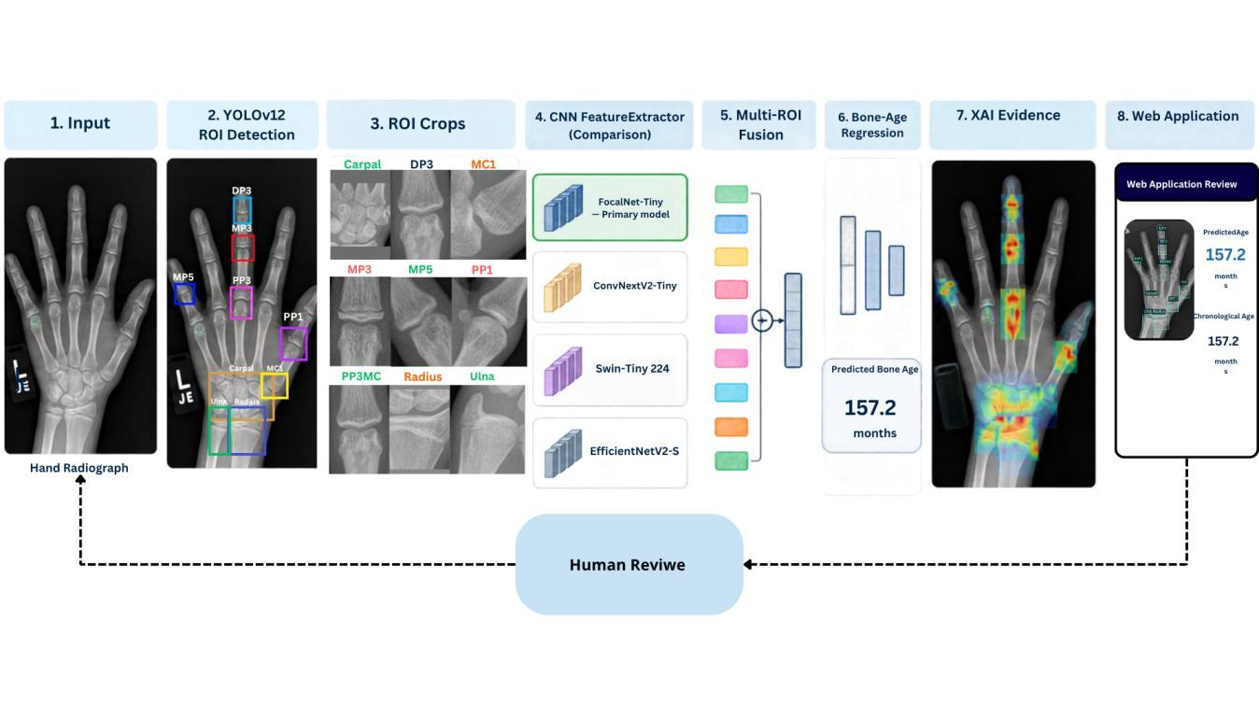
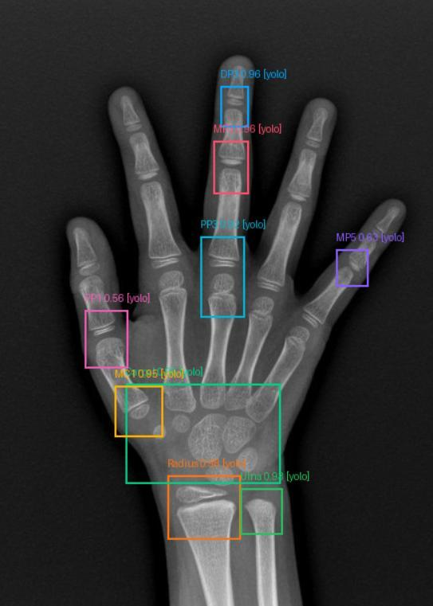

2.3 Model evaluation and statistical measures
A selected FocalNet-Tiny regression configuration was summarized using mean absolute error (MAE), root mean squared error (RMSE), median absolute error, signed bias and proportions of cases within prespecified month-error thresholds. Signed error was calculated as predicted minus reference bone age; thus negative values mean underestimation and positive values mean overestimation. Patient-level bootstrap intervals quantify sampling variation of cohort-level metrics rather than predictive uncertainty for any individual child [19,20].
Other investigated backbone families included ConvNeXtV2-Tiny, EfficientNetV2-S and Swin-Tiny. They provide research context for backbone exploration, but the present report avoids a series of model-by-model diagnostic plots because the main scientific question concerns explanation review and the web workflow. The selected FocalNet-Tiny result is reported as one configuration only, without implying that numerical MAE establishes attribution validity.

2.4 XAI visualization and interpretation
Five post-hoc visualization techniques were included: Grad-CAM, Grad-CAM++, ScoreCAM, EigenCAM, and the project’s high-resolution LayerCAM-HR adaptation [6 –10]. Grad-CAM uses gradients to weight spatial feature activations; Grad-CAM++ modifies gradient weighting; ScoreCAM estimates feature-map relevance from output responses to masked inputs; EigenCAM visualizes dominant components of activations; and LayerCAM combines spatial information from hierarchical layers. These constructions are not interchangeable . In particular, EigenCAM is not target-conditioned in the same manner as gradient-based CAM.
The heatmaps represent method-dependent spatial responses, not a complete reconstruction of the model’s decision process. A hotspot near a growth plate may be anatomically plausible, but visual correspondence alone does not demonstrate that the pixels were decisive for the month-level estimate. Likewise, a broad response over the carpus can reflect spatial smoothing, layer selection or image normalization rather than clinically validated relevance. Maps must be interpreted together with the original radiograph and the precise target and processing settings [11–14].

2.5 Framework for explanation assessment
Explanation evaluation requires separate dimensions. Anatomical plausibility asks whether a reviewer judges highlighted structures relevant to skeletal maturation. Faithfulness assesses whether controlled changes to highlighted image areas alter the model output more than appropriate controls.
Robustness examines prediction and attribution changes under clinically tolerable shifts in image quality, geometry, or acquisition appearance. Parameter-randomization checks further probe whether the map actually depends on learned model parameters [11 –14]. A visually attractive overlay should not substitute for these experiments. For a reproducible quantitative audit, raw ROI-level attribution tensors, image-to-ROI transforms, perturbation masks, normalization conventions, and the model checkpoint used to generate each explanation should be archived. An expert assessment should use prespecified criteria, blinded review where feasible, and explicit disagreement handling. These constitute the proposed evaluation protocol; the newly supplied 260-case spreadsheet does not contain new model-matched raw attribution tensors or blinded expe rt ratings, so this study does not rank the five XAI methods by faithfulness.

2.6 Web application and structured review
The Skeleton Bone Age web interface was designed as a shared workspace for the source radiograph, region boxes, bone-age estimate, alternative XAI overlays, model selection and review status. Separating the radiographic evidence, numerical output and post-hoc maps lets a user question an apparently accurate prediction rather than merely accept the displayed month value. The interface shown in the project screenshot supports the presence of these visible controls; usability and backend behaviors must be tested separately [15–18].
The intended review sequence is image inspection, ROI verification, prediction inspection, explanation comparison, reviewer decision and recording of reasons. A traceable record should contain a pseudonymous case identifier, image version, detector and regressor versions, XAI method and settings, original and corrected ROI coordinates where applicable, reviewer action, reason category and timestamp. Until functional tests document successful storage and retrieval, these fields should be described as a specified feedback schema rather than as a fully validated audit trail.
Expert comments are not permitted to change the served model automatically. A controlled future update would require feedback quality checking, adjudication when experts disagree, dataset versioning, training isolated from the assessment cohort, preregistered criteria for regression and subgroup harms, and a rollback mechanism. This process is a governance design, not evidence that the present interface has already improved clinical accuracy [21,22].

3. Results

3.1 Selected bone-age regression performance
On the 260-case recorded test cohort, the selected FocalNet-Tiny configuration achieved MAE 6.619 months (95% patient-bootstrap CI 5.893–7.331), RMSE 8.795 months, median absolute error 5.398 months and signed bias +0.755 months. The proportions within ±6 and ±12 months were 55.0% and 86.5%, respectively. These results describe numeric agreement with the RSNA reference labels; they do not measure whether an explanation is anatomically meaningful or faithful. As the cohort was historically inspected, the figures should not be interpreted as unbiased evidence for choosing a final clinical model.
Table 1. Selected FocalNet-Tiny performance on the 260-case retrospective evaluation cohort. The 95% interval for MAE was calculated using patient-level bootstrap resampling. Measure Result Evaluation cohort 260 cases Mean absolute error 6.619 months MAE 95% bootstrap CI 5.893–7.331 months Root mean squared error 8.795 months Median absolute error 5.398 months Signed bias +0.755 months Within ±6 months 55.0% Within ±12 months 86.5% The selected prediction –reference scatterplot shows many observations near the line of identity, while the Bland –Altman panel reveals both positive and negative differences across the age range.
The error histogram centers near zero but contains individual deviations extending beyond one year. Taken together, these patterns show that modest average error can coexist with larger errors for particular patients. The dashed agreement limits indicate the observed distribution of differences and should not be interpreted as predefined clinical safety thresholds.
Figure 3. Evaluation of the selected FocalNet-Tiny configuration (260 cases): predicted versus reference bone age, Bland–Altman differences, and the signed-error distribution. This is the only model-specific diagnostic composite shown in the main text.

3.2 Qualitative XAI evidence
The project-supplied multi-method montage displays one hand radiograph alongside Grad-CAM, Grad-CAM++, ScoreCAM, EigenCAM and LayerCAM-HR overlays. For the illustrated image, an earlier FocalNet-Tiny configuration yielded a reference age of 162 months and a displayed prediction near 157.2 months. Importantly, that attribution example is not a model-matched explanation of the selected 6.619-month evaluation configuration. The montage demonstrates differing visual patterns on a shared case, not measured superiority of one XAI method.
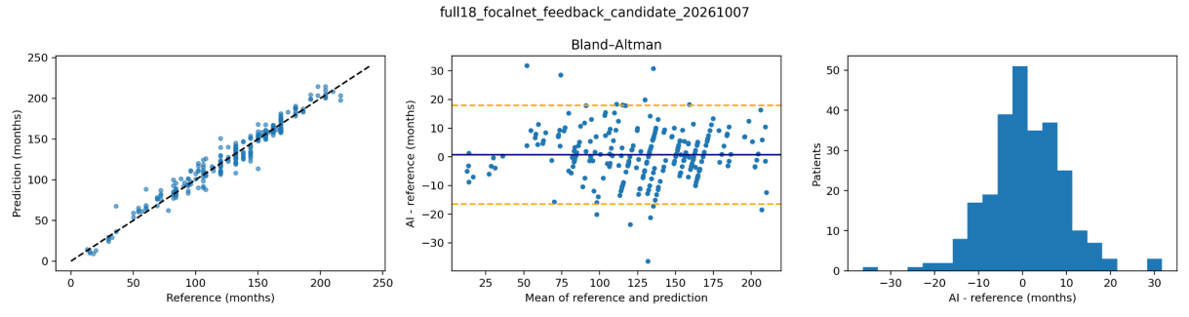
Figure 4. Representative five-method XAI comparison on the same project case. The source image and overlays are preserved from the original project exports; heatmap brightness is method- and display-dependent. These images originate from an earlier FocalNet- Tiny checkpoint and are not quantitative faithfulness measurements. ROI-level panels show that localized color patterns can differ substantially even when the anatomical crop and case are unchanged. Broad smooth responses, compact growth-plate hotspots and fine high-resolution patterns should not be compared using color intensity alone because map generation and normalization differ. Region-gate values, where shown, describe fusion coefficients;
they do not by themselves measure causal contribution. A future matched-model occlusion study is needed to test whether the highlighted locations are behaviorally relevant.
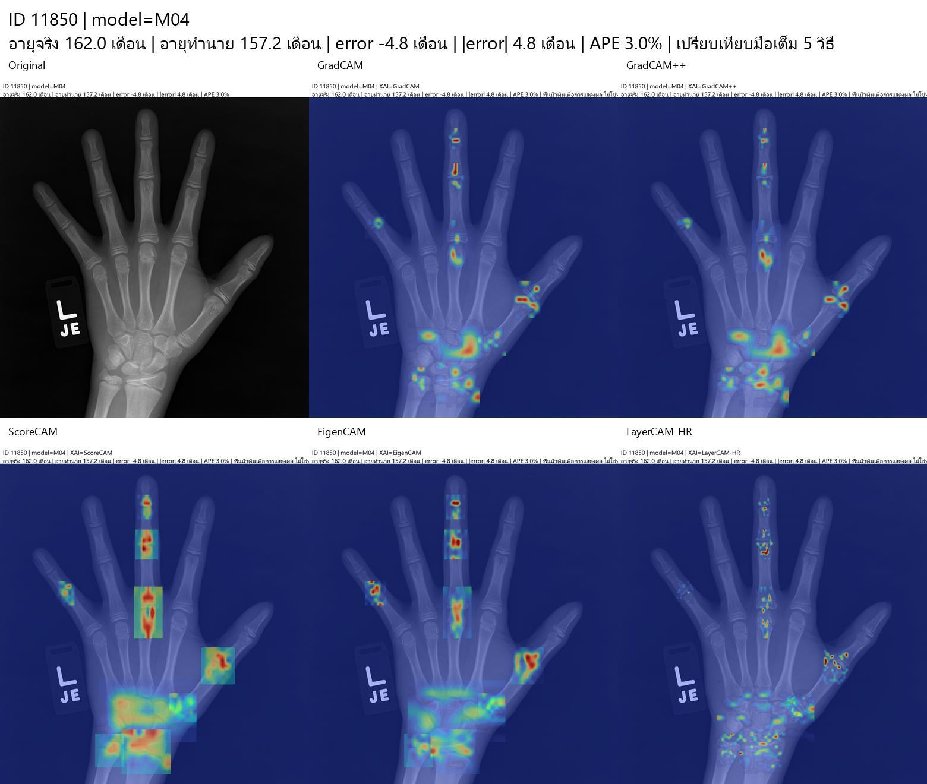
Figure 5. Nine-ROI qualitative attribution comparison from original project exports. Individual region responses differ between methods; ROI fusion weights must not be read as calibrated anatomical importance.

3.3 Web-based review evidence
The submitted screenshot displays the Skeleton Bone Age workspace, including a source-image viewport, colored regional overlays, model and XAI selectors, status indicators and navigation for feedback or history. The combined presentation supports inspection of prediction context and visually differentiated explanations without switching between disconnected image files. However, the screenshot documents visible interface design only. It does not establish completed clinical reader testing, role-based security, server persistence or accurate recomputation after every ROI edit.
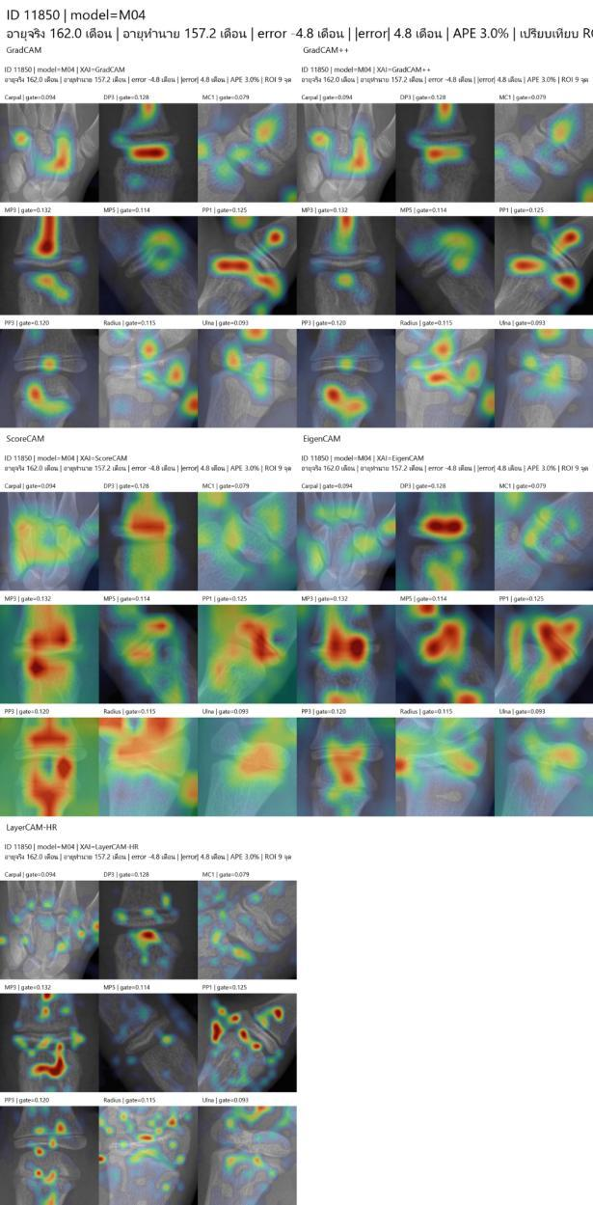
Figure 6. Original Skeleton Bone Age web-application screenshot showing image review, anatomical overlays, model/XAI selection and review-related navigation. Software functions not observable in a static screenshot require separate functional testing.

4. Discussion
Numerical prediction, spatial attribution, and user interpretation require separate evaluation. A bone-age estimate can be close to the reference while the saliency image remains ambiguous, noisy or dependent on visualization settings. Comparing different CAM families exposes this ambiguity but does not resolve it through a majority vote or visual preference [11 –14]. A scientifically defensible claim of explanation fidelity requires behavior-based tests applied to the same fixed model and case set.
Anatomical regions provide clinically understandable units of inspection; they do not reproduce GP or TW scoring and do not automatically ensure adequate evidence. The carpus, phalanges, metacarpal, radius and ulna have different maturation characteristics across childhood [1,2], so localization errors or an attribution concentrated on an unexpected substructure may merit expert review. Nevertheless, anatomical plausibility remains a clinical judgment to be established with explicit ratings, not an assertion derived from colorful overlays.
The web application places model evidence in the context of case review. A reviewer should be able to compare the original radiograph with ROI boxes, predicted age, alternative explanation methods and recorded decisions. Structured review could reveal incorrect localization, unstable overlays or disagreement with the reference interpretation; whether it actually reduces review time or improves decisions remains untested. Future interface evaluation should measure task
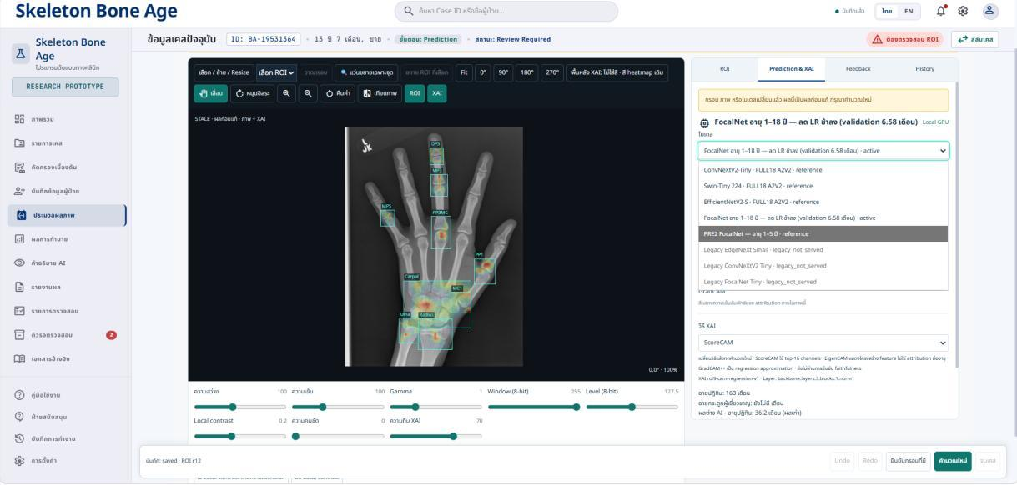
completion, review time, detection of seeded errors and feedback-record completeness using a defined protocol [15–18]. The numerical summary should also be interpreted with restraint. The reported MAE is an aggregate measure, and the diagnostic plot includes individual cases with substantially larger discrepancies. Moreover, the archival evaluation set had already been examined, and documentation of model initialization raises potential inherited exposure in part of the cohort. These limitations do not make the exported results unusable as descriptive evidence, but they preclude strong claims of independently confirmed clin ical performance or of improvement due specifically to expert feedback [19,20].

5. Study Limitations and Future Evaluation
The current evidence is limited by historical reuse of the evaluation cohort, unresolved cross-version training counts, lack of detector performance estimates on raw images, and absence of raw, model-matched attribution tensors for the selected FocalNet-Tiny configuration. Static screenshots do not establish completed feedback persistence, end-to-end correction behavior or clinical usability. No prospective external dataset or blinded specialist study was provided. These limitations prevent claims of clinical readiness and quantitative superiority among XAI methods.
A confirmatory evaluation should first establish a version-specific patient-disjoint data manifest, secure a genuinely uninspected test cohort, verify nine-ROI detection quality, and regenerate every XAI map from the exact selected model with archived settings. Faithfulness experiments should compare deletion or occlusion with control masks while controlling for out-of-distribution perturbation artifacts. Expert review tasks should then quantify anatomical ratings and the ability to identify incorrect evidence, and feedback-derived model changes should be evaluated offline before deployment [14–22].

6. Conclusion
We developed a web-based, nine-region bone-age assessment workflow that combines regression output, inspectable attribution views, and structured review controls. The selected FocalNet-Tiny configuration recorded an MAE of 6.619 months on 260 historically assessed cases. These numeric results establish descriptive prediction performance only; archived XAI examples and the visible web interface are evidence of visualization and interaction design, not proven explanation faithfulness or clinical utility. The main contribution is an explicit, auditable
framework for separating accurate prediction from credible model evidence and enabling future expert-centered evaluation.

References
[1] Greulich WW, Pyle SI. Radiographic Atlas of Skeletal Development of the Hand and Wrist. 2nd ed. Stanford University Press;
1959.
[2] Gaskin CM, Kahn SL, Bertozzi JC, Bunch PM. Skeletal Development of the Hand and Wrist: A Radiographic Atlas and Digital Bone Age Companion. Oxford University Press; 2011. doi:10.1093/med/9780199782055.001.0001.
[3] Lee BD, Lee MS. Automated Bone Age Assessment Using Artificial Intelligence: The Future of Bone Age Assessment. Korean J Radiol. 2021;22(5):792–800. doi:10.3348/kjr.2020.0941.
[4] Halabi SS, et al. The RSNA Pediatric Bone Age Machine Learning Challenge. Radiology. 2019;290(2):498–503. doi:10.1148/radiol.2018180736.
[5] Koitka S, et al. Mimicking the radiologists’ workflow: Estimating pediatric hand bone age with stacked deep neural networks. Med Image Anal. 2020;64:101743. doi:10.1016/j.media.2020.101743.
[6] Selvaraju RR, et al. Grad-CAM: Visual Explanations from Deep Networks via Gradient-Based Localization. ICCV; 2017. doi:10.1109/ICCV.2017.74.
[7] Chattopadhay A, Sarkar A, Howlader P, Balasubramanian VN. Grad-CAM++: Generalized Gradient-Based Visual Explanations for Deep Convolutional Networks. WACV; 2018. doi:10.1109/WACV.2018.00097.
[8] Wang H, et al. Score-CAM: Score-Weighted Visual Explanations for Convolutional Neural Networks. CVPR Workshops; 2020. https://arxiv.org/abs/1910.01279
[9] Muhammad MB, Yeasin M. Eigen-CAM: Class Activation Map Using Principal Components. IJCNN; 2020. https://arxiv.org/abs/2008.00299
[10] Jiang PT, Zhang CB, Hou Q, Cheng MM, Wei Y. LayerCAM: Exploring Hierarchical Class Activation Maps for Localization. IEEE Trans Image Process. 2021;30:5875–5888. doi:10.1109/TIP.2021.3089943.
[11] Adebayo J, et al. Sanity Checks for Saliency Maps. Adv Neural Inf Process Syst. 2018;31. https://proceedings.neurips.cc/paper/2018/hash/294a8ed24b1ad22ec2e7efea049b8737-Abstract.html
[12] Arun N, et al. Assessing the Trustworthiness of Saliency Maps for Localizing Abnormalities in Medical Imaging. Radiol Artif Intell. 2021;3(6):e200267. doi:10.1148/ryai.2021200267.
[13] Ghassemi M, Oakden-Rayner L, Beam AL. The false hope of current approaches to explainable artificial intelligence in health care. Lancet Digit Health. 2021;3(11):e745–e750. doi:10.1016/S2589-7500(21)00208-9.
[14] Jin W, Li X, Fatehi M, Hamarneh G. Guidelines and evaluation of clinical explainable AI in medical image analysis. Med Image Anal. 2023;84:102684. doi:10.1016/j.media.2022.102684.
[15] Chen H, Gomez C, Huang CM, Unberath M. Explainable medical imaging AI needs human-centered design: guidelines and evidence from a systematic review. npj Digit Med. 2022;5:156. doi:10.1038/s41746-022-00699-2.
[16] Tonekaboni S, Joshi S, McCradden MD, Goldenberg A. What Clinicians Want: Contextualizing Explainable Machine Learning for Clinical End Use. PMLR. 2019;106:359–380. https://proceedings.mlr.press/v106/tonekaboni19a.html
[17] Amershi S, et al. Guidelines for Human-AI Interaction. CHI; 2019. doi:10.1145/3290605.3300233.
[18] Cai CJ, Winter S, Steiner D, Wilcox L, Terry M. “Hello AI”: Uncovering the Onboarding Needs of Medical Practitioners for Human-AI Collaborative Decision-Making. Proc ACM Hum-Comput Interact. 2019;3(CSCW). doi:10.1145/3359206.
[19] Tejani AS, et al. Checklist for Artificial Intelligence in Medical Imaging (CLAIM): 2024 Update. Radiol Artif Intell. 2024;6(4):e240300. doi:10.1148/ryai.240300.
[20] Collins GS, et al. TRIPOD+AI statement: updated guidance for reporting clinical prediction models that use regression or machine learning methods. BMJ. 2024;385:e078378. doi:10.1136/bmj-2023-078378.
[21] World Health Organization. Ethics and Governance of Artificial Intelligence for Health. WHO; 2021. https://www.who.int/publications/i/item/9789240029200
[22] US FDA, Health Canada, MHRA. Good Machine Learning Practice for Medical Device Development: Guiding Principles. 2021. https://www.fda.gov/medical-devices/software-medical-device-samd/good-machine-learning-practice-medical-device- development-guiding-principles
[23] Teodoro RDA, et al. Automatic bone age assessment: a deep learning case study on the Brazilian population with a supporting mobile application prototype. Sci Rep. 2026;16:4488. doi:10.1038/s41598-025-34651-7.
[24] Bland JM, Altman DG. Statistical methods for assessing agreement between two methods of clinical measurement. Lancet. 1986;1(8476):307–310.

Author confirmed declarations
Author contributions: Witsanu Intasuwan developed the web application and analysis workflow. Kanokwatt Shiangjen supervised the project. Both authors are affiliated with the University of Phayao. Detailed CRediT role assignments and final manuscript approval require author review.
Funding: The authors report no funding for this work. Conflicts of interest: The authors declare no conflicts of interest. Ethics approval or exemption: Pending author confirmation.

