Explainable Bone Age Assessment through Regional Visualization and Expert Review in a Web Application
Witsanu Intasuwan, Kanokwatt Shiangjen
University of Phayao, Phayao, Thailand

Abstract
Bone age assessment describes skeletal maturation from hand and wrist radiographs. A small prediction error does not establish whether anatomically relevant evidence supports an estimate. We developed a web application integrating nine anatomical regions of interest, FocalNet regression, post hoc explainable artificial intelligence, and structured expert review. We analysed archived predictions from a fixed FocalNet checkpoint for 260 RSNA cases, using reference bone age rather than chronological age as the regression target. Mean absolute error was 6.619 months (patient bootstrap 95% confidence interval, 5.937–7.351), root mean squared error was 8.795 months, and mean signed error was +0.755 months. Absolute error was within 6 months in 55.0% of cases and within 12 months in 86.5%. The archived evaluation was previously inspected, and its records flag possible overlap with data used to initialize the model; these results are therefore descriptive rather than evidence of independent generalization. The application supports image adjustment, ROI correction, prediction review, explanation inspection, and versioned feedback. New Grad-CAM and Eigen-CAM illustrations were generated from the same checkpoint, with image, ROI geometry, and normalization recorded. These illustrations establish traceability of the displayed maps, not explanation faithfulness. The contribution is an inspectable prediction and review workflow; clinical effectiveness and feedback driven model improvement remain to be evaluated.
Keywords: bone age assessment; explainable artificial intelligence; FocalNet; regional image analysis; web application; expert review

1. Introduction
Bone age describes skeletal maturation and can differ from chronological age. Hand and wrist radiographs show changes in ossification, epiphyseal morphology, carpal development, and physeal fusion. Conventional assessment includes the Greulich–Pyle atlas and Tanner–Whitehouse scoring approaches, which provide related but distinct ways of interpreting maturity [1, 2]. The atlas by Gaskin and colleagues illustrates development across phalanges, metacarpals, carpal bones, and the distal radius and ulna [3]. This distribution of anatomical information motivates regional inspection, although the atlases do not prescribe the nine computational regions used in this system.
Deep learning enables automated bone age estimation from radiographs. The RSNA Pediatric Bone Age Machine Learning Challenge established a widely used evaluation setting based on agreement with a reference bone age [4]. Region based systems have attempted to reflect anatomical inspection by combining information from local ossification areas [5]. Our system uses FocalNet features [6] within a regional regression workflow. We do not claim that this design reproduces a clinician’s reasoning or introduces a new backbone architecture.
Prediction error and explanation quality address different questions. Grad-CAM, Grad-CAM++, Score-CAM, Eigen-CAM, and LayerCAM produce spatial visualizations through different operations [7, 8, 9, 10, 11]. Their maps can differ even for the same image. Visual plausibility alone is insufficient to establish dependence on learned parameters or relevance to a prediction, as shown by saliency sanity checks and medical imaging studies [12, 13, 14, 15]. Explanation evidence must therefore be evaluated separately from numerical agreement.
A web application can make regional inputs and model output available for review in the same workspace. Human centered XAI and human–AI interaction research emphasize explanations that fit the intended task and allow users to inspect uncertainty and contest output [16, 17, 18, 19]. We developed a workflow that links ROI inspection, a single FocalNet estimate, post hoc visualization, and structured feedback. The study describes its implementation and retrospective numerical performance; it does not test clinical benefit or autonomous online learning.

2. Materials and Methods

2.1 Study design data and reference standard
This retrospective methodological study used archived predictions associated with RSNA hand and wrist radiographs. The numerical analysis included one successful prediction per patient for 260 cases under the original stored ROI protocol. The target was the reference bone age supplied in the archived evaluation file, not age calculated from dates of birth and examination. Chronological age, when displayed in the interface, was a separate contextual variable. No Thai clinical cases were included in this manuscript.
The analysis was restricted to one fixed FocalNet checkpoint. The checkpoint was selected retrospectively for this report after inspection of the archived results, rather than through a prospectively prespecified selection procedure. The model had undergone prior offline refinement before the archived evaluation; no parameters were fitted and no images were selected according to prediction error in the present analysis. The exact checkpoint hash, input file hash, row selection rules, and analysis seed are provided in the supplementary provenance record.
Data partition provenance remains a limitation. The source PDF described differing preparation inventories of 3,600 augmented training image rows and 4,821 training patient identifiers; these counts have not been reconciled and are not treated as interchangeable. The evaluation records also state that the set had been inspected in earlier analyses and flag 15 patients as overlapping training or tuning records associated with model initialization. The patient memberships have not been independently reconciled. Until this is resolved, this analysis cannot be described as an independent or untouched test. Patient level separation and reporting of data partitions follow the transparency principles in CLAIM and TRIPOD+AI [20, 21].

2.2 Anatomical ROI localization and regression
The regional inputs comprised the carpal region, distal phalanx of the third digit, first metacarpal, middle phalanges of the third and fifth digits, proximal phalanges of the first and third digits, distal radius, and distal ulna. The computational pipeline uses a YOLO detector to propose boxes, followed by review of the full radiograph and each crop. Prediction is gated until all nine required regions are present and confirmed. The quantitative results analysed here used stored ROI inputs; they do not measure the complete detector to prediction pipeline or detector localization accuracy.
The served regression architecture extracts FocalNet features from the ROI images, projects them into a common representation, models regional interactions, aggregates regional features, and incorporates sex information before regression. The archived protocol specifies aspect preserving padding to a 224 × 224 input and the original intensity convention. The analysis uses the recorded predictions from that protocol. GUI enhancement settings used for a separate demonstration must not be assumed to match the archived quantitative inputs.
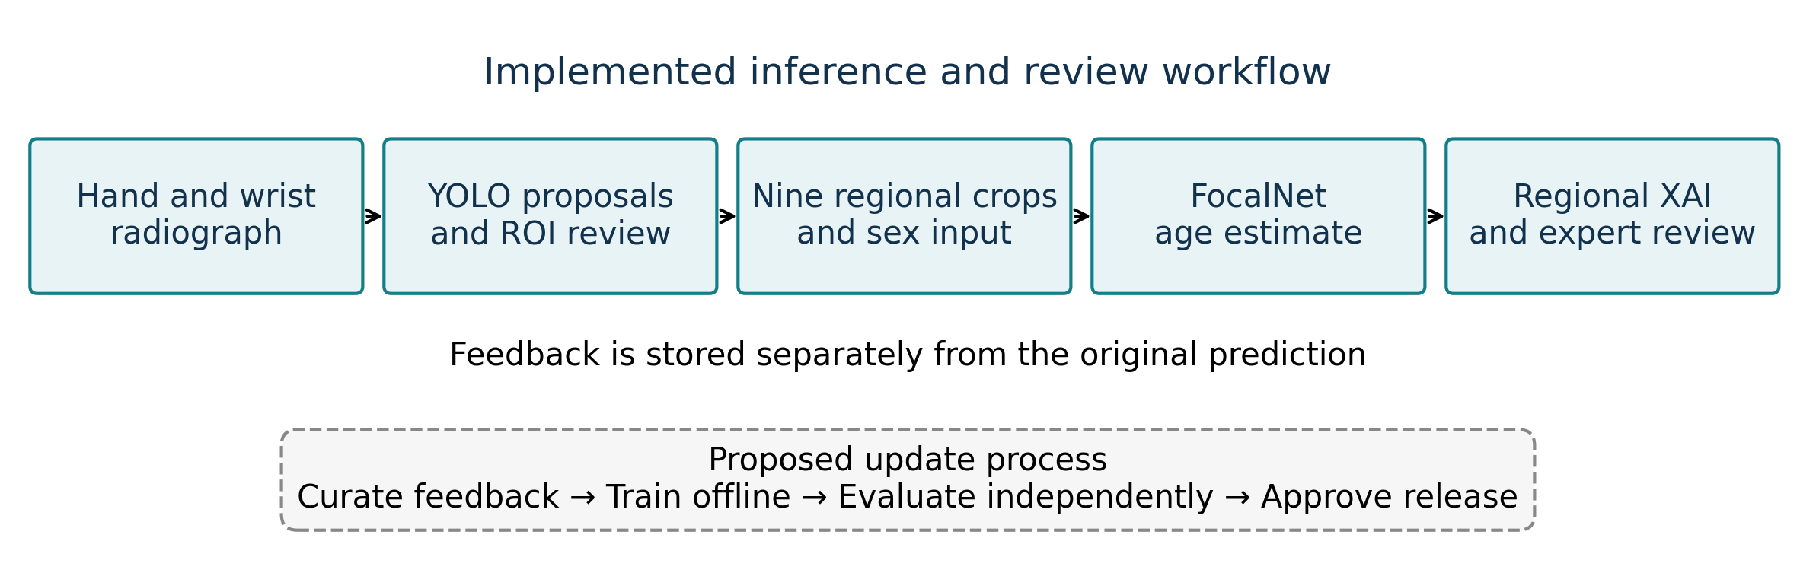
Figure 1. Implemented prediction and review workflow. ROI proposals require review before prediction. Feedback is recorded separately; curation, offline training, independent evaluation, and release approval form a proposed future update process, whose benefit was not evaluated here.

2.3 Model evaluation and statistical measures
Error was defined as predicted minus reference bone age in months. We calculated mean absolute error (MAE), root mean squared error (RMSE), median absolute error, and mean signed error (bias). MAE was the primary descriptive outcome. A percentile 95% confidence interval for MAE was estimated from 20,000 patient level bootstrap resamples with replacement using a fixed seed of 20261105. This interval replaces the undocumented interval in the source PDF and is linked to executable analysis code; it does not represent an individual prediction interval.
We also calculated the percentages of cases within absolute errors of 3, 6, 9, and 12 months. These are tolerance based agreement summaries, not general classification accuracy. Scatter plots compare predicted and reference bone ages. Bland–Altman plots show signed differences against pairwise means, with descriptive limits of agreement calculated as bias ± 1.96 times the sample standard deviation of errors [22]. We did not prespecify clinical acceptability limits and do not interpret these lines as evidence of clinical interchangeability.
Errors were summarized by sex and by reference bone age strata of less than 6 years, 6 to less than 12 years, and 12 to less than 19 years. These strata were derived from the reference bone age, not chronological age. Subgroup counts accompany each estimate. The subgroup analysis is exploratory and does not establish age specific superiority. Precision, recall, F1 score, and a confusion matrix were not primary outcomes because the model predicts a continuous age rather than a clinical class.

2.4 XAI visualization and interpretation
The project provides Grad-CAM, Grad-CAM++, Score-CAM, Eigen-CAM, and LayerCAM views [7, 8, 9, 10, 11]. For the present revision, Grad-CAM and Eigen-CAM illustrations were generated using the same checkpoint as the numerical analysis and one RSNA demonstration image. The image was used to demonstrate regional inspection rather than selected by its prediction error. No reference age was assigned to this demonstration and it was not added to the 260-case numerical cohort. Grad-CAM used the gradient of the scalar predicted age and the final spatial feature map (7 × 7). An additional LayerCAM illustration used an earlier spatial feature map (14 × 14). No quantitative ranking of explanation methods is reported.
Eigen-CAM summarizes principal components of feature activations and is not inherently targeted to the scalar age estimate [10]. Regional gate weights describe the aggregation mechanism and are not confidence scores. Each ROI map was independently normalized to the range 0–1, restored by removing aspect padding, and resized to its source box by bilinear interpolation. Turbo colors were overlaid with opacity equal to 0.65 times the normalized response. Where boxes overlapped, the map with the larger opacity was displayed; pixels outside all boxes were unchanged. Red denotes a high relative response within that ROI, not confidence, a cross-region importance ranking, or a contribution measured in months. Raw maps, input and checkpoint hashes, box coordinates, and rendering settings were retained in the supplementary provenance record. No parameter randomization or matched perturbation experiment was performed.

2.5 Framework for explanation assessment
Anatomical plausibility, faithfulness, and stability were treated as separate evaluation requirements. Anatomical plausibility concerns whether highlighted regions correspond to relevant structures, whereas faithfulness requires evidence that the explanation changes appropriately when the model or its influential inputs change. Stability concerns changes under controlled variations in the image or explanation procedure [12, 13, 14, 15]. These requirements define future experiments; no completed reader study or perturbation result is inferred from the displayed images.

2.6 Web application and structured review
The interface presents the radiograph, ROI boxes, crop previews, model estimate, explanation controls, and feedback form. Users can adjust brightness, contrast, gamma, window and level, sharpness, and local contrast. When adjusted image inference is selected, the resulting pixels can affect detection and prediction. Zoom, pan, display rotation, loupe magnification, and XAI opacity affect viewing. Editing ROI geometry changes the crops and requires renewed review. The loupe provides a magnified local view for inspecting joint detail without changing the model input.
Feedback records separate the unmodified model result from expert assessment and comments about ROIs or XAI. A future update cycle requires provenance and permission checks, data curation, a versioned dataset, offline training, evaluation, and human approval before release. Submitting feedback does not update the served model automatically. No performance improvement from feedback is claimed. The design is informed by human centered review principles and governance guidance [16, 17, 18, 19, 23, 24]. Ethics approval or exemption remains pending author confirmation.

3. Results

3.1 FocalNet bone age regression performance
The analysis included 260 patient records. FocalNet had an MAE of 6.619 months (95% bootstrap CI, 5.937–7.351) and an RMSE of 8.795 months. Mean signed error was +0.755 months, indicating a small average overestimate across this dataset. Median absolute error was 5.398 months. These aggregate values do not imply that individual errors were small or that the evaluation was independent of earlier model development.
Table 1. Descriptive FocalNet performance on the archived evaluation cohort. All age errors are in months.
Measure | Value
Patients | 260
MAE | 6.619
MAE 95% bootstrap CI | 5.937–7.351
RMSE | 8.795
Bias | +0.755
Median absolute error | 5.398
Within ±3 months | 30.0%
Within ±6 months | 55.0%
Within ±9 months | 71.9%
Within ±12 months | 86.5%
Descriptive limits of agreement were -16.45 to 17.96 months. The difference between a small mean bias and these wider limits illustrates why bias alone does not characterize individual agreement (Figure 2). The cumulative error curve summarizes the range of absolute errors without converting the regression task into arbitrarily defined classes (Figure 3).
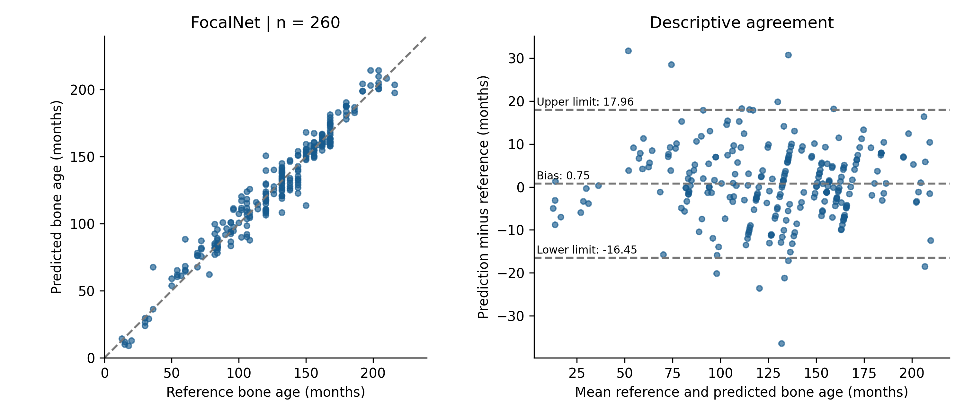
Figure 2. FocalNet predictions against reference bone age and descriptive Bland–Altman agreement. The diagonal denotes equality. Horizontal lines denote mean signed error and bias ± 1.96 sample standard deviations; no clinical acceptability threshold is implied. Each point represents one patient.
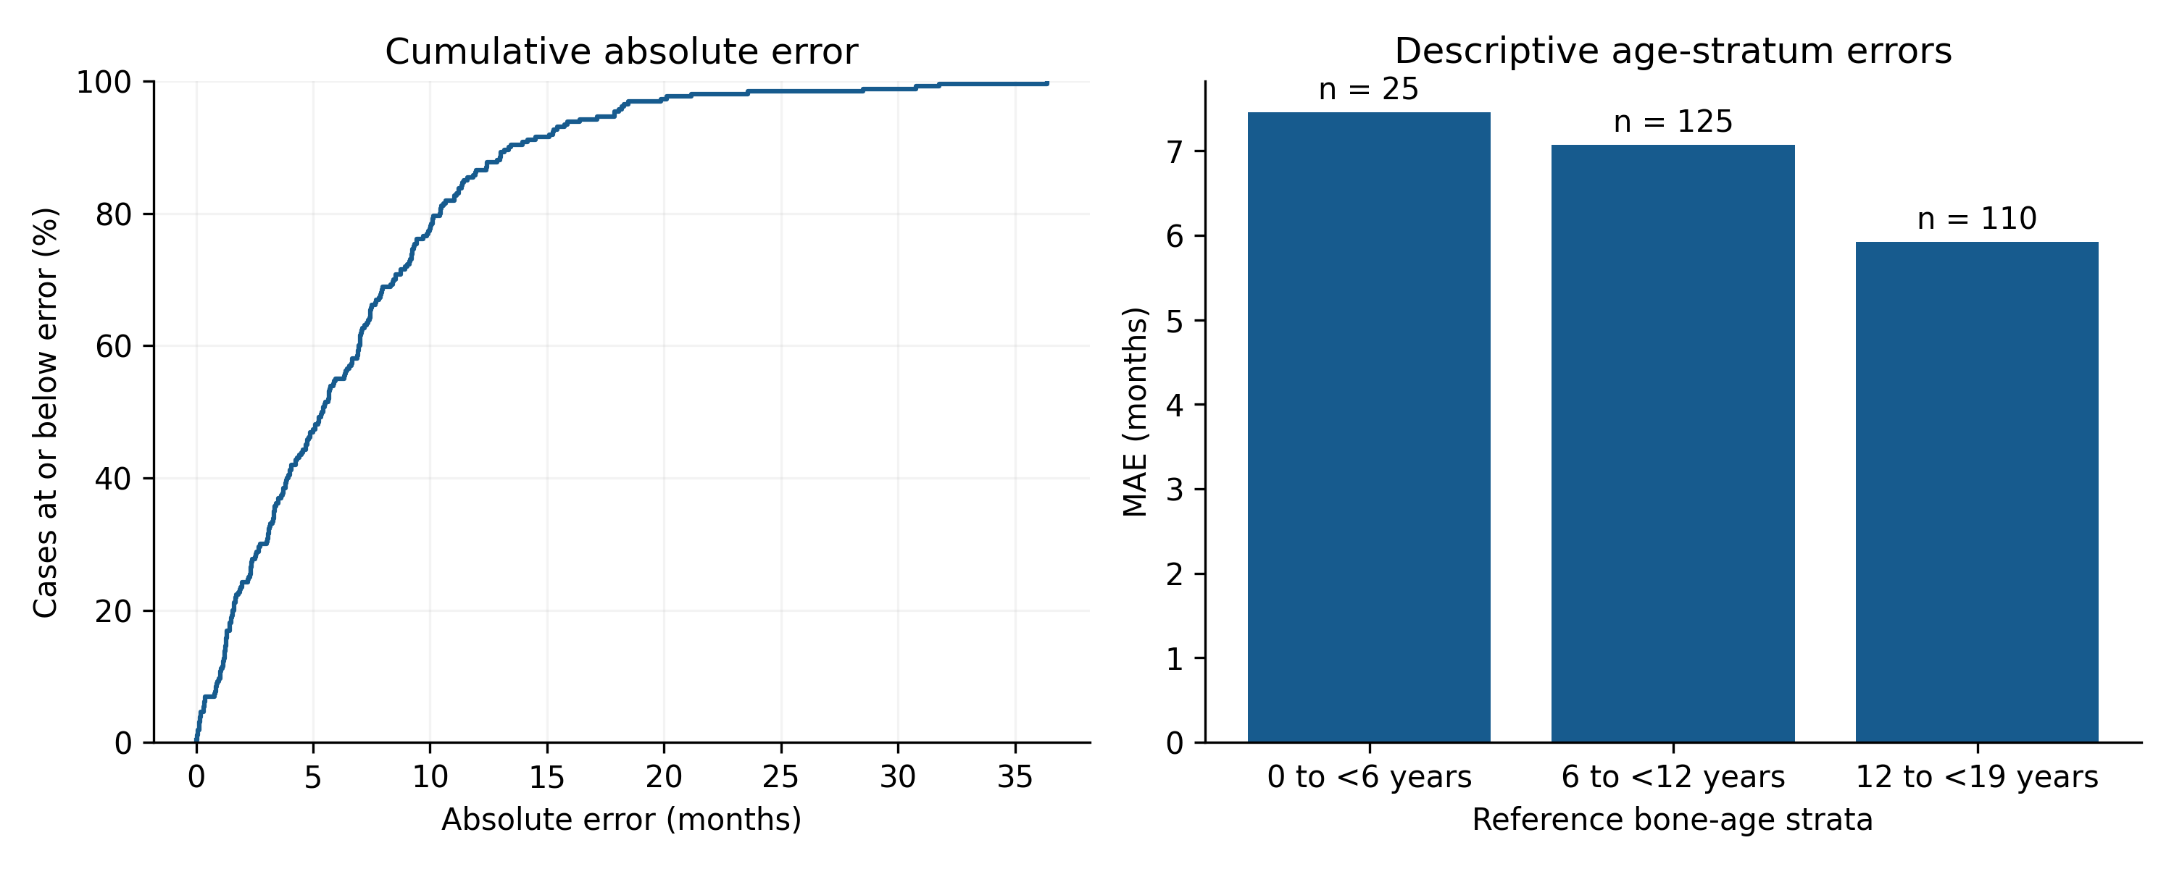
Figure 3. Cumulative absolute error and descriptive error by reference bone age stratum. The cumulative curve includes all 260 cases. Counts above the bars identify subgroup support; age is reference bone age, not chronological age.
Table 2. Descriptive subgroup errors. Age strata use reference bone age.
Group | Patients | MAE months | Bias months
Female | 122 | 7.494 | +0.834
Male | 138 | 5.846 | +0.685
0 to <6 years | 25 | 7.452 | +4.376
6 to <12 years | 125 | 7.069 | +0.908
12 to <19 years | 110 | 5.919 | -0.243

3.2 Qualitative XAI evidence
The checkpoint matched illustrations show spatially different responses for Grad-CAM and Eigen-CAM on the same image and reviewed ROI geometry (Figure 4). Regional views make it possible to examine responses near epiphyses, joint spaces, and crop boundaries (Figure 5). Responses are not restricted to a manually defined bone mask, and some extend toward the edge of a crop. These observations describe the displayed maps without establishing causal relevance to the predicted age. The manuscript reports no XAI accuracy, faithfulness score, or preferred CAM method.
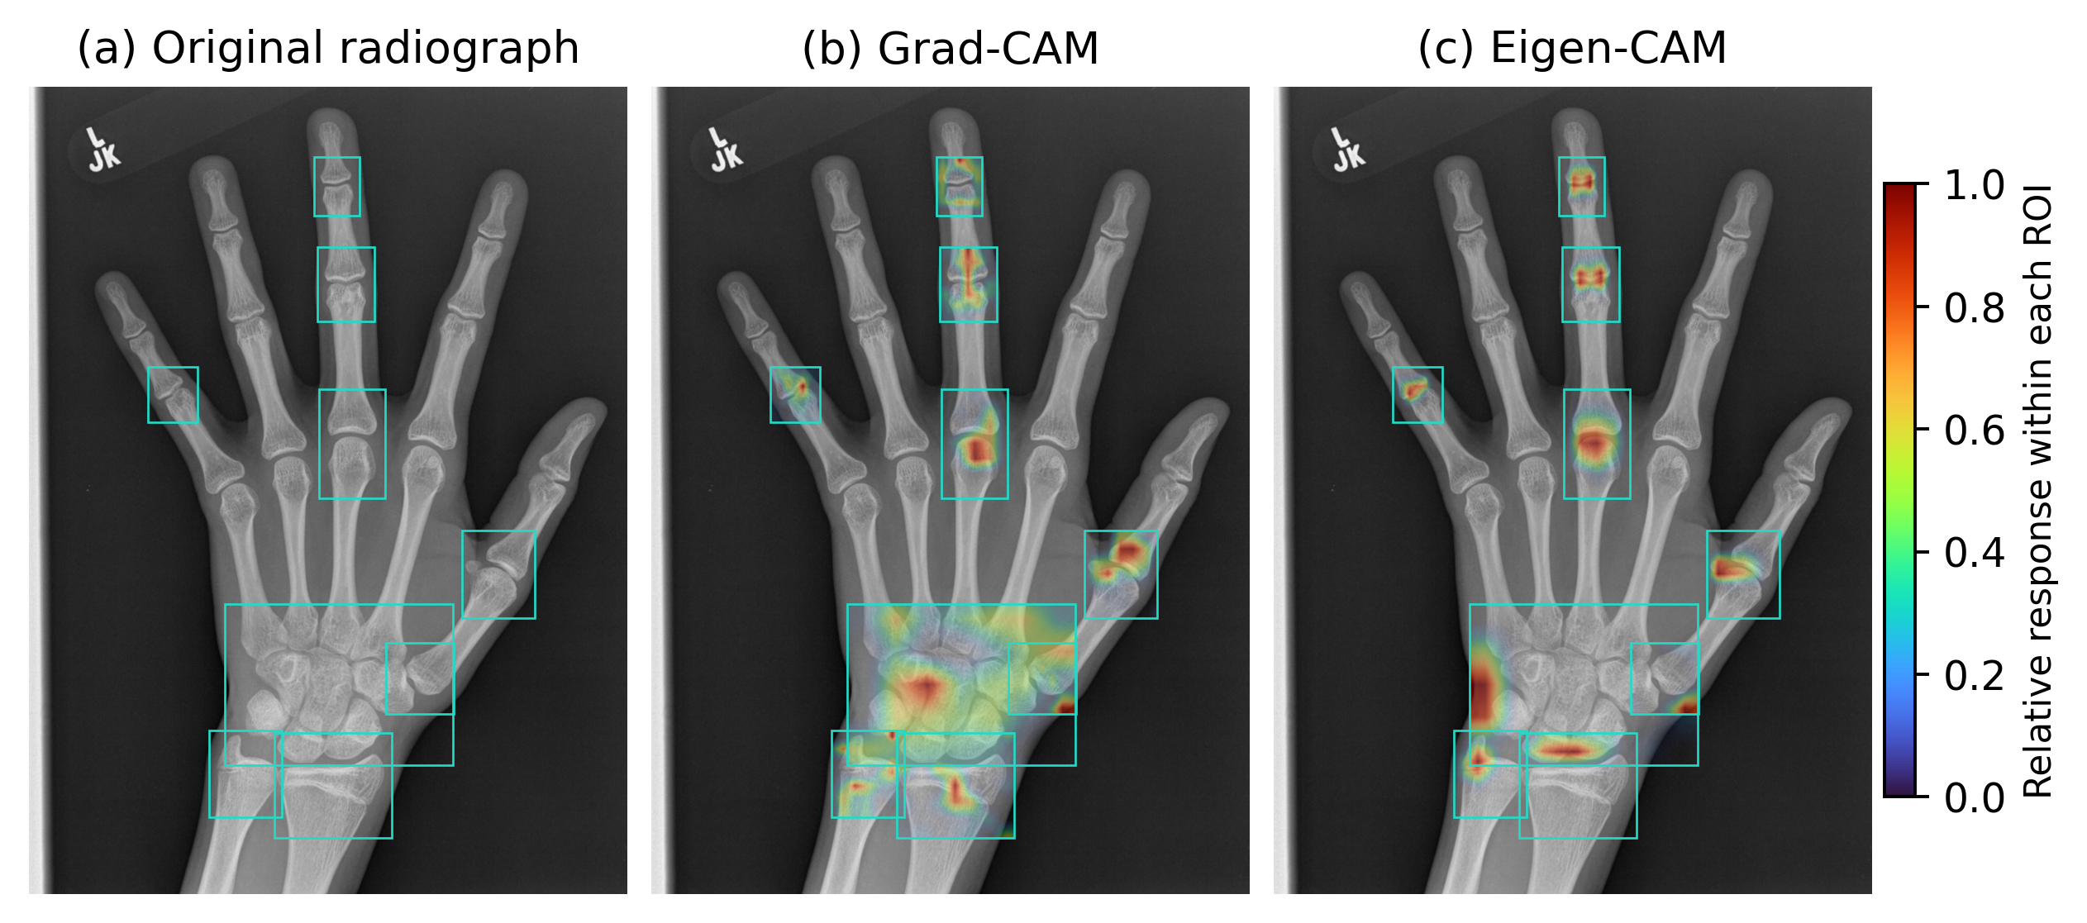
Figure 4. Original radiograph and checkpoint matched Grad-CAM and Eigen-CAM views of one RSNA demonstration. The same image, reviewed boxes, and FocalNet checkpoint were used in both methods. Colors are normalized independently within each ROI. Red denotes high relative response and must not be interpreted as confidence or an age contribution. The demonstration is separate from the numerical cohort.
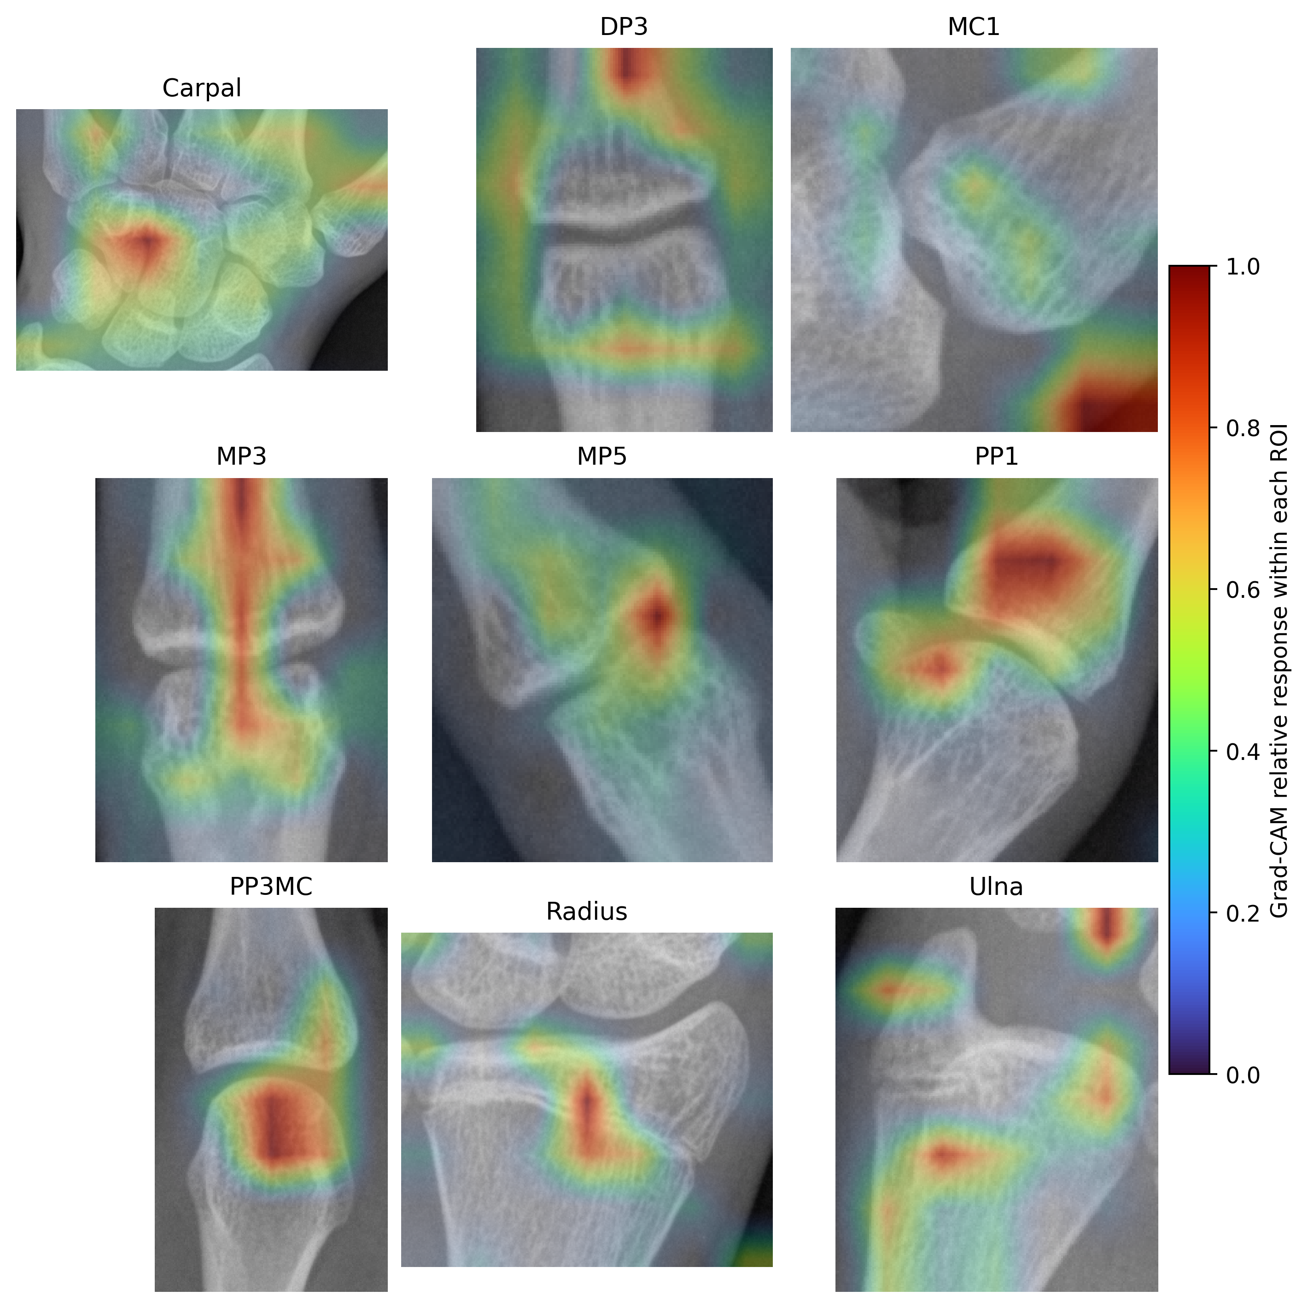
Figure 5. Grad-CAM views of the nine regional inputs from the same demonstration. The third proximal phalanx input is labelled PP3MC in the application. Independent within-ROI normalization preserves spatial patterns but prevents direct comparison of color intensity across regions. Boundary responses remain visible rather than being removed for presentation.

3.3 Web based review evidence
The interface supports inspection of the full radiograph and individual crops, a loupe view, image adjustments, model output, and structured feedback. Figure 6 illustrates the workspace and its explanation controls. The screenshot documents the presence and visual arrangement of controls. Task completion time, reviewer agreement, diagnostic decisions, and usability scores were not measured, so no improvement in clinical work or review efficiency can be attributed to the application.
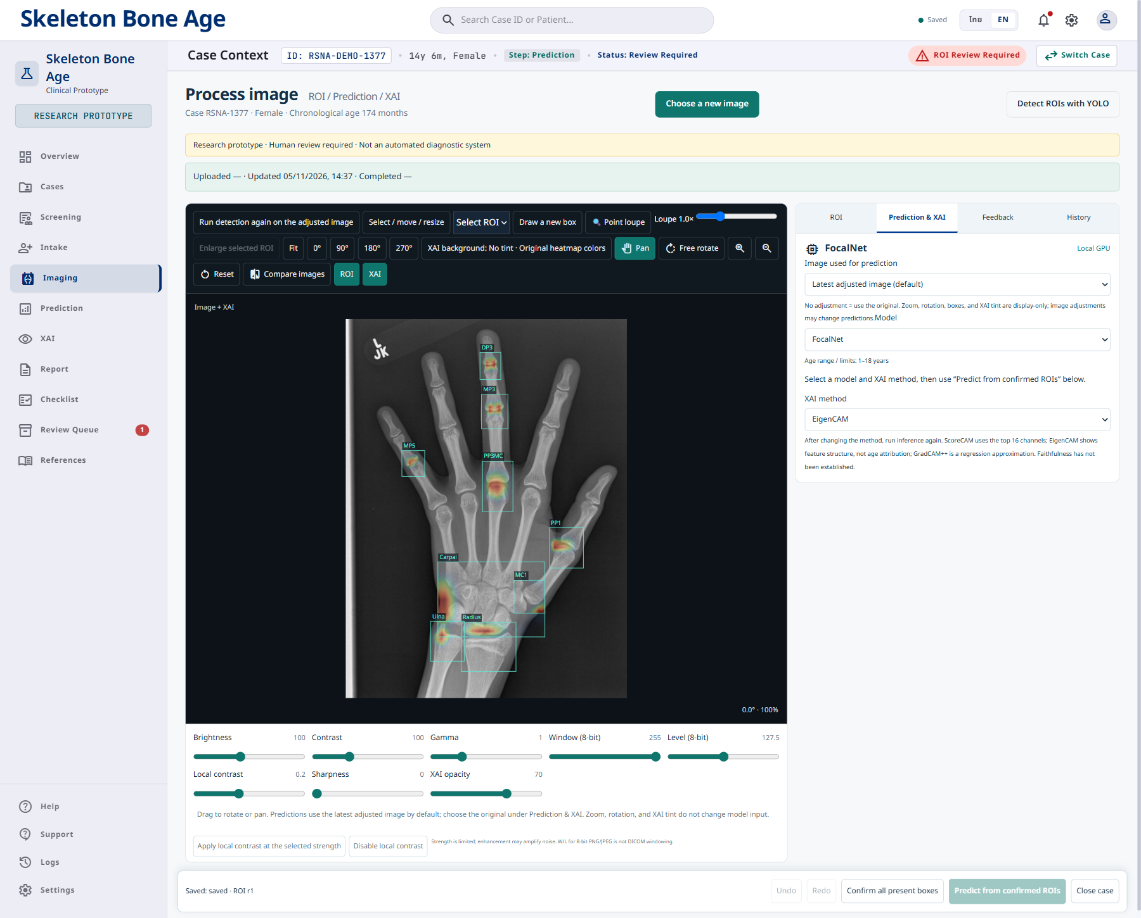
Figure 6. English language review workspace captured from the locally running application. Image controls and model settings are presented alongside the radiograph. Interface values are demonstration context, not additional clinical observations. The screenshot documents functionality and does not establish usability or clinical benefit.

4. Discussion
The numerical findings describe the selected FocalNet checkpoint on 260 archived records. The MAE of 6.619 months summarizes average absolute disagreement, while the RMSE of 8.795 months places greater weight on large errors. Positive average bias was modest, but the spread of signed differences was substantially wider. These results support reporting the distribution of errors alongside an average, rather than representing the system through one favourable example or one scalar metric.
The contribution of the web application lies in making inputs and outputs inspectable within the same case review process. Regional crops allow reviewers to identify missing or misplaced inputs, and a recorded expert opinion preserves disagreement without overwriting the original model estimate. These functions create a basis for studying error detection and correction. Their practical benefit remains a hypothesis because a controlled user study has not been performed [16, 17, 18, 19].
A regional design does not eliminate shortcut learning. Markers, borders, background texture, or preprocessing artefacts may remain within a crop. Likewise, agreement with reference bone age does not establish that an explanation is faithful. A useful subsequent study would match checkpoint, image, ROI geometry, normalization, and attribution method before applying parameter randomization and perturbation tests [12, 13, 14, 15]. The matched illustrations improve the auditability of the explanation workflow, but a single case cannot establish the reliability of these maps across patients.
Evaluation on other populations also requires care. Bone age is a reference based maturity estimate, whereas chronological age measures elapsed time. Errors against these two quantities answer different questions. A study of a Brazilian population with a supporting application illustrates the importance of reporting dataset context [25]; its performance is not directly comparable with the present cohort. The present manuscript includes no evidence of generalization to Thai clinical data.

5. Study Limitations and Future Evaluation
The main limitation is evaluation provenance. The archived set was inspected previously and its records flag overlap associated with model initialization. These conditions prevent an unqualified claim of independent testing. A patient level lineage audit is required before excluding the flagged individuals or assigning a final test designation. The conflicting historical training inventories must also be reconciled. Numerical confidence intervals reflect sampling variation conditional on the analysed records; they do not correct leakage or selection bias.
The results concern stored regional inputs and do not establish full hand end to end performance. Detector localization, incomplete ROI handling, and robustness to image enhancement require separate evaluation. Subgroup estimates are descriptive and may be unstable where counts are small. No blinded expert ratings, clinical effectiveness study, or measured usability experiment was available. Ethics approval or exemption remains pending confirmation.
Future work should first resolve patient level data lineage and evaluate a frozen checkpoint on a genuinely untouched cohort. An explanation study should extend the present checkpoint matched raw maps to multiple cases with prespecified plausibility, faithfulness, and stability criteria. A separate user study can measure ROI correction success, missed errors, task time, and reviewer workload. Feedback driven model updates require an independent evaluation protocol and release approval; no such improvement is inferred from the current interface.

6. Conclusion
We developed a web based workflow combining nine regional inputs, FocalNet bone age regression, explanation inspection, and structured expert review. The selected checkpoint had an MAE of 6.619 months and RMSE of 8.795 months on 260 archived cases. These descriptive results are limited by evaluation provenance and do not establish independent generalization. The system provides an inspectable setting for future studies of model evidence and expert review; explanation faithfulness, clinical benefit, and feedback driven improvement remain unmeasured.

Declarations
Author contributions: Witsanu Intasuwan developed the application and analysis workflow. Kanokwatt Shiangjen supervised the project. Final author approval and detailed contribution assignments require confirmation. Funding: No funding was reported. Conflicts of interest: The authors declare no conflicts of interest. Ethics approval or exemption: Pending author confirmation.
Data and code availability: The code for the application is available at https://github.com/I-Witsanu02/Bone_age subject to repository access. The analysis code, aggregate results, and checkpoint provenance accompany this manuscript. Source radiographs and trained weights are not included in this document; their use and redistribution are subject to the applicable permissions. No new clinical dataset was collected for this revision.

References
[1] Greulich WW, Pyle SI. Radiographic Atlas of Skeletal Development of the Hand and Wrist. 2nd ed. Stanford University Press; 1959.
[2] Lee BD, Lee MS. Automated Bone Age Assessment Using Artificial Intelligence: The Future of Bone Age Assessment. Korean Journal of Radiology. 2021;22(5):792. doi:10.3348/kjr.2020.0941.
[3] Gaskin CM, Kahn SL, Bertozzi JC, Bunch PM. Skeletal Development of the Hand and Wrist: A Radiographic Atlas and Digital Bone Age Companion. Oxford University Press; 2011. doi:10.1093/med/9780199782055.001.0001.
[4] Halabi SS, Prevedello LM, Kalpathy-Cramer J, Mamonov AB, Bilbily A, Cicero M, et al.. The RSNA Pediatric Bone Age Machine Learning Challenge. Radiology. 2019;290(2):498-503. doi:10.1148/radiol.2018180736.
[5] Koitka S, Kim MS, Qu M, Fischer A, Friedrich CM, Nensa F. Mimicking the radiologists’ workflow: Estimating pediatric hand bone age with stacked deep neural networks. Medical Image Analysis. 2020;64:101743. doi:10.1016/j.media.2020.101743.
[6] Yang J, Li C, Dai X, Gao J. Focal Modulation Networks. Advances in Neural Information Processing Systems. 2022;35. doi:10.52202/068431-0304.
[7] Selvaraju RR, Cogswell M, Das A, Vedantam R, Parikh D, Batra D. Grad-CAM: Visual Explanations from Deep Networks via Gradient-Based Localization. 2017 IEEE International Conference on Computer Vision (ICCV). 2017:618-626. doi:10.1109/ICCV.2017.74.
[8] Chattopadhay A, Sarkar A, Howlader P, Balasubramanian VN. Grad-CAM++: Generalized Gradient-Based Visual Explanations for Deep Convolutional Networks. 2018 IEEE Winter Conference on Applications of Computer Vision (WACV). 2018:839-847. doi:10.1109/WACV.2018.00097.
[9] Wang H, et al. Score-CAM: Score-Weighted Visual Explanations for Convolutional Neural Networks. CVPR Workshops; 2020. https://arxiv.org/abs/1910.01279
[10] Muhammad MB, Yeasin M. Eigen-CAM: Class Activation Map Using Principal Components. IJCNN; 2020. https://arxiv.org/abs/2008.00299
[11] Jiang PT, Zhang CB, Hou Q, Cheng MM, Wei Y. LayerCAM: Exploring Hierarchical Class Activation Maps for Localization. IEEE Transactions on Image Processing. 2021;30:5875-5888. doi:10.1109/TIP.2021.3089943.
[12] Adebayo J, et al. Sanity Checks for Saliency Maps. Adv Neural Inf Process Syst. 2018;31. https://proceedings.neurips.cc/paper/2018/hash/294a8ed24b1ad22ec2e7efea049b8737-Abstract.html
[13] Arun N, Gaw N, Singh P, Chang K, Aggarwal M, Chen B, et al.. Assessing the Trustworthiness of Saliency Maps for Localizing Abnormalities in Medical Imaging. Radiology: Artificial Intelligence. 2021;3(6):e200267. doi:10.1148/ryai.2021200267.
[14] Ghassemi M, Oakden-Rayner L, Beam AL. The false hope of current approaches to explainable artificial intelligence in health care. The Lancet Digital Health. 2021;3(11):e745-e750. doi:10.1016/S2589-7500(21)00208-9.
[15] Jin W, Li X, Fatehi M, Hamarneh G. Guidelines and evaluation of clinical explainable AI in medical image analysis. Medical Image Analysis. 2023;84:102684. doi:10.1016/j.media.2022.102684.
[16] Chen H, Gomez C, Huang CM, Unberath M. Explainable medical imaging AI needs human-centered design: guidelines and evidence from a systematic review. npj Digital Medicine. 2022;5(1):156. doi:10.1038/s41746-022-00699-2.
[17] Tonekaboni S, Joshi S, McCradden MD, Goldenberg A. What Clinicians Want: Contextualizing Explainable Machine Learning for Clinical End Use. PMLR. 2019;106:359–380. https://proceedings.mlr.press/v106/tonekaboni19a.html
[18] Amershi S, Weld D, Vorvoreanu M, Fourney A, Nushi B, Collisson P, et al.. Guidelines for Human-AI Interaction. Proceedings of the 2019 CHI Conference on Human Factors in Computing Systems. 2019:1-13. doi:10.1145/3290605.3300233.
[19] Cai CJ, Winter S, Steiner D, Wilcox L, Terry M. "Hello AI": Uncovering the Onboarding Needs of Medical Practitioners for Human-AI Collaborative Decision-Making. Proceedings of the ACM on Human-Computer Interaction. 2019;3(CSCW):1-24. doi:10.1145/3359206.
[20] Tejani AS, Klontzas ME, Gatti AA, Mongan JT, Moy L, Park SH, et al.. Checklist for Artificial Intelligence in Medical Imaging (CLAIM): 2024 Update. Radiology: Artificial Intelligence. 2024;6(4):e240300. doi:10.1148/ryai.240300.
[21] Collins GS, Moons KGM, Dhiman P, Riley RD, Beam AL, Van Calster B, et al.. TRIPOD+AI statement: updated guidance for reporting clinical prediction models that use regression or machine learning methods. BMJ. 2024;385:e078378. doi:10.1136/bmj-2023-078378.
[22] Bland JM, Altman DG. Statistical methods for assessing agreement between two methods of clinical measurement. Lancet. 1986;327(8476):307–310. doi:10.1016/S0140-6736(86)90837-8.
[23] World Health Organization. Ethics and Governance of Artificial Intelligence for Health. WHO; 2021. https://www.who.int/publications/i/item/9789240029200
[24] US FDA, Health Canada, MHRA. Good Machine Learning Practice for Medical Device Development: Guiding Principles. October 2021. https://www.canada.ca/en/health-canada/services/drugs-health-products/medical-devices/good-machine-learning-practice-medical-device-development.html
[25] Teodoro RdA, de Lima FV, Popa M, Sampaio GS, Kochi C, Longui CA, et al.. Automatic bone age assessment: a deep learning case study on the Brazilian population with a supporting mobile application prototype. Scientific Reports. 2026;16(1):4488. doi:10.1038/s41598-025-34651-7.

