**Adaptive Mail: A Flexible Email Client App**

An Android Application using Kotlin

**Submitted by:**

Aswin S - 71772218102

Balaraman N - 71772218103

Deepika P - 71772218108

Elakkiya R - 71772218112

**INTRODUCTION:**

**Overview:**

Adaptive Mail is an email management application that simplifies the way users send, receive, and manage their email communications. It offers a secure registration and login process, allowing users to efficiently manage emails through intuitive interfaces.

Adaptive Mail supports basic email functionalities, like composing, sending, and viewing detailed information of received messages, focusing on privacy and ease of use. Hence Adaptive Mail aims to simplify communication for busy users.

**Purpose:**

The purpose of Adaptive Mail is to provide a streamlined, secure, and user-friendly email experience. By integrating essential email functionalities with a focus on simplicity, the app ensures that users can manage their emails effectively without the clutter of unnecessary features.

The **Adaptive Mail** project is designed to create an intuitive, secure, and efficient email management platform. Its purpose includes:

1. **Simplify Email Management**: Provide an easy-to-use system for sending, receiving, and managing emails, catering to users who prefer minimalistic interfaces.
2. **Enable Secure Communication**: Ensure robust account security through Firebase Authentication for registration and login.
3. **Enhance User Experience**: Allow users to view the detailed content of emails, including sender, recipient, subject, and body, for both sent and received messages, ensuring comprehensive email tracking.
4. **Focus on Core Features**: Prioritize essential functionalities while avoiding the complexity of traditional email clients.
5. **Support Scalability**: Lay a strong foundation for future features like attachments, filters, and offline access, addressing evolving user needs.

**LITERATURE SURVEY:**

**Existing Problem:**

Traditional email clients can be complex and overloaded with features that may not benefit users who prefer simplicity. Many users face challenges in managing their emails effectively, especially when dealing with inbox clutter, registration processes, and security concerns.

**Proposed Solution:**

Adaptive Mail offers a straightforward and minimalistic approach to email management. The app allows users to register, log in securely, and access only essential functionalities, such as sending, receiving, and viewing email details, providing an efficient and less distracting environment for communication.

**THEORETICAL ANALYSIS:**

**Block Diagram:**

Diagrammatically, the app's workflow begins with user registration, followed by a login verification. Once logged in, users can access functionalities for composing, sending, and viewing emails. The app uses basic protocols to fetch and display messages securely.

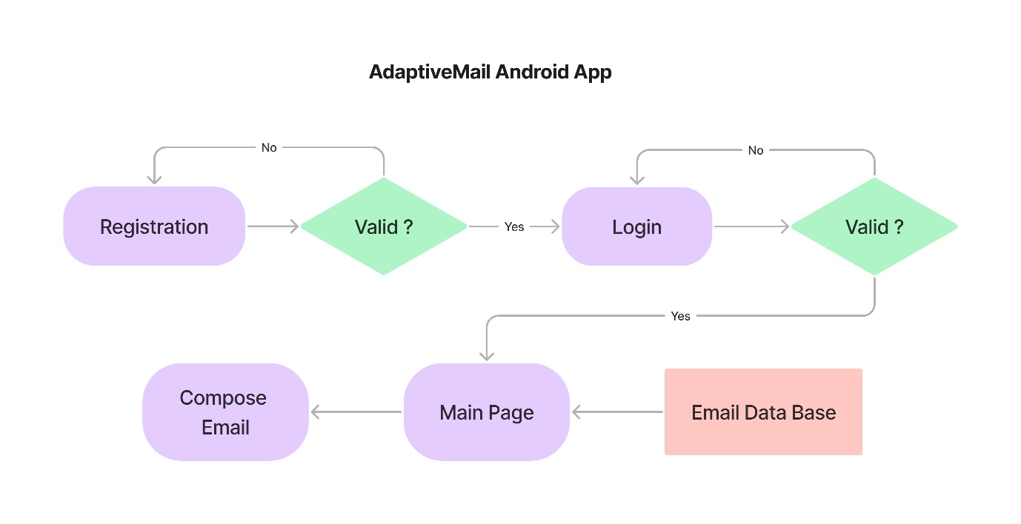

**HARDWARE / SOFTWARE DESIGNING:**

The Hardware and Software Requirements for the Adaptive mail project includes the following:

**Hardware Requirements:**

1. **Android Device**:
   * **Minimum OS Version**: Android 5.0 (Lollipop) or later to support essential security and functionality.
   * **Memory**: At least 2GB of RAM for smooth performance with Firebase connections and real-time data handling.
   * **Storage**: Minimum 100 MB of free space for app installation, updates, and cached email data.
2. **Network Connectivity**:
   * **Internet Access**: Reliable internet connection (Wi-Fi or mobile data) is essential for registration, login, sending, receiving, and synchronizing emails in real time.

**Software Requirements:**

**1.Operating System**:

* **Android Studio Compatibility**: Android Studio version 2021.1 or later, which supports the latest Kotlin updates and Firebase SDKs.

**2.Development Language**:

* **Kotlin**: The Adaptive Mail app is built using Kotlin, a modern language known for its readability, performance, and compatibility with Android APIs.

**3.Backend Services**:

* **Firebase Authentication**: Manages user registration and login with secure email-password-based authentication.
* **Firebase Realtime Database**: Stores user emails, inbox information, and message details, allowing real-time access and updates.

**4.Libraries and Dependencies**:

* **Android SDK:** The latest SDK tools and libraries compatible with Android 5.0+.
* **Firebase SDKs:** Required for authentication, database integration, and data synchronization.
* **RecyclerView:** For displaying lists of messages in a scrollable view, enhancing the UI experience.

**5.IDE**:

* **Android Studio**: The recommended integrated development environment (IDE) for coding, testing, and debugging.

**EXPERIMENTAL INVESTIGATIONS:**

In developing **Adaptive Mail**, various experimental processes were implemented to optimize functionality and enhance user satisfaction. These focused on identifying usability challenges, ensuring reliable performance, and safeguarding user data. Key investigations included:

**Usability Testing:**

Usability testing was conducted to assess the app’s user-friendliness, with testers completing tasks like registration, login, and navigating the email interface. Based on feedback, the interface was refined to enhance user experience.

**Performance Testing:**

Tests were performed to ensure fast loading times for inbox messages and smooth navigation between sending, receiving, and viewing emails.

**Security Testing:**

Security assessments focused on safeguarding user credentials during registration and login, with encryption implemented to protect sensitive data.

**RESULTS:**

**Final findings (Output) of the project along with screenshots.**

**Enhanced Email Management**: Adaptive Mail provides a clean and organized interface, allowing users to register, log in, and manage emails effortlessly.

**Efficient Navigation**: Users can send and receive emails without navigating complex menus, ensuring a seamless communication experience.

**Secure Communication**: With secure registration and login, Adaptive Mail protects user data and ensures only authorized access to email communications.

**ADVANTAGES & DISADVANTAGES:**

**Advantages:**

* User-Friendly Interface: Adaptive Mail offers a simple and intuitive layout for all users.
* Efficient Email Management: Provides essential email functionalities without additional complexity.
* Secure Authentication: Protects user data through secure registration and login protocols.

**Disadvantages:**

* Internet Dependency: Requires internet access for email functionalities.
* Limited Features: Basic functionality without advanced features found in more comprehensive email clients.

**APPLICATIONS:**

Adaptive Mail is applicable in:

* **Personal Email Management**: Helps users handle basic communication needs in an organized way.
* **Business and Professional Use**: Ideal for professionals needing a simple tool to manage work emails without clutter.
* **Educational Use**: Assists students and teachers in managing essential academic communications.

**CONCLUSION:**

Adaptive Mail successfully addresses the need for a simple, secure, and efficient email management tool. By focusing on essential functionalities, it offers users a streamlined experience that avoids the distractions of traditional email clients. With secure registration and login, Adaptive Mail prioritizes data privacy and user convenience.

**FUTURE SCOPE:**

Potential enhancements for Adaptive Mail include:

* **Advanced Filtering Options**: Allow users to filter emails by categories.
* **Enhanced Security Features**: Adding two-factor authentication for improved account security.
* **Attachment Support**: Enabling users to send and receive attachments.
* **Customization Options**: Allowing users to personalize the app’s interface and notification settings.

**Project Source :**

Github Link:

* + <https://www.github.com/I-am-Aswin/AdaptiveMail.git>

Video Link :

* + https://drive.google.com/file/d/1v3_jvBzYu5M5c_HN5CQCg8T3aV23ALyk/view?usp=sharing