Large Exercise — How a URL Becomes a Webpage
This is the full document for the Large Exercise, written entirely in Markdown and ready for Pandoc conversion.
It contains: a Summary, Introduction, Background, Elaboration, two Mermaid diagrams, one architecture drawing reference, and one mindmap reference.

1. Summary
This document explains what happens behind the scenes when you enter a URL in your browser and press Enter.
From DNS lookup, to server communication, to rendering the final webpage — this guide breaks down every stage in a clear, beginner-friendly way.

2. Introduction
This document is for new engineering students learning how the web works.
Understanding how a URL becomes a webpage helps with:
- debugging network issues
- building full-stack apps
- understanding browser behavior
- improving performance
You do not need deep networking knowledge — basic computer use is enough.

3. Background
Before a webpage loads, several systems work together:
- DNS translates domain names into IP addresses so the browser knows where the server is.
- TCP/TLS creates a secure connection between browser and server.
- HTTP is used to request webpage resources like HTML, CSS, JS, and images.
- Rendering engines inside the browser convert raw files into the final visible page.
These systems evolved over time with new standards like HTTPS, CDNs, caching layers, and modern JavaScript engines.

4. Elaboration
Below are the detailed steps that occur when loading a webpage, along with diagrams and references. ## 4.1 Mindmap — How a URL Becomes a Webpage
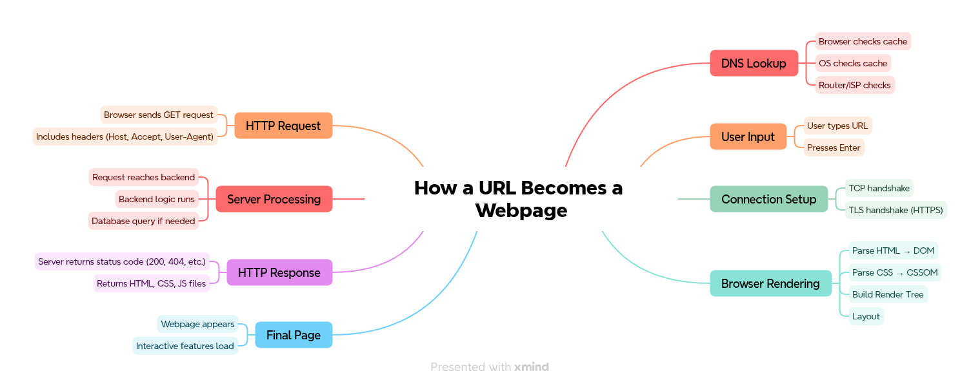
Mindmap

4.2 Architecture Diagram
Architecture

4.3 Step-by-Step Process

Step 1 — DNS Lookup
When you type https://example.com, the browser checks:
- Browser cache
- OS DNS cache
- Router cache
- ISP resolver
- Authoritative DNS servers
The final result returns an IP address.
Example: 93.184.216.34.

Step 2 — TCP Handshake
Browser and server establish a reliable connection:
- SYN →
- SYN-ACK ←
- ACK →
This forms a connection channel.

Step 3 — TLS Handshake (for HTTPS)
If the site uses HTTPS:
- Browser validates the server certificate
- Keys are exchanged securely
- All communication becomes encrypted
This prevents attackers from reading or modifying traffic.

Step 4 — Sending an HTTP Request
Example request:
GET / HTTP/1.1
Host: example.com
Accept: text/html
User-Agent: Chrome
Browser sends this through the established connection.

Step 5 — Backend Processes the Request
On the server:
- Request hits the backend route
- Server may talk to a database
- Templates or JSON may be generated
- Response is built
- Server sends response back to browser

Step 6 — Browser Rendering
The browser receives files and builds the webpage through:
- DOM — HTML structure
- CSSOM — CSS styling
- Render Tree — combined view
- Layout — element sizes & positions
- Painting — drawing pixels
- JavaScript execution — dynamic behavior
Finally, the webpage appears on screen.

4.4 Mermaid Diagram — DNS to TCP Flow

4.4 Simple DNS to Server Flow
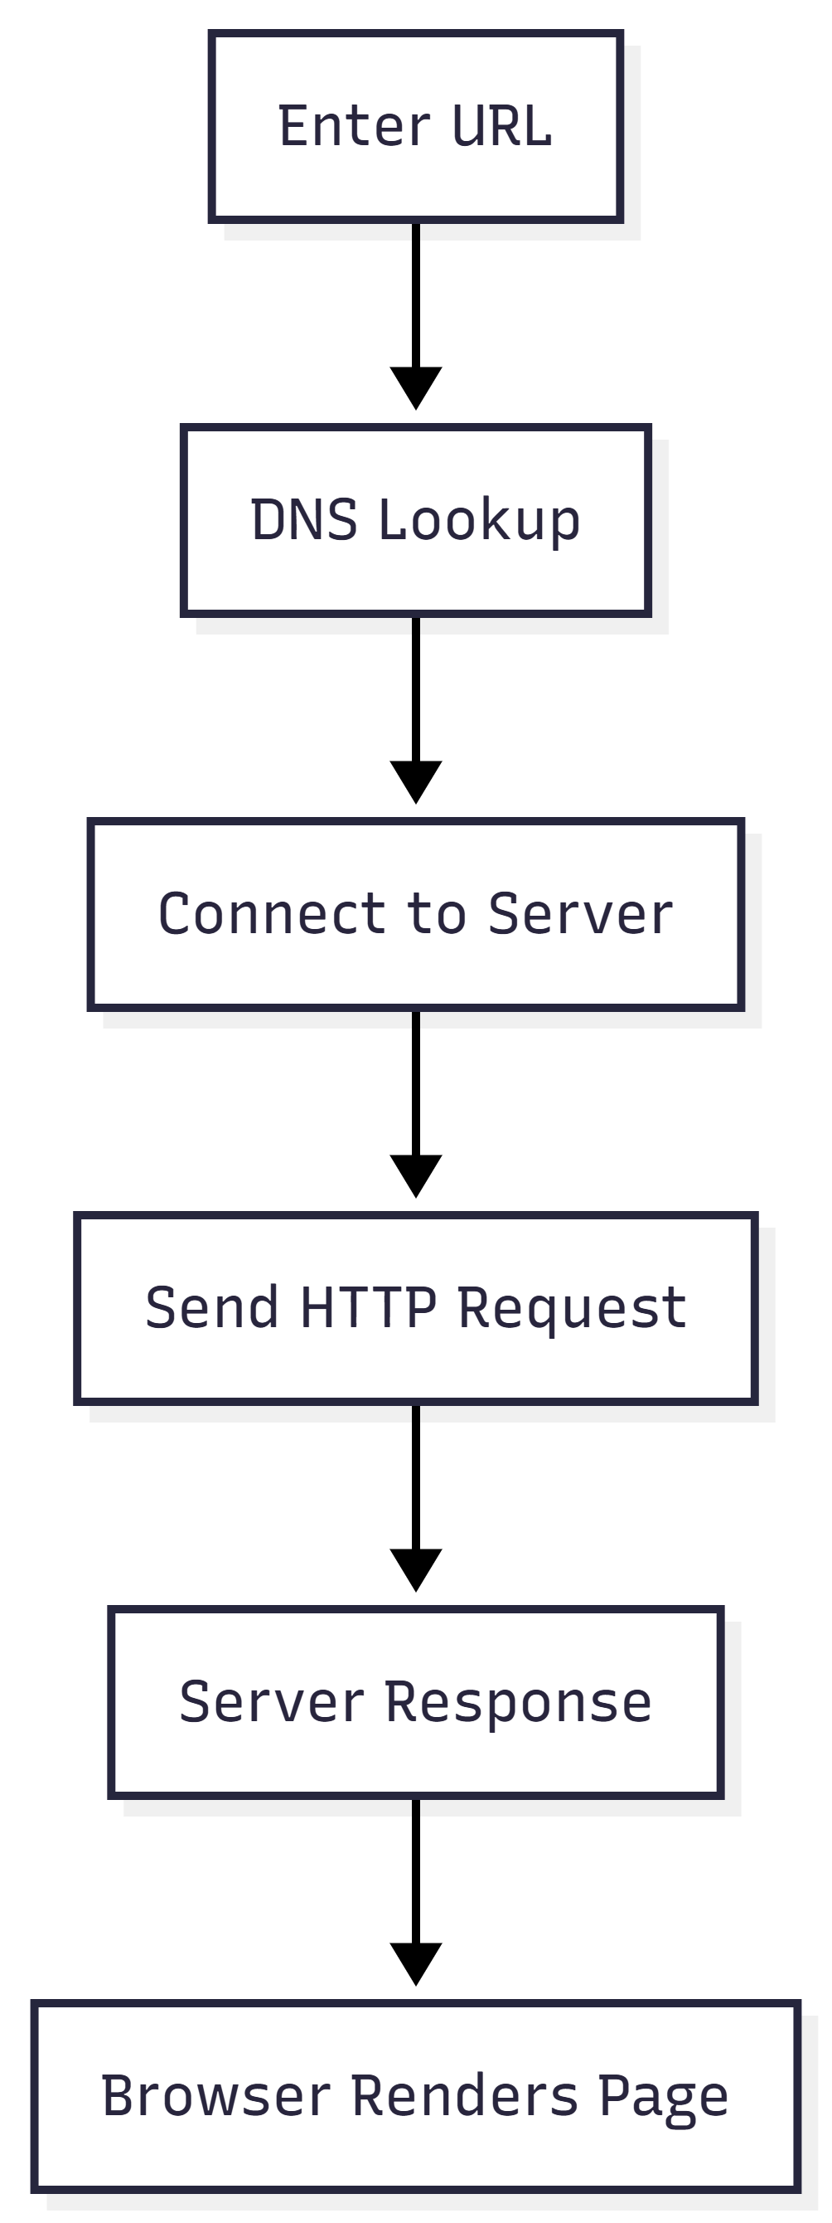
DNS to Server Diagram
## 4.4 Simple DNS to Server Flow
![DNS to Server Diagram](./dns-to-server-sequence.png)

4.5 Mermaid Diagram — Complete Page Load Flow

4.5 Simple Page Load Flow
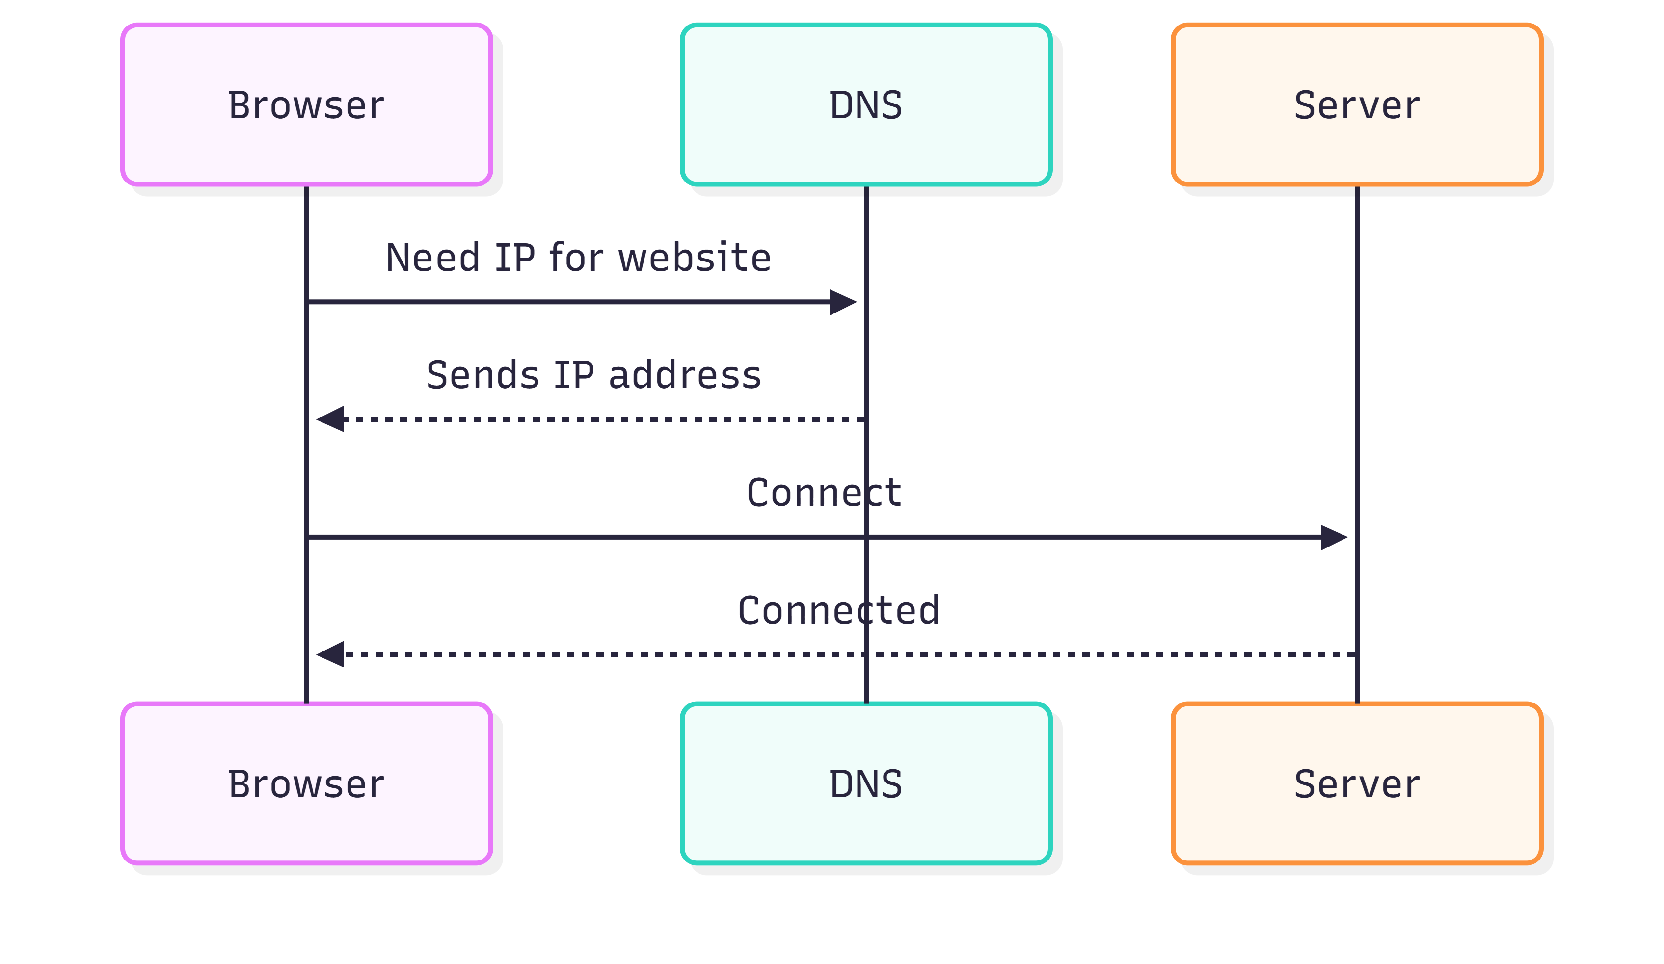
Page Load Flowchart

