RDBMS Assignment

Data Query Language

1. List the Name and Designation code of the staff who have joined before Jan 2003 and whose salary range is between 12000 and 25000. Display the columns with user defined Column headers. Hint: Use As clause along with other operators.

Ans-

select Staff_Name as Name ,Design_code as Designation_code

-> from Staff_Masters

-> where Staff_sal between 12000 and 25000 and HireDate<'2003-01-01';

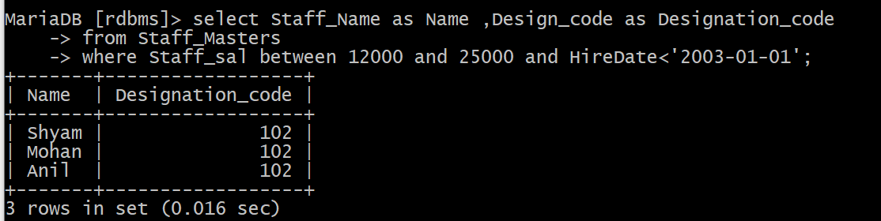

2. List the staff code, name, and department number of the staff who have experience of 18 or more years and sort them based on their experience.

Ans-

select staff_code,staff_name,dept_code

-> from staff_masters

-> where floor((datediff(curdate(),hiredate))/365)>=18;

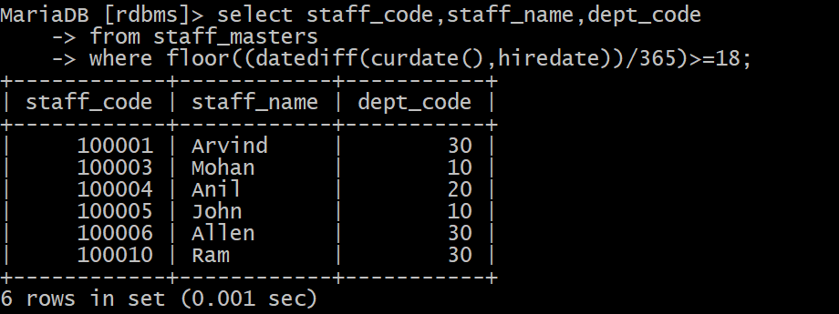

3. Display the staff details who do not have manager.

Ans. select * from staff_masters where mgr_code is null;



4. Display the Book details that were published during the period of 2001 to 2004. Also display book details with Book name having the character ‘&’ anywhere.

Ans:

select * from book_master

-> where book_pub_year between 2001 and 2004 or book_name like '%&%';

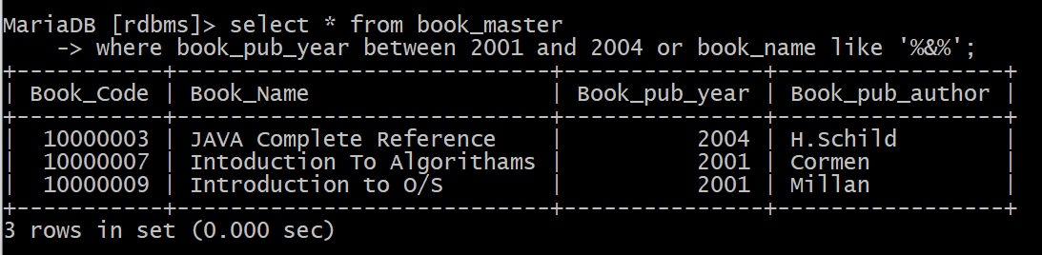

5. List the names of the staff having ‘_’ character in their name.

Ans: select * from staff_masters where staff_name like'%\_%';



## Single Row Functions:

1. Create a query which will display Staff Name, Salary of each staff. Format the salary to be 15 characters long and left padded with ‘$’.

Ans:

select staff_name,lpad(staff_sal,15,'$') as salary from staff_masters;

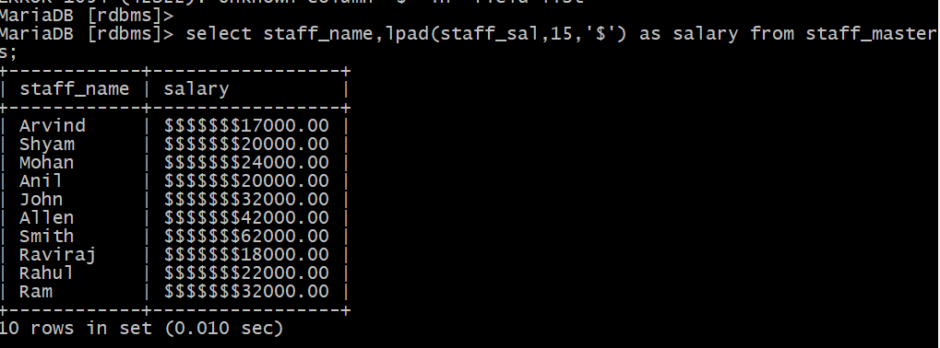

2.Display name and date of birth of students where date of birth must be displayed in the format similar to “January, 12 1981” for those who were born on Saturday or Sunday.

Ans: select student_name,date_format(student_dob,'%M, %d %Y') as dob

-> from student_master

-> where date_format(student_dob,'%a') like 'SAT' or date_format(student_dob,'%a') like 'SUN';

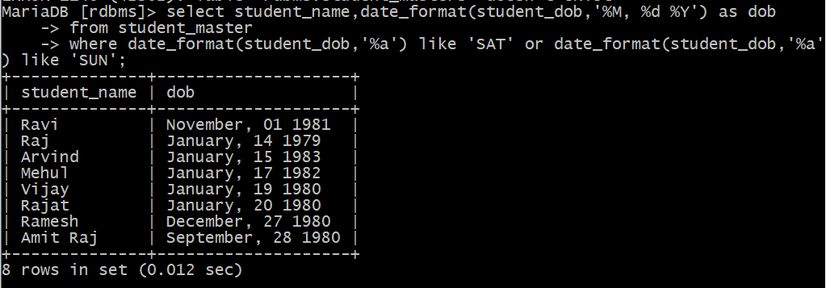

3. Display each Staff name and number of months they worked for the organization. Label the column as ‘Months Worked’. Order your result by number of months employed. Also Round the number of months to closest whole number.

Ans:

select staff_name, round((datediff(curdate(),hiredate))/365)*12 as Months_Worked

-> from staff_masters

-> order by round((datediff(curdate(),hiredate))/365)*12 desc;

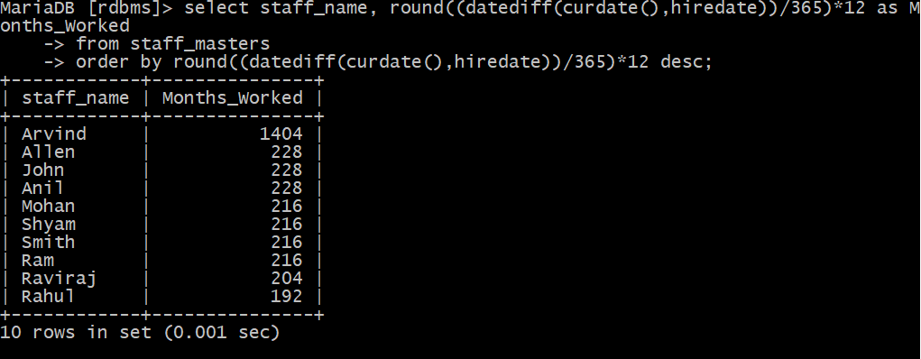

4.List the details of the staff who have joined in first half of December month (irrespective of the year).

Ans:

select *

-> from staff_masters

-> where month(hiredate)=12 and day(hiredate) between 1 and 15;

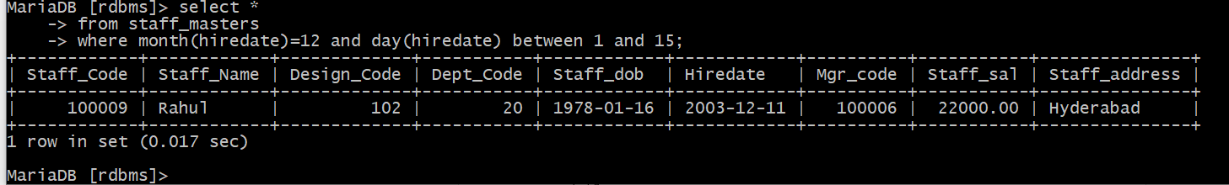

5. Write a query that displays Staff Name, Salary, and Grade of all staff. Grade depends on the following table.

|  |  |
| --- | --- |
| Salary | Grade |
| Salary >=50000 | A |
| Salary >= 25000 < 50000 | B |
| Salary>=10000 < 25000 | C |
| OTHERS | D |

Ans:

select staff_name,staff_sal as salary, case

-> when staff_sal>=50000 then 'A'

-> when staff_sal>=25000 and staff_sal<50000 then 'B'

-> when staff_sal>=10000 and staff_sal<25000 then 'C'

-> else 'D'

-> end

-> from staff_masters;

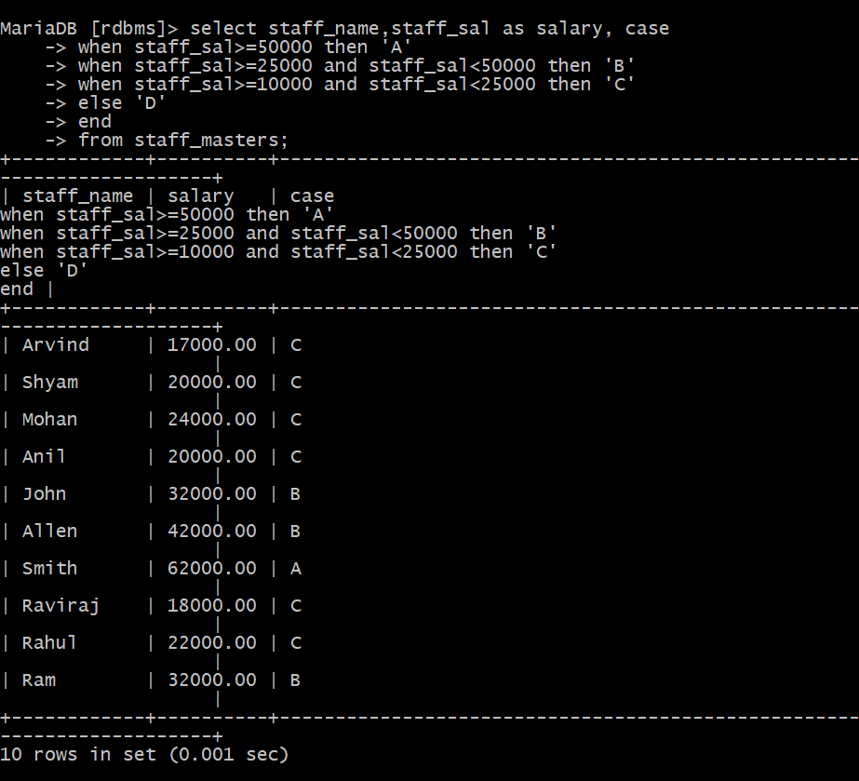

6. Display the Staff Name, Hire date and day of the week on which staff was hired. Label the column as DAY. Order the result by the day of the week starting with Monday. Hint: Use to_char with hiredate and formats ‘DY’ and ’D’

Ans:

select staff_name,hiredate,dayname(hiredate) as Day

-> from staff_masters

-> order by case dayofweek(hiredate)

-> when 1 then 7

-> else dayofweek(hiredate)-1

-> end;

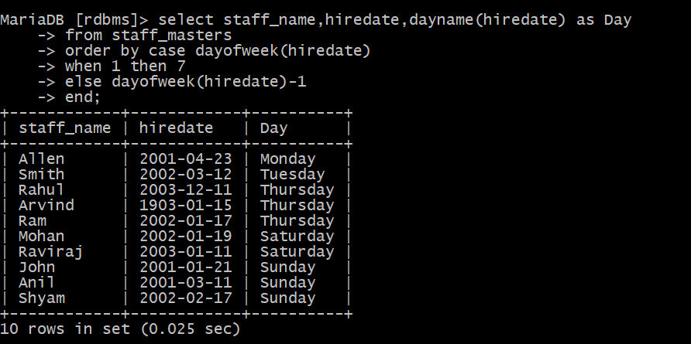

7. Write a query to find the position of third occurrence of ‘i’ in the given word ‘Mississippi’.

Ans:

select length(substring_index('Mississippi','i',3))+1 as Position from dual;

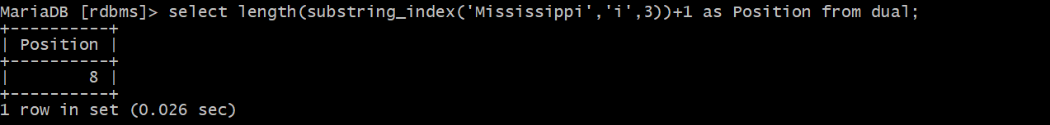

8. Display Student code, Name and Dept Name. Display “Electricals” if dept code = 20, “Electronics” if Dept code =30 and “Others” for all other Dept codes in the Dept Name column. Hint: Use Decode.

Ans:

MariaDB [rdbms]> select student_code,student_name,

-> case

-> when dept_code=30 then "Electronics"

-> when dept_code=20 then "Electricals"

-> else "Others"

-> end

-> from student_master;

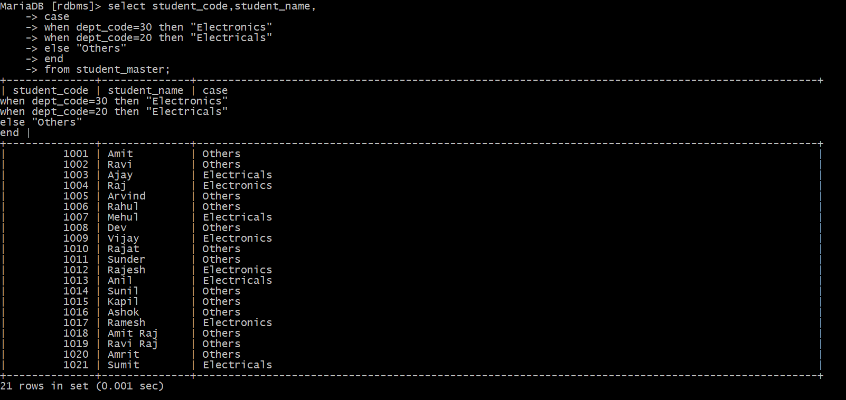

## Group Functions:

1. Display the Highest, Lowest, Total & Average salary of all staff. Label the columns Maximum, Minimum, Total and Average respectively for each Department code. Also round the result to the nearest whole number.

Ans:

select round(max(staff_sal)) as Maximum, round(min(staff_sal)) as Minimum, round(sum(staff_sal)) as total, round(avg(staff_sal)) as Average, Dept_code

-> from staff_masters

-> group by dept_code;

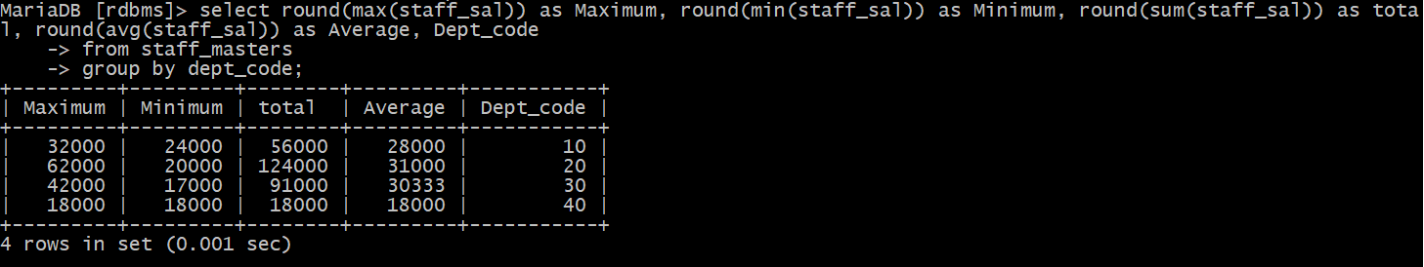

2. Display Department code and number of managers working in that department. Label the column as ‘Total Number of Managers’ for each department.

Ans:

select dept_code,count(mgr_code) as 'Total Number of Managers'

-> from staff_masters

-> group by dept_code;

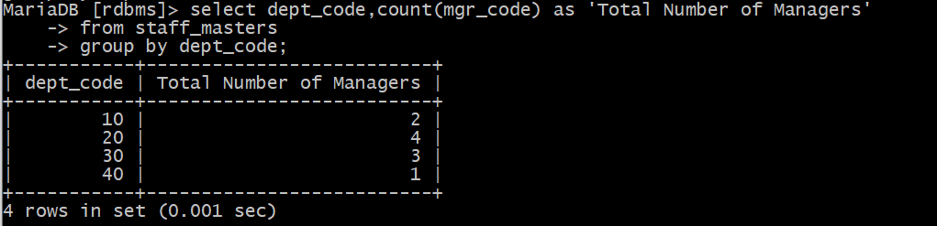

3. Get the Department number, and sum of Salary of all non-managers where the sum is greater than 20000.

Ans:

MariaDB [rdbms]> select dept_code as Deaprtement_code,sum(staff_sal)

-> from staff_masters

-> where staff_code not in(select mgr_code from staff_masters)

-> group by dept_code

-> having sum(staff_sal)>20000;

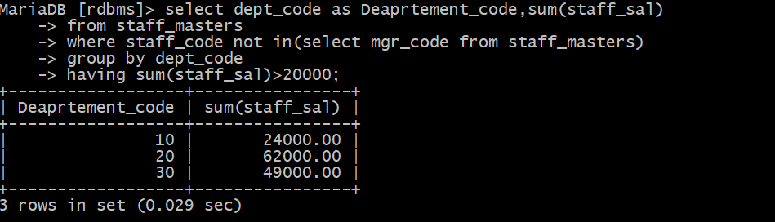

## Joins and Subqueries

1. Write a query which displays Staff Name, Department Code, Department Name, and Salary for all staff who earns more than 20000.

Ans:

select staff_name,a.dept_code,staff_sal,dept_name

-> from staff_masters as a inner join department_master as b on a.dept_code=b.dept_code

-> where staff_sal>20000;

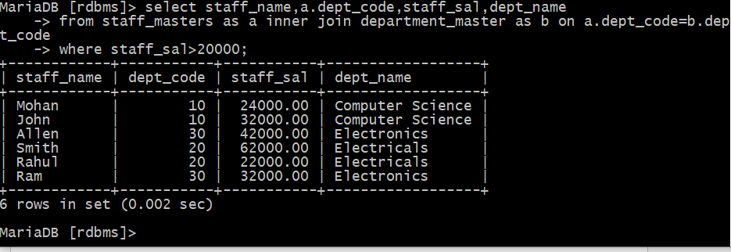

2. Display Staff Code, Staff Name, Department Name, and his manager’s number and name. Label the columns Staff#, Staff, Mgr#, Manager.

Ans:

select a.staff_name as StaffName, a.dept_code as DeparmentCode, dept_name, a.mgr_code as ManagerNumber, b.staff_name as ManagerName

from staff_masters b,staff_masters a inner join department_masters on a.dept_code=department_masters.dept_code

where a.mgr_code=b.staff_code;

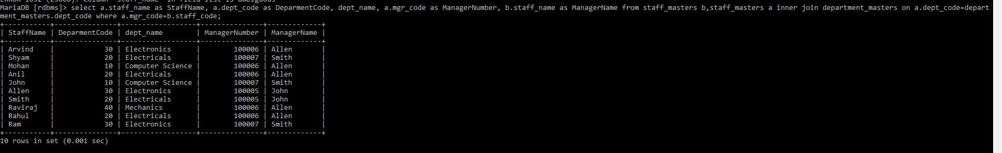

3.Create a query that will display Student Code, Student Name, Book Code, and Book Name for all students whose expected book return date is today.

Ans:

select a.book_code, a.student_code, b.book_name, c.student_name

from student_masters c,book_transactions a inner join book_masters b on a.book_code=b.book_code

where a.student_code=c.student_code and a.book_expected_return_date = '2011-02-09';



4.Create a query that will display Staff Code, Staff Name, Department Name, Designation name, Book Code, Book Name, and Issue Date for only those staff who have taken any book in last 30 days. . If required, make changes to the table to create such a scenario.

Ans:

selecta.book_code,b.book_name,a.book_issue_date,c.staff_code,c.staff_name,d.design_name,e.dept_name

from book_transactions a inner join book_masters b inner join staff_masters c inner join designation_masters d inner join department_masters e on a.book_code=b.book_code and a.staff_code=c.staff_code and c.design_code=d.design_code and c.dept_code=e.dept_code where (datediff('2011-03-16',a.book_issue_date)) between 0 and 30;



5. Generate a report which contains the following information. Staff Code, Staff Name, Designation Name, Department, Book Code, Book Name, Author, Fine For the staff who has not returned the book. Fine will be calculated as Rs. 5 per day. Fine = 5 * (No. of days = Current Date – Expected return date). Include records in the table to suit this problem statement.

Ans:

selecta.book_code,b.book_name,a.book_issue_date,c.staff_code,c.staff_name,d.design_name,e.dept_name, b.book_pub_author, 5*(datediff(a.book_actual_return_date,a.book_expected_return_date)) from book_transactions a inner join book_masters b inner join staff_masters c inner join designation_masters d inner join department_masters e on a.book_code=b.book_code and a.staff_code=c.staff_code and c.design_code=d.design_code and c.dept_code=e.dept_code where (datediff(a.book_actual_return_date,a.book_expected_return_date))>0;



6. List Staff Code, Staff Name, and Salary for those who are getting less than the average salary of organization.

Ans:

select staff_code, staff_name, staff_sal from staff_masters where staff_sal<(select avg(staff_sal) from staff_masters);

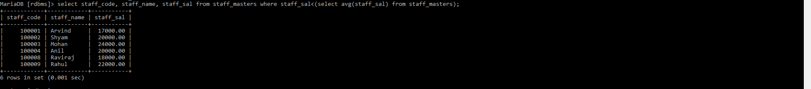

7. Display Author Name, Book Name for those authors who wrote more than one book.

Ans:

select book_name, book_pub_author from book_masters where book_pub_author = (select book_pub_author from book_masters group by book_pub_author having count(book_pub_author)>1);



8.Display Staff Code, Staff Name, and Department Name for those who have taken more than one book.

Ans:

select a.staff_code, b.staff_name, c.dept_name from book_transactions a inner join staff_masters b inner join department_masters c on a.staff_code=b.staff_code and b.dept_code=c.dept_code group by staff_code having count(a.staff_code)>1;



9.Display the Student Code, Student Name, and Department Name for that department in which there are maximum number of student studying.

Ans:

select a.student_code, a.student_name,b.dept_name from student_masters a join department_masters b on a.dept_code=b.dept_code where a.dept_code=(select dept_code from student_masters group by dept_code having count(dept_code) order by count(dept_code)desc limit 1);

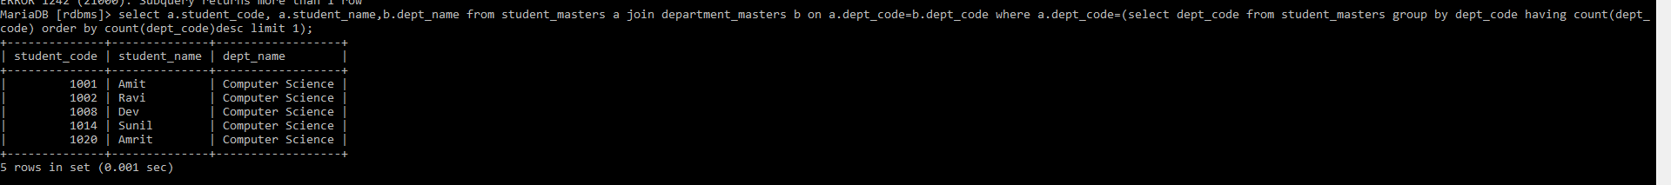

10.Display Staff Code, Staff Name, Department Name, and Designation name for those who have joined in last 3 months.

Ans:

select a.staff_code, a.staff_name, b.dept_name, c.design_name from staff_masters a inner join department_masters b inner join designation_masters c on a.dept_code=b.dept_code and a.design_code=c.design_code where datediff('2003-03-15',hiredate) between 0 and 90;



11. Display the Manager Name and the total strength of his/her team.

Ans:

select a.staff_name,count(b.mgr_code) from staff_masters a,staff_masters b where b.mgr_code=a.staff_code group by b.mgr_code;



12.Display the details of books that have not been returned and expected return date was last Monday. Book name should be displayed in proper case.. Hint: You can change /add records so that the expected return date suits this problem statement.

Ans:

select book_name from book_masters inner join book_transactions on book_masters.book_code=book_transactions.book_code where date_sub(curdate(),interval weekday(curdate()) day) and book_actual_return_date is null;



## Database Objects

1.Create the Customer table with the following columns.

CustomerId int(5)

Cust_Name varchar(20)

Address1 Varchar(30)

Address2 Varchar(30)

Ans:

create table Customer(

-> customerid int(5),

-> cust_name varchar(20),

-> address1 varchar(30),

-> address2 varchar(30));

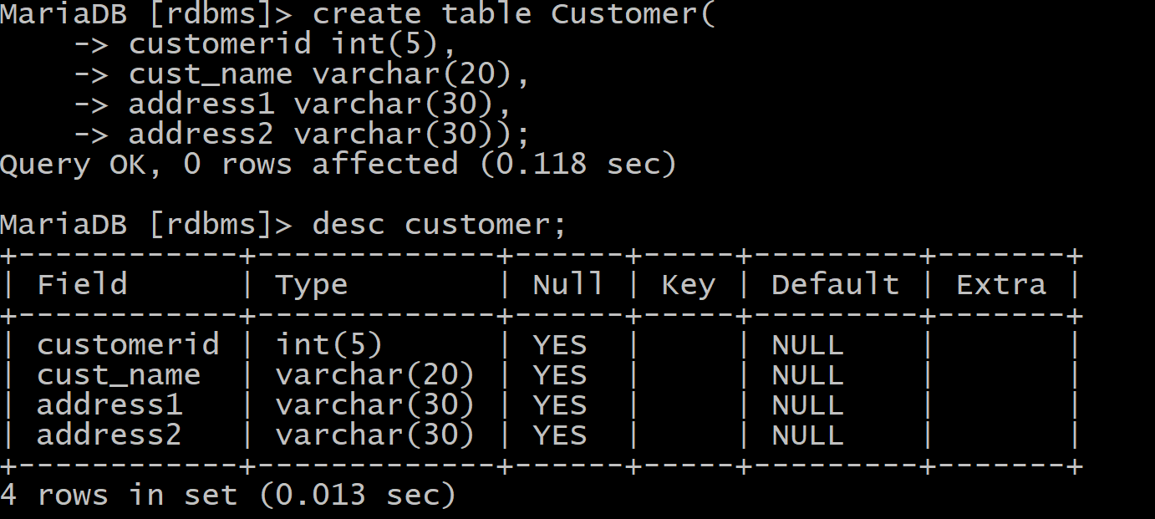

2. Modify the Customer table Cust_Name column of datatype with Varchar2(30), rename the column to CustomerName and it should not accept Nulls.

Ans:

alter table Customer

-> change cust_name customername varchar(20);

alter table Customer

-> MODIFY customername varchar(20) NOT NULL;

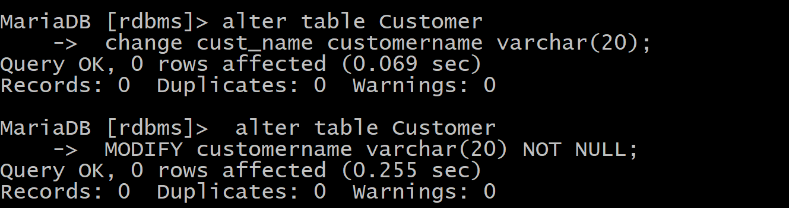

3.a) Add the following Columns to the Customer table.

Gender Varchar(1)

Age int(3)

PhoneNo int(10)

b) Rename the Customer table to Cust_Table

Ans:

alter table Customer

-> add column Age int(3);

alter table Customer

-> add column Gender varchar(1);

alter table Customer

-> add column Phoneno int(10);

rename table Customer to Cust_table;

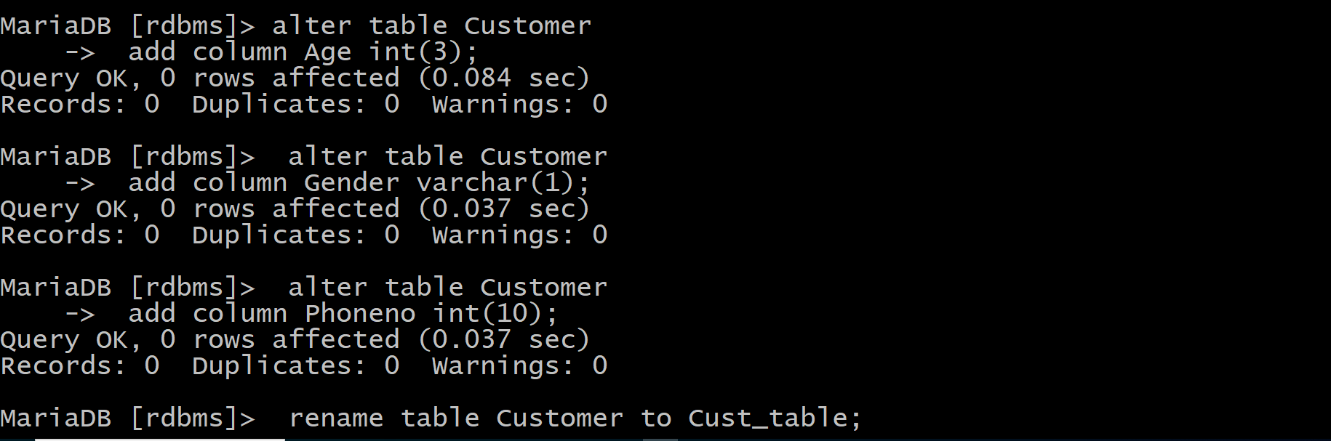

4.Insert rows with the following data in to the Customer table.

Insert into customer values: (1000, ‘Allen’, ‘#115 Chicago’, ‘#115 Chicago’, ‘M’, ‘25, 7878776’)

In similar manner, add the below records to the Customer table:

1001, George, #116 France, #116 France, M, 25, 434524

1002, Becker, #114 New York, #114 New York, M, 45, 431525

Ans:

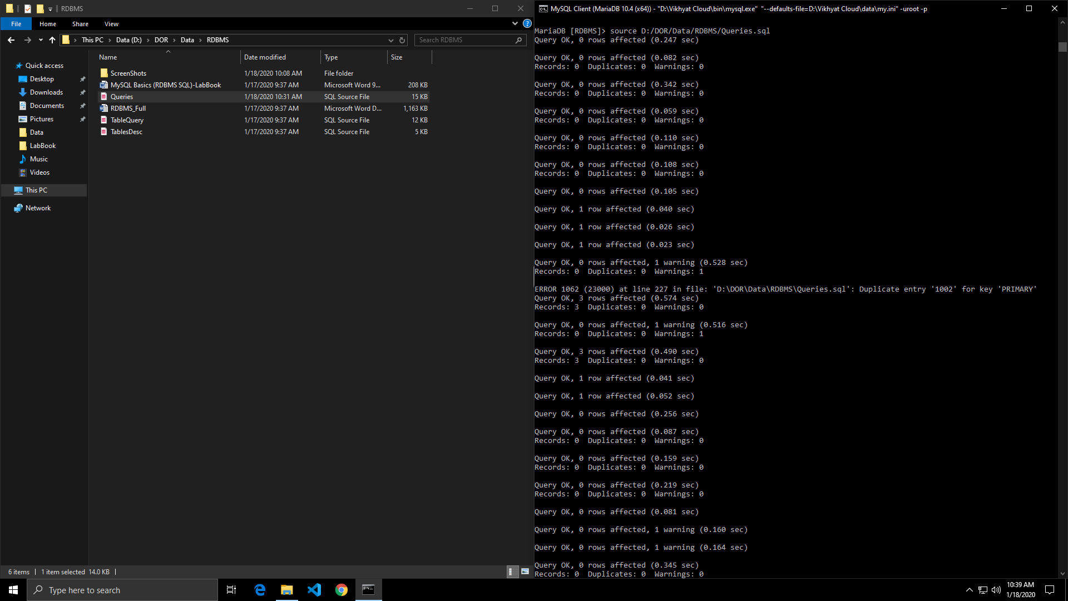



**Data Manipulation Language**

1.Create Employee table with same structure as EMP table.

SQL>Create table employee as select * from emp where 1=3

SQL>desc employee.

Ans:

CREATE TABLE Emp

(

EMPNO int(4) NOT NULL,

ENAME varchar(10),

JOB varchar(9),

MGR int(4),

HIREDATE DATE,

SAL numeric(7, 2),

COMM numeric(7, 2),

DEPTNO int(2)

);

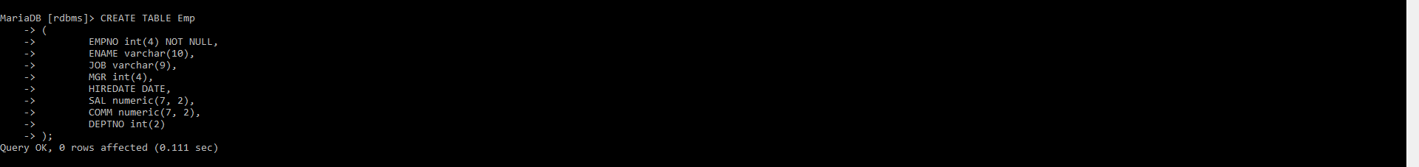

2.Write a query to populate Employee table using EMP table’s empno, ename, sal, deptno columns.

insert into emp (empno, ename, sal, deptno) values (7369,'SMITH',800,20);

insert into emp (empno, ename, sal, deptno) values (7499,'ALLEN',1600,30);

insert into emp (empno, ename, sal, deptno) values (7521,'WARD',1250,30);

insert into emp (empno, ename, sal, deptno) values (7566,'JONES',2975,20);

insert into emp (empno, ename, sal, deptno) values (7654,'MARTIN',1250,30);

insert into emp (empno, ename, sal, deptno) values (7698,'BLAKE',2850,30);

insert into emp (empno, ename, sal, deptno) values (7782,'CLARK',2450,10);

insert into emp (empno, ename, sal, deptno) values (7788,'SCOTT',3000,20);

insert into emp (empno, ename, sal, deptno) values (7839,'KING',5000,10);

insert into emp (empno, ename, sal, deptno) values (7844,'TURNER',1500,30);

insert into emp (empno, ename, sal, deptno) values (7876,'ADAMS',1100,20);

insert into emp (empno, ename, sal, deptno) values (7900,'JAMES',950,30);

insert into emp (empno, ename, sal, deptno) values (7902,'FORD',3000,20);

insert into emp (empno, ename, sal, deptno) values (7934,'MILLER',1300,10);



3.Write a query to change the job and deptno of employee whose empno is 7698 to the job and deptno of employee having empno 7788.

Ans:

update emp set job=(select job from emp where empno=7788), deptno=(select deptno from emp where empno=7788) where empno=7698;

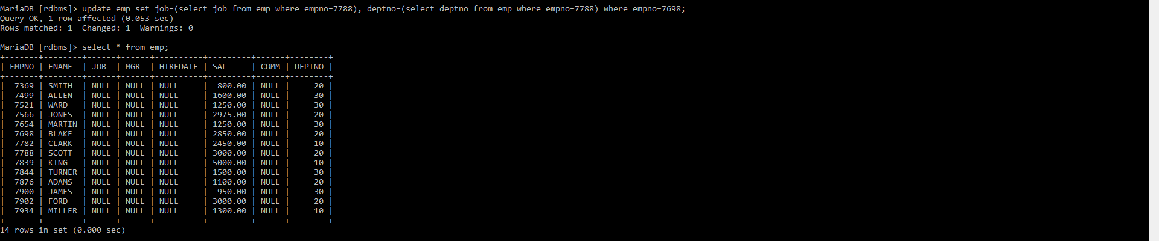

4.Delete the details of department whose department name is ‘SALES’.

Ans:

delete from department_masters where dept_name='Sales';

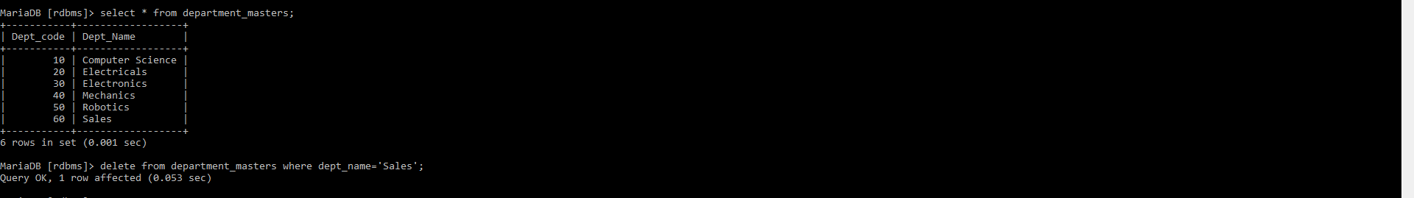

5. Write a query to change the deptno of employee with empno 7788 to that of employee having empno 7698.

Ans:

update emp set job=(select job from emp where empno=7698), deptno=(select deptno from emp where empno=7698) where empno=7788;

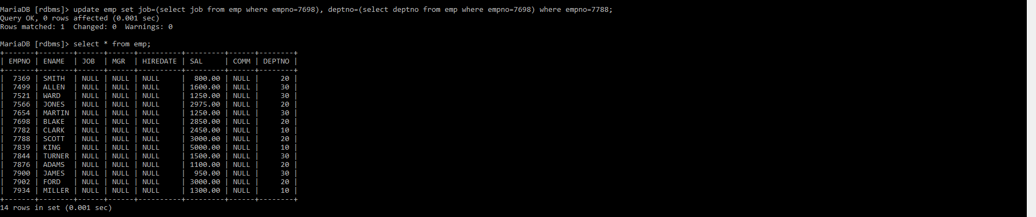

6. Insert the following rows to the Employee table through parameter substitution.

• 1000,Allen, Clerk,1001,12-jan-01, 3000, 2,10

• 1001,George, analyst, null, 08 Sep 92, 5000,0, 10

• 1002, Becker, Manager, 1000, 4 Nov 92, 2800,4, 20

• 1003, 'Bill', Clerk, 1002, 4 Nov 92,3000, 0, 20

Ans:

insert into emp values (1000,'Allen','Clerk',1001,'2001-01-12',3000,2,10);

insert into emp values (1001,'George','Analyst',null,'1992-09-08',5000,0,10);

insert into emp values (1002,'Becker','Manager',1000,'1992-11-04',2800,4,20);

insert into emp values (1003,'Bill','Clerk',1002,'1992-11-04',3000,0,20);

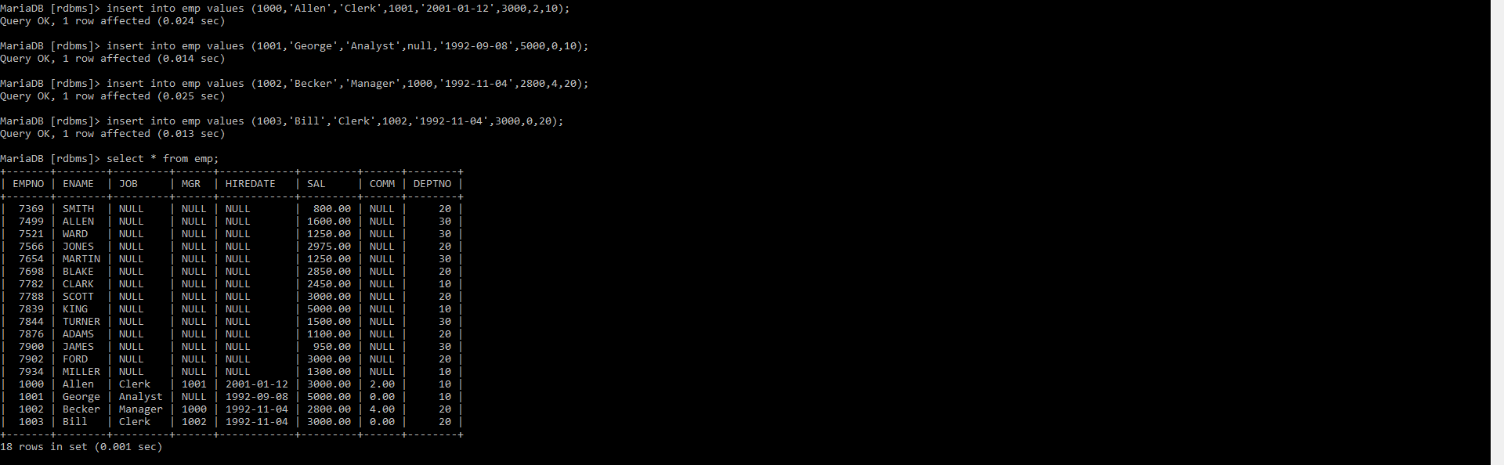

**Transaction Control Language Statements**

1.Insert rows with the following data into the Customer table. 6000, John, #115 Chicago, #115 Chicago, M, 25, 7878776, 10000

• 6001, Jack, #116 France, #116 France, M, 25, 434524, 20000

• 6002, James, #114 New York, #114 New York, M, 45, 431525, 15000.50

Use parameter substitution.

Ans:

Create or replace table customermaster(customerid INT(5),customername varchar(30),Address1 varchar(30),Address2 varchar(30),Gender varchar(1),Age INT(3),phoneno INT(10),sales numeric(10,2));

insert into customermaster (customerid, customername ,address1 ,address2, gender, age, phoneno,sales) values ( 6001, 'John','#115 Chicago', '#115 Chicago', 'M',25, 7878776, 10000);

insert into customermaster (customerid, customername ,address1 ,address2, gender, age, phoneno,sales) values ( 6001, 'Jack','#116 France', '#116 France ', 'M', 25, 434524, 20000);

insert into customermaster (customerid, customername ,address1 ,address2, gender, age, phoneno,sales) values ( 6002, 'James','#114 New York', '#114 New York', 'M', 45, 431525, 15000.50 );

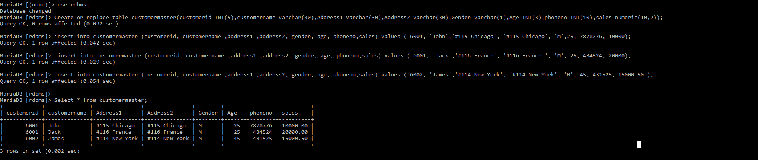

2.Create a Savepoint named ‘SP1’ after third record in the Customer table.

Ans:

Select * from customermaster;



3.Insert the below row in the Customer table.

6003, John, #114 Chicago, #114 Chicago, M, 45, 439525, 19000.60.

Ans:

insert into customermaster (customerid, customername ,address1 ,address2, gender, age, phoneno,sales) values ( 6003, 'John','#114 Chicago', '#114 Chicago', 'M',45, 439525, 19000.60);

Select * from customermaster;

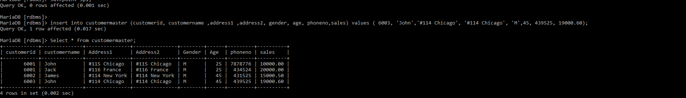

4.Execute rollback statement in such a way that whatever manipulations done before Savepoint sp1 are permanently implemented, and the ones after Savepoint SP1 are not stored as a part of the Customer table.

Ans:

rollback to sp1;

Select * from customermaster;

