**CLOUD STORAGE MANAGEMENT SYSTEM**

Software Design Specification

**(SDS)**

Signatures

|  |  |  |
| --- | --- | --- |
| **Date** | **Revision** | **Approved By** |
| 26-02-2019 | 1.1 | Ujjainee Das |
| 26-02-2019 | 1.1 | Jasleen Saggu |
| 26-02-2019 | 1.1 | Harsh Verma |

Change History

|  |  |  |
| --- | --- | --- |
| **Revision** | **Date** | **Description** |
| 1.0 | 12-02-2019 | Initial Revision |
| 1.1 | 26-02-2019 | Second Revision |
| 1.2 |  | First Final Revision |
|  |  |  |

Table of Contents

1 Introduction 1

1.1 Purpose 1

1.2 Scope 1

1.3 Definitions and Acronyms 1

1.4 References 1

2 Decomposition Description 2

2.1 Module Decomposition 2

2.2 Concurrent Process Decomposition 2

2.3 Data Decomposition 2

3 Dependency Description 4

3.1 Inter-module Dependencies 4

3.1.1 Independent Modules 4

3.1.2 Dependent Modules 4

3.2 Inter-process Dependencies 4

3.3 Data Dependencies 4

4 Interface Description 6

4.1 Module Interface 6

4.1.1 Login Configuration Module Description 6

4.1.2 Downloading Module Description 7

4.1.3 Torrent Manager Module Description 8

4.1.4 Transmission Control Module Description 10

4.2 Process Interface 11

4.2.1 Login Process Description 11

4.2.2 Update Password Process Description 11

4.2.3 Upload Torrent Process Description 11

4.2.4 Download files Process Description 12

5 Detailed Design……………………. ………………………………………………….13

5.1 Sequence and Collaboration Diagrams………………………………………...………..14

5.1.1 Download Module……………………………………………………………..15

5.1.2 Login Module…………………………………………………………...15

5.1.3 Manage Module 15

Cloud Storage Class Diagram 16

6 Use Case Diagram…………………………………………………………………………16

7 Architectural Model…………………………………………………………………………17

Preface

This document presents the Software Design Specification for Cloud Storage Management System. The major sections of the document address the system decomposition by module, concurrent process, and data entity. The system dependencies are also described.

Section 2, Decomposition Description, gives a view of the whole system design including concurrent processes and data entities that are common amongst all system modules.

Section 4, Interface Description, goes into detail about the user interface for each module of the cloud storage management system. This is followed by an important discussion of the processes implemented in logic for each module of the system. This section also shows the major operations in the project and includes their activity diagram.

Section 3, describes the dependencies between different modules.

Section 5, Detailed Design, extends the design discussion found in Section 2 and describes the design for each system module in more detail. A sequence diagram, collaboration diagram and is included for each module design discussion. This is followed by a description of the data requirements for each module and the design of those data elements.

Section 6, includes a UML class diagram that describes the functionalities of the entire system

1. **Introduction** 
   1. **Purpose**

The purpose of the Software Design Specification is to describe the specific design of the cloud storage system. The design specification includes an overview of the design along with software module decomposition.

This document provides a detailed description of each software module’s design. For each module, a user interface design, activity diagram, collaboration diagram and sequence diagram is given. As well, a process description is described for each module. It is in the process description that the details of what logic will need to be implemented are given.

* 1. **Scope**

It is within the scope of the Software Design Specification to describe the specific system design of the cloud storage system. This would include user interface design, object-oriented class design, sequence diagram, collaboration diagram, activity diagram and data design. Any specific detail that is needed about the standards or technology used to design the software are within the scope of this document.

It is outside the scope of this document to describe why the regular torrent downloading is inefficient systems and technology or the general problem with unwanted same pc storage. It is also outside the scope of this document to describe in any detail at all how certain mentioned standards or technologies work and operate.

## Definitions, Acronyms, and Abbreviations

Table of Definitions, Acronyms, and Abbreviations

|  |  |
| --- | --- |
| **Definition, Acronym, or Abbreviation** | **Description** |
| SDS | Software Design Specification. |

## 1.4 References

Table of References

|  |  |
| --- | --- |
| **References** | **Description** |
| Software Development Plan | The Software Development Plan from the cloud storage system was referenced. |
| Software Requirements Specification | The Software Requirements Specification from the cloud storage system was referenced. |

# **2 Decomposition Description**

## 2.1 Module Decomposition

The cloud storage software has been decomposed into the following modules.

* Client account creation Module: This module collects data from the user and establishes a new account for a user.
* Login module: This module gets the userid and password from the user and checks if it is valid. Allows the user to login to the system
* Upload torrent Module: This module allows the user to upload the link for the file to be downloaded and checks if it is valid.
* Download file Module: This module deals with downloading the file for which the user provided the link in the previous module.
* Accessing data Module: This module allows the user to access all the files the user downloaded. The user will access only those files which the user downloaded.
* payment Module: This module helps user pay for the services. It gets the account number from the user and processes the transaction.

## 2.2 Concurrent Process Decomposition

The cloud storage system consists of mainly two processes:

The uploading and verification of the torrent

And downloading of the file by the system to be accessed by the user.

A complete view of the project suggests that there are two processes, the uploading of the torrent and downloading of the file. The system accepts the torrent from the user and uploads it. It verifies if the torrent provided is valid. Then if it is valid, the system immediately starts downloading the file These two processes run concurrently.

## 2.3 Data Decomposition

The following are the major data components, user Information and the file information.

User Information: This is a database that contains the information of the user. It has the following data items;

* Name: A string-containing name of user
* Email id: The email id.
* Password: A Password to obtain access to the account.
* Storage used: Stores amount of storage space used by the used
* Date of payment: contains the date when last payment was made
* Days left: contains days the user can use the services before another payment is made.

The file information: This is a database that that contains all the files that has been downloaded.

* File id: Each file is given a unique id
* Email id: E-Mail id of the user who downloaded the file.
* Storage used: Stores the amount of the memory used.by the file.

# **3 Dependency Description**

## 3.1 Inter-module Dependencies

### **3.1.1 Independent Modules**

The following modules are independent and do not rely on any other modules to initiate them or to provide data.

* Account creation module
* Login module
* Update password

### **3.1.2 Dependent Modules**

The following modules are dependent on one another for their functioning.

* Upload torrent Module: This module gets a torrent from the user and uploads it. The system verifies if the torrent is valid
* Download file Module: This module is responsible for downloading the file the user wants to access from the torrent provided by the user. Therefore this module is dependent on the previous module.

## 3.2 Inter-process Dependencies

As described previously, the modules update torrent and download files are inter dependent.

Downloading a file is impossible until a torrent has been uploaded and validated. It is as if one action triggers the other. After the torrent is validated, the downloading starts spontaneously.

## 3.3 Data Dependencies

The following Data Flow Diagram shows the data dependencies between the various entities and modules.

## A. Level 0

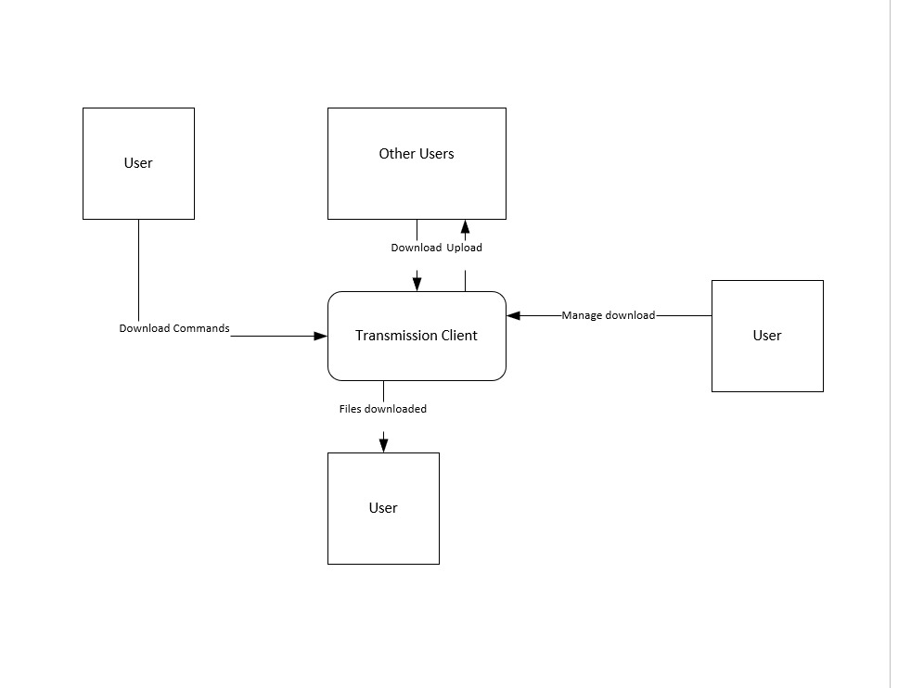

**B. LEVEL 1**

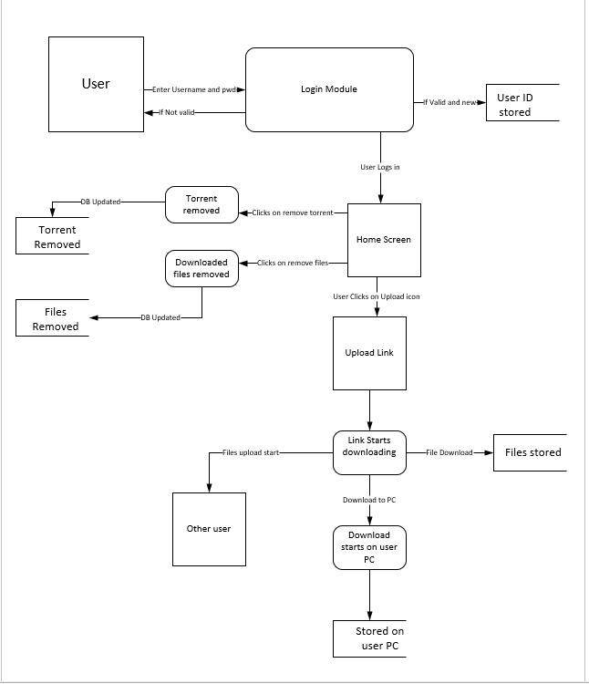

# **4** **Interface Description**

## 4.1 Module Interface

**4.1.1 Login Page Module Description**

**4.1.1.1 User Interface Design**

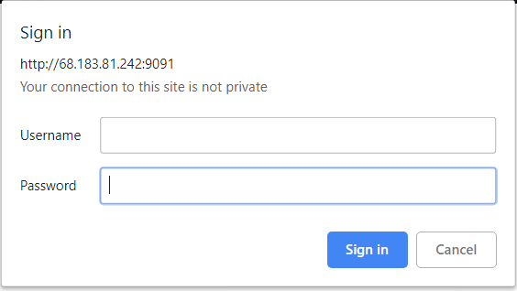

Figure 1. IP address, transmission port number, username, password.

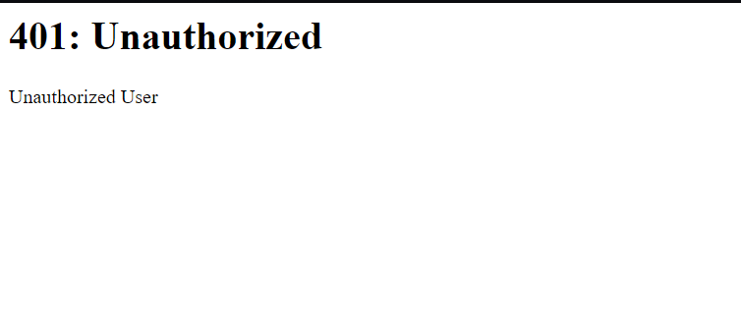

Figure 2. Unauthorized Page

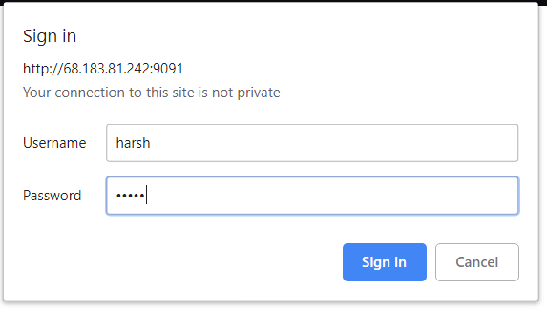  
Figure 3. Credentials filled.

**4.1.1.2 Description**

The landing page of the site brings the customer to this screen where he can login using his ID and password. Incorrect credentials will allow the user to again enter the credentials.

After the validation of the password and the user ID he will be redirected to the main home page.

If user decides to press cancel this window alert will vanish and the page will be left blank.

**4.1.2 Downloading Module**

**4.1.2.1 User Interface Design**

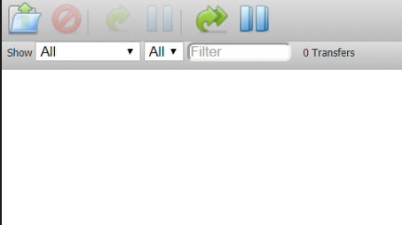

Figure 4. Download icon

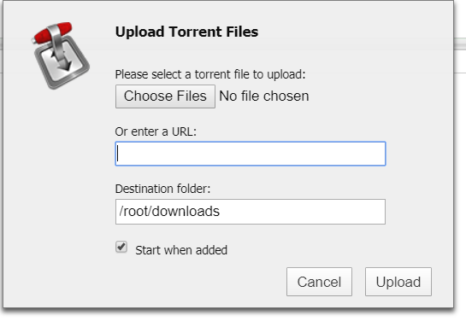

Figure 5. Download Screen with url

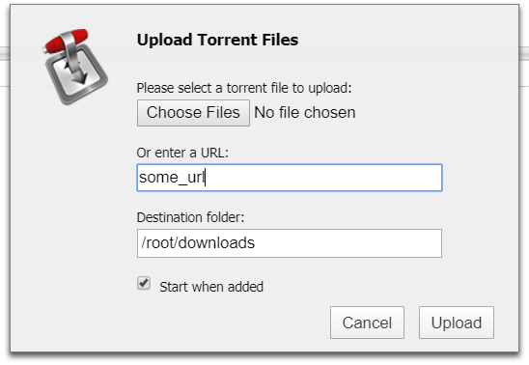

Figure 6. URL enter

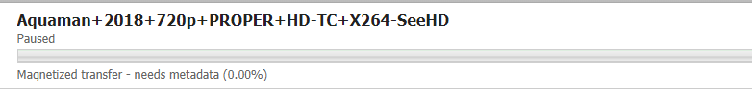

Figure 7. Download Started.

**4.1.2.2 Description**

The download screen can be reached using the icon showed and will show a pop-up window. The user then can choose to Enter his own URL or can choose a torrent file from the PC. After the user presses the Upload button, the files start downloading on the server.

**4.1.3 Torrent Manage Module**

**4.1.3.1 User Interface**

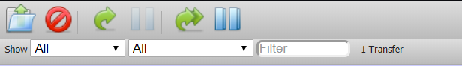

Figure 8 Basic Control for Torrent

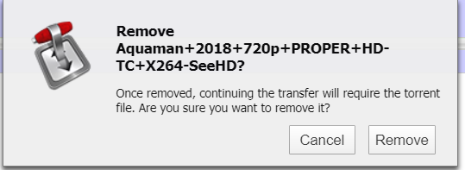

Figure 9 Torrent removal

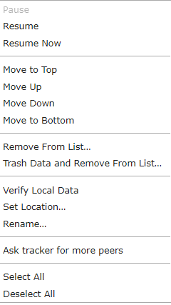

Figure 10 Detailed Controls

**4.1.3.2 Description**

The basic controls allow the user to pause, stop, delete the selected torrent and it’s files. The user would be prompted for confirmation regarding the same through a window alert. The other more advanced features could be used using the right click feature on the desired active/inactive torrent.

**4.1.4 Transmission Control Panel**

**4.1.4.1 User Interface**



Figure 11 Configuration, Settings

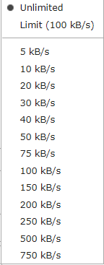

Figure 11 Set download/upload rate

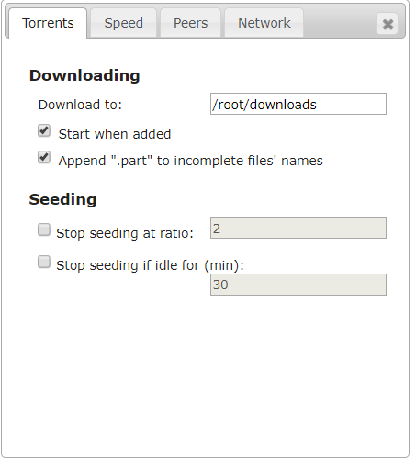

Figure 12 Detailed Configuration

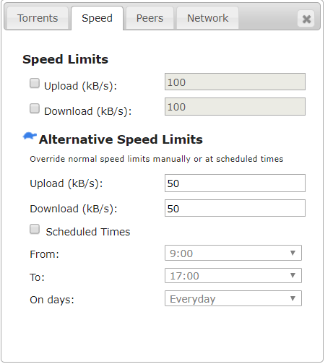

Figure 13 Speed control

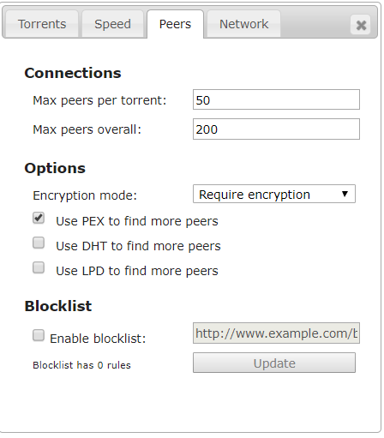

Figure 14 Advance Control for peer selection

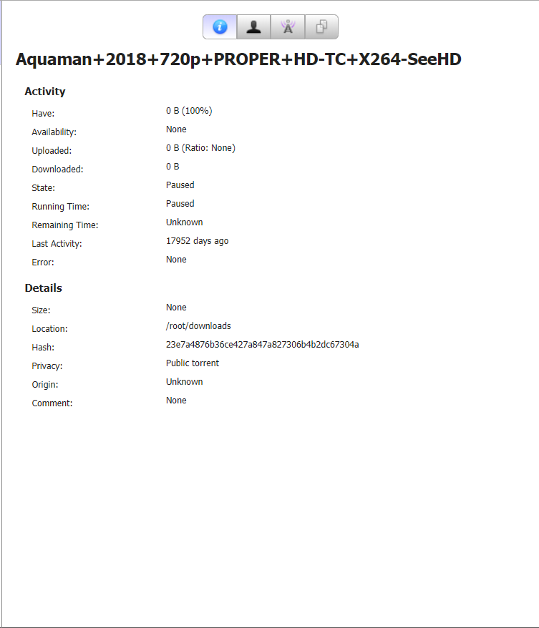

Figure 15 Detail stats on torrent

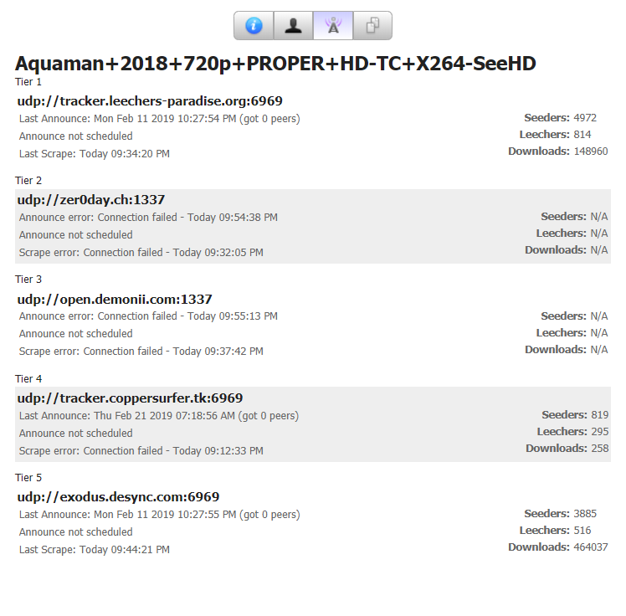

Figure 16 Tracker Information

**4.1.4.2 Description**

The transmission control panel would provide the user to manage the download speed of the torrent and other activities including the peer list and trackers. It also allows the user to change the directory for the downloads for all the download taking place in the future. The user can also alter the speed with which the downloads take place.

## 

## 4.2 Process Interface

### **4.2.1 Login Process Description**

The primary objective of this module is to allow the user to log in to his/her account. This module ensures that the users’ personal data is not accessed by any unauthorized person. The user can log into their account by providing the emailed and the password. Once logged into account the user can access all the files downloaded.

### **4.2.2 Update password Process Description**

If by any chance the user forgets password, then he/she has the privilege to change password. The user is asked to provide valid email id, he/she used for logging into their account. If password is valid then a confirmation mail is sent to the user on that email address. The user clicks on the provided link and a screen pops out. The system asks the user for a new password. The password is changed.

### **4.2.3 Upload torrent**

This module accepts the torrent of the file to be downloaded. Once torrent is uploaded, it is validated. If valid, it spontaneously goes to the next module.

### **4.2.4 Download files**

This module is dependent on the previous module. The file gets downloaded if the torrent is valid and if the connection is secure. The user can see the rate of downloading the file. The transmission control panel would provide the user to manage the download speed of the torrent and other activities including the peer list and trackers. It also allows the user to change the directory for the downloads for all the download taking place in the future. The user can also alter the speed with which the downloads take place. The user can pause the download and even delete the torrent.

### **4.2.5 Access files**

All the files can be accessed by the user by logging into the account. In this module, The user can view all the files downloaded by the user and can maintain them.

**4.3 Major operation**

**4.3.1 Log in**

**4.3.1.1 Activity diagram**

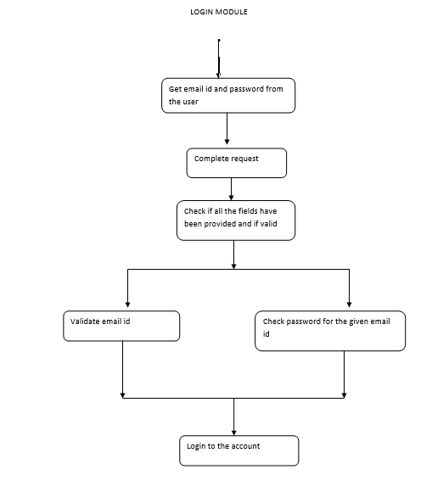

**4.3.1.2 Description**

Once the user has created an account, they are free to log in to their account and use all the system functionalities. However, to log in to the system, the user must provide the userid and password

The system checks if both the user id and password has been provided. If not the system displays a warning to the user. The system checks if the userid and the password provided are present in the database. If so, the user logs into his/her account.

**4.3.2 Update password**

**4.3.2.1 Activity diagram**

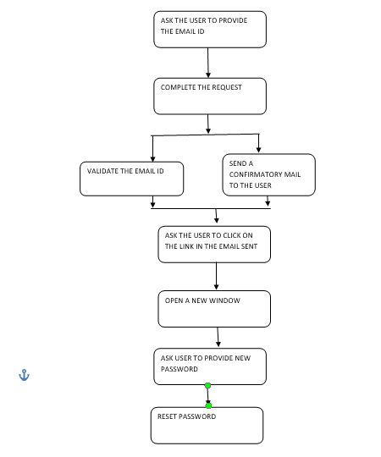

**4.3.2.2 Description**

In case the user forgets his/her password, he/she can change his/he password

If both the fields have been provided by the user, the system checks if the given email id is present in the database. If so, a confirmatory mail is sent to the user with a link. When the user clicks the link, The user is asked for the new password.

**4.3.3 Download files**

**4.3.3.1 Activity diagram**

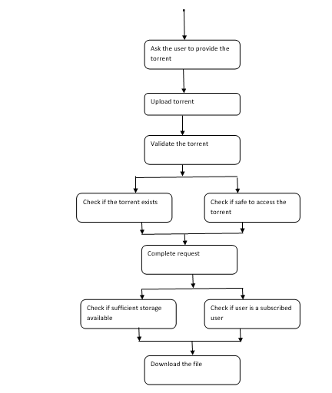

**4.3.3.2 Description**

This module accepts the torrent of the file to be downloaded. Once torrent is uploaded, it is validated. If valid, it spontaneously goes to the next module.

This module is dependent on the upload torrent module. The file gets downloaded if the torrent is valid and if the connection is secure. The user can see the rate of downloading the file. The transmission control panel would provide the user to manage the download speed of the torrent and other activities including the peer list and trackers. It also allows the user to change the directory for the downloads for all the download taking place in the future. The user can also alter the speed with which the downloads take place. The user can pause the download and even delete the torrent.

**5 Design Description**

**5.1 Sequence Diagrams**

**5.1.1 Download Module**

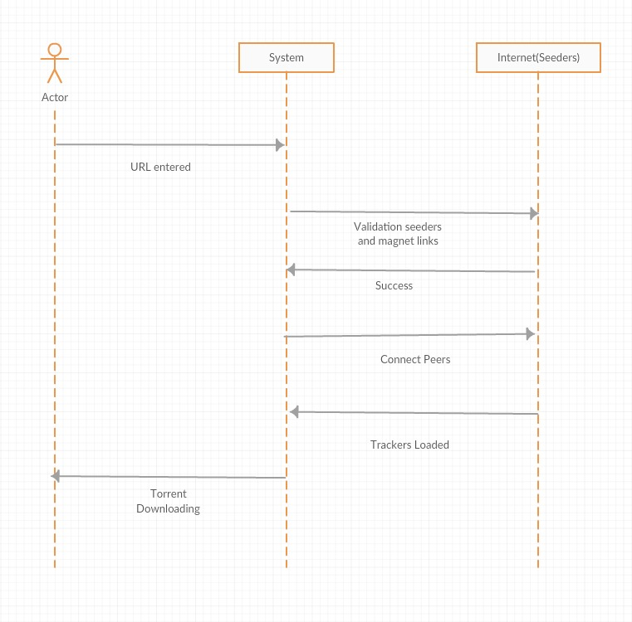

**5.1.1.1 Collaboration diagram**

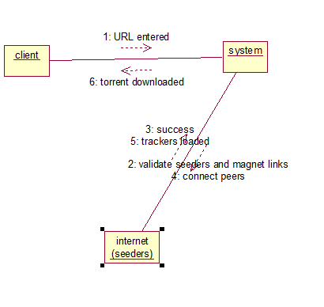

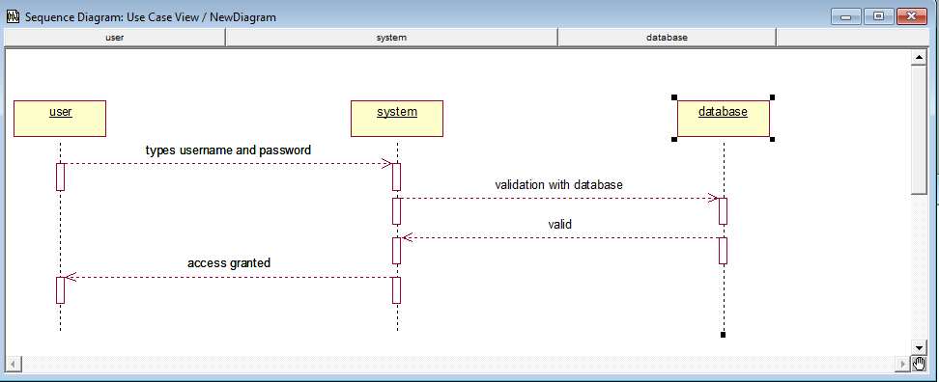

**5.1.2 Login Module**

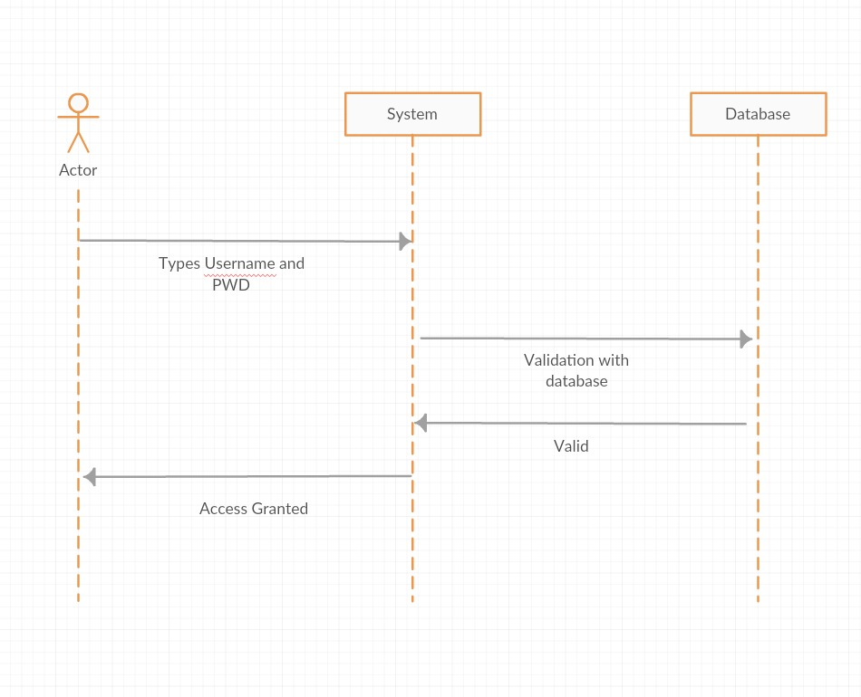

**5.1.2.1 Collaboration diagram**

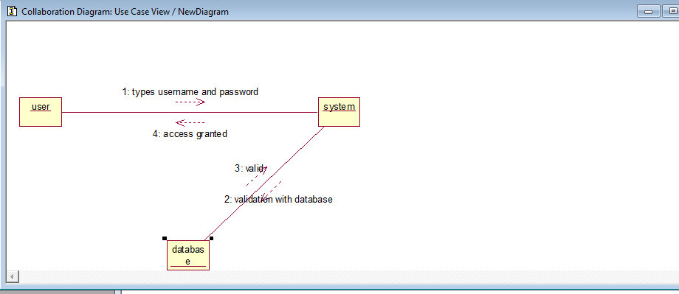

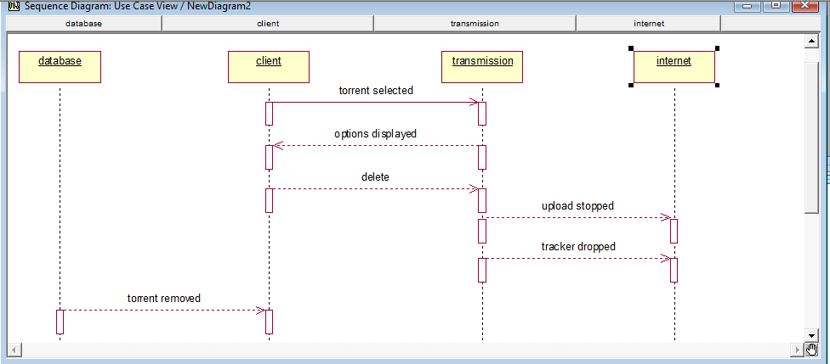

**5.1.3 Manage Module**

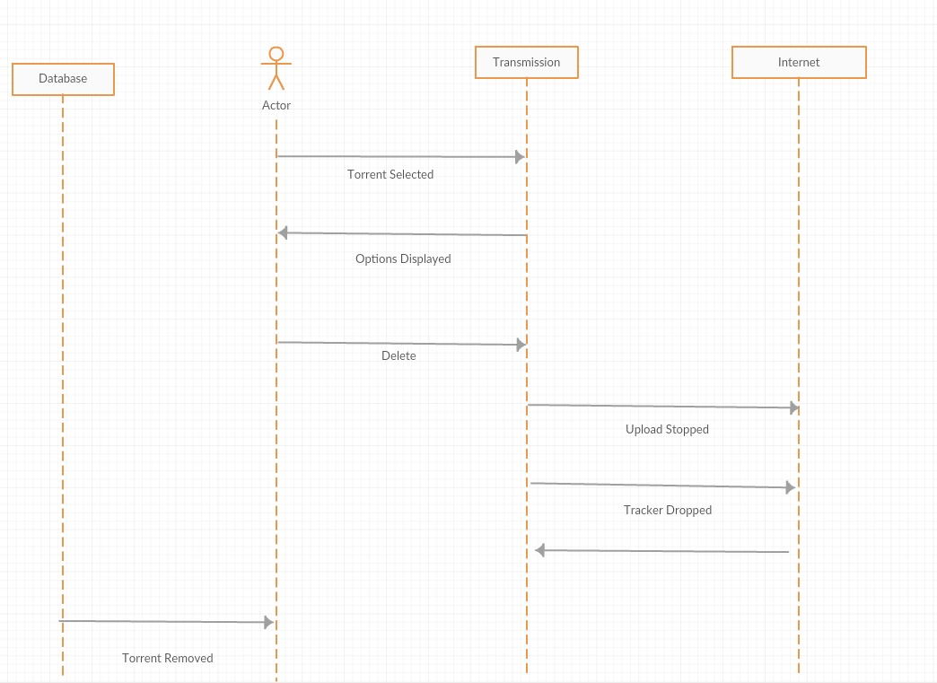

**5.1.3.1 Collaboration diagram**

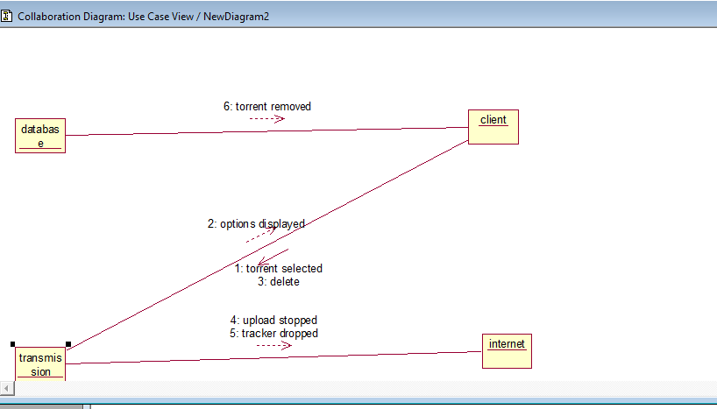

**Cloud Storage Class Diagram**

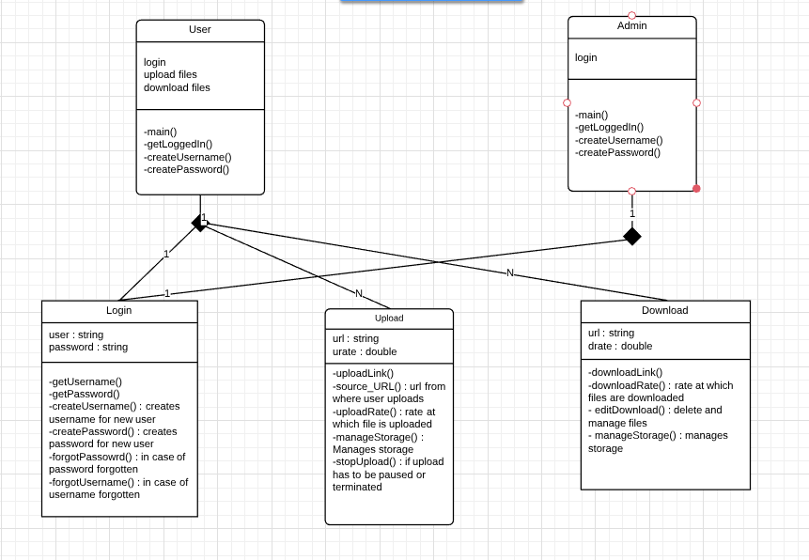

**6 Use Case Diagram**

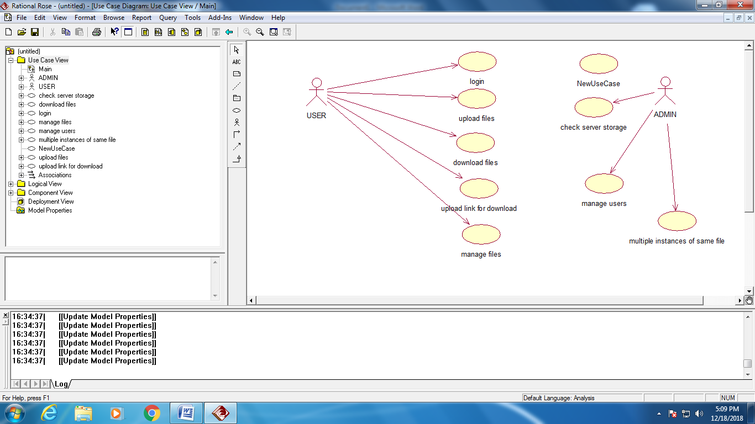

**7 Architectural Model**

The architectural model chosen by us for our project will be the **client server architecture model**.

Client/server architecture is a computing model in which the server hosts, delivers and manages most of the resources and services to be consumed by the client. This type of architecture has one or more client computers connected to a central server over a network or internet connection. This system shares computing resources.

The reason for our choosing this model would is that our service purely depends on our database and our ability to let the users access their downloads at any point of time. This means that out systems are never down and are always up for the user to manager their downloads.

In addition, considering the updates that may take place in our database to improve our capabilities could take place without disturbing the ongoing process of the users. This will also allow us to remove and add feature without the permission of the clients in increments directly to the server. The data then can be passed to the user using the blackboard mechanism. This will also promote integrability.