**Sault College**

Name: Pratik Shrestha

Student ID: 23026137

**Lab Assignment-2**

Professor: Nawaz Chowdhury

Course: Web Development 2

Code: CSD-213

“I declare that this submission is my own work in compliance with Sault College Academic Policies.”

**Date: 17 September 2024**

**Table of Content**

**Assignment Steps** 3

Creating the table : Source Code 3

Creating the table : Source Code 4

Output 5

Defining default Rows and Columns  5

Using the Delete Button  6

Displaying the message 7

Reassigning the insertion  8

# 

**Lab Assignment Steps**

## **Step-1: Creating a layout and buttons**

**Source Code:** 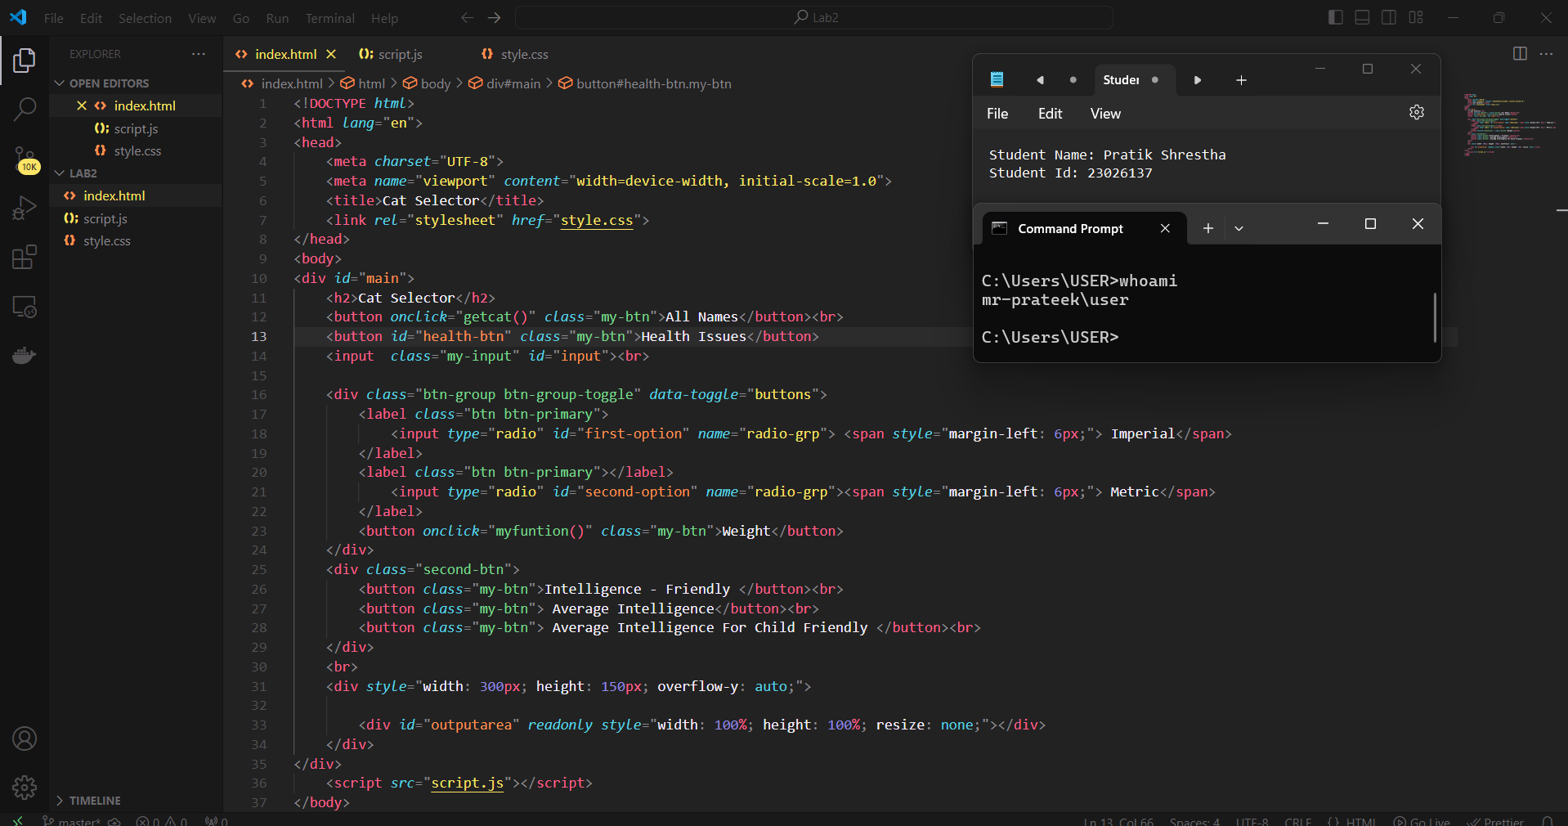

Figure 1: Creating layout for the Cat Selector

**Styles for the layout and buttons**

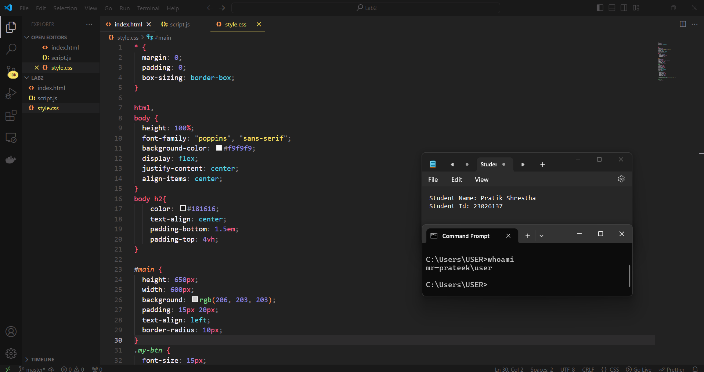

Figure : Styling for Cat Selector

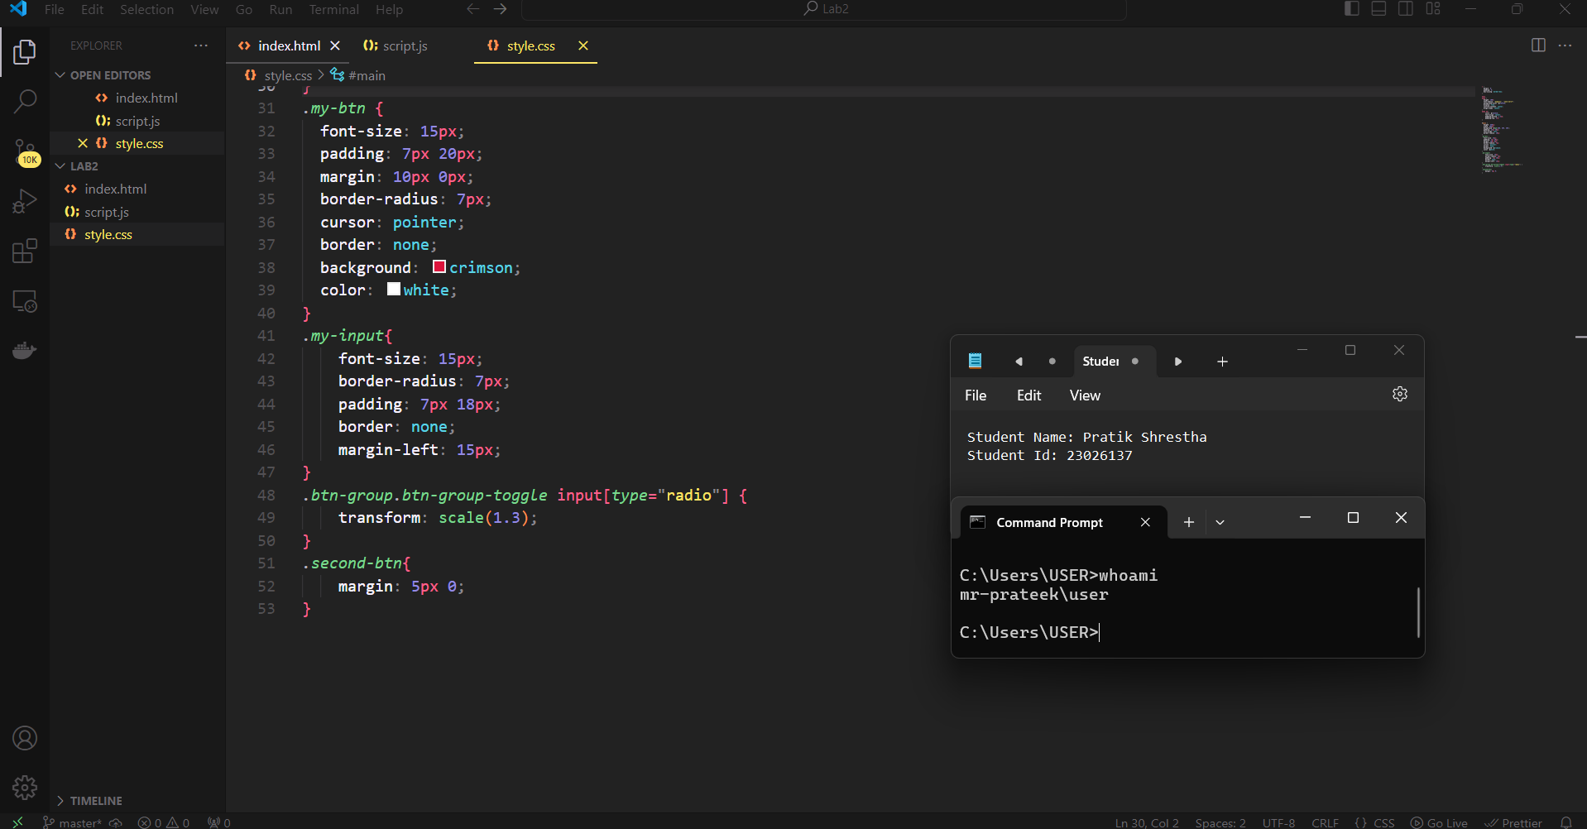

Figure : Styling for Cat Selector

**Logic For the Program**

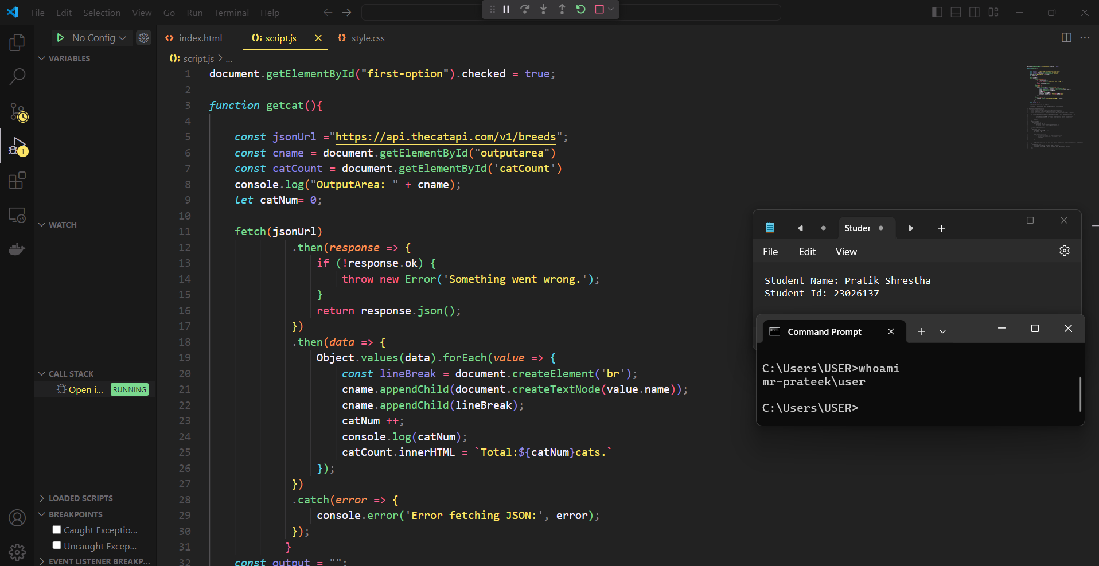

Figure 4: Script for the Cat Selector

**Output :**

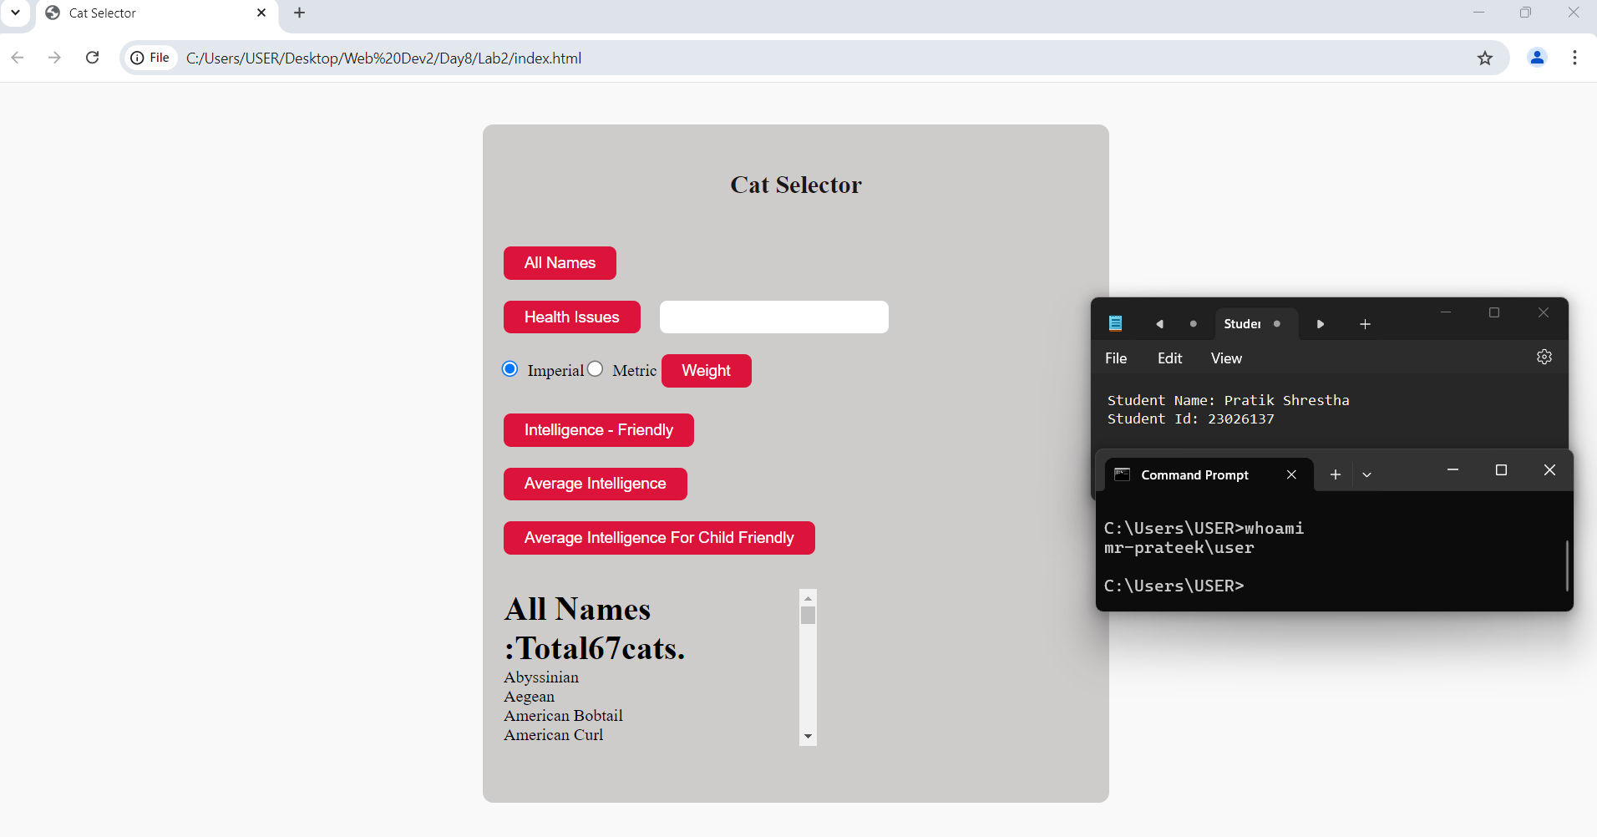

Figure : Showing all name of cat

Github link: https://github.com/I-am-Prateek/Cat-Selector