**Sault College**

Name: Pratik Shrestha

Student ID: 23026137

**Test -1**

Professor: Nawaz Chowdhury

Course: Web Development 2

Code: CSD-213

“I declare that this submission is my own work in compliance with Sault College Academic Policies.”

**Date: 10 September 2024**

**Table of Content**

**Test Assignment Steps** 3

Creating the form : Source Code 3

Creating the table : Source Code 4

Output 5

Defining default Rows and Columns  5

Using the Delete Button  6

Displaying the message 7

Reassigning the insertion  8

# 

**Test Assignment Steps**

## **Step-1: Creating the Form**

**Source Code:**

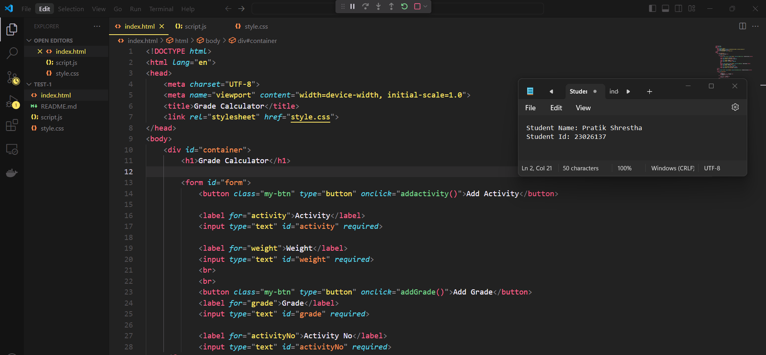

Figure 1: Creating Form

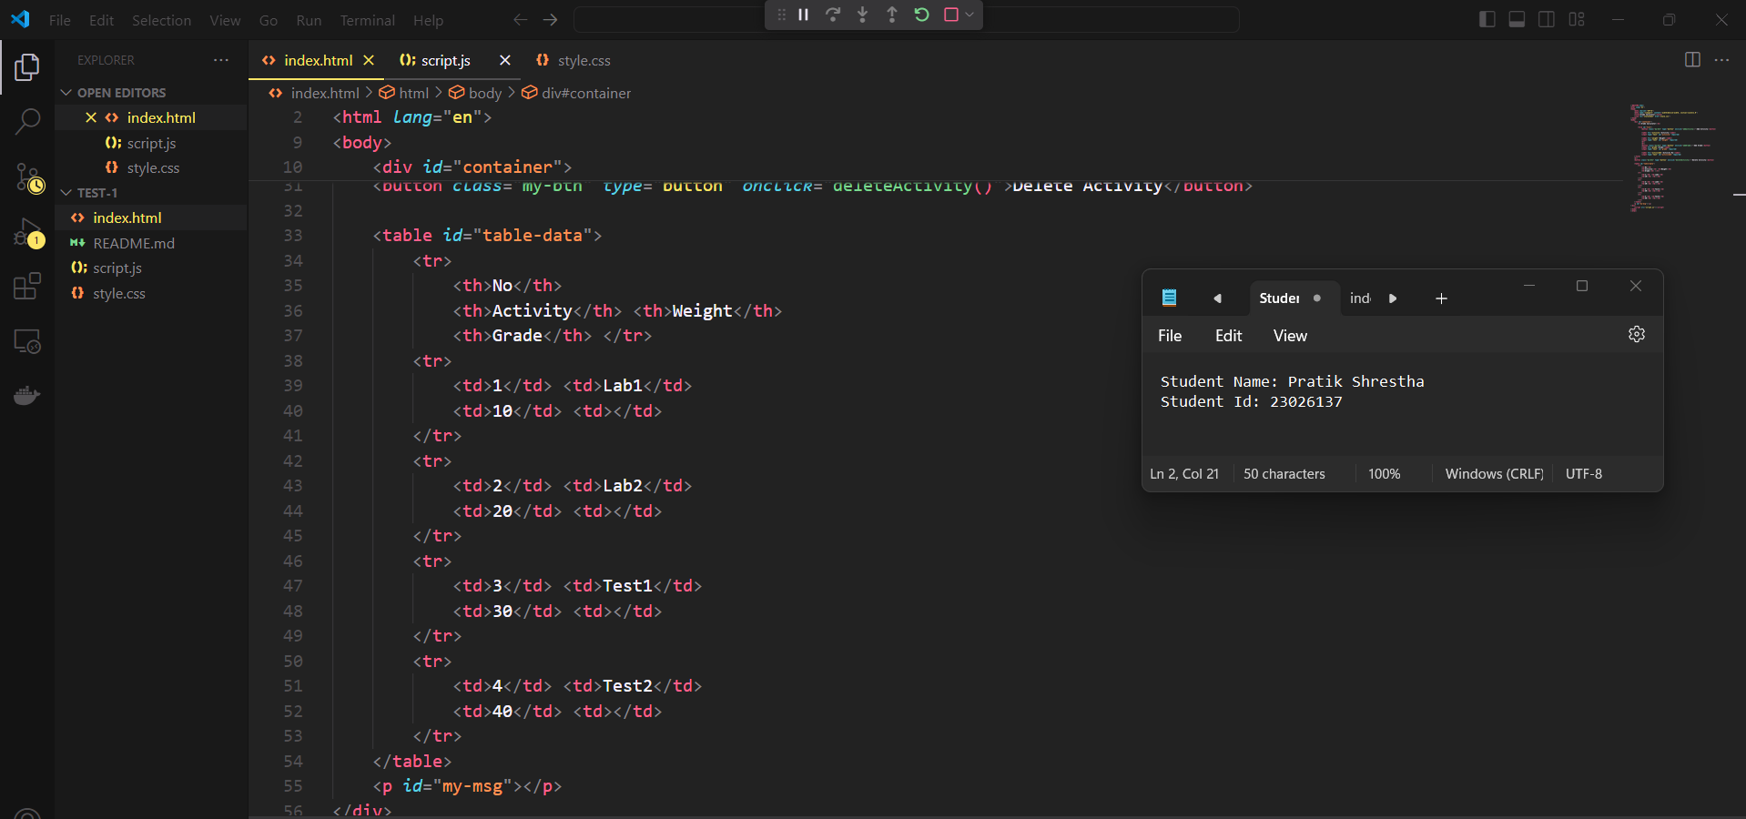

Figure 2: Creating table

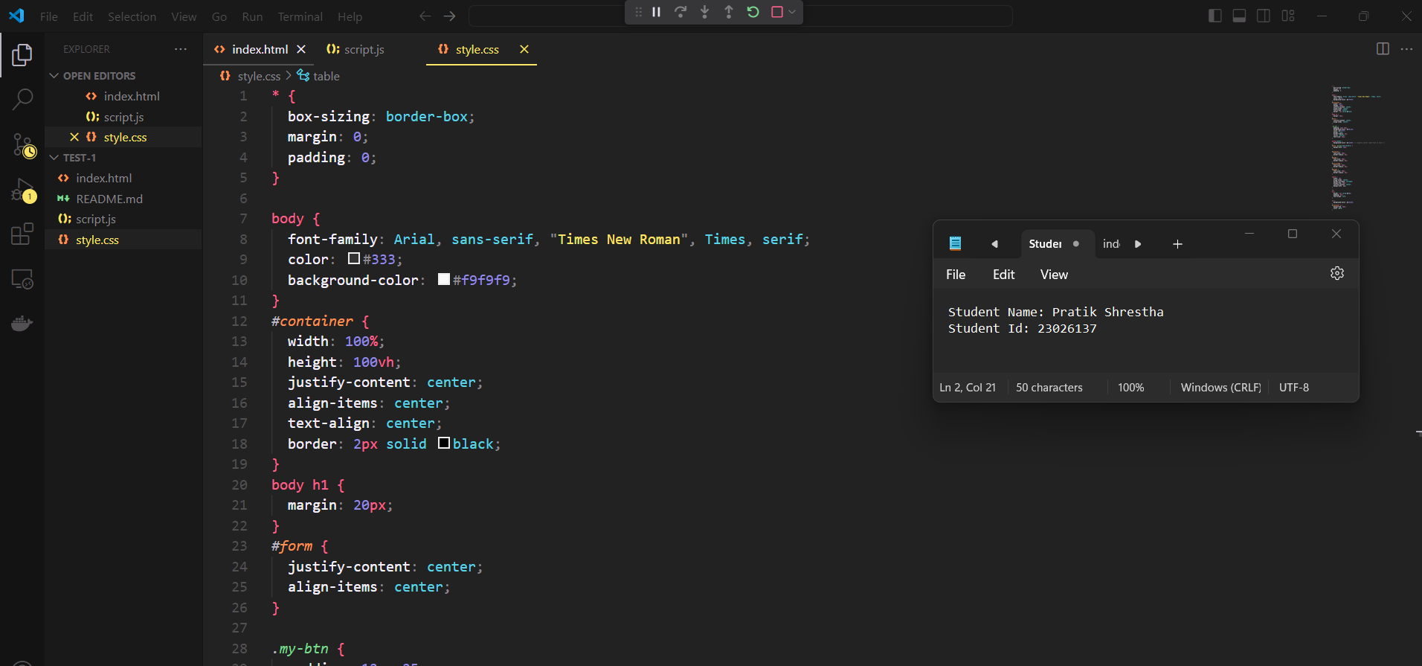

Figure 3: Style for Form and Table

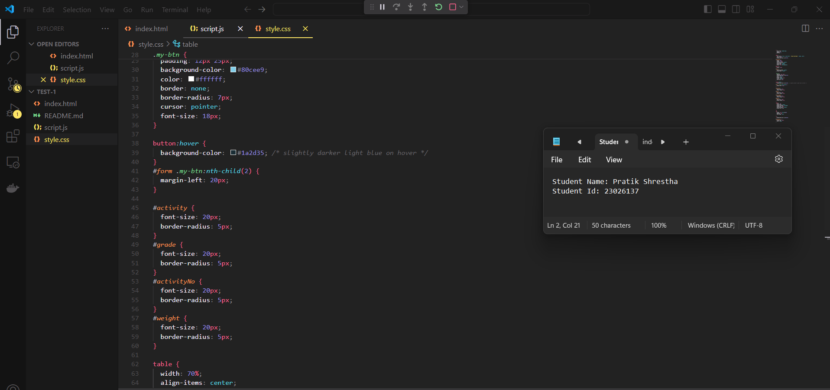

Figure : Style For Table

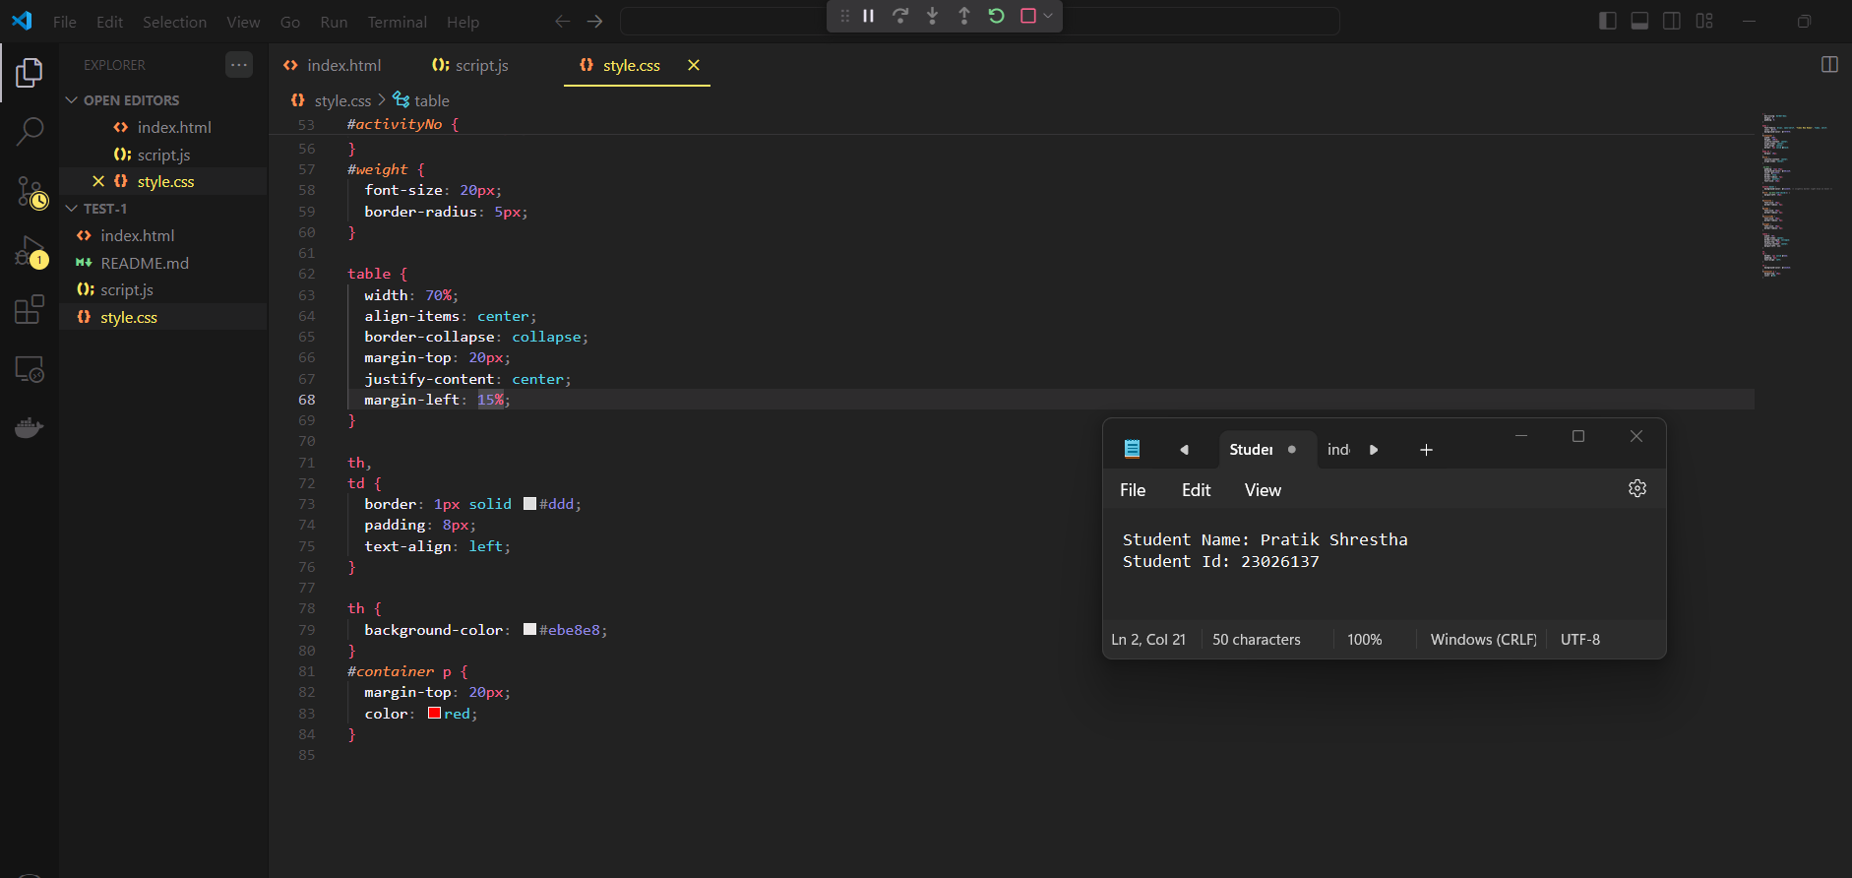

Figure : Style for Table

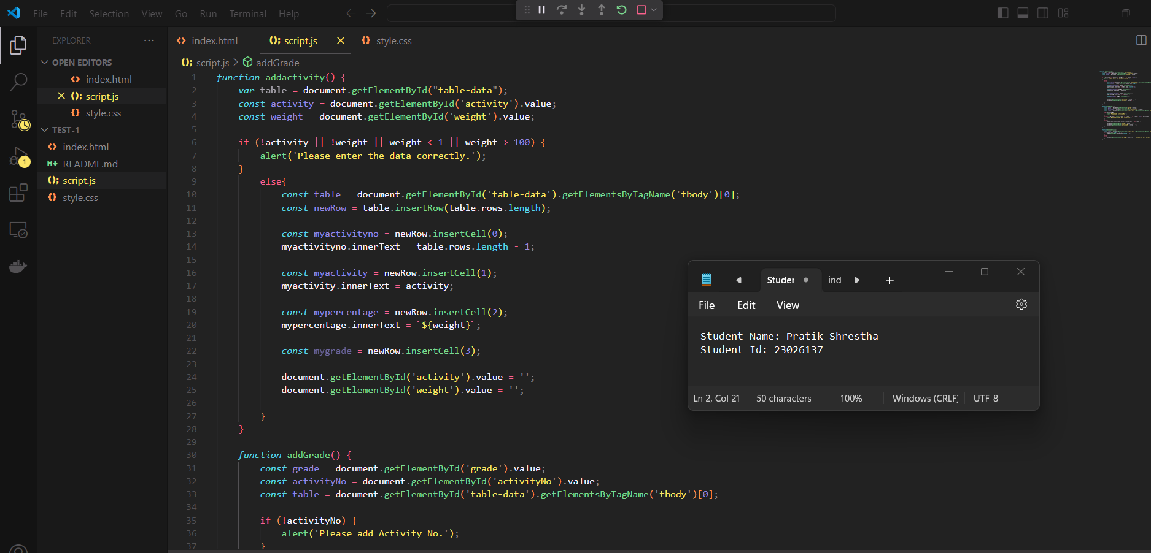

Figure 6: Defining Logic

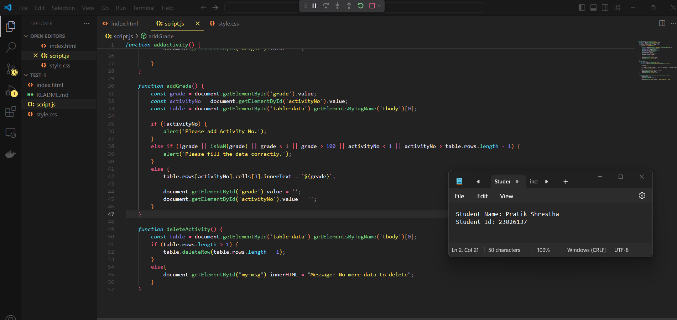

Figure : Defining Logic

**OUTPUT:**

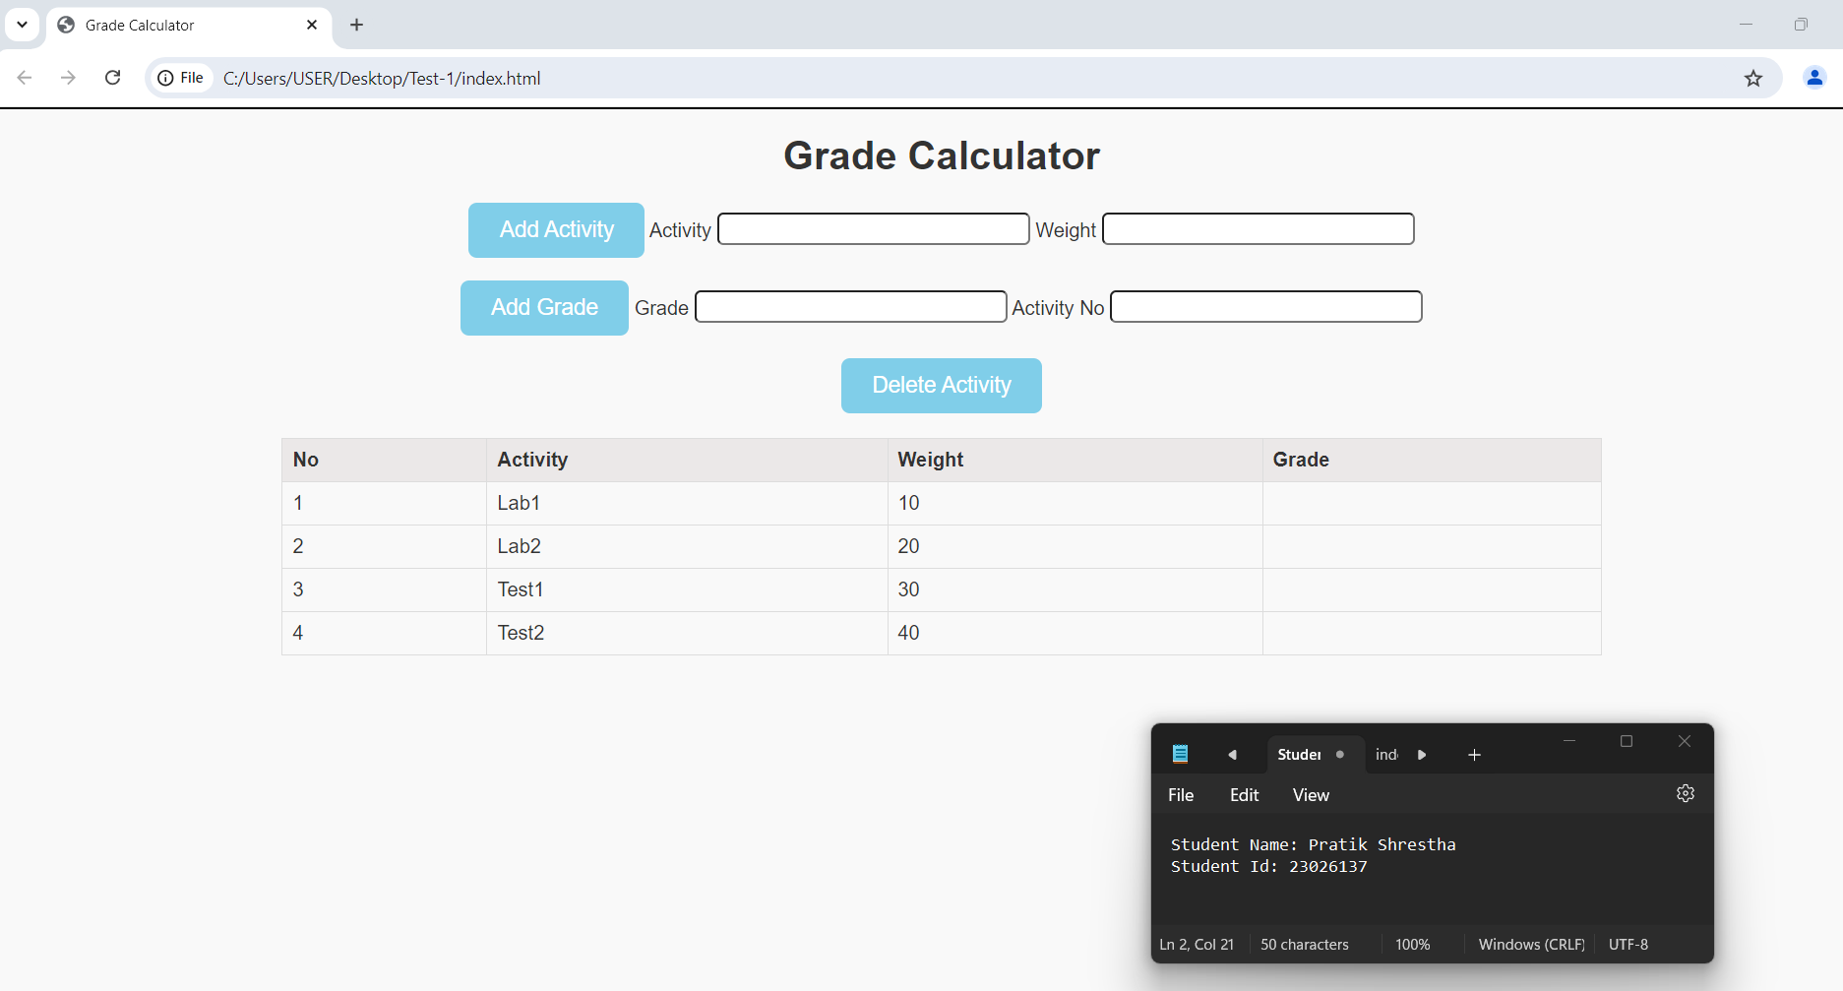

Figure : Output

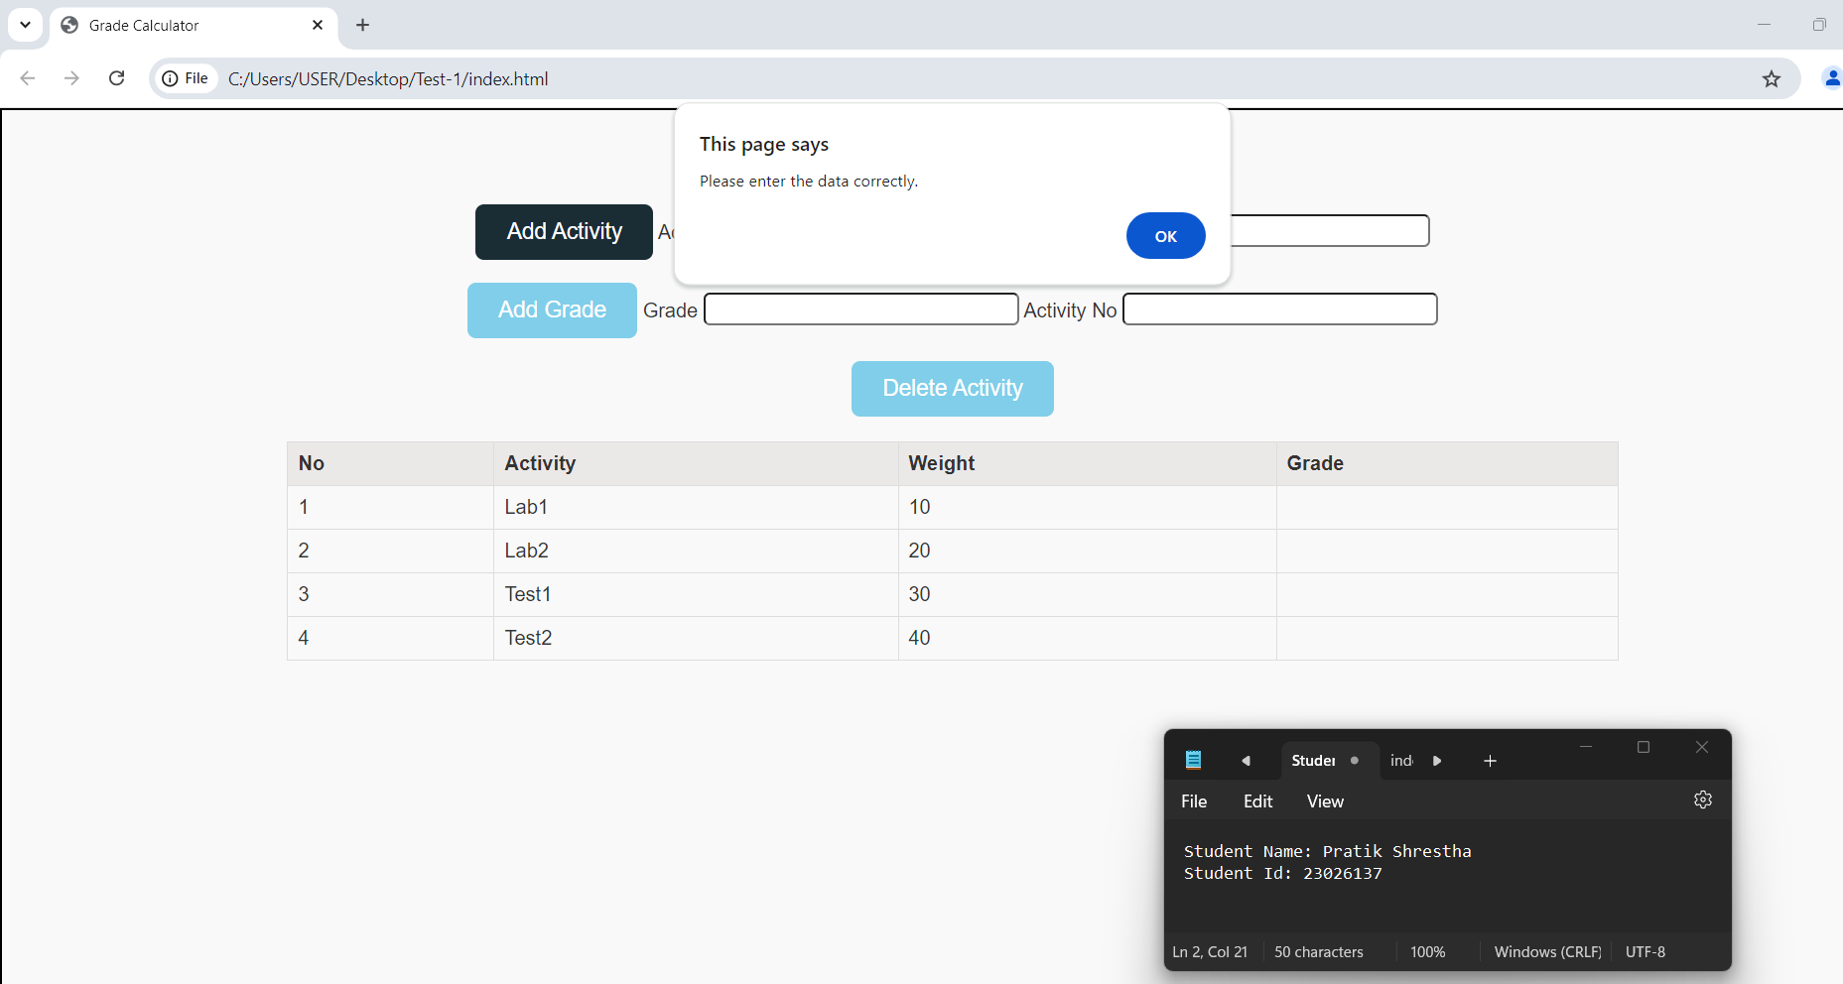

Figure : Displaying Alert

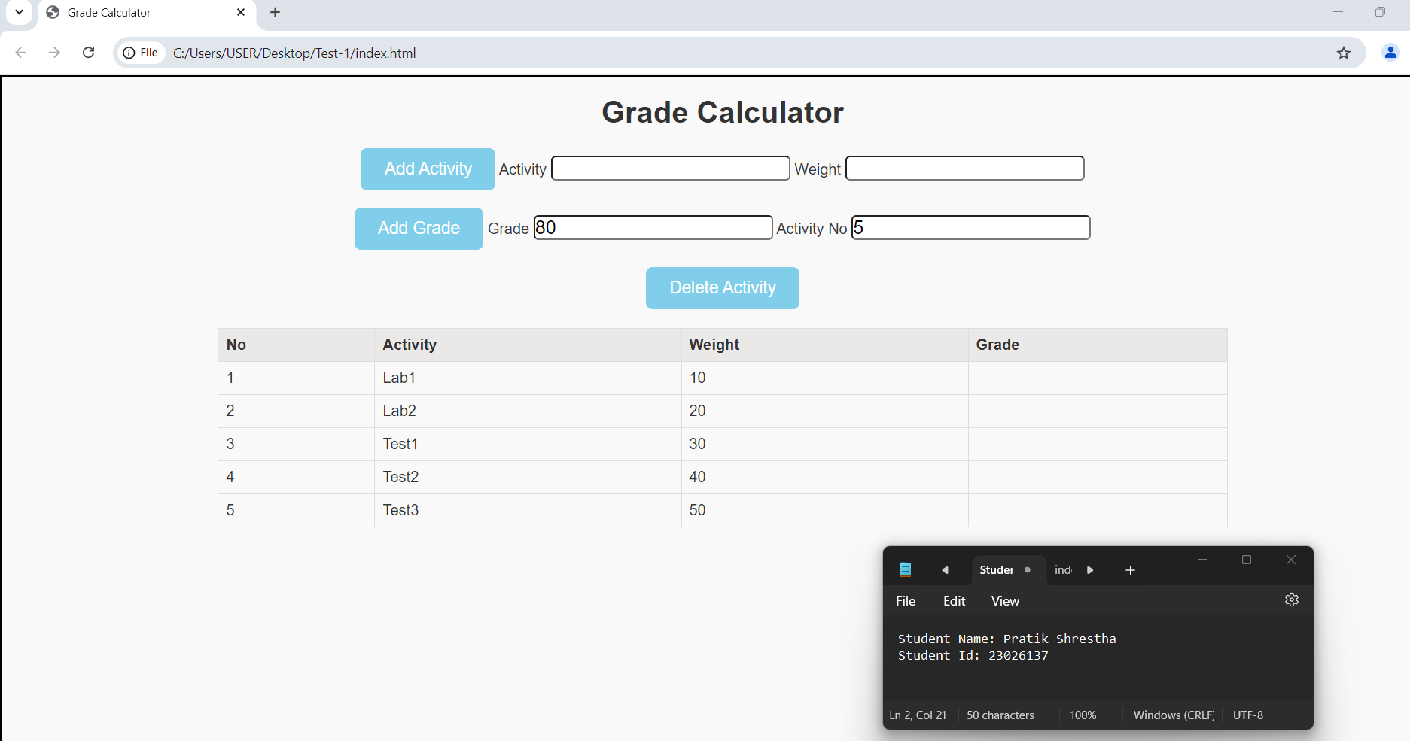

Figure : Adding Data

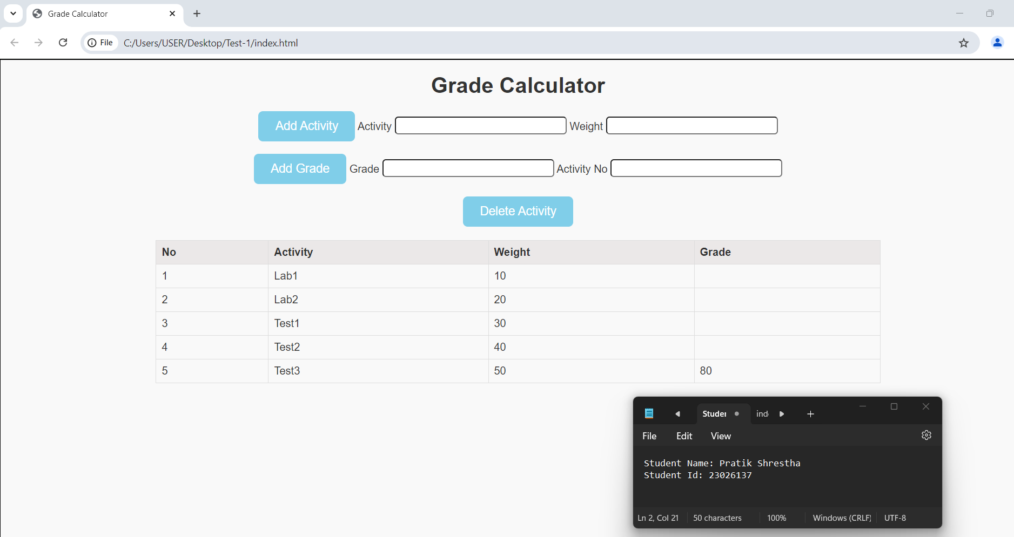

Figure : Adding Grade

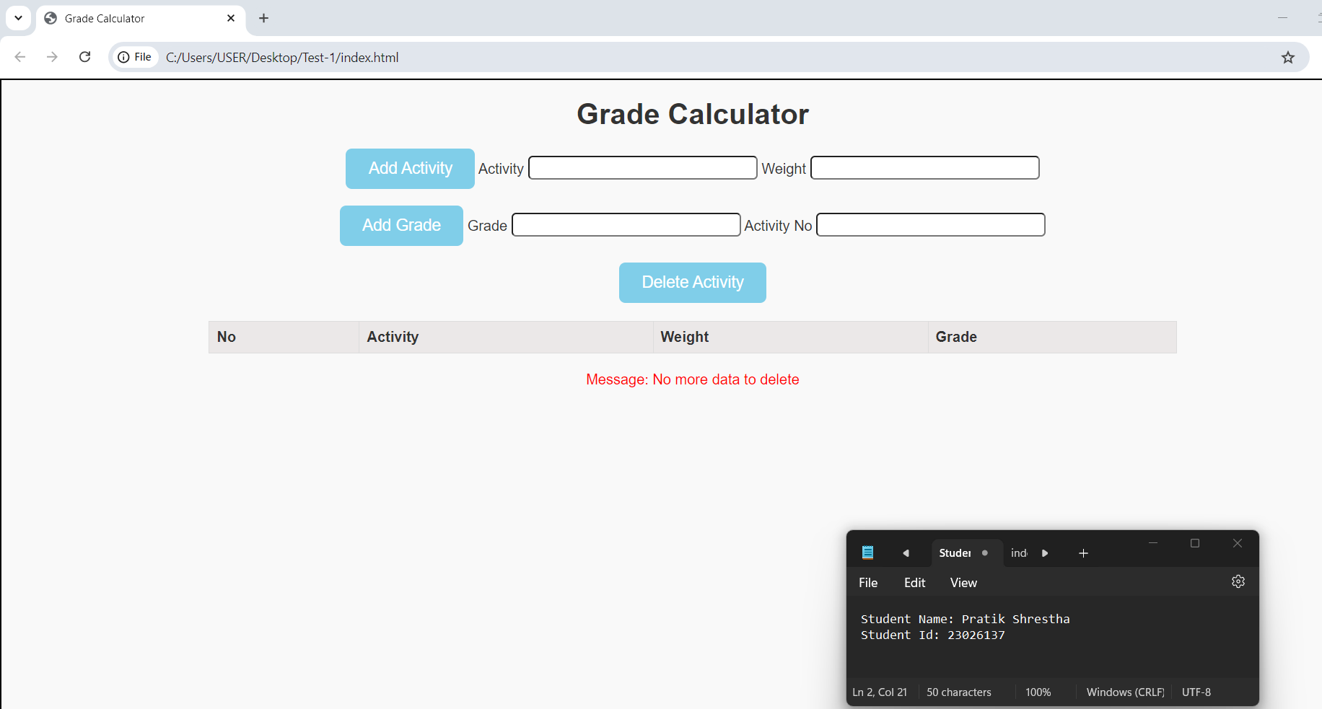

Figure : Error Message after all data is deleted