

**PROJECT TITLE:**

**CUSTOMER BILLING SYSTEM**

**NAME: SABBIR AHAMMED**

**ID: 171-35-1979**

**Supervisor Name: NUSRAT JAHAN**

**Department: Software Engineering**

**Faculty of Science and Information Technology**

**December 2017**

**Project in Brief**

Project Title: Customer Billing System

Supervised by: NUSRAT JAHAN

Name: SABBIR AHAMMED

ID: 171-35-1979

Date Started: 24/11/2017

Date Completed: 14/12/2017

Tools used: CODE BLOCKS

Operating System: MICROSOFT WINDOWS

**Abstract**

**Table of Contents**

**Chapter 1**

1.Introduction----------------------------------------------------------------------------------------------------------------- 6

1.1 About the System------------------------------------------------------------------------------------------------------------------ 7

1.2 Purpose ------------------------------------------------------------------------------------------------------------------------------ 7

1.3 Scope --------------------------------------------------------------------------------------------------------------------------------- 7

1.4 Vision --------------------------------------------------------------------------------------------------------------------------------- 7

1.5 Why this system is necessary? ------------------------------------------------------------------------------------------------- 8

1.6 Proposed Solution ----------------------------------------------------------------------------------------------------------------- 8

**Chapter 2**

2.Requirement Specification --------------------------------------------------------------------------------------------- 9

2.1 Functional Requirement ---------------------------------------------------------------------------------------------------------- 10

2.2 Non-functional Requirement ---------------------------------------------------------------------------------------------------- 10

**Chapter 3**

3.System Analysis ------------------------------------------------------------------------------------------------------------ 11

3.1 Use Case Model -------------------------------------------------------------------------------------------------------------------- 12

3.2 Use Case Description -------------------------------------------------------------------------------------------------------------- 13

**Chapter 4**

4. Implementation ----------------------------------------------------------------------------------------------------------- 14

4.1 Tools & Technologies ------------------------------------------------------------------------------------------------------------- 15

**Chapter 5**

5. System Testing ------------------------------------------------------------------------------------------------------------- 16

5.1 Why Software Testing is Essential? -------------------------------------------------------------------------------- 17

5.1.1 Black Box Testing --------------------------------------------------------------------------------------------------------------- 17

5.1.2 White Box Testing -------------------------------------------------------------------------------------------------------------- 17

5.2 Test Cases ----------------------------------------------------------------------------------------------------------------

5.2.1

**Chapter 6**

6. Conclusion ------------------------------------------------------------------------------------------------------------------- 18

6.1 Good features of the System ----------------------------------------------------------------------------------------------------- 19

6.2 Limitations of the System ---------------------------------------------------------------------------------------------------------- 19

6.3 Future Enhancements --------------------------------------------------------------------------------------------------------------- 19

**Chapter 7**

7. User Manual ------------------------------------------------------------------------------------------------------------------------------- 20

7.1 Screen of Selling System ----------------------------------------------------------------------------------------------------------- 21

**Chapter 8**

8. References --------------------------------------------------------------------------------------------------------------------------------- 23

**Chapter 1**

**Introduction**

**Introduction**

* 1. **About the System:**

In this system, the operator can add products details in the time of storing products in the store. In the adding option the system will ask for product ID, product name, unit price of the product and the number of product you stored in your store. This system has two more option. One is for searching product to check the unit price or available quantity. Another is selling option or the main option. In this option operator can calculate the total price of the products that a customer wanted to buy very easily by some necessary input. In this option, operator will be asked for the name of the products and their quantity. Operator can also calculate discount, vat and cash back bonus. Every time the quantity of products that have sold will be deleted from the stored quantity of the products.

* 1. **Purpose:**

The aim of this system is to develop the Customer Billing System. With this system a shopkeeper can easily calculate the prices of the products during selling in a short time. He can also calculate discount, vat and cash back offer. This will also help him to know which product is running out. It will also save the time of the customers.

* 1. **Scope:**

This system can:

1. Calculate the bill.
2. Display the bill to the customer.
3. Calculate discount and vat percentage.
4. Store products with their price and information.
5. Can see the report of product by searching.
   1. **Vision:**

In this system, there should be an admin option for the owner of the shop. Only admin can log in to the admin option with a secure password. In that option, the owner can see the overall reports like, total sells, which product is running out. Admin can also offer cash back bonus or discount by his option.

* 1. **Why this System is necessary?**

At first we can say that, with this system a shopkeeper can provide an accurate calculation of the prices of products to the customer in a short time. This saves the time of customer and they don’t need to ask the prices of products differently as the prices are shown to them in display. It can be said that, the system will make our daily life a little easier.

* 1. **Proposed Solution:**

In admin option, a password system should be implement. There will also have a file which will save all the selling report of a day. Thus the owner can see the report. There will also have a condition of stored quantity of product.

The condition is that, if any product quantity run below 5, the condition will print the product name and its quantity in admin option. So that the owner can notice.

**Chapter 2**

**Requirement Specification**

**Requirement Specification**

**2.1 Functional Requirements:**

1. Add new products
2. Search products by their ID
3. Sell products by searching their name
4. Calculate all product’s price that a customer takes at a time with discount, vat and cash back bonus
5. Modify stored quantity of a product after selling some

**2.2 Non-functional Requirements:**

1. After working with any option, system will open main menu
2. After complete work of one option, system will clean the screen
3. Every option has its different color

**Chapter 3**

**System Analysis**

**System Analysis**

**3.1 Use Case Model:**

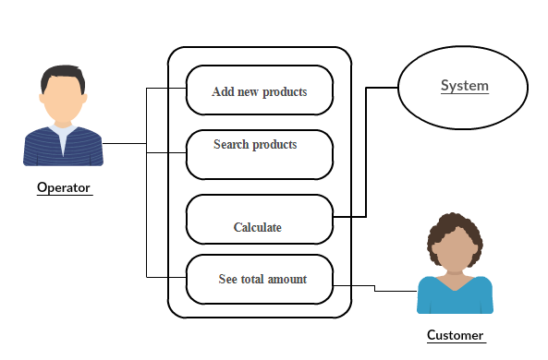

**Fig: Use case model**

**3.2 Use case description:**

Add new products: Only operator can use this option to add new products when products are stored in the shop. Operator have to enter a product id for each product. He also has to input the unit price and stored product’s quantity. So that operator can see the available quantity of a product later in search option.

Search products: This option is also available for the operator. He can search any product by its id. In search option operator can see the product name, unit price and available quantity.

Calculation: All the calculation is done by the system. The system takes necessary information from the operator and from the file and calculate the products prices, discount, vat and cash back offer and finally display the total bill.

Total amount: After all the calculations the system display each products prices and total bill. This display option is available for both the operator and the customer. So that customer can see the prices and the products.

**Chapter 4**

**Implementation**

**Implementation**

**4.1 Tools and Technologies:**

Following are the tools and technologies used in development of this project.

**Code Blocks**

**C programming language**

**Chapter 5**

**System Testing**

**System Testing**

* 1. **Why Software Testing is Essential:**

1. Software testing is really required to point out the [defects](http://istqbexamcertification.com/what-is-defect-or-bugs-or-faults-in-software-testing/)and errors that were made during the [development phases](http://istqbexamcertification.com/what-are-the-software-development-life-cycle-sdlc-phases/).
2. It’s essential since it makes sure of the Customer’s reliability and their satisfaction in the application.
3. It is very important to ensure the Quality of the product.  Quality product delivered to the customers helps in gaining their confidence. (Know more about [Software Quality](http://istqbexamcertification.com/what-is-software-quality/))
4. Testing is necessary in order to provide the facilities to the customers like the delivery of high quality product or software application which requires lower maintenance cost.
5. Testing is required for an effective performance of software application or product.
6. It’s important to ensure that the application should not result into any [failures](http://istqbexamcertification.com/what-is-a-failure-in-software-testing/)because it can be very expensive in the future or in the later stages of the development*.*
   1. **White Box Testing:**

White box testing is a testing case design method that uses the control structure of the procedure design to derive test cases. All independents path in a module are exercised at least once, all logical decisions are exercised at once, execute all loops at boundaries and within their operational bounds exercise internal data structure to ensure their validity. Here the customer is given three chances to enter a valid choice out of the given menu. After which the control exits the current menu.

* 1. **Black Box Testing:**

            Black Box Testing attempts to find errors in following areas or categories, incorrect or missing functions, interface error, errors in data structures, performance error and initialization and termination error. Here all the input data must match the data type to become a valid entry.

**Chapter 6**

**Conclusion**

**Conclusion**

**6.1 Good Feature of the System:**

This system is only for the shopkeeper. So it’s very easy to use for him. No password for him will be asked. So if there is any shift system in the shop, the next member not have to log in with password.

**6.2 Limitation of the System:**

As the system has no password, so if anybody can operate the system. So there must have some security system in the platform of shopkeeper so that no one else can enter to that platform.

**6.3 Future Enhancements:**

Admin portion will be added in the system, so that the owner can see the overall reports. Password system will be added in the admin portion. A default password will be added in the system for the shopkeepers, so that nobody else can do anything with the products.

**Chapter 7**

**User Manual**

**User Manual**

**7.1 Screen of Selling System:**

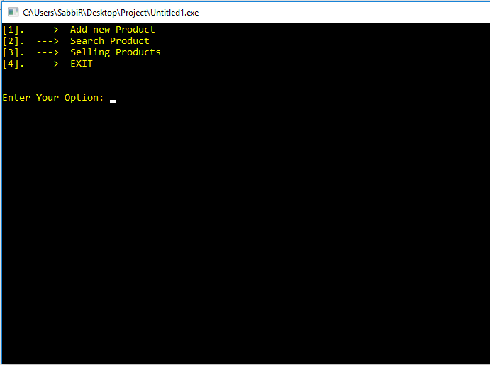

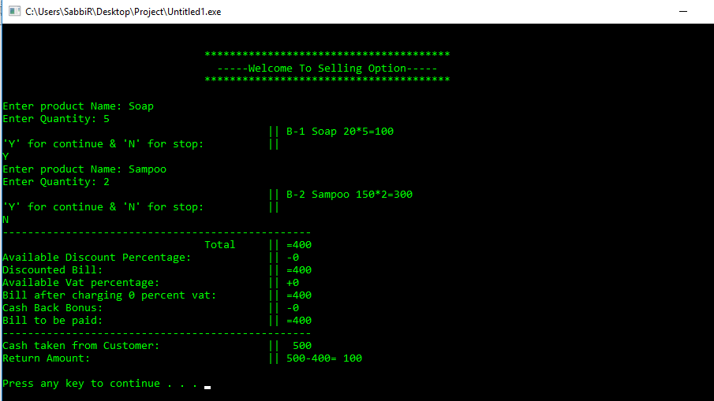

**Chapter 8**

**References**

**References**

1. **Let us c**
2. **C language**