Q1. Write a program to print personal details like Name, Surname ,Total Marks, Gender, by taking the input from the user.

#include<iostream.h>

#include<conio.h>

class myself{

char name[10];

char surname[10];

char gender;

int marks;

public:

void get();

void display();

};

void myself::get(){

cout<<"GET:";

cout<<"\n\nEnter name:";

cin>>name;

cout<<"Enter surname:";

cin>>surname;

cout<<"Gender:";

cin>>gender;

cout<<"Enter marks:";

cin>>marks;

}

void myself::display(){

cout<<"\nDISPLAY:";

cout<<"\n\nName:";

cout<<name;

cout<<"\nSurname:";

cout<<surname;

cout<<"\nGender:";

cout<<gender;

cout<<"\nMarks:";

cout<<marks;

}

void main(){

clrscr();

myself m;

m.get();

m.display();

getch();

}

Output:

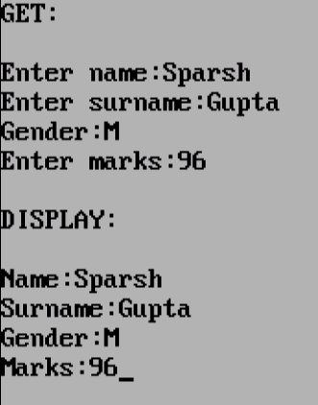

Q2. Create a class ‘Employee’ that has Employee number,Employee name as data members and member functions, ‘get_data’ to input the data, ‘display_data’ to output the data. Write the ‘main’ function to create an array of ‘Employee’ objects, accept and print the details of atleast 6 employees.

#include<iostream.h>

#include<conio.h>

#include<string.h>

class employee{

int emp_no;

char emp_name[10];

public:

void getdata(int a,char b[10]){

emp_no=a;

strcpy(emp_name,b);

}

void getdata(){

cout<<"\nEmployee ID:"<<emp_no;

cout<<"\nEmployee Name:"<<emp_name<<endl;

}

};

void main()

{

textbackground(WHITE);

textcolor(BLACK);

clrscr();

employee e[6];

cout<<"GETDATA:\n";

for(int i=0;i<6;i++)

{

int a;

cout<<"\nEnter Employee ID "<<i+1<<":";cin>>a;

char b[10];

cout<<"Enter Employee Name:";cin>>b;

e[i].getdata(a,b);

}

cout<<"\nDISPLAY:\n";

for(i=0;i<6;i++)

{

e[i].getdata();

}

}

Output:

